12/24/2025, Legacy (last week)
https://www.youtube.com/live/5J1-5WD0mm8?si=lH8hqU5QRhMbxKJ5
“Join A Team | Christmas Eve Service,” Phil EuBank, Lead Pastor



Introduction:
22:00/1:15:08


25:00/1:15:08

Phil EuBank, Lead Pastor


Luke 1:31
English Standard Version
³¹ And behold, you will conceive in your womb and bear a son, and you shall call his name Jesus.

The main point of Luke 1:31 is the angelic announcement to Mary that she will miraculously conceive and give birth to a son, whom she must name Jesus, a name meaning "God saves," revealing His divine purpose as the promised Messiah and Savior for His people, fulfilling Old Testament prophecies of a great king and redeemer.
Key aspects of Luke 1:31:
- Miraculous Conception: An angel (Gabriel) tells the virgin Mary she will become pregnant, not through human means, but through the Holy Spirit (Luke 1:35).
- The Name "Jesus": The name itself signifies His mission—to save His people from their sins.
- Fulfillment of Prophecy: This birth fulfills promises from the Hebrew Scriptures (like Isaiah 7:14) about a virgin bearing a son, the Son of God, who will reign.
- God's Salvation Plan: It marks the beginning of God's plan to bring salvation to the world through this unique child, uniting divine and human natures.


Revelation 11:15: Born to Reign forever:
The Seventh Trumpet
¹⁵ The seventh angel sounded his trumpet, and there were loud voices in heaven, which said:
“The kingdom of the world has become
the kingdom of our Lord and of his Messiah,
and he will reign for ever and ever.”

Revelation 11:15 marks the sounding of the seventh trumpet, bringing heavenly proclamation that "The kingdoms of this world have become the kingdoms of our Lord and of His Christ, and He shall reign forever and ever!". This verse signifies the decisive declaration that God's rule and that of His Messiah will definitively triumph over all earthly powers, leading to an eternal reign, and is followed by worship and praise for God taking His power and beginning to rule.
Key aspects of Revelation 11:15:
- Seventh Trumpet: This is a pivotal moment, signaling the culmination of divine judgments and the transition to Christ's eternal reign.
- Heavenly Voices: Loud voices announce this victory, emphasizing its cosmic significance.
- Christ's Reign: The core message is the complete transfer of global authority to God and Jesus, who will rule eternally.
- Transition: It's a declaration of Christ's rightful dominion, moving from a spiritual reality to a physical, universal acknowledgment of His kingship.
Context within Revelation 11:
This verse follows the prophecy of the two witnesses (Revelation 11:1-14) and precedes the description of the ark of the covenant being seen in heaven and further divine phenomena like earthquakes and hail. It's a moment of ultimate triumph and worship, as detailed in verses 16-19, where elders thank God for taking His great power and beginning to reign.

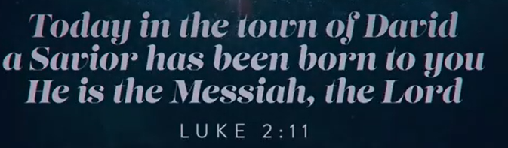
Luke 2:11
English Standard Version
¹¹ For unto you is born this day in the city of David a Savior, who is Christ the Lord.

Luke 2:11 (Luke 2:11) from the Bible announces the birth of Jesus, stating, "Today in the town of David a Savior has been born to you; he is the Messiah, the Lord" (or similar translations like "Christ the Lord"), spoken by angels to shepherds, highlighting Jesus as humanity's deliverer, the anointed one, and divine Lord.
Key Points:
- Context: An angel appears to shepherds outside Bethlehem to announce Jesus' birth, offering "good news of great joy for all people".
- Key Titles for Jesus:
  - Savior (Soter): One who rescues humanity from sin and alienation.
  - Messiah/Christ (Christos): The Greek term for the Hebrew "anointed one," fulfilling Old Testament prophecies.
  - Lord (Kyrios): A title of divine authority and sovereignty.
- Significance: This verse encapsulates the core message of Jesus' birth, identifying Him as the promised deliverer, the Christ, and the Lord, born in David's city (Bethlehem).


We have week between Christmas and New Year. This week is one of the busiest weeks and highest earing of box office revenue week of the year for movie theaters.
When the family go for vacation and the house get quiet, we don’t always get comfortable with that.



We want to sit in the dark and eat popcorn. We want to transport to different reality for three hours. We pay $20 for popcorn to escape the silence of our own living rooms.



Or look at our phone, dating apps, like hinge, tinder report of this week between Christmas and New Year. This is the peace week of the entire year.



Sometimes around Christmas, people are not around the table. It is silence of the dead week and can amplify the loneness. We start to swiping and scroll ourselves desperate to fill the quiet with some type of noise.



There is a National return week. We get billions of dollars in return merchandise over the next seven days.



On the surface, we have reasons to pick up the right color, right choice, etc. to satisfy our disappointed hope in January. We have culture of terrify the silence. The party is over, we go back to normal life.



This dead week is silence. We feel like our soul is looking for something that Amazon cannot deliver for Christmas. This is a good description of human without God. This is the reason that Christmas actually come in in the first place throughout the human history. Humanity has largely lived in that Gap, feeling that kind of dead week feeling.



This is why human looking for star and Jesus was born in the Christmas.

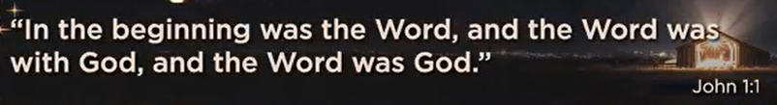
John 1:1
English Standard Version
The Word Became Flesh
1 In the beginning was the Word, and the Word was with God, and the Word was God.

The main point of John 1:1 is to identify Jesus Christ as the eternal, divine "Word" (Logos) who existed with God from the beginning, participated in creation, and is God Himself, establishing His pre-existence, deity, and intimate relationship with the Father before becoming human. It introduces Jesus not as a created being, but as the divine expression of God, co-equal and co-eternal with the Father, setting the foundation for the entire Gospel.
Key Components Explained:
- "In the beginning was the Word": Echoes Genesis 1:1, placing the Word (Jesus) at creation's dawn, existing eternally before anything else.
- "and the Word was with God": Shows the Word (Jesus) is distinct from God (the Father) but in intimate relationship and fellowship.
- "and the Word was God": Affirms the Word's full divinity and shared essence with God; Jesus is not just like God but is God.
Significance:
- Deity of Christ: Proves Jesus is fully God, not just a prophet or good teacher.
- Pre-existence: Establishes Jesus' existence before time began, challenging ideas of His origin.
- Trinity: Lays groundwork for understanding God as Father, Son (Word), and Holy Spirit, distinct yet one.
- Incarnation Preparation: Sets up John 1:14, where "the Word became flesh" (Jesus) to reveal God to humanity.

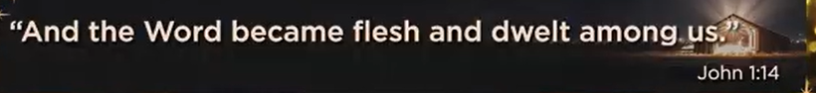
John 1:14
English Standard Version
¹⁴ And the Word became flesh and dwelt among us, and we have seen his glory, glory as of the only Son^{[a]} from the Father, full of grace and truth.

The main point of John 1:14 is the Incarnation: the divine "Word" (Jesus Christ, who is God) became fully human ("flesh") and lived among us, revealing God's glorious presence, character, grace, and truth in a tangible way, bridging the gap between the divine and humanity. It signifies that God, instead of humanity reaching for Him, came down to us in Jesus, offering salvation through His gracious presence and faithfulness.
Key Aspects:
- The Word Became Flesh: Jesus, the eternal divine Word (Logos) from John 1:1, took on human nature, proving He was truly God and truly man, countering ideas that He was only a spirit or illusion.
- Dwelt Among Us: Jesus "pitched His tent" or lived among people, echoing God's presence with Israel in the Old Testament tabernacle, making God accessible.
- We Saw His Glory: His divine glory, characteristic of the Father, was visible in His life, miracles, teachings, and sacrifice, demonstrating God's majesty.
- Full of Grace and Truth: This glory wasn't overwhelming but was expressed through God's compassionate favor (grace) and His faithfulness (truth), offering a way for people to find redemption and relationship with Him.
In essence, John 1:14 reveals Jesus as God's ultimate self-revelation, bridging heaven and earth through His incarnate life, offering grace and truth to humanity.

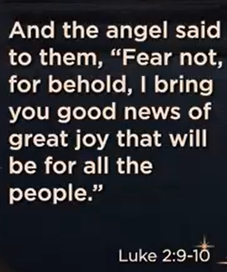
Luke 2:9-10
English Standard Version
⁹ And an angel of the Lord appeared to them, and the glory of the Lord shone around them, and they were filled with great fear. ¹⁰ And the angel said to them, “Fear not, for behold, I bring you good news of great joy that will be for all the people.

The main point of Luke 2:9-10 is the divine announcement of Jesus' birth as "good news of great joy for all the people," delivered by an angel to terrified shepherds, reassuring them that God's powerful presence brings comfort, salvation, and universal hope, not fear, marking a pivotal moment of universal Good News (the Gospel).
Key Themes in Luke 2:9-10:
- Divine Presence & Awe: The glory of the Lord and the angel's appearance signify God's active involvement and presence, inspiring awe and initial terror in the shepherds.
- Fear & Reassurance: The angel immediately dispels the shepherds' fear ("Do not be afraid!") to prepare them for the joyous message, showing God brings comfort amidst uncertainty.
- Universal Good News (Gospel): Jesus' birth is presented as a message for everyone, not just a select few, emphasizing hope and salvation for all humanity, regardless of social status, as the marginalized shepherds are chosen as first recipients.
- Great Joy: The core purpose of this announcement is to bring immense joy, highlighting that the arrival of Christ is the ultimate reason for celebration and hope.
In essence, these verses transition from the shock of divine encounter to the transformative promise of salvation and universal joy found in the birth of Jesus, the Savior.


"Silence of Presence" refers to a profound state where silence isn't an absence of sound, but a rich, active presence of awareness, connection, and deep listening, offering comfort, clarity, and spiritual depth, allowing genuine being to emerge beyond mere words, found in contemplative practices, relationships, and the natural world. It's about being there fully, letting inner stillness resonate, and perceiving reality more clearly, whether connecting with others or with the divine.
Key Aspects:
- Not Just Absence: Silence is an active, living presence, not merely the lack of noise, often containing profound meaning.
- Deep Listening: It's the space to truly hear God, ourselves, and others, fostering empathy and connection.
- Inner Sanctuary: It opens an inner space where the mind calms, allowing for self-discovery and clarity.
- Spiritual Connection: In spirituality, it's a way to encounter the divine, experience awe, and feel belonging.
- Support for Others: Offering silent presence is a powerful act of love, showing care without needing words, especially in times of need.
Examples in Practice:
- Meditation: Cultivating silence to feel a vast, undisturbed presence.
- Relationships: Sitting with someone in silence, providing a supportive, non-judgmental space.
- Contemplation: Using silence to listen for God's voice or deeper truths.
In essence:
It's the recognition that in stillness, something fundamental is revealed, allowing us to be more attuned, more present, and more authentically ourselves and connected to all things.

12/24/2025, Legacy (last week)
https://www.youtube.com/live/5J1-5WD0mm8?si=lH8hqU5QRhMbxKJ5
“Join A Team | Christmas Eve Service,” Phil EuBank, Lead Pastor

Summary:
1. Luke 1:31: Angels announce to Mary that she will be give birth to a son, whom she must name Jesus (meaning "God saves,") for God’s promised Messiah (Savior) in Old Testament.
2. Revelation 11:15: Jesus is born to reign forever
3. Luke 2:11: In the town of David, a Savior has been born. He is the Messiah.
4. We have week between Christmas and New Year. Most family go for vacation. This week is called dead week and silence. The shepherds are looking for star and Jesus is born in Christmas.
5. John 1:1: Identify Jesus’s eternal, existed with God, relations with God, and born as human.
6. John 1:14: Jesus is incarnated (transformed) from spirit into human being and lived among us. Jesus has God's glory, character, grace, and truth. He bridges the gap between the divine and humanity.
7. Luke 2:9-10: Angel announced Jesus' birth "good news of great joy for all the people," delivered by an angel to terrified shepherds.
8. Silence of Presence: Silence is not an absence of sound, but offer spiritual depth beyond mere words. In silence, we connect more with God.

