03/14/2026, Menlo Church Worship, Legacy (last week)
https://www.youtube.com/live/7r7aPuwqkl0?si=4bKQfSfIdNLRgCnF
“I Am With You in the Fight | I Am: The God Who Gets Close,” Phil EuBank, Lead Pastor

Introduction:
12:00/1:15:04


20:00/1:15:04
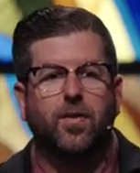
Phil EuBank, Lead Pastor

03/07/2026, Menlo Church Worship, Legacy (last week)
https://www.youtube.com/live/7r7aPuwqkl0?si=4bKQfSfIdNLRgCnF
“I Am With You in the Fight | I Am: The God Who Gets Close,” Phil EuBank, Lead Pastor

We are in the second week of series “I Am.” Last week, we talked about God gives command Moses in the desert. Today, we talk about Jacob who fight with God. At the end, God changes the Jacob (Follower/Replacement) into Isarael (One who fight with God).

Summary

