01/24/2026, Menlo Church Worship, Legacy (last week)
https://www.youtube.com/live/WoquG1Avbhc?si=aVGpu3w83RXChyxU
“Perfect Parents | PERFCT,” Phil EuBank, Lead Pastor



Introduction:
12:00/1:14:56


21:00/1:14:56

Phil EuBank, Lead Pastor

As a parents to spend uneven time among kids. There is no perfect parents.

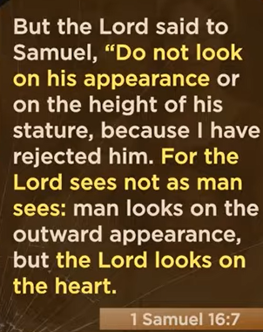
1 Samuel 16:7
English Standard Version
⁷ But the Lord said to Samuel, “Do not look on his appearance or on the height of his stature, because I have rejected him. For the Lord sees not as man sees: man looks on the outward appearance, but the Lord looks on the heart.”

The main point of 1 Samuel 16:7 is that God does not evaluate people based on outward appearance, stature, or charisma, but rather focuses on their internal character and heart. It highlights that divine judgment prioritizes inner qualities like faith and integrity over physical attributes.
Key Takeaways:
- God's Perspective vs. Human Perspective: Humans often judge by outward appearances, but God sees the true nature of the heart.
- Context of Anointing: The verse occurs when Samuel is choosing a new king for Israel, rejecting the impressive-looking Eliab for David, whom God chose.
- Focus on Character: The lesson emphasizes that God values inner virtues and a heart dedicated to Him.
- Application: It serves as a reminder not to make quick judgments based on superficial traits, but to focus on character, similar to "God Looks on the Heart (1 Samuel 16:7) - Radical".

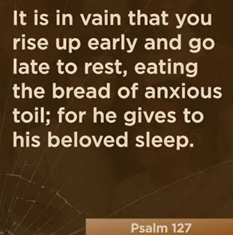



Psalm 127
English Standard Version

Unless the Lord Builds the House
A Song of Ascents. Of Solomon.
127 Unless the Lord builds the house,
those who build it labor in vain.
Unless the Lord watches over the city,
the watchman stays awake in vain.

The main point of Psalm 127 is that all human effort—whether building a home, guarding a city, or working for16 sustenance—is futile and "in vain" without God's blessing and17 sovereignty. It teaches that true security and prosperity come from trusting in God's providence rather than relying solely on self-sufficient, anxious toil, which includes recognizing children as a precious gift from Him.
Key Themes and Takeaways:
- The Futility of Self-Sufficiency: Unless the Lord is the foundation, human labor to build homes or guard cities is empty.
- Anxious Toil vs. Rest: The psalm critiques working late and rising early out of anxiety, emphasizing that God provides for His loved ones even while they sleep.
- Children as a Heritage: Children are described as a "reward" and "heritage" from the Lord, serving as a source of strength and blessing, likened to "arrows in the hand of a warrior".
- Divine Sovereignty: Ultimately, the psalm highlights that God is the source of all success and security, encouraging a life of dependence on Him.
This "song of ascents" (likely by Solomon) encourages believers to balance work with trust in God's provision.


Colossians 3:20-21
English Standard Version
²⁰ Children, obey your parents in everything, for this pleases the Lord. ²¹ Fathers, do not provoke your children, lest they become discouraged.

Colossians 3:20-21 establishes that Christian family life should be built on mutual respect and love, where children are to obey their parents to please the Lord, and parents (specifically fathers) are commanded to lead with patience rather than harshness to avoid discouraging their children. This fosters a home environment where authority is used for encouragement, not provocation.
Key Aspects of Colossians 3:20-21
- Children’s Responsibility (v. 20): Children are instructed to obey their parents in "all things," which is seen as a way to honor God and is "well-pleasing to the Lord". This obedience is framed as part of a healthy, functioning, and godly household.
- Parents’ Responsibility (v. 21): Fathers (and by extension, parents) are warned not to "provoke," "exasperate," or "embitter" their children, which can lead to them becoming discouraged or losing heart.
- The Goal of Parenting: The goal is to avoid fostering a "broken spirit" in children through overly harsh or unreasonable discipline.
- Context: These verses are part of a broader set of instructions for Christian living in the home, emphasizing that faith should directly influence family relationships.
In essence, the passage balances the need for obedience from children with the need for nurturing, non-abusive, and encouraging leadership from parents.

34:11/1:14:56


34:55/1:14:56


39:02/1:14:56

39:50/1:14:56




Matthew 3:17
English Standard Version
¹⁷ and behold, a voice from heaven said, “This is my beloved Son,^{[a]} with whom I am well pleased.”
Read full chapter

The main point of Matthew 3:17 ("This is my beloved Son, with whom I am well pleased") is the divine confirmation of Jesus as the Son of God and the promised Messiah at the start of his ministry. It highlights God the Father’s approval of Jesus, fulfilling prophecies and affirming his sinless, righteous identity to the world.
- Divine Endorsement: God the Father validates Jesus' identity immediately following his baptism.
- Messianic Confirmation: The voice from heaven declares Jesus as the beloved Son, echoing Old Testament prophecies.
- Pleasure and Approval: The declaration "with whom I am well pleased" signifies total approval of Jesus’ character, mission, and submission to the Father's plan, identifying him as the ultimate representative of God.
- The Trinity: The scene showcases all three persons of the Trinity: the Father speaking, the Son being baptized, and the Spirit descending.





43:22/1:14:56

MS: middle school



47:00/1:14:56




48:00/1:14:56


01/24/2026, Menlo Church Worship, Legacy (last week)
https://www.youtube.com/live/WoquG1Avbhc?si=aVGpu3w83RXChyxU
“Perfect Parents | PERFCT,” Phil EuBank, Lead Pastor

