05/09/2026, Menlo Church Worship (Summary of last week, 05/03/2028)
https://www.youtube.com/watch?v=V6kRPnGiKVg

“Digital Thorns,” Joey Odom, Guest Speaker, Menlo Church Sermon (Phil EuBank, Lead Pastor)

5:08/1:15:01

Allison Li

Introduction:
9:13/1:15:01

Mark Swarner, Campus Pastor

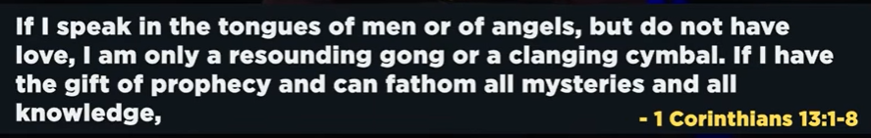

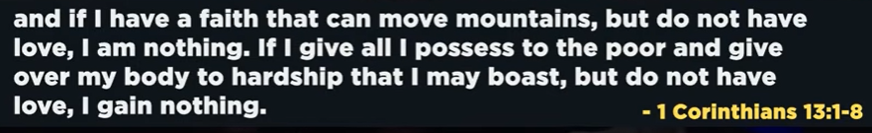

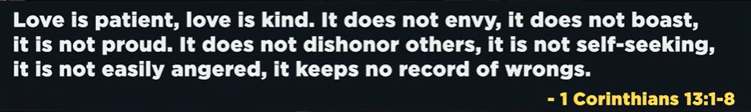

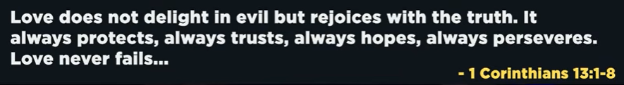

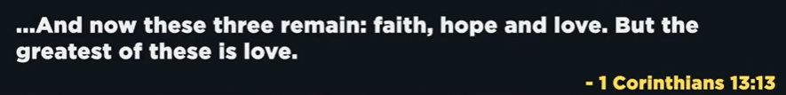

19:53/1:15:01

Phil EuBank, Lead Pastor

We are thrilled to have Joey Odom to be our guest speaker. Joe is a thought leader in the space of being present in an age and moment of supreme distraction. He is cofounder of a company that help people think through their relationships with technology.

21:10/1:15:01

Joey Odom, Aro, Co-Founder

25:10/1:15:01
We talk about phone and technology today. When we talk about technology, we often feel three things: shame, blame, defensive. This message is for you and good for your life.

28:21/1:15:01
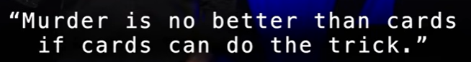
“Murder is no better than cards if cards can do the trick.”, C.S. Lewis (1942)

You are right—in the real world, murder and a card game are completely different things. One is a horrific crime, and the other is just a way to pass the time. [1]
However, the quote compares them strictly from the perspective of a demon whose only goal is to separate a person from God. To a demon, they are comparable because they can lead to the same final result: [1, 2]
- The Shared Result: For the demon, "success" means a soul is lost. If a person drifts away from God because they are distracted by a mindless card game every night for 40 years, the demon wins just as much as if that person had committed a murder.
- A Question of Efficiency: Screwtape argues that murder is actually "no better" than cards because murder is loud. It shocks the conscience and might make a person repent. A card game is quiet and safe for the demon because the person never realizes their soul is in danger.
- The "Nothing": Lewis uses "cards" to represent any trivial, mindless activity that wastes a life. He suggests that a soul can be destroyed by "nothing"—a long, dim life of boredom and distraction—just as effectively as by a single great evil. [1, 2, 3, 4, 5, 6, 7, 8, 9, 10, 11]
In short, they are compared as two different paths to the same destination. Murder is a sudden cliff, while a card game (when used as a distraction from one's spiritual life) is a "gentle slope" that leads to the same place without the person ever noticing they are falling. [1, 2]

Murder (kill people) and card game (kill time) are different at very beginning. But will be same at the end. Satan separates the people soul from God. Card distracts people attention.

29:20/1:15:01

We have more than 50,000 card games in iPhone.

29:24/1:15:01

In addition to card games, we access 10 million games on our iPhone.

29:31/1:15:01
In addition to 10 million games, we have more than 30 million videos on TikTok uploaded every day.

29:38/1:15:01
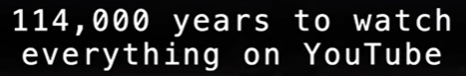
On YouTube, it takes 114,000 years to watch all videos on YouTube.
How can we have time together with God?

31:00/1:15:01
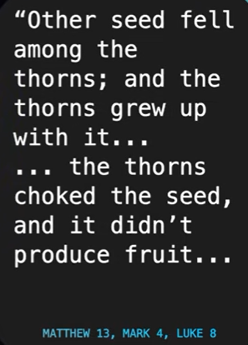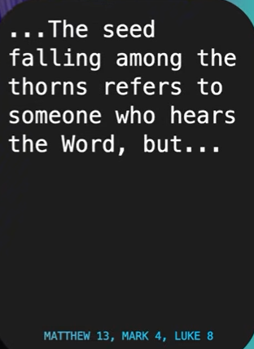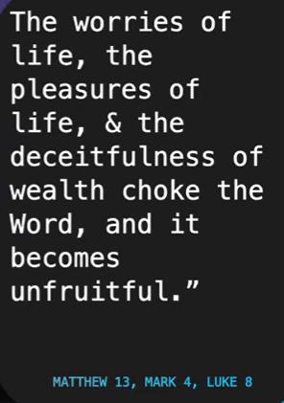
Matthew 13, Mark 4, Luke 8

Other seed fall among the thorns. The thorns grew up with seed.
The thorns choke the seed and the thorns did not produce the fruit. The seed falling among the thorns, and never grows the fruit.
The seed falling among the thorns refers to someone who bears the word.
But the worries of life, the pleasure of life, and deceitfulness (欺騙) of wealth choke the word, and it becomes unfruitful.

31:38/1:15:01
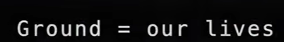

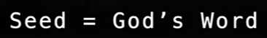

The above message from Jesus has four characters. first character is the ground. The ground represents us. It is our lives.
Next, we have the seed. This represents the God’s word.
Then, we have the fruits, which is the potential outgrowth of the seed.
Finally, we have the thorns. The thorns are the threat to the seed. They represent the worries of life, the pleasures of life, and deceitfulness of wealth.

32:12/1:15:01
Jesus is the GOAT (Great Of All Time). Jesus told this story 2,000 years ago to the farmers in a agrarian (農業的) society. It is a prefect application for their lives at that time

32:48/1:15:01
Jesus told us three things: The worries of life, the pleasures of life, and the deceitfulness of wealth.

33:23/1:15:01
Thorn #1: Worries of life.
What was the last time we go over the twister or X? We read the news from phone, Iran war, Hormuz strait, etc. Those are worries of the life instantly begin to flood your heart. These are totally inactionable by us. We ca do very little about. They fill our heart and paralyze us. It stops us to take action to do something.

34:41/1:15:01
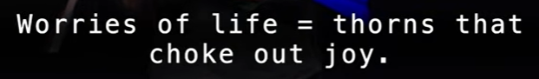
Worries of life choke out the joy.

34:54/1:15:01
Second thorn: Pleasures of life.
We watch the pornography, games, ESPN Sport, NFL, NBA, etc. These are pleasures of life. We have distraction from these. We try to remove or escape ourselves from the current moment,

36:26/1:15:01
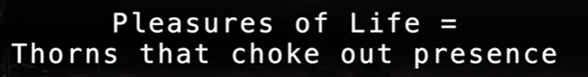
The pleasures of life choke out presence.

36:36/1:15:01
Thorn #3: Deceitfulness of wealth
Finally, Deceitfulness of wealth

38:11/1:15:01
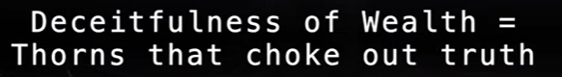
We have friends travel all around. We just compare the money and social media. It chokes out the contentment (satisfaction).
Deceitfulness of wealth choke out the truth.

We have three thorns (Worries of life, pleasures of life, and Deceitfulness of wealth) which choke out the seed so that it does not produce fruit.

39:01/1:15:01
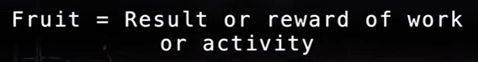
What is the fruit? Furit is result or reward of work or activity.

39:33/1:15:01
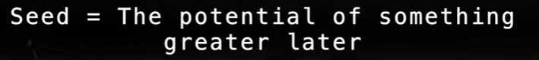
We want fruit which come from seed. The seed is potential of something greater later on.

42:00/1:15:01
The seeds are surround by the digital thorns. These digital thorns kill our lives.

43:35/1:15:01
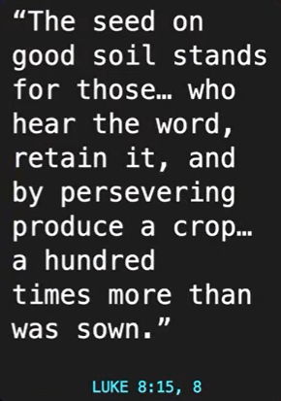
Luke 4:15, 8
The seed on good soil stands for those… who hear the word, retain it, and by preserving produce a crop… a hundred times than was sown.

44:35/1:15:01
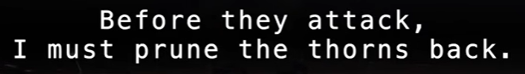
Before they attack, I must prune the thorns back.

45:19/1:15:01

1. Let’s live differently: Stop the incoming messages.

46:19/1:15:01
Don’t bring thorns (iPhone) to a fruit party

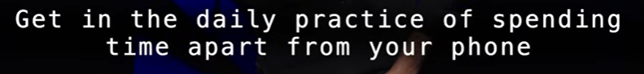
Get in the daily practice of sending time apart from your phone.

47:19/1:15:01
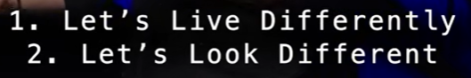

48:19/1:15:01
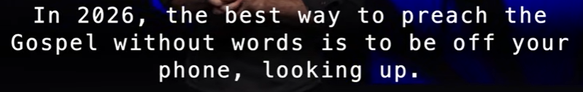
In 2026, the best way to preach the Gospel without words is to be off your phone, looking up.

49:19/1:15:01
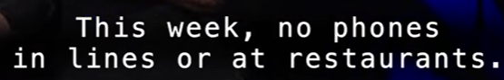
No phones in lines or at restaurants.

49:30/1:15:01

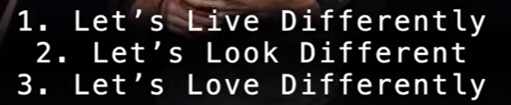

49:40/1:15:01
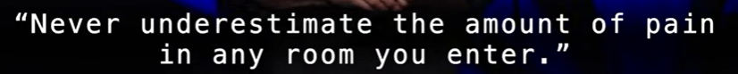
Never underestimate the amount of pain in any room you enter.

Pray:



======
05/09/2026, Menlo Church Worship (Summary of last week, 05/03/2028)
https://www.youtube.com/watch?v=V6kRPnGiKVg

“Digital Thorns,” Joey Odom, Guest Speaker, Menlo Church Sermon (Phil EuBank, Lead Pastor)
“Digital Thorns,” Joey Odom, Guest Speaker, Menlo Church Sermon (Phil EuBank, Lead Pastor)

We have all kinds of Digital thorns: more than 50,000 card games in iPhone, 10 million games on our iPhone, 30 million videos on TikTok uploaded every day. On YouTube, it takes 114,000 years to watch all videos on YouTube. How can we have time together with God?

Summary:
1. Matthew 13, Mark 4, Luke 8: Seed fall among the thorns. The thorns grew up with seed. The thorns choke the seed and the thorns did not produce the fruit. The seed falling among the thorns, and never grows the fruit. The seed falling among the thorns refers to someone who bears the word.
2. The above Bible scriptures have four characters: ground (our life), Seed (God’s word), fruits (growth of the seed), thorns (threat to the seed)
3. We have Three thorns:
a. Worries of life: Worries of life choke out the joy.
b. Pleasures of life: The pleasures of life choke out presence.
c. Deceitfulness of wealth: We enjoy money. Deceitfulness of wealth choke out the truth.
4. We have three thorns which choke out the seed and does not produce fruit. In real world, we have all kinds of digital thorns (news, game, video, etc). The seeds are surround by the digital thorns. These digital thorns kill our lives.
5. Luke 4:15, 8: The seed on good soil stands for those who hear the word, retain it, and by preserving produce a crop, etc. a hundred times than was sown.
6. Conclusion:
Before thorns attack, we must prune the thorns back. How to prevent the digital thorns:
a. Let’s live differently: 1) Stop the incoming messages, 2) Don’t bring thorns (iPhone) to a fruit party,
3) Get in the daily practice of sending time apart from your phone.
b. Let’s look differently: turn off your phone in worship, no phone in anywhere.
c. Let’s love differently: Never underestimate the amount of pain (medical diagnostic, financial situation, etc) in any room you enter. Require us to slowdown, put down, lookup, etc.

==> Mandarin
2026年5月7日，Menlo教會敬拜（上週聚會摘要，2028年4月26日）
https://www.youtube.com/watch?v=V6kRPnGiKVg
“數字荊棘”，特邀講員 Joey Odom，Menlo教會講道（主任牧師：Phil EuBank）

我們面臨著各種各樣的「數位荊棘」：iPhone 上有超過 5 萬種紙牌遊戲，總計 1000 萬款各類遊戲；TikTok（抖音國際版）上每天有 3000 萬條影片上傳。而在 YouTube 上，若想看完所有的視頻，需要耗費 11.4 萬年的時間。面對這一切，我們怎能騰出時間來與神同在呢？

摘要：
1. 《馬太福音》13章、《馬可福音》4章、《路加福音》8章：種子落在了荊棘叢中。荊棘與種子一同生長，最後荊棘扼殺了種子，導致種子無法結出果實。落在荊棘中的種子，永遠無法結出果實。這裡的“落在荊棘中的種子”，象徵著那些聽聞了神的話語的人。
2. 上述聖經經文中包含了四個要素：土地（即我們的生命）、種子（即神的話語）、果實（即種子的成長與結實）、荊棘（即對種子的威脅）。
3. 我們面臨三種「荊棘」：
a. 生活的憂慮：生活的憂慮會扼殺內心的喜樂。
b. 生活的享樂：生命的享樂會扼殺我們對神同在的感知。
c. 金錢的誘惑：我們常沉溺於金錢帶來的享受；而金錢的虛謊與誘惑，會扼殺我們對真理的持守。
4. 這三種荊棘會扼殺種子，使其無法結出果實。在現實世界中，我們面臨著各種形式的「數位荊棘」（如新聞資訊、電子遊戲、短片等）。神的話語——那顆種子——正被這些數字荊棘層層包圍。這些數字荊棘正在扼殺我們的生命。
5. 《路加福音》4章15節、8章：落在「好土」上的種子，象徵那些聽聞神的話語、將其存記於心，並憑著堅忍與持守結出果實的人——其收成甚至可達撒種量的百倍之多。
6. 結論：
在荊棘發動侵襲之前，我們必須先將其修剪、清除。那麼，我們該如何防範這些「數字荊棘」呢？
a.讓我們換個方式生活：1) 停止接收各類資訊；2) 參加「水果派對」時，別帶著「荊棘」（即 iPhone）入場；
3) 養成日常習慣，每天留出一段完全脫離手機的時間。
b. 讓我們換個方式檢視周圍：在敬拜時請關閉手機，在任何場合都盡量放下手機。
c. 讓我們換個方式去愛：永遠不要低估你所踏入的任何房間裡可能潛藏的痛苦（無論是源於疾病診斷、財務困境，還是其他方面）。這要求我們放慢腳步、放下手機、抬起頭來，去注意身邊的人事。

==> Japanese

2026年5月7日、メンロ教会礼拝（先週の要約、2028年4月26日）
https://www.youtube.com/watch?v=V6kRPnGiKVg
「デジタルの棘」ジョーイ・オドム氏（ゲストスピーカー）、メンロ教会説教（フィル・ユーバンク主任牧師）

私たちはあらゆる種類のデジタルの棘に囲まれています。iPhoneには5万種類以上のカードゲーム、1000万種類ものゲーム、TikTokには毎日3000万本もの動画がアップロードされています。YouTubeでは、すべての動画を見るのに11万4000年もかかります。どうすれば神と共に過ごす時間を持つことができるでしょうか？

要約：
1. マタイによる福音書13章、マルコによる福音書4章、ルカによる福音書8章：種は茨の中に落ちた。茨は種と共に生えたが、種を窒息させ、実を結ばなかった。いばらの中に落ちた種は、実を結びません。いばらの中に落ちた種とは、御言葉を携える人を指します。

2. 上記の聖書の箇所には、土台（私たちの人生）、種（神の言葉）、実（種の成長）、いばら（種への脅威）という4つの要素があります。
3. 私たちには3つのいばらがあります。
a. 人生の心配事：人生の心配事は喜びを窒息させます。

b. 人生の快楽：人生の快楽は存在を窒息させます。

c. 富の欺瞞：私たちは金銭を楽しみます。富の欺瞞は真実を窒息させます。

4. 私たちには、種を窒息させ、実を結ばせない3つのいばらがあります。現実の世界では、あらゆる種類のデジタルないばら（ニュース、ゲーム、動画など）が存在します。種はデジタルないばらに囲まれています。これらのデジタルないばらは私たちの人生を殺します。

5. ルカによる福音書 4:15、8：良い地に蒔かれた種は、み言葉を聞いてそれを心に留め、それを守り続けることで、蒔いた種の百倍の実を結ぶ人々のことを表しています。

6. 結論：いばらが襲いかかる前に、いばらを刈り取らなければなりません。デジタル上のいばらを防ぐ方法：a.生き方を変えよう：1）絶えず届くメッセージを遮断する、2）「果実の宴」に「棘（iPhone）」を持ち込まない、
3）毎日、携帯電話から離れて過ごす時間を設ける習慣をつける。
b. 見方を変えよう：礼拝中は携帯電話の電源を切る。いかなる場所であっても、常に携帯電話を手にしている状態をやめる。
c. 愛し方を変えよう：自分が足を踏み入れるあらゆる場所において、そこに存在する痛み（病気の診断結果や経済的な苦境など）の大きさを決して過小評価してはならない。立ち止まり、手にしているものを置き、顔を上げて周囲を見渡す――そうした姿勢を自らに課そう。

