10/25/2026, Menlo Church Worship (Summary of last week, 10/31/2026)
https://www.youtube.com/watch?v=3F6waMyjTb4&t=19s
https://github.com/peterhchen/1000_Family/tree/main/Church/2026
Posture for People, Policies, and the Polls| Beyond the Ballot | Menlo Church,
Matt Summers, Pastor of Spiritual Formation
Phil EuBank, Lead Pastor

0:00/33:42
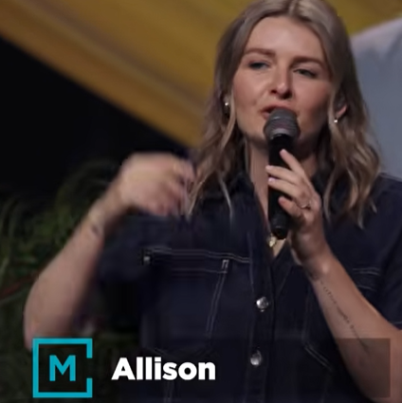
Allison Joy Li

Introduction:
0:00/33:42
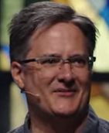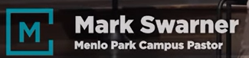
Mark Swarner, Campus Pastor

0:00/33:42
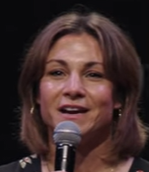

0:06/33:42
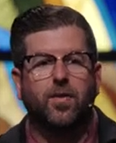
Phil EuBank, Lead Pastor

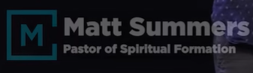
Matt Summers, Pastor of Spiritual Formation

************
************
10/25/2026, Menlo Church Worship (Summary of last week, 10/31/2026)
https://www.youtube.com/watch?v=3F6waMyjTb4&t=19s
https://github.com/peterhchen/1000_Family/tree/main/Church/2026
Posture for People, Policies, and the Polls| Beyond the Ballot | Menlo Church,
Matt Summers, Pastor of Spiritual Formation

