02/07/2026, Menlo Church Worship, Legacy (last week)
https://www.youtube.com/live/gjDnH48q-Vs?si=b1QK17jhjU0Zi2NT
“Love is More Than a Feeling | Love is…,” Phil EuBank, Lead Pastor



Introduction:
10:00/1:14:58


10:26/1:14:58
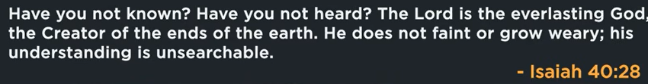

10:37/1:14:58


10:53/1:14:58
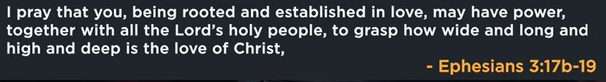

21:00/1:14:58

Phil EuBank, Lead Pastor
We have new series in February about “Love…” Note that this is not a dating sermon.
Today, we talked the Bible Definition of Love and the Tool we will use for Love.

23:14/1:14:58
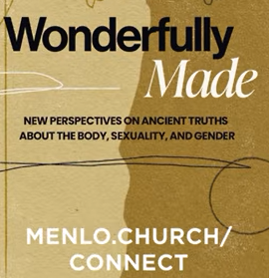

25:14/1:14:58



 s
26:00/1:14:58
Love is?
People have different answer: Fun, popcorn, Instagram, a spark, soulmate
There is a Vibes (共鸣) in Loves. It is like chemistry, feeling, etc. in a moment.
Love is something that we fall into.
Then in the moment that feeling fades, love leaves, see the Romantic relationship that we have or the close friends that we are thinking.

27:47/1:14:58

What if love is less decoration and more foundation?
This is what we are going to talk about today.
We have our house as a family which is owned by a foundation. We are very grateful for.
There are some aspects of the house were decorative and can be changed easily. What aspect of the house actually supported the house?
In God blueprint, love is not the paint. Love is the support structure. Love is the beams that support the house from collapsing.

In order to better understand what love is, we need Biblical definition of love. Love is a topic that Bible addresses consistently throughout entire Bible. Love is one of most common concept that we find in Bible.

30:00/1:14:58

1 John 4:7-8
English Standard Version
God Is Love
⁷ Beloved, let us love one another, for love is from God, and whoever loves has been born of God and knows God. ⁸ Anyone who does not love does not know God, because God is love.

The main point of 1 John 4:7-8 is that because God is the source and essence of love, Christians must love one another as proof of their relationship with Him. Genuine knowledge of God results in a life marked by love, while a lack of love indicates a lack of knowledge of God.
GotQuestions.org +3
Key takeaways from this passage:
- God's Character: Love is not merely an action God does; it is the very essence of His nature, as stated in 1 John 4:8.
- The Call to Action: Because love originates from God, believers are commanded to love one another.
- Proof of Knowledge: Loving others is evidence that a person is born of God and truly knows Him.
- The Definition of Love: This refers to agape love (sacrificial, selfless love) rather than just romantic affection.

30:30/1:14:58

1 John 4:9-10
English Standard Version
⁹ In this the love of God was made manifest among us, that God sent his only Son into the world, so that we might live through him. ¹⁰ In this is love, not that we have loved God but that he loved us and sent his Son to be the propitiation for our sins.

The main point of 1 John 4:9-10 is that God’s love is definitively demonstrated through the incarnation and sacrificial death of Jesus Christ, rather than initiated by human effort. God sent His Son as the "propitiation" (atoning sacrifice) for sins so that humanity might receive spiritual life through Him.

Key takeaways from this passage include:
- Love Initiated by God: God’s love is not a reaction to human love, but a proactive act: "not that we loved God, but that he loved us".
- The Ultimate Demonstration: The sending of Jesus Christ into the world is the supreme display of God’s love.
- Purpose of Sacrifice: Jesus was sent to be the atoning sacrifice (propitiation) for sins, removing the barrier between God and humanity.
- Life Through Him: The goal of this sacrifice is that humanity might "live through him"—referring to eternal, spiritual life.

This passage highlights that the incarnation (Christmas) and the atonement (Cross) are the tangible, historical proofs of God's love.

God love us and sent his Son for our sins.

31:00/1:14:58

Beloved, if God so loved us, we also ought to love one another. No one has ever seen God; if we love one another, God abides in us and his love is perfected in us.

1 John 4:11-12
English Standard Version
¹¹ Beloved, if God so loved us, we also ought to love one another. ¹² No one has ever seen God; if we love one another, God abides in us and his love is perfected in us.

The main point of 1 John 4:11-12 is that because God has demonstrated supreme, sacrificial love by sending His Son, believers are compelled to love one another as a reflection of His character. This active, shared love acts as proof of God’s indwelling presence, making His love complete and visible in the world.

Key takeaways from these verses include:
- The Mandate to Love: Since God initiated this unconditional love, believers "ought" to show the same, especially when others are difficult to love.
- God’s Visible Presence: Although God is invisible, He becomes visible through the loving actions of believers within the community.
- Completing Love: Loving others brings God's love to its intended maturity ("perfected") within believers, demonstrating that He truly lives in them.
- Evidence of Faith: This horizontal love for others is the ultimate evidence of a vertical relationship with God.
- 1 John 4:11-12 (NIV): "Dear friends, since God so loved us, we also ought to love one another. No one has ever seen God; but if we love one another, God lives in us and his love is made complete in us."

God love is abided us.

36:00/1:14:58

A self-sacrificing choice to seek the highest good of another, regardless of how they respond
If Love is just vibes, Jesus would never have to gone to the Cross.

God Love is Jesus sacrifice himself for our sins.

37:00/1:14:58

Expressive Individualism
In the human history people looked at externally beyond themselves to define reality.
They look to God to their community or to a moral code to tell hem how to live for a long time.
Contain four quadrant, scripture, tradition, logic, and experience.
We look at inward feeling and desire and express feeling to outside.
We anchor Jesus: Love is God, then express it to the outside.

42:00/1:14:58

Beloved, if God so loved us, we also ought to love one another. No one has ever seen God; if we love another, God abides in us and his love is perfected in us.

1 John 4:11-12
English Standard Version
¹¹ Beloved, if God so loved us, we also ought to love one another. ¹² No one has ever seen God; if we love one another, God abides in us and his love is perfected in us.

(Same as in the 31:00/1:14:58)

42:30/1:14:58

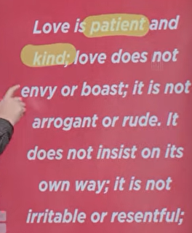
Love is patient and kind; love does not envy or boast; it is not arrogant or rude. It does not insist on its own way; it is not irritable or resentful;

1 Corinthians 13:4-5
English Standard Version
⁴ Love is patient and kind; love does not envy or boast; it is not arrogant ⁵ or rude. It does not insist on its own way; it is not irritable or resentful

The main point of 1 Corinthians 13:4-5 is that true, godly love (agape) is defined by selfless actions and character—specifically patience, kindness, and humility—rather than selfish desires, pride, or resentment. It serves as a corrective to the Corinthian church's focus on selfish spiritual gifts, defining love as the essential, patient, and non-boastful foundation for all Christian relationships.
Key Characteristics of Love in 1 Cor 13:4-5:
- Active Virtue: Love is not merely a feeling but is patient (endures difficulty) and kind (acts for others' good).
- Anti-Selfishness: It does not envy, boast, act proudly, behave rudely, or seek its own way.
- Forgiving Nature: It is not easily angered and keeps no record of wrongs.
In essence, these verses describe a self-sacrificing love that mirrors the character of Jesus Christ, prioritizing the needs of others over personal rights.

43:00/1:14:58

All in Greek is “Paspana”
It does not rejoice at wrongdoing, but rejoices with the truth. Love bears all things, believes all things, hopes all things, endures all things.
1 Corinthians 13:6-7
English Standard Version
⁶ it does not rejoice at wrongdoing, but rejoices with the truth. ⁷ Love bears all things, believes all things, hopes all things, endures all things.

The main point of 1 Corinthians 13:6-7 is that true, godly love (𝑎𝑔𝑎𝑝𝑒) is defined by moral integrity and unconditional commitment, refusing to delight in wrongdoing while actively promoting truth, protecting, trusting, hoping, and persevering. It highlights that love is a selfless, enduring action that focuses on righteousness and the well-being of others.
Key insights from 1 Corinthians 13:6-7:
- Moral Alignment (v. 6): Love does not rejoice in injustice, sin, or the misfortune of others, but finds joy in truth and righteousness.
- Active Endurance (v. 7): Love is characterized by four unwavering actions:
  - Protects: It covers, shields, and guards others rather than exposing them.
  - Trusts: It believes the best in people and trusts in God's power to work in situations.
  - Hopes: It maintains a positive outlook, trusting that God's truth will prevail.
  - Perseveres: It endures, stands firm, and never gives up, even through difficult circumstances.
- The Source: This type of love is not merely human, but rather the selfless, sacrificial love of God fueled by the Holy Spirit.
In essence, these verses emphasize that love is not just a feeling, but a deliberate choice to act in righteousness and endurance for the good of others.

44:00/1:14:58

Difficult: Annoyance, Selfish
What if love is less decoration and more foundation?
(same as 27:47/1:14:58)

46:00/1:14:58
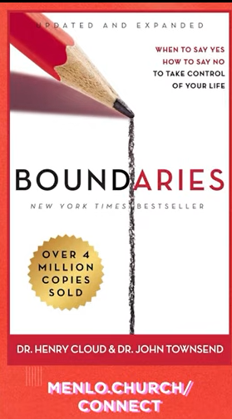
Boundaries by Dr. Henry Cloud and Dr. John Townsend:
You set a boundary to protect yourself to prevent the dangerous.
We deal with annoyance and selfishness. We do not deal with safety.

“Boundaries” by Dr. Henry Cloud and Dr. John Townsend teaches that setting personal, emotional, and physical limits is essential for a healthy, responsible, and balanced life. The core message is that boundaries act as "property lines" defining11, ownership over one’s own feelings, thoughts, and behaviors, allowing individuals to say "yes" to what is good and "no" to what is harmful.
Key Takeaways
- Boundaries Define Responsibility: Boundaries clarify what is your responsibility (your emotions, behaviors, choices) and what is not.
- Not Selfish, But Loving: Setting boundaries is not selfish; it is an act of self-care and kindness that fosters healthier, more honest, and sustainable relationships.
- Personal Property Lines: Boundaries are essential for protecting your mental, physical, emotional, and spiritual well-being.
- Biblical and Psychological Integration: The authors combine biblical principles with psychology to explain why setting limits is necessary to avoid burnout and codependency.
- Empowerment through "No": Learning to say "no" to requests that violate your limits is key to taking control of your life.

The book also explores the "Ten Laws of Boundaries" to guide readers in identifying and managing boundary issues, such as fear, guilt, and the, desire to please others.

47:00/1:14:58
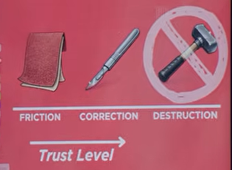
Friction, Correction, Destruction (Trust Level)
Tool to set up boundary: Friction, Correction, Destruction (Trust Level)

The interaction between friction, correction, and destruction defines how trust is built, maintained, or broken within teams and organizations. While, in physical terms, friction is a "necessary evil" that causes wear, in organizational behavior, "productive friction" can strengthen trust, while "unmanaged friction" destroys it.

Here is a breakdown of these concepts based on current organizational psychology and leadership research:
1. Friction: The Catalyst (Productive vs. Destructive)
Friction is not inherently bad; it represents resistance, opposing viewpoints, or necessary pauses in workflow.
- Productive Friction (Constructive): Encourages healthy, open disagreement and debate. It slows processes down to prevent mistakes, ensure security (e.g., confirmation steps), and foster deeper team collaboration.
- Destructive Friction (Unmanaged Tension): Results from poor communication, lack of clarity, or unaddressed conflict. This creates a "toxic undercurrent" that limits transparency, lowers morale, and causes employees to question if they are valued.
- The Trust Friction Curve: When granting autonomy, an initial dip in performance (friction) is normal. If leaders abandon teams during this dip, they break trust. If they support them through it, trust and performance rise stronger than before.

2. Correction: The Trust Builder
Correction is the act of addressing friction, fixing mistakes, or adjusting strategies in real-time. It moves an organization from "guesswork to precision".
- Active Correction: Involves inviting tough questions, modeling vulnerability by admitting mistakes, and providing clear, consistent feedback.
- Intentional Listening: Developing a practice of listening to unheard voices and allowing team members to voice concerns prevents minor frustrations from escalating into full destruction.
- Systemic Correction: Removing unnecessary steps (red tape) while keeping necessary safeguards (e.g., security checks) allows for a "friction-free" experience that increases efficiency.

3. Destruction: The Trust Breaker
Trust is destroyed when friction is ignored, improperly managed, or when leaders fail to provide the necessary "clarity" to overcome it.
- The "Silent" Killer: A lack of clear expectations, shifting priorities, or being blindsided by feedback destroys trust.
- Ignoring Human Element: Replacing human interaction with total, unmonitored automation (e.g., excessive AI or algorithmic management) can make processes feel impersonal, leading to a loss of trust.
- Unmanaged Conflict: Allowing tension to fester rather than managing it directly breaks down confidence in leadership.

Summary Table: Trust Impact
Component | Action | Impact on Trust
Good Friction | Slowing down to ensure quality/safety | Builds Trust (shows care)
Bad Friction | Unclear processes, high bureaucracy | Destroys Trust (causes frustration)
Correction | Addressing issues early & openly | Strengthens Trust (shows competence)
Destruction | Ignoring, avoiding, or hiding errors | Erodes Trust (creates anxiety)
Ultimately, to maintain a high trust level, leaders must "channel" friction rather than eliminate it, using it to foster dialogue and ensure safety, rather than letting it become a barrier to performance.

47:00/1:14:58

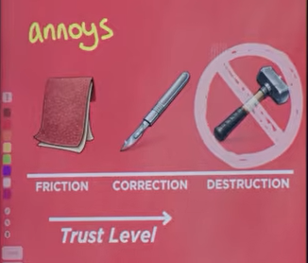

48:30/1:14:58
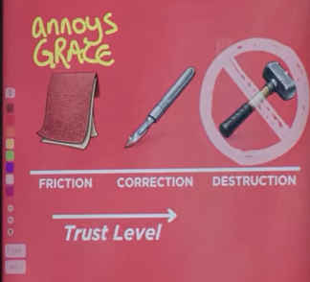
Friction can be the annoys and grace.

49:00/1:14:58

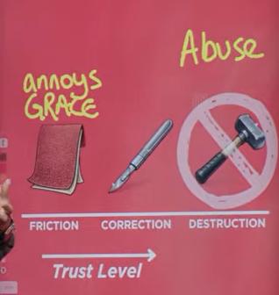
Destruction can be Abuse

50:00/1:14:58
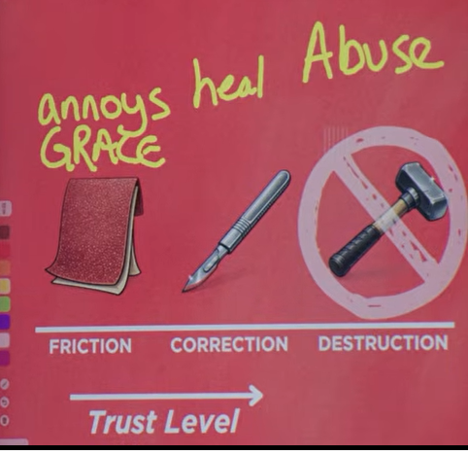
Heal is a Scalpel (解剖刀) between friction and destruction. Scalpel is someone love you and give you a hand.

52:00/1:14:58
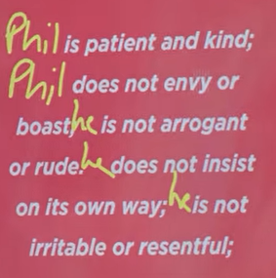
Fill with Phil
(Same as 42:30/1:14:58)

53:00/1:14:58
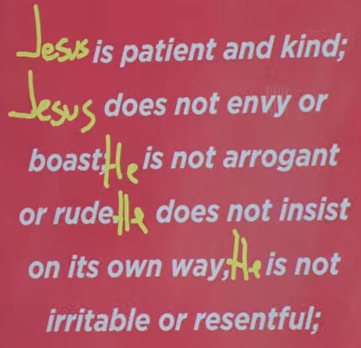
Fill out with Jessus.
1 Corinthians 13:4-5
Jesus is patient and kind; Jesus does not envy or boast; He is not arrogant or rude. He does not insist on its own way; He is not irritable or resentful

54:00/1:14:58


02/07/2026, Menlo Church Worship, Legacy (last week)
https://www.youtube.com/live/gjDnH48q-Vs?si=b1QK17jhjU0Zi2NT
“Love is More Than a Feeling | Love is…,” Phil EuBank, Lead Pastor

We have new series in February about “Love…” Note that this is not a dating sermon.
Today, we talked the Bible Definition of Love and the Tool we will use for Love.

Summary:
1. People have different definition for Love: Love is Fun, popcorn, Instagram, a spark, soulmate, Vibes (共鸣), etc. Love has chemistry, feeling, etc. In a moment, we fall into Love. Then, that feeling fades, love is gone. In Bible, Family is built based Love.
2. 1 John 4:7-8: Define what is Love. a. Love is from God. b. God is love.
3. 1 John 4:9-10: God love us and sent his Son for our sins.
4. God Love us and send his Son Jesus sacrifice for our sins.
5. Expressive Individualism: Identify one’s unique inner feelings and express them outwardly.
6. Expressive Individualism: We look at inward feeling and desire and express feeling to outside.
We anchor Jesus: Love is God, then express it to the outside.
7. 1 Corinthians 13:4-5: Define God Love with moral integrity and unconditional commitment.
8. Boundaries (1992) by Dr. Henry Cloud and Dr. John Townsend: You set a boundary to protect yourself to prevent the dangerous. We deal with annoyance and selfishness. We do not deal with safety.
9. Tool to set up boundary: Friction, Heal/Correction, Destruction (Trust Level):
a. Friction can be the annoys and grace.
b. Destruction can be Abuse
c. Correction/Heal is a Scalpel (解剖刀) between friction and destruction. Scalpel is someone love you and give you a hand.
10. Conclusion:
1 Corinthians 13:4-5: Jesus is patient and kind; Jesus does not envy or boast; He is not arrogant or rude. He does not insist on its own way; He is not irritable or resentful.

