08/15/2026, Menlo Church Worship (Summary of last week, 08/09/2026)
https://youtu.be/uztLKp0DPY0?si=b9U0Yey3n3C4cCwL
https://github.com/peterhchen/1000_Family/tree/main/Church/2026
The Religion of "Good People" (The Nones / Agnostics) | Let's Be Honest| Menlo Church Phil EuBank, Lead Pastor

0:00/36:30
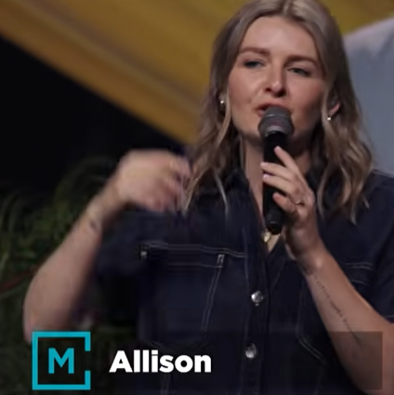
Allison Joy Li

Introduction:
0:00/36:30
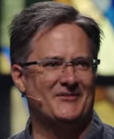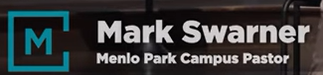
Mark Swarner, Campus Pastor

0:00/36:30


00:12/36:30
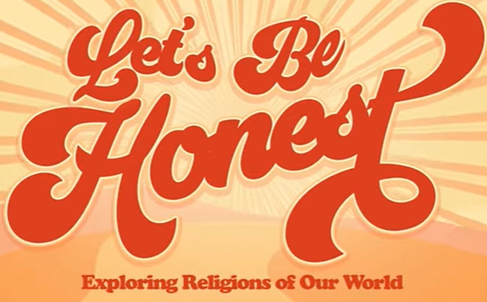

00:48/36:30
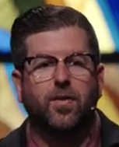
Phil EuBank, Lead Pastor

01:30/36:30
Seven weeks ago. We started this “Let's Be Honest” series.
1) June 28: Judaism, 2) July 5: Islam, 3) July 12: Buddhism, 4) July 19: Mormonism, 5) July 26: Catholicism, 6) August 2: The Nones/Agnostics, 7) August 9: The Gospel

Today, we are the end of the series. Today, we talk about “It Is Finished (The Gospel) | Le’s Be Honest”.
In the past, we talked about the Judaism, Islam, Buddhism, Mormonism, Catholicism. Last week, we looked at the most popular in the Bar Area, which is the religion of being a good person.

Every week, we ask the same questions, “What does this faith ask of you?”

04:06/36:30

************
************
08/15/2026, Menlo Church Worship (Summary of last week, 08/09/2026)
https://youtu.be/uztLKp0DPY0?si=b9U0Yey3n3C4cCwL
https://github.com/peterhchen/1000_Family/tree/main/Church/2026
The Religion of "Good People" (The Nones / Agnostics) | Let's Be Honest| Menlo Church Phil EuBank, Lead Pastor

01:30/36:30
In this “Let's Be Honest” series, we have
1) June 28: Judaism, 2) July 5: Islam, 3) July 12: Buddhism, 4) July 19: Mormonism, 5) July 26: Catholicism, 6) August 2: The Nones/Agnostics, 7) August 9: The Gospel

Today, we talk about It Is Finished (The Gospel).

