07/04/2026, Menlo Church Worship (Summary of last week, 06/28/2026)
https://www.youtube.com/live/5AKejgUZ_4g?si=OTZLUjZ5W38v0t4i
https://github.com/peterhchen/1000_Family/tree/main/Church/2026
The Burden of the Law | Let's Be Honest| Menlo Church Phil EuBank, Lead Pastor

7:089/1:16:14
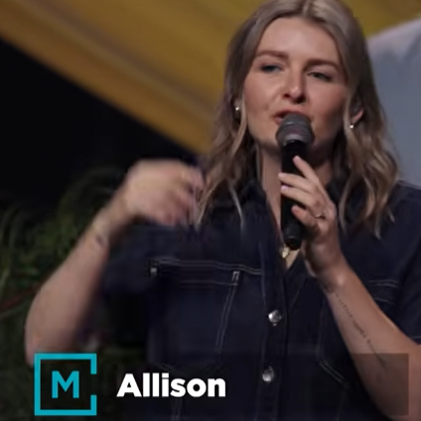
Allison Joy Li

Introduction:
20:24/1:16:14

Mark Swarner, Campus Pastor

27:30/1:16:14
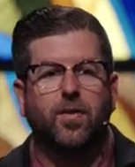
Phil EuBank, Lead Pastor

27:27/1:16:14

************
07/04/2026, Menlo Church Worship (Summary of last week, 06/28/2026)
https://www.youtube.com/live/5AKejgUZ_4g?si=OTZLUjZ5W38v0t4i
https://github.com/peterhchen/1000_Family/tree/main/Church/2026
The Burden of the Law | Let's Be Honest| Menlo Church Phil EuBank, Lead Pastor

