03/22/2026, Menlo Church Worship
https://www.youtube.com/live/lgypyAuVwn4?si=ojysE71vFTRyKbws
“I Am With You At the Table | I Am …The God Who Gets Close,” Phil EuBank, Lead Pastor

We are in the fifth of “I Am…” series. We talk "I Am With You At the Table."

Introduction:
10:47/1:15:00
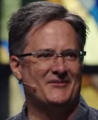

21:56/1:15:00
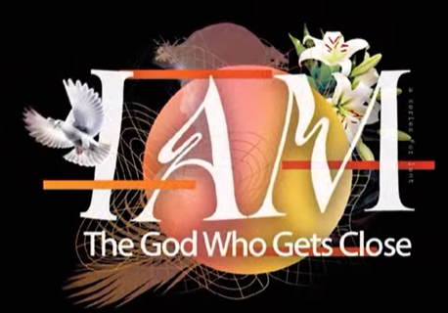

22:00/1:15:00
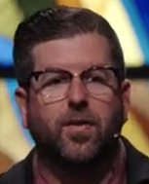
Phil EuBank, Lead Pastor

God restores Elijah’s despondent spirit by "still, small voice" (a gentle whisper).

03/22/2026, Menlo Church Worship
https://www.youtube.com/live/lgypyAuVwn4?si=ojysE71vFTRyKbws
“I Am With You At the Table | I Am …The God Who Gets Close,” Phil EuBank, Lead Pastor

Summary

