03/21/2026, Menlo Church Worship, Legacy (last week)
https://www.youtube.com/live/K3vZNKn_Wdw?si=03UWdljbCXa-9rvp
“I Am With You in the Silence | I Am: The God Who Gets Close,” Phil EuBank, Lead Pastor

"I Am With You in the Silence" centers on the premise that God is not absent during quiet, lonely, or painful times but is actively present, offering comfort and strength. It emphasizes finding God through stillness rather than noise, encouraging a shift from striving and anxiety to restful, trusting, and intimate communion with Him.
Key themes include:
- Presence in Absence: God's presence is often felt most profoundly in silence, rather than through dramatic, loud actions.
- A "Still Small Voice": Similar to Elijah's experience on Mount Horeb, God often communicates quietly, requiring people to silence their own noisy lives to hear him, according to Harvest Christian Church.
- Finding Inner Peace: The silence is a "holy place" that provides strength, rest, and love for the lonely spirit, acting as a refuge for the troubled heart, say Unity.
- Surrender over Striving: It is a call to stop performing and to, instead, surrender worries and surrender control to God, as discussed by Medium.
This theme is often associated with the idea that the Holy Spirit dwells within believers, providing continuous reassurance

"I Am With You in the Silence": Find and communicate with God in silence rather than noise.

Introduction:
10:47/1:15:00




21:56/1:15:00


22:00/1:15:00

Phil EuBank, Lead Pastor

30:22:00/1:15:00



30:58/1:15:00


31:40:00/1:15:00

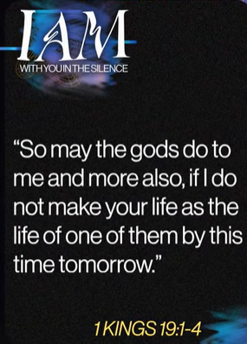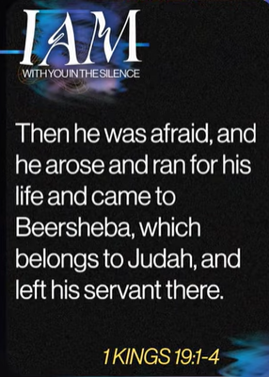

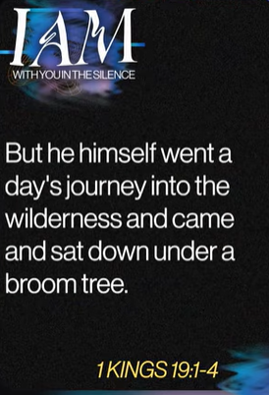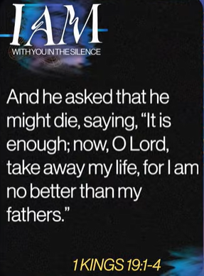
1 Kings 19:1-4
English Standard Version
Elijah Flees Jezebel
19 Ahab told Jezebel all that Elijah had done, and how he had killed all the prophets with the sword. ² Then Jezebel sent a messenger to Elijah, saying, “So may the gods do to me and more also, if I do not make your life as the life of one of them by this time tomorrow.” ³ Then he was afraid, and he arose and ran for his life and came to Beersheba, which belongs to Judah, and left his servant there.
⁴ But he himself went a day's journey into the wilderness and came and sat down under a broom tree. And he asked that he might die, saying, “It is enough; now, O Lord, take away my life, for I am no better than my fathers.”

1 Kings 19:1-4 highlights the sudden, severe emotional and spiritual collapse of the prophet Elijah, who falls into fear and depression after threats from Jezebel, leading him to flee into the wilderness and request death. This passage showcases that even great believers can suffer burnout and despair.

Key Points in 1 Kings 19:1-4:
- The Reaction to Threat (1-3): Despite his victory on Mount Carmel, Elijah flees in terror when Jezebel threatens his life, showing his vulnerability.
- Isolation and Despair (4): Elijah leaves his servant behind and goes into the wilderness alone, seeking seclusion.
- Burnout/Depression (4): Elijah sits under a broom tree and asks God to take his life, feeling his work was fruitless and he was no better than his predecessors.
- Humanity of a Prophet: The narrative demonstrates the rapid transition from public triumph to private despair, highlighting the fragility of human emotional states.

This section acts as a starting point for God's eventual restoration of Elijah, showing that God does not abandon his servants in their lowest moments.

1 Kings 19:1-4: God does not abandon Elijah.

37:55/1:15:00


42:40/1:15:00


46:35/1:15:00


48:45/1:15:00






1 Kings 19:9-13
English Standard Version
The Lord Speaks to Elijah
⁹ There he came to a cave and lodged in it. And behold, the word of the Lord came to him, and he said to him, “What are you doing here, Elijah?” ¹⁰ He said, “I have been very jealous for the Lord, the God of hosts. For the people of Israel have forsaken your covenant, thrown down your altars, and killed your prophets with the sword, and I, even I only, am left, and they seek my life, to take it away.” ¹¹ And he said, “Go out and stand on the mount before the Lord.” And behold, the Lord passed by, and a great and strong wind tore the mountains and broke in pieces the rocks before the Lord, but the Lord was not in the wind. And after the wind an earthquake, but the Lord was not in the earthquake. ¹² And after the earthquake a fire, but the Lord was not in the fire. And after the fire the sound of a low whisper.^{[a]} ¹³ And when Elijah heard it, he wrapped his face in his cloak and went out and stood at the entrance of the cave. And behold, there came a voice to him and said, “What are you doing here, Elijah?”

The main point of 1 Kings 19:9-13 is that God restores Elijah’s despondent spirit by appearing not in dramatic power, but in a "still, small voice" (a gentle whisper). This teaches that God often works through quiet perseverance, encouraging Elijah to trust His gentle leading over spectacular displays and reassuring him that his prophetic work is not finished.

Key takeaways from the text include:
- The Nature of God’s Presence: Elijah witnesses wind, earthquake, and fire, but God is not in them; He is in the silence, signaling a shift toward quiet, persistent work rather than just thunderous destruction.
- Encouragement over Dispair: Elijah is overwhelmed and lonely, claiming he is the only faithful one left. God answers this despair by offering a personal encounter, not by immediately destroying his enemies.
- Restoration and Re-commissioning: God asks, "What are you doing here, Elijah?" to prompt a redirection from fear-driven inactivity back to his prophetic mission (anointing kings and Elisha).
- Divine Perspective: The encounter on Mount Horeb highlights that God's plan is still moving forward despite the lack of immediate, widespread revival, notes the Direction Journal.

This passage highlights that even great leaders can experience burnout, and it emphasizes listening to God’s whisper over noisy fear.

God restores Elijah’s despondent spirit by "still, small voice" (a gentle whisper).

03/21/2026, Menlo Church Worship, Legacy (last week)
https://www.youtube.com/live/K3vZNKn_Wdw?si=03UWdljbCXa-9rvp
“I Am With You in the Silence | I Am: The God Who Gets Close,” Phil EuBank, Lead Pastor

Summary
"I Am With You in the Silence": Find and communicate with God in silence rather than noise.
1. 1 Kings 19:1-4: God does not abandon Elijah.
2. 1 Kings 19:9-13: God restores Elijah’s despondent spirit by "still, small voice" (a gentle whisper).

Conclusion:
When God is silence. Be patient and wait for God answer.

