08/08/2026, Menlo Church Worship (Summary of last week, 08/02/2026)
https://youtu.be/fDVXRjOFins?si=4l_stqHKSE9crttB
https://github.com/peterhchen/1000_Family/tree/main/Church/2026
The Religion of "Good People" (The Nones / Agnostics) | Let's Be Honest| Menlo Church Phil EuBank, Lead Pastor

0:00/37:21
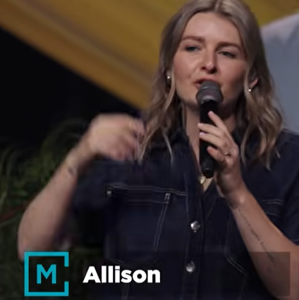
Allison Joy Li

Introduction:
0:00/37:21
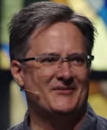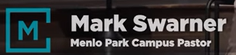
Mark Swarner, Campus Pastor

0:00/37:21
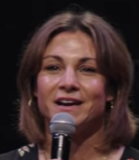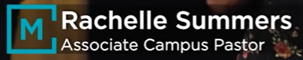

00:11/37:21
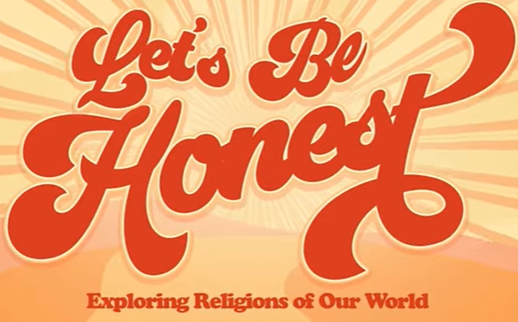

00:35/37:21
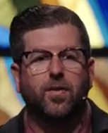
Phil EuBank, Lead Pastor

01:30/37:21
In this “Let's Be Honest” series, we have
1) June 28: Judaism, 2) July 5: Islam, 3) July 12: Buddhism, 4) July 19: Mormonism, 5) July 26: Catholicism, 6) August 2: The Nones/Agnostic, 7) August 9: The Gospel

************
************
08/08/2026, Menlo Church Worship (Summary of last week, 08/02/2026)
https://youtu.be/fDVXRjOFins?si=4l_stqHKSE9crttB
https://github.com/peterhchen/1000_Family/tree/main/Church/2026
The Religion of "Good People" (The Nones / Agnostics) | Let's Be Honest| Menlo Church Phil EuBank, Lead Pastor

