05/30/2026, Menlo Church Worship (Summary of last week, 05/24/2028)
https://www.youtube.com/watch?v=CJuK_Kr6aNk
Baptism Sunday | Phil EuBank

5:08/1:16:16
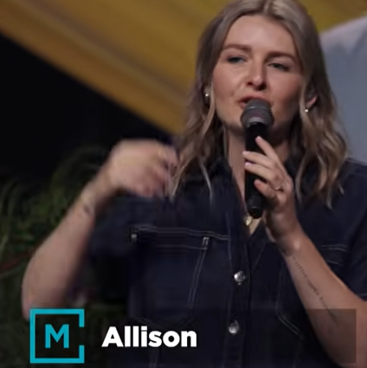
Allison Joy Li

Introduction:
9:13/1:16:16
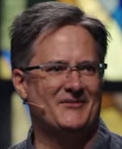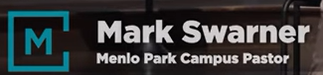
Mark Swarner, Campus Pastor

19:52/1:16:16
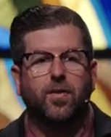
Phil EuBank, Lead Pastor

======
05/30/2026, Menlo Church Worship (Summary of last week, 05/24/2028)
https://www.youtube.com/watch?v=CJuK_Kr6aNk
Baptism Sunday | Phil EuBank

