07/18/2026, Menlo Church Worship (Summary of last week, 07/12/2026)
https://youtu.be/ihCJVAMdc5c?si=-VLPqyBGhqf-pUwq
https://github.com/peterhchen/1000_Family/tree/main/Church/2026
The Cycle of Self-Liberation (Buddhism) | Let's Be Honest| Menlo Church Phil EuBank, Lead Pastor

0:00/33:27
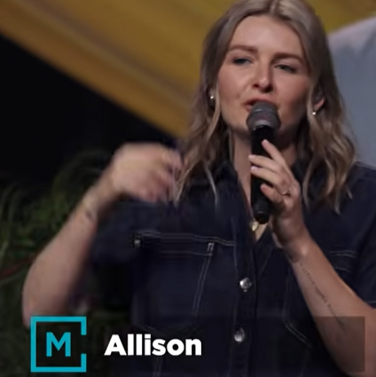
Allison Joy Li

Introduction:
0:00/33:27
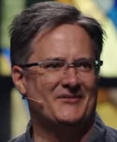
Mark Swarner, Campus Pastor

0:01/33:27
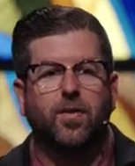
Phil EuBank, Lead Pastor

0:21/33:27
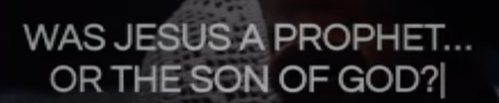
Was Jesus a Prophet or the Son of God?

0:25/33:27
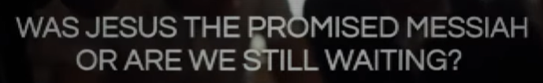
Was Jesus the promised Messiah or are we still waiting?

0:28/33:27
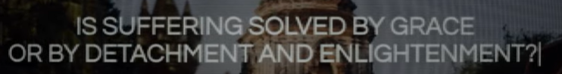
Is Suffering solved by grace or by detachment and Enlightenment?

0:35/33:27
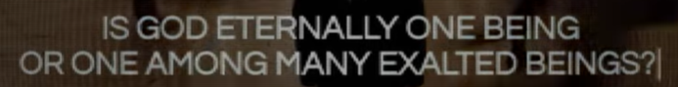
Is God Eternally one being or one among many exalted beings?

0:43/33:27
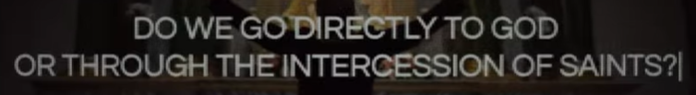
Do we go directly to God or Through the intercession of Sanit?

0:48/33:27
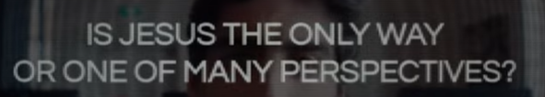
Is Jesus the only way or one of many perspectives?

0:50/33:27

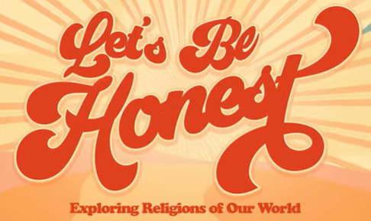

0:51/33:27



We love our neighbor with for the bay, know the bay, and love our neighbor.

************
************

07/18/2026, Menlo Church Worship (Summary of last week, 07/12/2026)
https://youtu.be/ihCJVAMdc5c?si=-VLPqyBGhqf-pUwq
https://github.com/peterhchen/1000_Family/tree/main/Church/2026
The Cycle of Self-Liberation (Buddhism) | Let's Be Honest| Menlo Church Phil EuBank, Lead Pastor

