11/15/2025, Legacy (last week)
https://www.youtube.com/live/VTUC5ywRPoo?si=44LrrQN900lB7Umi
“Angry About Grace | Numb and Number,” Phil EuBank, Lead Pastor



Introduction:
10:00/1:14:56

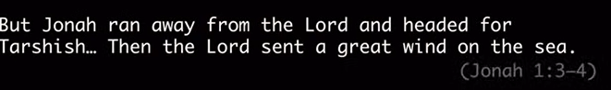

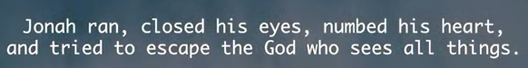
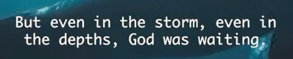



19:53/1:14:56

Phil EuBank, Lead Pastor

Self-Righteous people punish themselves.

Resisting the redemption they need.

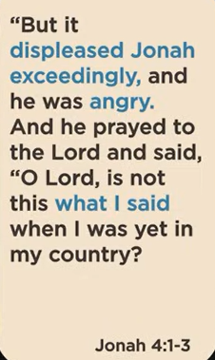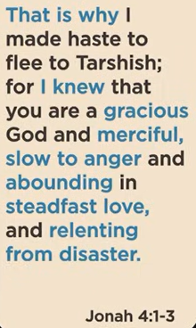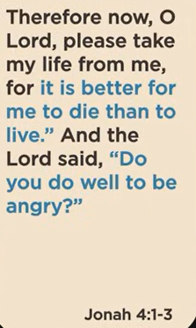
Jonah 4:1-3

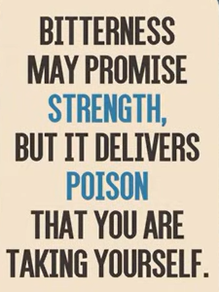
Bitterness may promise strength, But it delivers poison that you are taking yourself,


Choosing comfort that takes over compassion that gives.

26:20/1:14:56


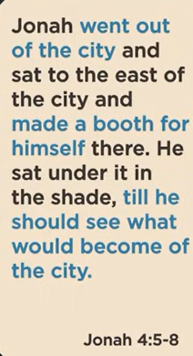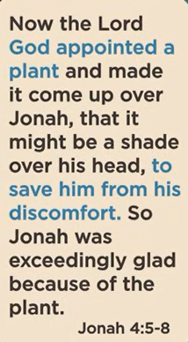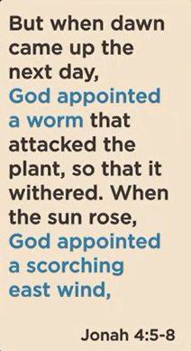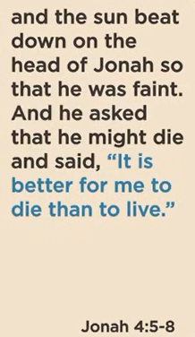
Jonah 4:5-8

42:31/1:14:56

Missing the heart of God.

44:27/1:14:56
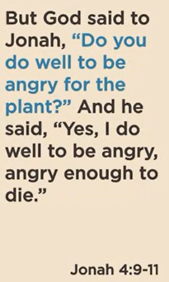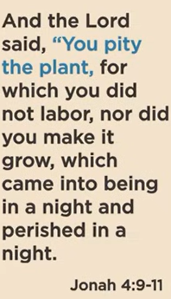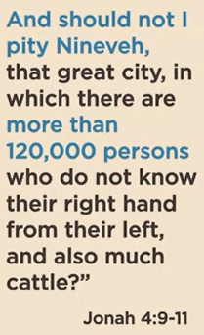
Jonah 4:9-11

48:08/1:14:56
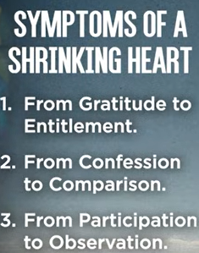
Symptoms of a Shrinking Heart
1. From Gratitude to entitlement.
2. From Confession to Comparison
3. From Participation to Observation.

11/15/2025, Legacy (last week)
https://www.youtube.com/live/VTUC5ywRPoo?si=44LrrQN900lB7Umi
“Angry About Grace | Numb and Number,” Phil EuBank, Lead Pastor

Summary:

