11/22/2025, Legacy (last week)
https://www.youtube.com/live/tPAnkXXTYTM?si=3sgdFt9SPIxxyzL9
“Don't Stop Believing | Hope for Everyone,” Phil EuBank, Lead Pastor


Introduction:
10:00/1:15:01


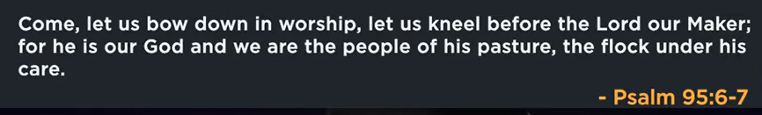

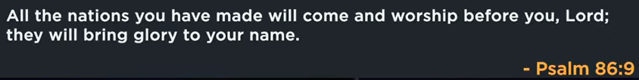

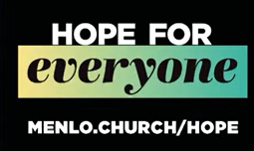

19:53/1:15:01
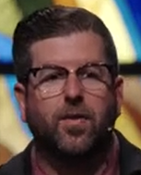
Phil EuBank, Lead Pastor
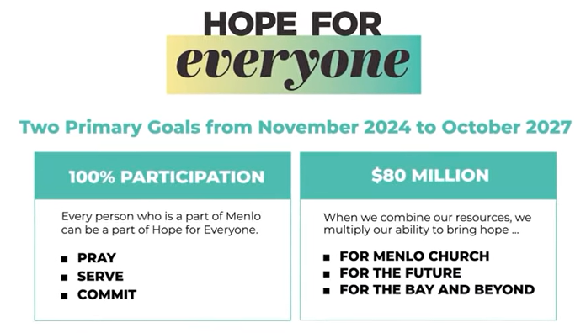

We study Prophet Haggai.


We build very beginning, consider, and then Go.

Haggai 1:2-4
² This is what the Lord Almighty says: “These people say, ‘The time has not yet come to rebuild the Lord’s house.’”
³ Then the word of the Lord came through the prophet Haggai: ⁴ “Is it a time for you yourselves to be living in your paneled houses, while this house remains a ruin?”


Google Gemini “peninsula church network, ca church co-op plating, for the Bay”

The Peninsula Church Network is an informal, collaborative organization of churches and pastors in the San Francisco Bay Area Peninsula, focused on mutual support and community service. It primarily focuses on connection, collaboration, and compassion among existing churches and welcomes new church planters to the area.
Peninsula Church Network (PCN)
The PCN unites churches to reach and transform the Bay Area. Key aspects of the network include:
- Pastor Support: The network prioritizes building relationships and encouraging pastors, especially welcoming new church planters.
- Collaboration: It facilitates cooperation among various local churches to maximize their collective impact on the community.
- Community Resource: The network provides a church directory to help people find a church home in the area.
You can learn more on the Peninsula Church Network website.
Church Planting/Co-op Planting in the Bay Area
The term "co-op planting" may refer to the collaborative approach used by networks like the PCN. Other networks involved in church planting and cooperative efforts in the wider California and Bay Area region include:
- Pacific Church Network: This organization, linked to youth retreats and other events, is another regional network of churches.
- Peninsula Bible Church: While not a network itself, this church has a rich history in the Bay Area and is involved in various ministry events and local meetups, sometimes hosting events for "The Network" (likely PCN or a related young adult group).
- Peninsula Covenant Church: Part of the Covenant Church of America, this church also engages in community and youth programs.
For more information on specific church planting resources or "co-op plating" methods, it is recommended to contact the Peninsula Church Network directly to inquire about their specific strategies and resources.



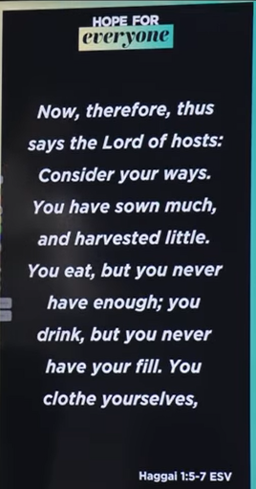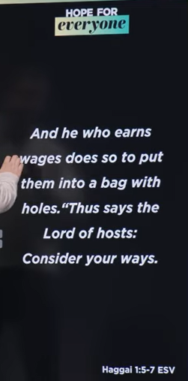
Haggai 1:5-7
English Standard Version
⁵ Now, therefore, thus says the Lord of hosts: Consider your ways. ⁶ You have sown much, and harvested little. You eat, but you never have enough; you drink, but you never have your fill. You clothe yourselves, but no one is warm. And he who earns wages does so to put them into a bag with holes.
⁷ “Thus says the Lord of hosts: Consider your ways.


Google Gemini “When goof things, become ultimate things, they stop being goof for us.”
The statement means that when good things become the ultimate focus of life, they can become harmful, a concept often described as "idolatry". This happens when something that is good in itself—like a job, a relationship, or a possession—takes the place of a higher value or becomes the sole source of one's identity, meaning, and security. In this state, the good thing can become an object of worship that distracts from a more central purpose and can lead to disappointment, frustration, or a sense of loss if that thing is threatened or taken away.
- Shifting a good thing into an ultimate thing: The problem isn't with the thing itself, but with the position it occupies in your life. For example, a job is good, but it becomes detrimental when it defines your entire identity and you feel lost if you lose it.
- Becoming an idol: This principle is often linked to the concept of idolatry, where a good thing—family, career, health, or comfort—is elevated to a supreme status, taking the place of what should be the ultimate focus.
- Consequences: When an idol is the ultimate thing in your life, its loss can be devastating, causing anger, despair, or inconsolable frustration. It can also lead to a cycle of chasing the next best thing, never feeling content.
- Examples: Common examples include making a job or status your identity, obsessing over material possessions, or placing your entire sense of happiness on a romantic relationship, notes Tim Keller.
- Finding balance: To enjoy good things without idolizing them, one can practice contentment and consciously place ultimate value on a higher principle, such as a spiritual belief, which helps maintain a healthy perspective.

We invest the AI and we all knows the return in the future.
We cannot over invest in eternal.

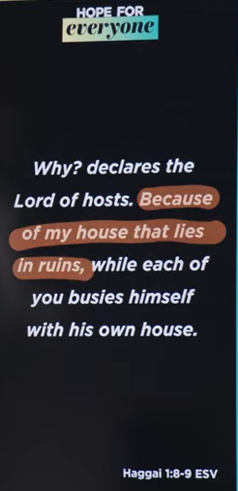
Haggai 1:8-9
English Standard Version
⁸ Go up to the hills and bring wood and build the house, that I may take pleasure in it and that I may be glorified, says the Lord. ⁹ You looked for much, and behold, it came to little. And when you brought it home, I blew it away. Why? declares the Lord of hosts. Because of my house that lies in ruins, while each of you busies himself with his own house.

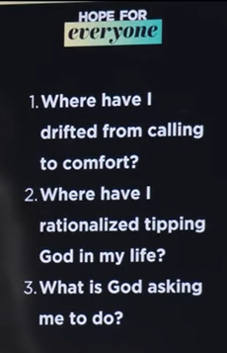
Rationalized tipping (合理化小费) to God.

11/22/2025, Legacy (last week)
https://www.youtube.com/live/tPAnkXXTYTM?si=3sgdFt9SPIxxyzL9
“Don't Stop Believing | Hope for Everyone,” Phil EuBank, Lead Pastor

Summary:

