01/10/2026, Legacy (last week)
https://www.youtube.com/live/l8tzXKk-KjY?si=rYlnuDkpcyDF68Wo
“Perfect Family | PERFCT,” Phil EuBank, Lead Pastor



Introduction:
22:00/1:14:58










25:00/1:14:5w8

Phil EuBank, Lead Pastor

22:27/1:14:57
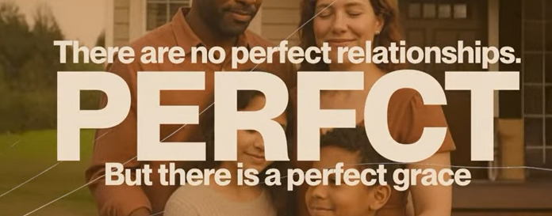
There are no perfect relationships. PERFCT, but there is a perfect grace.


Go doesn’t heal perfect families; He heals honest ones.


A giant Musical Event: David, This Christmas in theaters, December 19.

HBO max Original, David: Part 2, Broken Crown


Part 1: The Rise

1 Samuel 17:45-47
English Standard Version
⁴⁵ Then David said to the Philistine, “You come to me with a sword and with a spear and with a javelin, but I come to you in the name of the Lord of hosts, the God of the armies of Israel, whom you have defied. ⁴⁶ This day the Lord will deliver you into my hand, and I will strike you down and cut off your head. And I will give the dead bodies of the host of the Philistines this day to the birds of the air and to the wild beasts of the earth, that all the earth may know that there is a God in Israel, ⁴⁷ and that all this assembly may know that the Lord saves not with sword and spear. For the battle is the Lord's, and he will give you into our hand.”

The main point of 1 Samuel 17:45-47 is that true victory comes not from human strength or weapons, but from trusting in God's power, as David declares he comes "in the name of the LORD Almighty" and that "the battle is the Lord's," demonstrating that God uses the weak to show His glory and defeat giants (challenges) for His people.
Key takeaways:
- God's Glory: David's fight is for God's honor, to prove He is the true God, not for personal glory.
- Trust in God, Not Self: David contrasts Goliath's physical might (sword, spear) with his reliance on God's power, showing that human weakness is overcome by divine strength.
- The Battle Belongs to the Lord: This passage teaches that God fights for His people, and believers should face their "giants" (challenges) with faith, knowing God orchestrates the victory.
- Courage Through Faith: David's story encourages courage by showing that God equips and empowers His followers to overcome seemingly insurmountable obstacles.

28:08/1:14:57

Part 2: The rooftop

29:00/1:14:57

2 Samuel 11:1
English Standard Version
David and Bathsheba
11 In the spring of the year, the time when kings go out to battle, David sent Joab, and his servants with him, and all Israel. And they ravaged the Ammonites and besieged Rabbah. But David remained at Jerusalem.

The main point of 2 Samuel 11:1 is that King David neglected his duty to lead his army to war, choosing instead to stay in Jerusalem during springtime when kings normally campaigned, setting the stage for his temptation, sin with Bathsheba, and subsequent moral downfall. This deliberate choice to remain idle, when he should have been with his troops, highlights the danger of idleness and how it makes leaders vulnerable to sin, initiating a tragic chain of events.
Key aspects of 2 Samuel 11:1:
- Context: "In the spring, at the time when kings go out to battle..." sets the expectation that David, as king, should be leading his forces.
- David's Action: "...David stayed in Jerusalem" marks a departure from his expected role.
- Consequence: His absence from the battlefield leaves him open to temptation, leading him to see and lust after Bathsheba from his rooftop.
- Biblical Lesson: It serves as a timeless warning about how neglecting responsibilities and being idle can open the door to severe moral failings, even for powerful leaders.

30:08/1:14:57

Part 3: The Prophecy

30:30/1:14:57

2 Samuel 12:10
English Standard Version
¹⁰ Now therefore the sword shall never depart from your house, because you have despised me and have taken the wife of Uriah the Hittite to be your wife.’

The main point of 2 Samuel 12:10 is that King David's severe sin with Bathsheba and murder of Uriah would bring lasting violence and conflict ("the sword") into his own household, illustrating God's justice and the inescapable consequences of sin, even after forgiveness. This prophecy foreshadows the tragic events within David's family, like his son Absalom's rebellion and internal bloodshed, fulfilling the principle that one reaps what they sow.
Key Aspects:
- Divine Judgment: God, through the prophet Nathan, declares that David's actions (despising God, taking Uriah's wife) warrant severe punishment.
- Symbolism of the Sword: "The sword" represents ongoing war, strife, and familial violence that would plague David's reign and descendants.
- Consequences vs. Forgiveness: While God forgives David (Psalm 51), it doesn't erase the natural consequences of his actions, highlighting that discipline and sorrow are part of spiritual growth.
- Fulfillment: The verse sets the stage for the tragic fulfillment seen in later chapters, with internal strife and death within David's family.

31:00/1:14:57

Lust: 欲望
Act 1: The Echo of Lust

31:30/1:14:57

Act 2: The failure of Community

32:00/1:14:57

Act3: The Silence of the Father

33:00/1:14:57
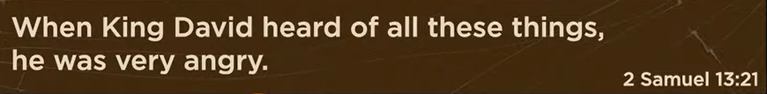
2 Samuel 13:21
English Standard Version
²¹ When King David heard of all these things, he was very angry.^{[a]}

2 Samuel 13:21's main point highlights King David's furious but conflicted reaction to his son Amnon raping his half-sister Tamar, revealing the corrupting consequences of sin in his own family, stemming from his own sin with Bathsheba, and showing his hypocritical failure to discipline his children, which sets the stage for future family tragedy. It's a pivotal moment showing how sin brings lasting pain and divine judgment through the very people David loved, as he couldn't administer justice due to his own guilt, notes StudyLight.org and Bible Hub.
Key Takeaways from 2 Samuel 13:21:
- Consequences of Sin: David's past sin with Bathsheba directly leads to the turmoil in his household, demonstrating that sin's impact isn't erased by forgiveness.
- David's Hypocrisy & Inaction: His anger is real, but he's paralyzed by guilt from his own adultery, preventing him from justly punishing Amnon, according to Hermeneutics Stack Exchange, notes Bible Hub.
- Family Breakdown: The verse underscores the brokenness in David's family, foreshadowing the rebellion and death that will plague his reign, says Center for Excellence in Preaching.
- False Pretenses: The entire chapter, including this verse, is marked by deception, a direct result of David's own moral failures, observes StudyLight.org.

36:00/1:14:57



The Generational Echo:
What God doesn’t transform, we will transmit

The core message of the phrase "What God doesn’t transform, we will transmit"—frequently attributed to Franciscan friar Richard Rohr—is that unprocessed pain, trauma, or emotional dysfunction from our past will inevitably be passed down to others (especially the next generation) unless it is brought to God for healing and transformation.
Main Points of the Concept:
- Pain Cannot Be Simply Buried: We cannot truly hide, ignore, or outrun our suffering; if it is not dealt with, it will "come out sideways" and harm the people we love.
- The Cycle of Transmission: If we do not allow God to transform our wounds, we will continue the "generational echo" by inflicting our pain, insecurities, and unhealthy patterns on our children or peers.
- Transformation Over Escape: The goal is not to avoid pain, but to allow it to be transformed by God—through grace and, for Christians, specifically through Jesus—so that suffering becomes a doorway to deeper healing rather than a source of destruction.
- Active Responsibility: Breaking the cycle requires consciously confronting our past, accepting what happened, and surrendering it to God to break the pattern.
- Alternative to "Transmitting": Instead of passing on dysfunction, the goal is to become a "cycle-breaker" who, through self-awareness and spiritual/emotional healing, stops the flow of pain, allowing for a new legacy.
In essence, the saying serves as a call to action to heal our own wounds so we do not perpetuate them in others.

41:36/1:14:57
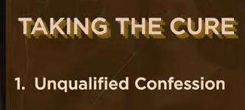
Taking the cure
1. Unqualified Confession

42:00/1:14:57
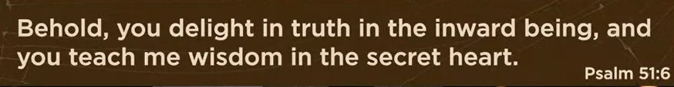
Psalm 51:6
English Standard Version
⁶ Behold, you delight in truth in the inward being,
and you teach me wisdom in the secret heart.

The main point of Psalm 51:6 is that God desires authentic, internal honesty (truth in the "inward parts") over outward appearances, and He uses that internal truth to teach wisdom in our secret hearts, leading to true repentance and transformation from within. It emphasizes that genuine faith means bringing our hidden struggles, brokenness, and motives to God, who then works to renovate our hearts, not just our actions, offering forgiveness and deeper understanding.
Key Aspects:
- God Looks Inward: God isn't impressed by surface-level goodness; He delights in sincerity and integrity deep within a person's being, as highlighted by David's sin with Bathsheba.
- Honesty is Key: True confession involves being completely honest with God about our thoughts, desires, and hidden faults, rather than covering them up.
- Wisdom from Within: When we bring our inner selves to God in truth, He responds by teaching us wisdom in the "secret heart," aligning our character with His truth.
- Heart Renovation: This verse calls for a deep internal change, a renovation of the heart, rather than just a modification of behavior, which is the foundation for truly knowing and following God.
In essence, Psalm 51:6 is a call to radical transparency with God, promising that such honesty leads to profound inner wisdom and spiritual restoration.

42:30/1:14:57

God won’t heal what you don’t reveal

The main point of "God won't heal what you don't reveal" is that vulnerability and honesty about your hidden pain, shame, or struggles with God are necessary for spiritual and emotional healing to occur; hiding these issues keeps you stuck, while bringing them into the light (God's presence) allows for restoration and freedom, often linked to biblical principles of confession and bringing darkness to light. It means admitting your weaknesses and hurts to God, rather than pretending to be fine, so He can work to restore you.
Key Concepts:
- Uncovering the Hidden: Healing requires bringing what's in the dark (secrets, shame, hidden pain, past wounds) into the light of God's presence.
- Authenticity over Perfection: God isn't looking for a perfect image but for the real, flawed you to offer healing; hiding your mess prevents change.
- Confession & Transparency: Acknowledging and expressing your internal struggles, rather than covering them with a spiritual "Band-Aid," allows God to heal.
- From Victim to Victorious: By facing your pain, you can move from being controlled by it to being empowered by God to overcome it.
In essence: You must give God permission and an opening (by revealing your need) for Him to do the work of healing in your life, as hiding the problem leaves it untouched and powerless to change.

43:48/1:14:57
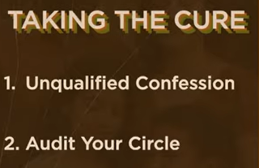
Taking the cure
1. Unqualified Confession
2. Audit your Circle

Based on the context of personal growth, self-improvement, and social environment management, the main point of "Taking the Cure" (1. Unqualified Confession, 2. Audit your Circle) is to take absolute ownership of your life and curate your environment to foster growth and mental well-being.
- 1. Unqualified Confession (Radical Self-Honesty): This refers to taking full, honest ownership of your current situation, behaviors, and limiting beliefs without making excuses or shifting blame. It is about acknowledging where you are, which is the first step toward changing where you are going.
- 2. Audit your Circle (Environmental Control): This involves evaluating the influence of the people around you and intentionally surrounding yourself with positivity, support, and growth-oriented individuals. It means reducing contact with those who hold you back or drain your energy to ensure your inner circle supports your personal and professional aspirations.
The Main Point: To achieve a better life, you must be honest with yourself about your shortcomings (Confession) and proactively manage who you allow to influence you (Audit).

45:30/1:14:57

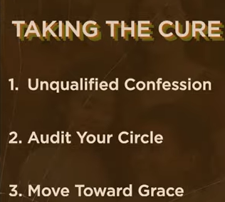
Taking the cure
1. Unqualified Confession
2. Audit your Circle
3. More Toward Grace

The main point of "Taking the Cure," with its steps of "Unqualified Confession," "Audit your Circle," and "More Toward Grace," is a process of spiritual or psychological recovery and personal transformation, likely within a Christian counseling or recovery context. The steps aim to guide an individual toward:
- Facing the truth and achieving honesty (Unqualified Confession): This involves admitting wrongdodoing or powerlessness and accepting God's forgiveness without condition.
- Building a supportive environment (Audit your Circle): This emphasizes the need for healthy, non-judgmental relationships and the importance of a supportive "circle of grace" to prevent further hurt or damage.
- Accepting divine assistance and letting go of self-reliance (More Toward Grace): This step points to embracing God's love and mercy, allowing the Holy Spirit to guide decisions, and recognizing that true healing comes from a strength beyond one's own.
Overall, the process is about moving from a state of guilt, shame, and self-destructive behavior to one of freedom, peace, and restored relationships with others and God.

45:50/1:14:57

Gospel Differentiation
I can love you, but I don’t need you to be perfect for ne to be Okay.

The main point of this statement, often framed as "Gospel Differentiation" in relationships, is that you can offer unconditional love to someone without being emotionally dependent on their perfection or behavior for your own sense of safety, value, or happiness. It is the practice of separating your emotional well-being from the performance of another person, mirroring the grace of God which loves individuals despite their flaws.
Key components of this concept include:
- Securing Your Own "Okayness": Your worth and peace are found in God (the Gospel), not in whether your partner, child, or friend acts perfectly.
- Loving Without Coercion: True love is a free choice, not a prison of obligation, allowing the other person to be flawed without fearing the loss of your love.
- Releasing Perfectionism: It moves relationships away from a "performance-based" model (I love you if you are perfect) to a "grace-based" model (I love you and I am secure in myself).
- Healthy Boundaries: It allows you to support others without becoming codependent, because your joy does not rely on them fixing their flaws.
In essence, it is the ability to say, "I love you, but I do not need you to be perfect for me to be okay".

51:00/1:14:57
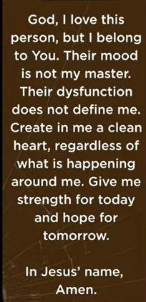
God, I love this person, but I belong to you. Their mood is not my master.
Their dysfunction (功能障碍) does not define me.
Create in me a clean heart, regardless of what is happening around me. Give me strength for today and hope for tomorrow. In Jesus’ name. Ame
n

01/10/2026, Legacy (last week)
https://www.youtube.com/live/l8tzXKk-KjY?si=rYlnuDkpcyDF68Wo
“Perfect Family | PERFCT,” Phil EuBank, Lead Pastor

Summary:
1.

