11/01/2026, Menlo Church Worship (Summary of last week, 11/07/2026)
https://youtu.be/LhTh2b_D16w?si=zbkiOzSJEaQCodue
https://github.com/peterhchen/1000_Family/tree/main/Church/2026
No Kings... But Jesus | Beyond the Ballot | Beyond the Ballot | Menlo Church, Phil EuBank, Lead Pastor

0:00/33:01
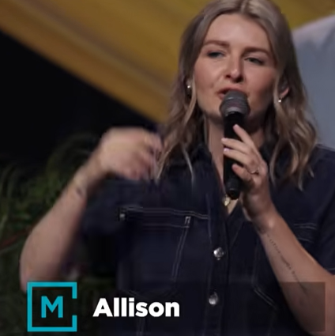
Allison Joy Li

Introduction:
0:00/33:01
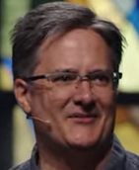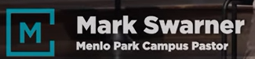
Mark Swarner, Campus Pastor

0:00/33:01
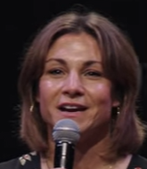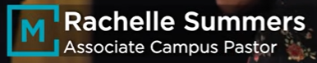

1:05/33:01
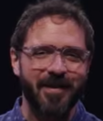
Matt Summers, Pastor of Spiritual Formation

3:30/33:01
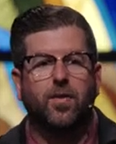
Phil EuBank, Lead Pastor

3:42/33:01
Pray: Thanks, you to guide us with faith to face a lot of scary and unknown.

We always want something that are good for us.

************
************
11/01/2026, Menlo Church Worship (Summary of last week, 11/07/2026)
https://youtu.be/LhTh2b_D16w?si=zbkiOzSJEaQCodue
https://github.com/peterhchen/1000_Family/tree/main/Church/2026
No Kings... But Jesus | Beyond the Ballot | Beyond the Ballot | Menlo Church, Phil EuBank, Lead Pastor

