12/20/2025, Legacy (last week)
https://www.youtube.com/live/EpCRELrxgdA?si=2dOFLJLT3TUDMWd1
“Come All Ye Anxious | Come All Ye Faithless,” Phil EuBank, Lead Pastor



“Ye” = “y’all.” The phrase
1. " Come All Ye Anxious " means “Come here. All of you who are Anxious".
2. "Come All Ye Faithless" means “Come here. All of you who are without faith".

Introduction:
10:00/1:15:04
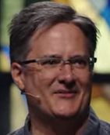

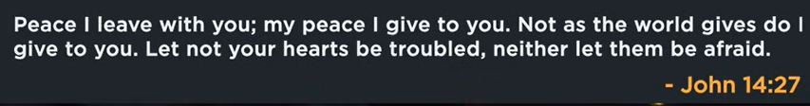

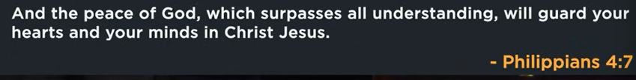

21:35/1:15:04
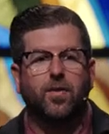
Phil EuBank, Lead Pastor

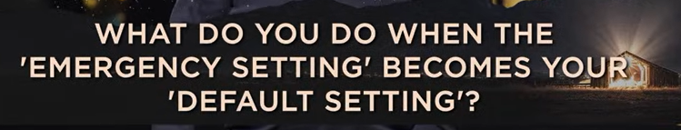
What do you do when the “emergency Setting” becomes your “Default Setting”?

When your brain stays in fight-or-flight mode (emergency setting) after a trauma (創傷), it becomes your normal state (default setting), leading to PTSD symptoms like hypervigilance, anxiety, and difficulty relaxing, requiring professional help to reset your nervous system and regain a sense of safety and calm.
In essence, it's about chronic stress response:
- Emergency Setting (Fight/Flight): Your natural, short-term response to danger (adrenaline rush, heightened senses).
- Default Setting (Chronic): When trauma freezes this response, making you feel constantly unsafe, even when there's no actual threat, explains HQ Therapy Rooms London.
What to do (as implied by the concept):
- Recognize the Shift: Understand that constant anxiety, sleep issues, or feeling on guard isn't "normal" but a sign of a stuck stress response (PTSD/C-PTSD).
- Seek Professional Help: Therapy (like Cognitive Processing Therapy mentioned in National Center for PTSD (.gov)) helps address trauma and retrain your brain.
- Grounding Techniques: Learn to bring yourself back to the present moment to calm your nervous system.
- Rebuild Safety: Focus on establishing trust and safety in your life and relationships, as trauma often disrupts these areas, notes the National Center for PTSD (.gov).

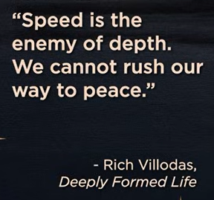
“Speed is the enemy of depth. We cannot rush or way to paces.” Rich Villodas, Deeply Formed Life

According to Rich Villodas' book, A Deeply Formed Life, the central idea behind the quote, "Speed is the enemy of depth. We cannot rush our way to paces," is that achieving meaningful spiritual and personal growth demands a deliberate and unhurried pace, as it cannot be attained through speed or shallow methods. More information can be found in A Deeply Formed Life by Rich Villodas.



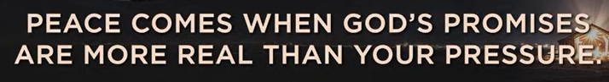


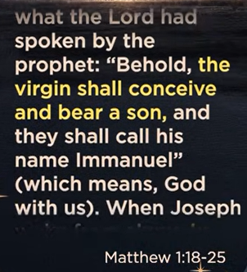


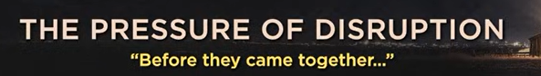



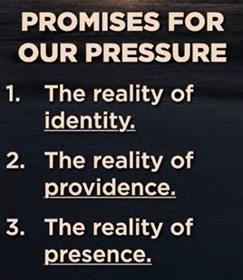

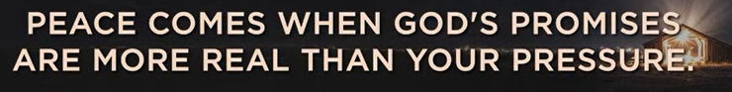

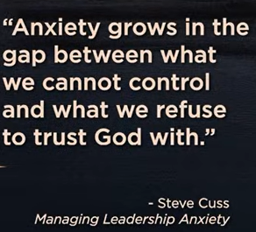

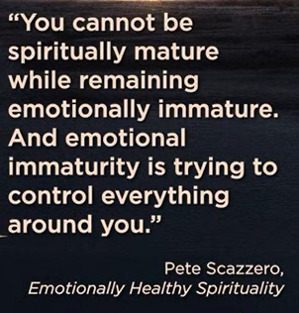

12/20/2025, Legacy (last week)
https://www.youtube.com/live/EpCRELrxgdA?si=2dOFLJLT3TUDMWd1
“Come All Ye Anxious | Come All Ye Faithless,” Phil EuBank, Lead Pastor

“Ye” = “y’all.” The phrase
1. " Come All Ye Anxious " means “Come here. All of you who are Anxious".
2. "Come All Ye Faithless" means “Come here. All of you who are without faith".

Summary:
1. What do you do when the “emergency Setting” becomes your “Default Setting?”: After a trauma (創傷), your brain stays in fight mode (emergency setting), it becomes your normal state (default setting), leading to PTSD (Post-Traumatic Stress Disorder) symptoms, such as, anxiety, you need help to reset your nervous system and regain calm.
2. "Speed is the enemy of depth. We cannot rush our way to paces," Rich Villodas, A Deeply Formed Life: Deep faith come with slow pace. Do not rush.

