05/16/2026, Menlo Church Worship (Summary of last week, 05/10/2028)
https://www.youtube.com/live/r1hc4T-NgcQ?si=tY031W7Ma2Ix5ZbO
No One Ever Told Me | Mother's Day | Vince & Jo Vitale, Phil & Alyssa EuBank (Phil EuBank, Lead Pastor)

5:08/1:15:12
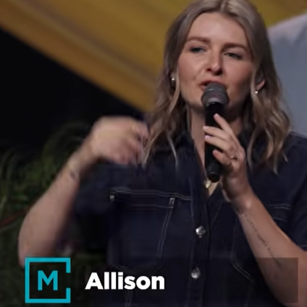
Allison Li

Introduction:
9:13/1:15:12
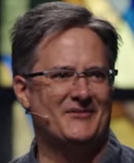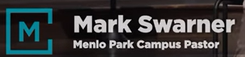
Mark Swarner, Campus Pastor

22:51/1:15:12

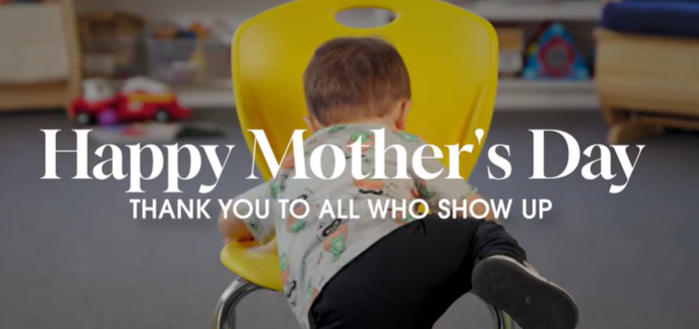

23:13/1:15:12
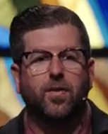
Phil EuBank, Lead Pastor

23:34/1:15:12
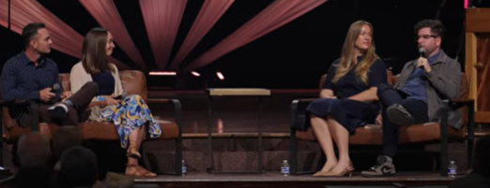
Right two persons are Alyssa and Phill EuBank
Let two persons are Jo and Vince Vitale. Joe got a great accent and Vince is from New Jersey. They host a podcast together.
We start with faith and wisdom of life.
Joe is a researcher and was studying at Princeton. Vince’s father is a pastor. They have different perspective of God. Love is a great motivator than fear.

33:28/1:15:12

======
05/16/2026, Menlo Church Worship (Summary of last week, 05/10/2028)
https://www.youtube.com/live/r1hc4T-NgcQ?si=tY031W7Ma2Ix5ZbO
No One Ever Told Me | Mother's Day | Vince & Jo Vitale, Phil & Alyssa EuBank (Phil EuBank, Lead Pastor)

