10/03/2026, Menlo Church Worship (Summary of last week, 09/27/2026)
https://youtu.be/rELnICc8cko?si=j4m0_PXMI1ZJ_ZbY
https://github.com/peterhchen/1000_Family/tree/main/Church/2026
The Purity of Reality | Repentance For the Rest of Us | Menlo Church, Mark Swarner, Campus Pastor
Phil EuBank, Lead Pastor

0:00/38:28

Allison Joy Li

Introduction:
0:00/38:28
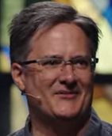
Mark Swarner, Campus Pastor

0:00/38:28


0:00/38:28
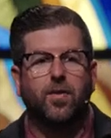
Phil EuBank, Lead Pastor

0:38/38:28
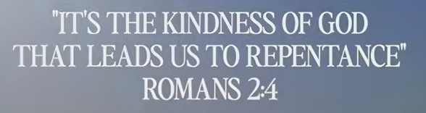

0:48/38:28


0:55/38:28

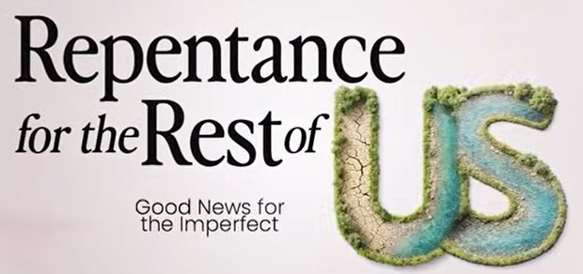

1:01/38:28


1:44/38:28
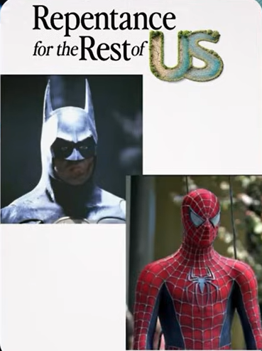
Most superman is bat man, spiderman, black panther, and flash.
Who are these heroic figures really behind the mask? Which one is the real one?
Every half of every superhero’s journey on the TV shows or the movies, the comic books, it is the loneliness that they feel behind the mask, behind the double life that they are leading. We all love to be superheroes, but we are not.
We are still wearing the mask and pretend we have it all together and we are self-sufficient and our families and our careers are great and we have everything that we need and it is up and to the right. But this pressure to be a superhero to only shows our strength and displays our successes and cover our falures.

************
************
10/03/2026, Menlo Church Worship (Summary of last week, 09/27/2026)
https://youtu.be/rELnICc8cko?si=j4m0_PXMI1ZJ_ZbY
https://github.com/peterhchen/1000_Family/tree/main/Church/2026
The Purity of Reality | Repentance For the Rest of Us | Menlo Church, Mark Swarner, Campus Pastor

