02/14/2026, Menlo Church Worship, Legacy (last week)
https://www.youtube.com/live/lwELDO2LIdo?si=9bTCl86e1wUXLJnp
“Love is Worth Waiting For | Love is…,” Phil EuBank, Lead Pastor

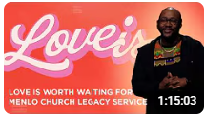

Introduction:
10:00/1:15:02
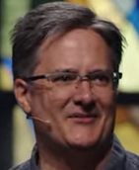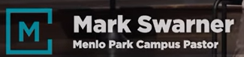

15:00/1:15:02
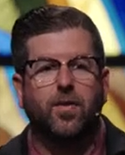
Phil EuBank, Lead Pastor

15:00/1:15:02
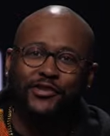

17:00/1:15:02
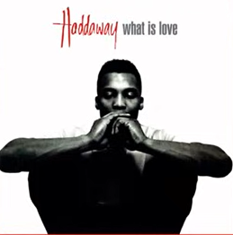

The song “What is love?”
“What is love? Baby, don’t hurt me.”

17:30/1:15:02
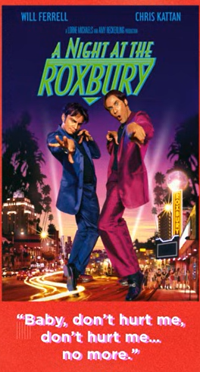

21:00/1:15:02
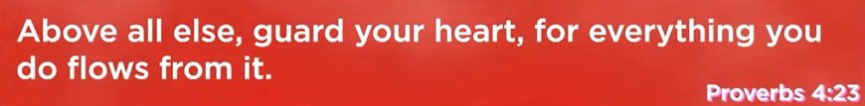
Proverbs 4:23
Proverbs 4:23
English Standard Version
²³ Keep your heart with all vigilance, for from it flow the springs of life.

22:00/1:15:02
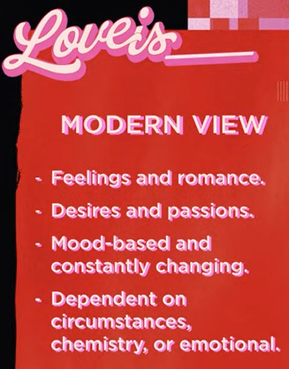
Modern view
1. Feelings and Romance
2. Desires and Passions
3. Mood-based and constantly changing
4. Dependent on circumstance chemistry, or emotional

23:12/1:15:02
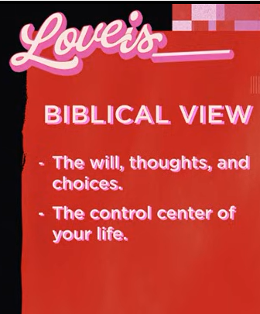
Biblical View
1. The will, thoughts, and choices.
2. The control center of your life.

25:12/1:15:02
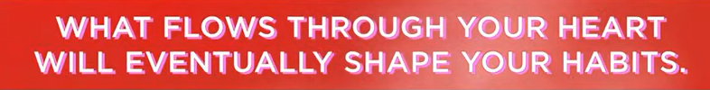
What Flows Through Your heart Will Eventually shape your habits.

30:00/1:15:02

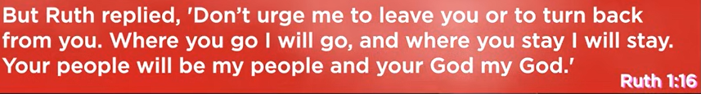

30:30/1:15:02

31:00/1:15:02
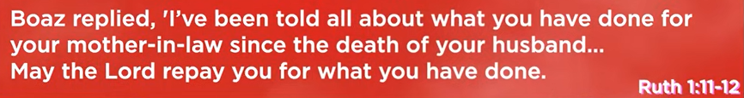
Ruth 1:11-12 is incorrect
Ruth 2:11-12
Boaz Replied, “I’ve been told all about what you have done for your mother-in-law since the death of your husband…”

Ruth 2:11-12
English Standard Version
¹¹ But Boaz answered her, “All that you have done for your mother-in-law since the death of your husband has been fully told to me, and how you left your father and mother and your native land and came to a people that you did not know before. ¹² The Lord repay you for what you have done, and a full reward be given you by the Lord, the God of Israel, under whose wings you have come to take refuge!”

31:30/1:15:02
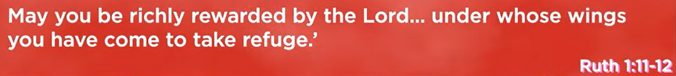
Ruth 2:11-12
English Standard Version
¹¹ But Boaz answered her, “All that you have done for your mother-in-law since the death of your husband has been fully told to me, and how you left your father and mother and your native land and came to a people that you did not know before. ¹² The Lord repay you for what you have done, and a full reward be given you by the Lord, the God of Israel, under whose wings you have come to take refuge!”

32:30/1:15:02
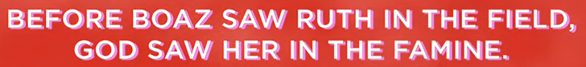

36:00/1:15:02
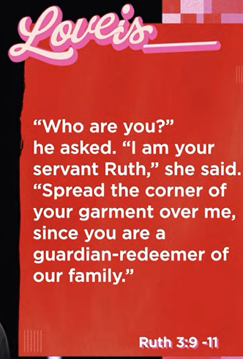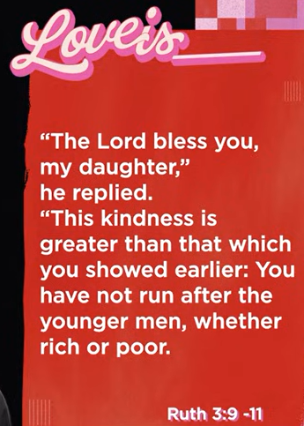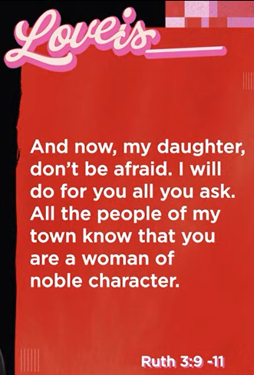
Ruth 3:9-11
English Standard Version
⁹ He said, “Who are you?” And she answered, “I am Ruth, your servant. Spread your wings^{[a]} over your servant, for you are a redeemer.” ¹⁰ And he said, “May you be blessed by the Lord, my daughter. You have made this last kindness greater than the first in that you have not gone after young men, whether poor or rich. ¹¹ And now, my daughter, do not fear. I will do for you all that you ask, for all my fellow townsmen know that you are a worthy woman.

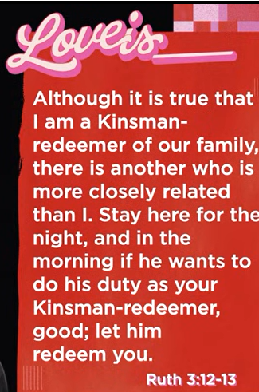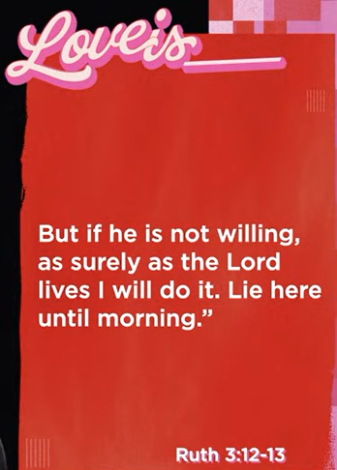
Ruth 3:12-13
English Standard Version
¹² And now it is true that I am a redeemer. Yet there is a redeemer nearer than I. ¹³ Remain tonight, and in the morning, if he will redeem you, good; let him do it. But if he is not willing to redeem you, then, as the Lord lives, I will redeem you. Lie down until the morning.”

46:00/1:15:02
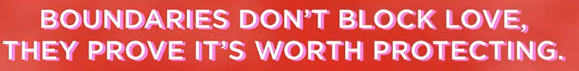
Boundaries don’t block love, they prove it’s worth protecting.

Boundaries are essential filters, not walls, that protect, honor, and sustain healthy relationships by defining personal respect. They allow for authentic connection by filtering out negativity and ensuring,, that only respectful, mutual, and safe interactions remain. Setting boundaries prevents resentment, preserves emotional well-being, and indicates that a relationship is worth nurturing.
Key aspects of this concept include:
- Protection over Obstruction: Boundaries do not block love; they protect it, allowing relationships to thrive rather than succumb to burnout.
- Filters, Not Walls: They act as filters that distinguish between nurturing connections and energy-draining ones.
- Self-Respect & Safety: Establishing limits is an act of self-love that demonstrates your worth and ensures you feel safe and respected.
- Clarity and Honesty: Clear boundaries prevent confusion, as they tell others how to successfully engage with you.
- Authentic Connections: People who respect your boundaries are those who truly value you, while those who push against them reveal why they are necessary.

47:30/1:15:02
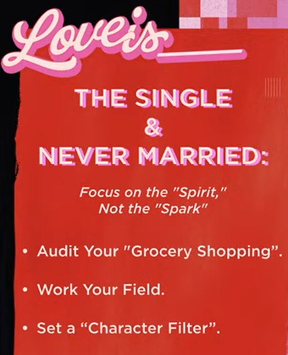

48:30/1:15:02
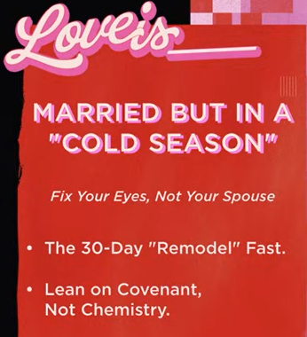

49:00/1:15:02
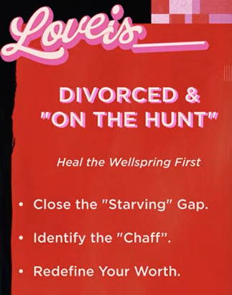

50:30/1:15:02
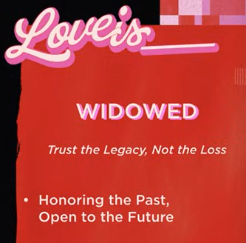

02/14/2026, Menlo Church Worship, Legacy (last week)
https://www.youtube.com/live/lwELDO2LIdo?si=9bTCl86e1wUXLJnp
“Love is Worth Waiting For | Love is…,” Phil EuBank, Lead Pastor

