11/12/2025, Legacy (last week)
https://www.youtube.com/live/4lt_1I_TbgU?si=v9Dbg1fUA_CTw9dP
“Come All Ye Joyless | Come All Ye Faithless,” Dr. Jo Vitale



“Ye” = “y’all.” The phrase
1. "Come All Ye Joyless" means “Come here. All of you who are without Joy".
2. "Come All Ye Faithless" means “Come here. All of you who are without faith".

Introduction:
10:00/1:15:03


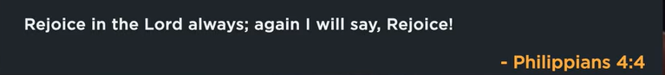
Philippians 4:4
English Standard Version
⁴ Rejoice in the Lord always; again, I will say, rejoice.


Psalm 118:24
English Standard Version
²⁴ This is the day that the Lord has made; let us rejoice and be glad in it.


1 Thessalonians 5:16-18
English Standard Version
¹⁶ Rejoice always, ¹⁷ pray without ceasing, ¹⁸ give thanks in all circumstances; for this is the will of God in Christ Jesus for you.

21:35/1:15:03

Phil EuBank, Lead Pastor


Joy grows in the places happiness cannot reach.
Explanation:
Joy is a deeper, more resilient state than happiness. Joy and thrive in hardship (where happiness fades) with faith and inner strength, is better than happiness.

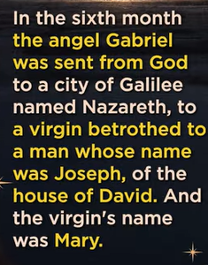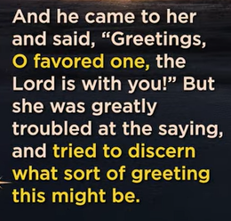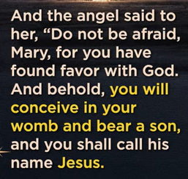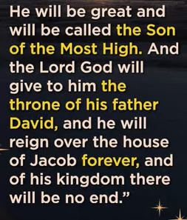

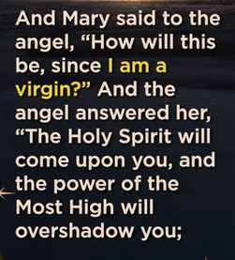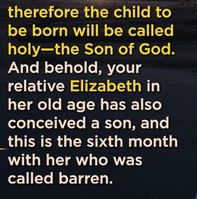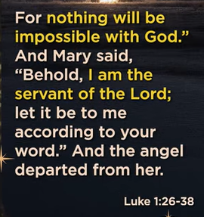
Luke 1:26-38
English Standard Version
Birth of Jesus Foretold
²⁶ In the sixth month the angel Gabriel was sent from God to a city of Galilee named Nazareth, ²⁷ to a virgin betrothed^{[a]} to a man whose name was Joseph, of the house of David. And the virgin's name was Mary. ²⁸ And he came to her and said, “Greetings, O favored one, the Lord is with you!”^{[b]} ²⁹ But she was greatly troubled at the saying, and tried to discern what sort of greeting this might be. ³⁰ And the angel said to her, “Do not be afraid, Mary, for you have found favor with God. ³¹ And behold, you will conceive in your womb and bear a son, and you shall call his name Jesus. ³² He will be great and will be called the Son of the Most High. And the Lord God will give to him the throne of his father David, ³³ and he will reign over the house of Jacob forever, and of his kingdom there will be no end.”
³⁴ And Mary said to the angel, “How will this be, since I am a virgin?”^{[c]}
³⁵ And the angel answered her, “The Holy Spirit will come upon you, and the power of the Most High will overshadow you; therefore the child to be born^{[d]} will be called holy—the Son of God. ³⁶ And behold, your relative Elizabeth in her old age has also conceived a son, and this is the sixth month with her who was called barren. ³⁷ For nothing will be impossible with God.” ³⁸ And Mary said, “Behold, I am the servant^{[e]} of the Lord; let it be to me according to your word.” And the angel departed from her.

The main point of Luke 1:26-38 (the Annunciation) is God's miraculous announcement to the Virgin Mary that she will conceive and give birth to Jesus, the Son of God and Messiah, through the Holy Spirit, revealing the Incarnation and calling Mary to a profound act of faith and obedience to become the mother of the promised King. It highlights divine grace, the fulfillment of prophecy (David's lineage), the power of God, and Mary's humble, trusting acceptance ("Here I am, the servant of the Lord").
Key Themes:
- Divine Intervention: God initiates contact through the Angel Gabriel, breaking into Mary's ordinary life with an extraordinary plan.
- The Virgin Birth & Incarnation: Mary will conceive without a human father, as the Holy Spirit comes upon her, making Jesus the Son of the Most High (God becoming human).
- Fulfillment of Prophecy: Jesus will inherit the throne of David, establishing an eternal kingdom, fulfilling Old Testament promises.
- Mary's Faith & Obedience: Despite confusion and challenges (how can this be?), Mary responds with radical trust, accepting God's will, making her a model of discipleship.
- God's Favor: Mary is "highly favored" and "found by God," signifying God's special grace on her to be the vessel for salvation.

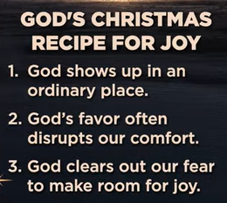
God’s Christmas recipe for Joy
1. God shows up in an ordinary place
2. God’s favor often disrupts our comfort.
3. God clears out our fear to make room for joy.

Luke 1:
- God shows up in an ordinary place: This reflects the birth of Jesus in a lowly manger, a humble and ordinary place, as described in Luke 2.
- God's favor often disrupts our comfort: This can be seen in Mary and Joseph's story, where God's plan disrupted their normal lives and required them to trust God in unexpected circumstances.
- God clears out our fear to make room for joy: This speaks to the message the angel gave the shepherds, "Do not be afraid. I bring you good news of great joy," directly linking the removal of fear to the arrival of joy.

Luke 1:38
English Standard Version
³⁸ And Mary said, “Behold, I am the servant^{[a]} of the Lord; let it be to me according to your word.” And the angel departed from her.

“I am the Lord’s servant. May it be to me according to your word.”
Mary does not understand what God want. Mary surrender to God.

The main point of Luke 1:38, Mary's response to the angel Gabriel ("Here am I, the servant of the Lord; let it be with me according to your word"), is profound, humble submission and radical faith in God's divine plan, signifying her complete surrender, obedience, and acceptance of her role as mother of Jesus, even with its unknown, challenging future. It's a model of yielding personal will to God's will, paralleling Jesus's own prayer in Gethsemane, showing total trust.
Key Aspects:
- Humility & Identity: Calling herself the "handmaid (servant) of the Lord" shows her lowliness and willingness to serve.
- Obedience & Faith: Saying "let it be with me according to your word" is her "Amen," a firm belief and readiness to obey God's impossible-seeming command.
- Unreserved Surrender: Mary gives herself unreservedly to God, allowing Him to direct her life completely, a conscious, daily choice.
- Trust in the Unseen: She trusts God's promise despite the incomprehensible circumstances, a core element of living faith.
- A Model for Believers: Her response serves as an example for all believers to surrender their lives and trust God's perfect, though sometimes unclear, will.

This Advent (Coming), Mary surrender to God, is unexpected and joy.

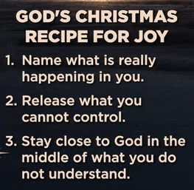
Cod’s Christmas Recipe for Joy:
1. Name what is really happening in you.
2. Release what you cannot control
3. Stau close to Gid in the middle of what you do not understand.

Find peace during the Christmas season:
Step 1: Name what is really happening in you. This encourages self-awareness. Acknowledge your genuine feelings, whether they are joy, stress, grief, or anxiety, rather than ignoring them or pretending everything is fine.
Step 2: Release what you cannot control. This speaks to the wisdom of letting go. Many aspects of the holiday season—other people's actions, unexpected events, the past, the future—are beyond your influence. Focusing energy only on what you can control (your reactions, your kindness, your presence) can bring peace.
Step 3: Stay close to God in the middle of what you do not understand. This emphasizes faith and trust. When life seems confusing, unfair, or overwhelming, the instruction is to maintain a spiritual connection and trust in a higher power's plan, rather than trying to figure everything out on your own.

11/12/2025, Legacy (last week)
https://www.youtube.com/live/4lt_1I_TbgU?si=v9Dbg1fUA_CTw9dP
“Come All Ye Joyless | Come All Ye Faithless,” Dr. Jo Vitale

“Ye” = “y’all.” The phrase
1. "Come All Ye Joyless" means “Come here. All of you who are without Joy".
2. "Come All Ye Faithless" means “Come here. All of you who are without faith".
Today worship is based on Luke chapter 1 in Bible. It introduces God’s fulfillment of His ancient promises through the faithful people: Zechariah, Elizabeth, Mary, and John the Baptist, to bring salvation and hope to the world with the coming of the Messiah (Jesus Christ) with joy, God's plan in unexpected ways, and preparing for the Messiah's arrival.

Summary:
1. Joy grows in the places that happiness cannot reach: Joy is a deeper, more resilient state than happiness. Joy and thrive in hardship (where happiness fades) with faith and inner strength, is better than happiness.
2. Luke 1:26-38: God told Virgin Mary that she will have baby Jesus, the Son of God and Messiah, through the Holy Spirit.
3. What is God’s Christmas recipe for Joy:
a. God shows up in an ordinary place: God gives birth of Jesus in a humble/ordinary place.
b. God disrupts our comfort: God gives us an unexpected circumstances through Mary.
c. God clears out our fear to make room for joy: God told Mary “Do not be afraid. I bring you good news of great joy.”
4. Luke 1:38: Mary told angel Gabriel "Here am I, the servant of the Lord; let it be with me according to your word”
5. Find peace during the Christmas season:
a. Name what is really happening in you: Know your feelings rather than ignore them.
b. Release what you cannot control: Focus only on what you can do.
c. Stay close to God if you do not understand: Trust God plan.

