04/11/2026, Menlo Church Worship (Summary of last week, 04/05/2028)
https://www.youtube.com/watch?v=JUfrb27B68I
“I Am With You In the Dark | I Am …The God Who Gets Close,” Phil EuBank, Lead Pastor

0:00/1:14:56
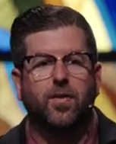
Phil EuBank, Lead Pastor

Introduction:
20:00/1:16:02
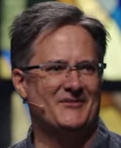

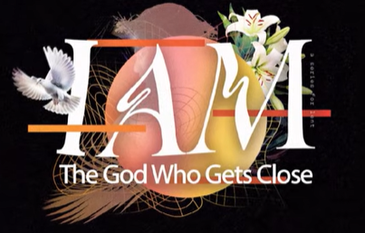

======
04/11/2026, Menlo Church Worship (Summary of last week, 04/05/2028)
https://www.youtube.com/watch?v=JUfrb27B68I
“I Am With You In the Dark | I Am …The God Who Gets Close,” Phil EuBank, Lead Pastor

Summary:

