02/21/2026, Menlo Church Worship, Legacy (last week)
https://www.youtube.com/live/SuuESedOiF0?si=gX-KGfkLwGDgcvxv
“Love is Holy, including Intimacy | Love is…,” Phil EuBank, Lead Pastor

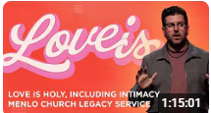

Introduction:
12:00/1:15:00
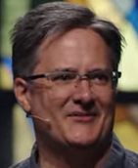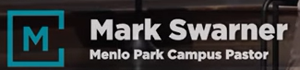

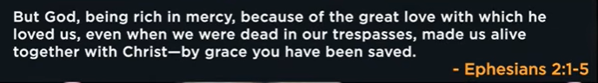

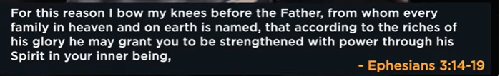

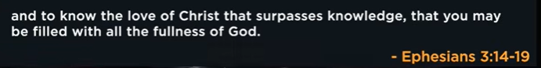

19:00/1:15:00
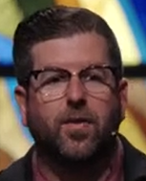
Phil EuBank, Lead Pastor

We talk about Love in this series. Last week, Jevon talk about heart. This week, we talk about the sex.

22:00/1:15:00
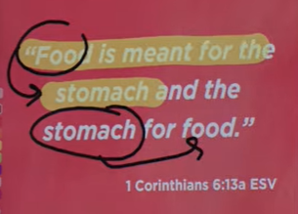
1 Corinthians 6:13a ESV

25:00/1:15:00
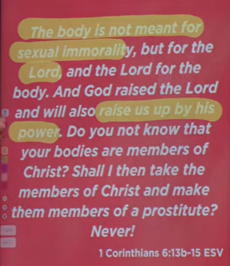
1 Corinthians 6:13a-15 ESV

31:30/1:15:00

Sex is Gross

34:00/1:15:00
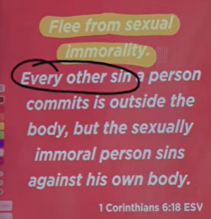
1 Corinthians 6:18 ESV

38:00/1:15:00

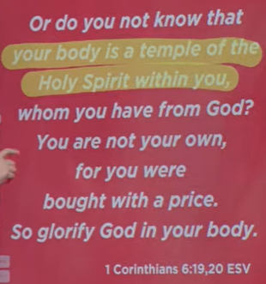
1 Corinthians 6:19-20 ESV

40:00/1:15:00

Sex is a Gift.

Sex is like a fire. You put the fire in fireplace. You Cannot bring the sex into the center of family. Fire will burn the entire house.

45:00/1:15:00

Song of Solomon 2:7 NLT

God give us a season of freedom. Some people have fireplace but they let the fire to go out.
If you are marriage never stop firefighting. Sex is a gift. Do not let the fire out of control.
Love is foundation. Love is Holy.

02/21/2026, Menlo Church Worship, Legacy (last week)
https://www.youtube.com/live/SuuESedOiF0?si=gX-KGfkLwGDgcvxv
“Love is Holy, including Intimacy | Love is…,” Phil EuBank, Lead Pastor

Summary

