08/22/2026, Menlo Church Worship (Summary of last week, 08/16/2026)
https://www.youtube.com/watch?v=OzpZKMucPfs
https://github.com/peterhchen/1000_Family/tree/main/Church/2026
The Mirrow| What Is a Follower Of the Way? | Menlo Church Phil EuBank, Lead Pastor

0:00/36:30

Allison Joy Li

Introduction:
0:00/36:30

Mark Swarner, Campus Pastor

0:00/36:30


00:12/36:30

00:48/36:30
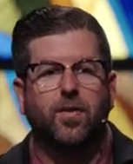
Phil EuBank, Lead Pastor

************
************
08/22/2026, Menlo Church Worship (Summary of last week, 08/16/2026)
https://www.youtube.com/watch?v=OzpZKMucPfs
https://github.com/peterhchen/1000_Family/tree/main/Church/2026
The Mirrow| What Is a Follower Of the Way? | Menlo Church Phil EuBank, Lead Pastor

