08/01/2026, Menlo Church Worship (Summary of last week, 07/26/2026)
https://www.youtube.com/watch?v=zD4qnpSfu9g
https://github.com/peterhchen/1000_Family/tree/main/Church/2026
They System of Merit (Catholicism) | Let's Be Honest| Menlo Church Phil EuBank, Lead Pastor

0:00/33:53

Allison Joy Li

Introduction:
0:00/33:53
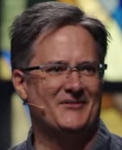
Mark Swarner, Campus Pastor

0:00/33:53
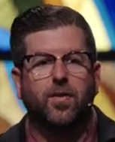
Phil EuBank, Lead Pastor

0:00/33:53
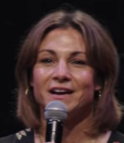

0:00/33:53
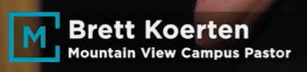
Brett Koerten, Mountain View Campus Lead Pastor

0:20/33:53
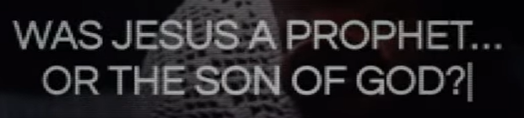

0:24/33:53
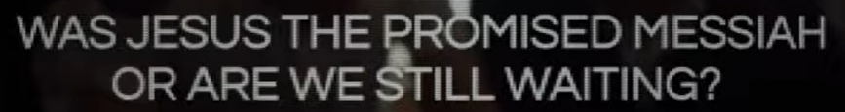

0:29/33:53
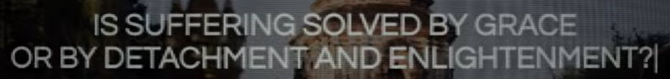

0:34/33:53
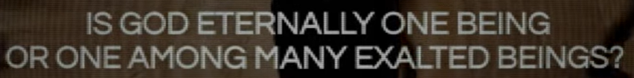

0:41/33:53
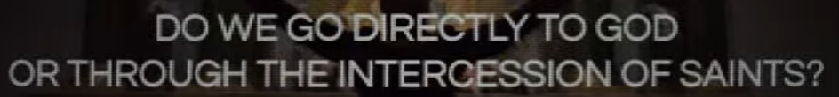

0:46/33:53
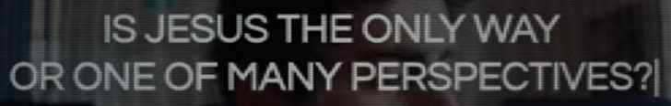

0:49/33:53
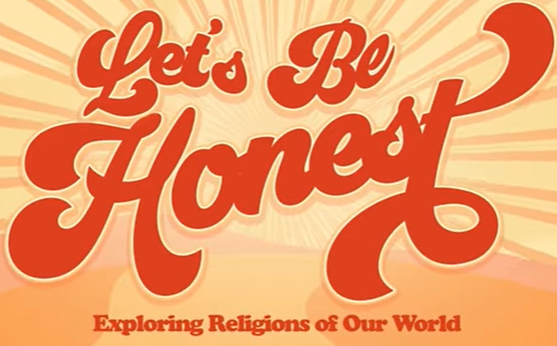

0:54/33:53

1:13/33:53
In this “Let's Be Honest” series, we have
1) June 28: Judaism, 2) July 5: Islam, 3) July 12: Buddhism, 4) July 19: Mormonism, 5) July 26: Catholicism, 6) August 2: The Nones/Agnostic, 7) August 9: The Gospel

2:04/33:53
Today, we talk about Mormonism.

************
************

