09/19/2026, Menlo Church Worship (Summary of last week, 09/13/2026)
https://www.youtube.com/watch?v=KQTVHSKmV68&t=10s
https://github.com/peterhchen/1000_Family/tree/main/Church/2026
The Two-Sided Coin | Repentance For the Rest of Us | Menlo Church
Phil EuBank, Lead Pastor

0:00/33:42
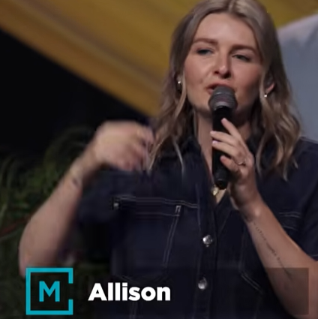
Allison Joy Li

Introduction:
0:00/33:42
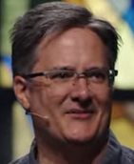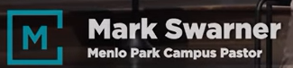
Mark Swarner, Campus Pastor

0:00/33:42
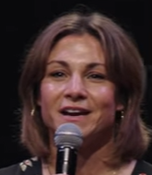

0:00/33:42
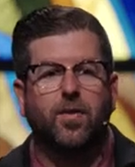
Phil EuBank, Lead Pastor

0:40/33:42
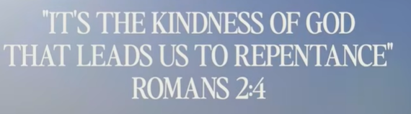

0:46/33:42
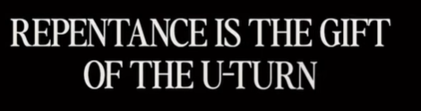

0:54/33:42
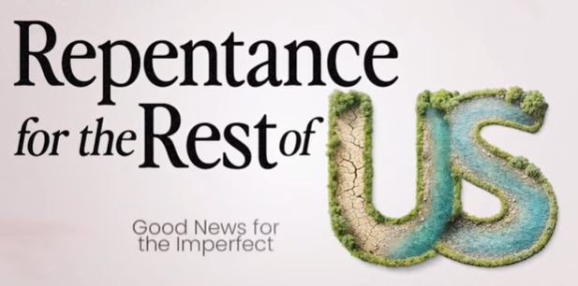

Repentance: 悔改

1:01/33:42
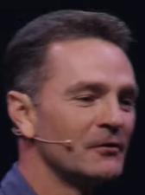
Vince Vitale, Guest Speaker

************
************
09/19/2026, Menlo Church Worship (Summary of last week, 09/13/2026)
https://www.youtube.com/watch?v=KQTVHSKmV68&t=10s
https://github.com/peterhchen/1000_Family/tree/main/Church/2026
The Two-Sided Coin | Repentance For the Rest of Us | Menlo Church
Phil EuBank, Lead Pastor

