01/31/2026, Menlo Church Worship, Legacy (last week)
https://www.youtube.com/live/lWgVXgKAvu4?si=_mQa0vqK2rdXDi7G
“Perfect Kids | PERFCT,” Phil EuBank, Lead Pastor



Introduction:
10:00/1:14:56



Matthew 19:14
English Standard Version
¹⁴ but Jesus said, “Let the little children come to me and do not hinder them, for to such belongs the kingdom of heaven.”

Matthew 19:14 ("Let the little children come to me...") highlights that the Kingdom of Heaven belongs to those who possess childlike humility, faith, and dependence. Jesus uses children as a model for true discipleship, emphasizing that unconditional trust and a pure heart—rather than status or authority—are essential for accessing God's kingdom.
Key Themes in Matthew 19:14:
- Childlike Faith: The main point is that followers of Jesus must adopt the trusting, humble, and dependent nature of a child to enter the kingdom.
- Inclusivity and Grace: Jesus shows that no one, regardless of social status or perceived importance, should be hindered from coming to Him.
- Value of the Humble: Children in this context represent the lowly, vulnerable, or insignificant, emphasizing that God’s kingdom welcomes those who are not "important" by worldly standards.
- Correction of Pride: Jesus corrects the disciples' prideful, restrictive view, asserting that children are a model for receiving his blessing and grace.


Mark 10:15
English Standard Version
¹⁵ Truly, I say to you, whoever does not receive the kingdom of God like a child shall not enter it.”

The main point of Mark 10:15 (ESV) is that entering the kingdom of God requires receiving it with the humility, trust, and complete dependence of a child. Jesus emphasizes that salvation is a gift received through humble faith, not earned, and that self-reliance is a barrier to the kingdom.
Key aspects of this teaching include:
- Childlike Dependence: The Greek term implies the helplessness of a young child, highlighting total reliance on God rather than self-sufficiency.
- Exclusivity: Jesus states that anyone who does not receive the kingdom like a child "shall not enter it".
- Receptivity over Merit: Just as children accept gifts without trying to earn them, believers must accept God's grace without pride.
- Context: This statement followed the disciples rebuking people for bringing children to Jesus, with Jesus correcting them to show the kingdom belongs to such individuals.



1 John 3:1
English Standard Version
3 See what kind of love the Father has given to us, that we should be called children of God; and so we are. The reason why the world does not know us is that it did not know him.

The main point of 1 John 3:1 is to marvel at the profound, "lavished" love of God that grants believers the immediate, undeserved status of being His children. It emphasizes that this identity is not merely a title but a present reality, resulting from God's grace and setting believers apart from the world.
Key highlights of 1 John 3:1 include:
- The Depth of God's Love: The verse begins with an exclamation ("Behold!") to consider the extraordinary, immense, and freely given (lavished) love of the Father.
- Identity as God’s Children: Through this love, believers are not just called, but actually are, the children of God.
- Present Reality: This status is not just a future hope, but a present, life-altering reality for those in Christ.
- Contrast with the World: The world does not recognize believers because it did not know Christ.

20:00/1:14:56

Phil EuBank, Lead Pastor

24:00/1:14:57
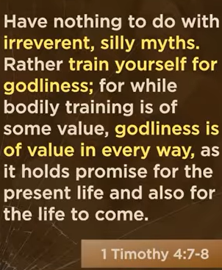
1 Timothy 4:7-8
English Standard Version
⁷ Have nothing to do with irreverent, silly myths. Rather train yourself for godliness; ⁸ for while bodily training is of some value, godliness is of value in every way, as it holds promise for the present life and also for the life to come.

The main point of 1 Timothy 4:7-8 is that spiritual training (godliness) is vastly superior to physical training, as it yields eternal benefits rather than temporary ones. Paul instructs believers to reject false, empty myths and instead discipline themselves for a life of active, godly devotion that holds value for both the present life and the afterlife.
Key Aspects:
- Active Discipline: "Train yourself" implies intentional effort and, at times, self-denial for spiritual growth.
- True Value: While physical exercise has some limited, temporary value, godliness brings comprehensive, eternal, and lasting benefits.
- Eternal Focus: Godly living is a "profitable" investment that extends beyond this life into the life to come.
- Prioritizing Truth: The instruction warns against wasting energy on "silly myths" and "old wives' tales" in favor of the truth of the gospel.

25:00/1:14:57
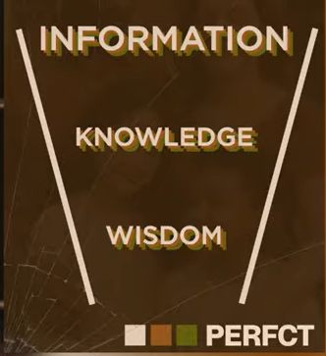
DIKW (Data, Information, Knowledge, Wisdom)
The DIKW pyramid defines the hierarchy of understanding: Data (raw facts) is processed into Information (organized data), which becomes Knowledge (applied, contextualized information), culminating in Wisdom (applied, ethical knowledge). It maps the transformation of data into actionable insights and sound judgment.
Key Components of the DIKW Model:
- Data (What): Raw, unorganized facts, signals, or observations (e.g., "30 degrees," "rain").
- Information (Who, What, Where, When): Data given meaning through context, structure, and organization.
- Knowledge (How):
Information applied through experience, study, or interpretation, enabling action and decision-making
.
- Wisdom (Why): The highest level; the ability to use knowledge for sound, ethical, and forward-looking judgment.
Key Differences and Examples:
- Context: Data lacks context; Information has context; Knowledge has understanding; Wisdom has foresight.
- Example: Data (Numbers), Information (A sales report), Knowledge (A market trend), Wisdom (Deciding to invest based on the trend).
- Purpose: Information helps us understand the present, while wisdom helps us predict and act for the future.
The DIKW model is widely used in knowledge management, information science, and decision support systems to illustrate how raw input can be transformed into valuable, actionable insights.

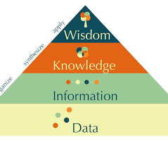
The DIKW pyramid (Data, Information, Knowledge, Wisdom) models the transformation of raw facts into actionable insight. Its main point is that value increases as data is contextualized into information, analyzed into knowledge, and finally applied through wisdom for better decision-making.
Key Components of the Hierarchy:
- Data: Raw, unorganized facts, signals, or symbols with little inherent value (e.g., numbers, raw sensor readings).
- Information: Data processed, structured, or contextualized to provide meaning (e.g., a dashboard showing sales trends).
- Knowledge: Information applied, synthesized, and understood through experience and analysis (e.g., knowing that a specific trend means a product is underperforming).
- Wisdom: The ability to use knowledge, insights, and judgment to make sound, ethical decisions and add long-term value.
Key Takeaways:
- Progression: The framework tracks the journey from "what" (data) to "how" (knowledge) and finally "why" (wisdom).
- Purpose: It helps transition from data overload to meaningful action.
- Limitation: While data and information can be easily automated, knowledge and wisdom heavily rely on human insight.

28:00/1:14:57
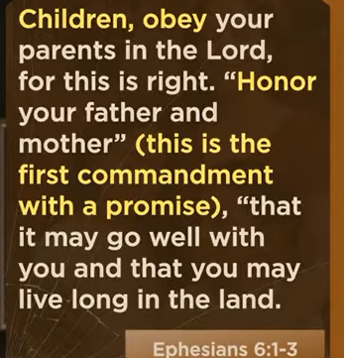
Ephesians 6:1-3
English Standard Version
Children and Parents
6 Children, obey your parents in the Lord, for this is right. ² “Honor your father and mother” (this is the first commandment with a promise), ³ “that it may go well with you and that you may live long in the land.”

The main point of Ephesians 6:1-3 is that children are called to obey and honor their parents as a spiritual duty "in the Lord," because it is right and brings the promise of blessing and long life. It highlights that obeying parents is a form of Christian obedience that reflects a heart submitted to God.
Key Aspects of Ephesians 6:1-3:
- Actionable Obedience: "Obey" implies listening and taking action under authority, while "honor" involves respect and high regard.
- "In the Lord": This phrase means obedience is rooted in the child’s relationship with Christ, making it a form of worship.
- A Righteous Act: Paul declares this obedience is "right," aligning with God's moral order and the Ten Commandments.
- The Promise: It is the first commandment with a promise attached—that life will go well and they will live long on the earth.
- Countercultural Value: In the context of Roman times, this teaching elevated the status of children and required parents to act with love rather than harshness, as discussed in this sermon from Harbor Community Church.
This passage reinforces that honoring parents is essential for a well-ordered life and spiritual maturity.

31:00/1:14:57
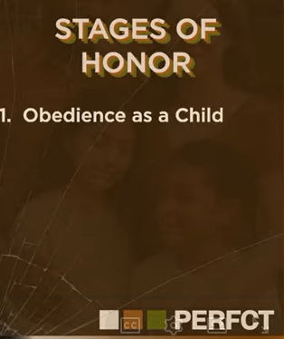

32:00/1:14:57
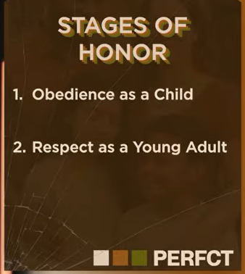
33:00/1:14:57

33:30/1:14:57
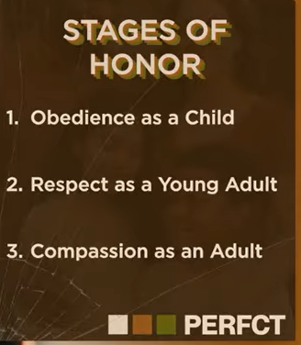
Stages of Honor
1. Obedience as a child
2. Respect as a Young Adult
3. Compassion as an Adult.

The stages of honor represent a lifelong, evolving relationship with parents, moving from child-like obedience to mature, compassionate care. It begins with obedience in childhood, transitions to respect as a young adult (even while gaining independence), and matures into compassionate support as an adult, often caring for parents in their old age.
- Stage 1: Obedience (Childhood)
  - Focuses on learning, listening, and following parental instructions.
  - Establishes safety, discipline, and respect for authority early in life.
- Stage 2: Respect (Young Adult/Teenager)
  - Involves honoring parents even when disagreeing or gaining independence.
  - Moves beyond blind obedience to recognizing the dignity and wisdom of parents.
- Stage 3: Compassion (Adult)
  - Focuses on caring for parents as they age or their health declines.
  - Involves honoring them through gratitude, kindness, and support in their later years.
This lifelong process ensures parents are valued, honored, and supported at every stage of life.

The "Stages of Honor" framework outlines how the biblical command to "honor your father and mother" evolves as a child matures into adulthood. The main point is that while the command to honor parents is permanent, the application of that honor changes based on the individual's stage of life and independence.
- 1. Obedience as a Child:
For young children, honor is expressed primarily through obedience—submitting to parental authority, following rules, and listening to instructions. This stage is designed to provide protection, build character, and teach the child how to live under authority.
- 2. Respect as a Young Adult:
As a person transitions into independence, the focus shifts from strict compliance to respectful interaction. This involves valuing their parents' wisdom, treating them with dignity, and acknowledging their role in the family without necessarily being under their direct control.
- 3. Compassion as an Adult:
In adulthood, especially as parents age, honor takes the form of compassion and care. This includes providing for their physical or financial needs, showing patience toward their limitations, and preserving their dignity as they become more dependent.

34:00/1:14:57
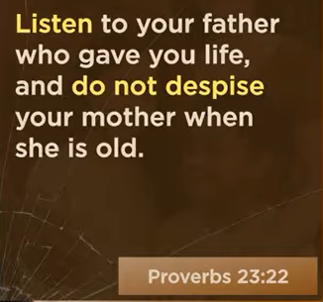
Proverbs 23:22
English Standard Version
²² Listen to your father who gave you life,
and do not despise your mother when she is old.

Proverbs 23:22 commands lifelong honor, respect, and obedience toward parents, emphasizing that children should listen to their father and not despise or neglect their mother, especially in her old age. It highlights that parental wisdom should be valued throughout life, regardless of a parent's frailty or age.
- Lifelong Duty: The verse instructs children to honor their parents not just when they are young, but to continue respecting their mother even when she is old.
- Active Listening: "Listen to your father" implies more than hearing; it means an eager, teachable spirit that follows wise, godly counsel.
- Avoid Contempt: "Do not despise your mother" warns against treating aging parents with scorn, neglect, or treating their advice as irrelevant.
- Gratitude and Respect: The verse reminds children of the debt of gratitude owed to the parents who brought them into the world.
This verse highlights the importance of honoring parents as a core component of wisdom, as also noted in this Bible Study Tools article.

40:00/1:14:57

Ways we approach God: 1. The Venmo Kid: Works for stuff

41:00/1:14:57
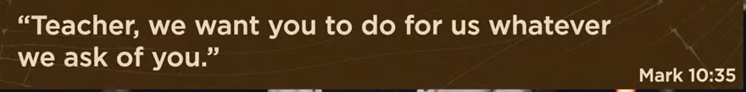
Mark 10:35
English Standard Version
The Request of James and John
³⁵ And James and John, the sons of Zebedee, came up to him and said to him, “Teacher, we want you to do for us whatever we ask of you.”

The main point of Mark 10:35-45 is that true greatness in the Kingdom of God is defined by humble service and sacrificial love, not by power or status. While James and John selfishly requested positions of glory, Jesus corrected them by defining leadership as serving others and giving one’s life as a ransom.
Key Takeaways regarding Mark 10:35-45:
- Misunderstanding Glory: James and John sought high positions, failing to realize that following Jesus meant sharing in his suffering ("the cup" and "baptism").
- Reversal of Values: Jesus teaches that in his kingdom, the first must be the slave of all.
- Christ as the Example: Jesus highlights his own mission—not to be served, but to serve and die for many.
- Counter-cultural Leadership: True authority is marked by humility, directly opposing the "lording over" style of worldly leaders.
This passage acts as a challenge to all disciples to reject self-seeking ambition and embrace a life of sacrifice.

41:20/1:14:57

Ways we approach God: 1. The Venmo (mobile payment) Kid: Works for stuff

41:40/1:47:57

Ways we approach God:
1. The Venmo (mobile payment) Kid: Works for stuff
2. The Report Card Kid:

42:00/1:14:57

Ways we approach God:
1. The Venmo (mobile payment) Kid: Works for stuff
2. The Report Card Kid: Works for status

42:30/1:14:57
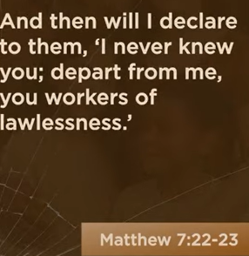
Matthew 7:22-23
English Standard Version
²² On that day many will say to me, ‘Lord, Lord, did we not prophesy in your name, and cast out demons in your name, and do many mighty works in your name?’ ²³ And then will I declare to them, ‘I never knew you; depart from me, you workers of lawlessness.’

Matthew 7:22-23 warns that outward religious acts, such as prophesying or performing miracles in Jesus' name, are not proof of salvation and do not guarantee entrance into the Kingdom of Heaven. The core message is that true discipleship requires a personal relationship with Jesus and active obedience to the Father's will, not merely invoking his authority.
Key points regarding this passage include:
- Judgment Day Surprise: Many people claiming "Lord, Lord" will be rejected because their, "works" were done for self-glory or lacked true obedience, GotQuestions.org.
- Relationship Over Works: Jesus states "I never knew you," highlighting that spiritual gifts or power without a personal, intimate relationship with Him is meaningless, Facebook.
- Warning Against "Lawlessness": Jesus calls these false followers "workers of lawlessness," emphasizing that they ignore God's commands despite their religious activity, Reddit.
- True Faith Produces Fruit: The passage distinguishes between a superficial profession of faith and a life transformed by following Jesus’ teachings, BibleRef.com.
This teaching comes at the end of the Sermon on the Mount, reinforcing the call for obedience rather than mere confession, tcdecker.com.

44:25/1:14:57
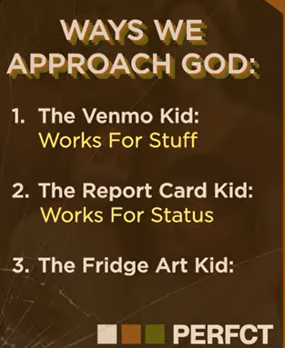
Ways we approach God:
1. The Venmo (mobile payment) Kid: Works for stuff
2. The Report Card Kid: Works for status
3. The Fridge Art Kid:

45:00/1:14:57

Ways we approach God:
1. The Venmo (mobile payment) Kid: Works for stuff
2. The Report Card Kid: Works for status
3. The Fridge Art Kid: Walk in Security

45:30/1:14:57

Healthy children receive their identity as a gift, not a grade

The concept "Healthy children receive their identity as a gift, not a grade" emphasizes that a child's sense of self should stem from unconditional acceptance, not from academic or behavioral performance. This perspective suggests that a child's worth is inherent, encouraging curiosity and self-discovery rather than focusing on external metrics or the fear of losing status through failure. For more details, visit The Gospel Coalition.

Children is judged by unconditional acceptance, not from academic/behavioral performance

46:00/1:14:57


01/31/2026, Menlo Church Worship, Legacy (last week)
https://www.youtube.com/live/lWgVXgKAvu4?si=_mQa0vqK2rdXDi7G
“Perfect Kids | PERFCT,” Phil EuBank, Lead Pastor

Summary:
1. 1 Timothy 4:7-8: Spiritual/God training is much more important than physical training. Spiritual training generates permanent benefits.
2. DIKW (Data, Information, Knowledge, Wisdom): In DIKW models, the data is extracted into information, analyzed into knowledge, and applied into wisdom for better decision-making.
3. Ephesians 6:1-3: In God kingdom, children obey/honor their parents for blessing and long life.
4. Lifelong process of children/parent: a. Obedience as a child, b. Respect as a Young Adult, c. Compassion as an Adult.
5. Proverbs 23:22: Children should always listen to their father and not neglect their mother. Parental wisdom should be valued throughout life.
6. Ways we approach God:
a. The Venmo (mobile payment) Kid: Works for stuff;
Mark 10:35-45: Jesus defined humble service and sacrificial love of God Kingdom.
b. The Report Card Kid: Works for status;
Matthew 7:22-23: Outward religious acts do not guarantee entrance into God Kingdom.
c. The Fridge (freezer) Art Kid: Walk in Security;
Children are judged by unconditional acceptance, not from academic performance

