03/07/2026, Menlo Church Worship, Legacy (last week)
https://www.youtube.com/live/7r7aPuwqkl0?si=4bKQfSfIdNLRgCnF
“I Am With You in the Fight | I Am: The God Who Gets Close,” Phil EuBank, Lead Pastor

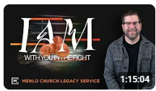

Introduction:
12:00/1:15:04
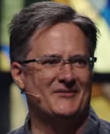

Moses mother float Moses down to the river.
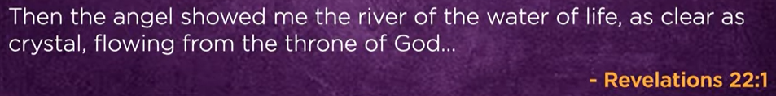

20:00/1:15:04
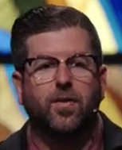
Phil EuBank, Lead Pastor

22:00/1:15:04



26:00/1:15:04
RAM in the computer is increasing. We upgrade our RAM.
What if God is not adding capacity to your life?
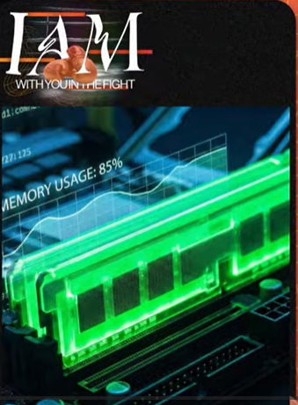

31:00/1:15:04

In the dessert, God give commend to Moses.

32:00/1:15:04

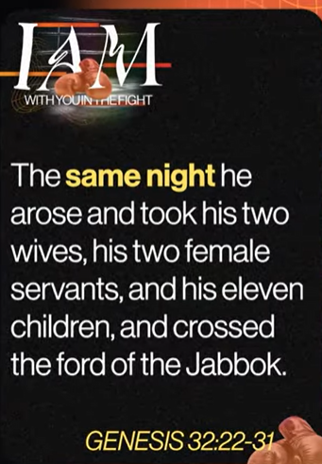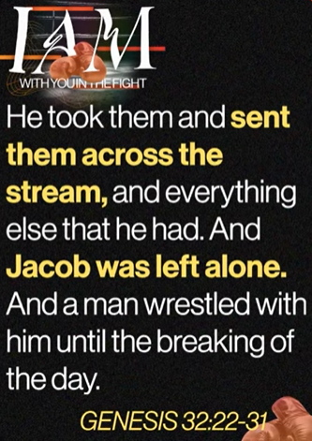

32:30/1:15:04
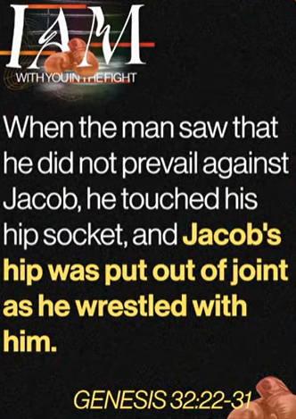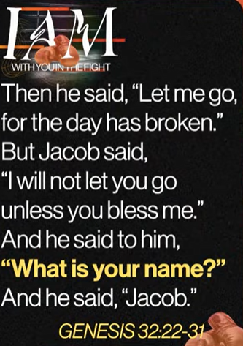

33:00/1:15:04
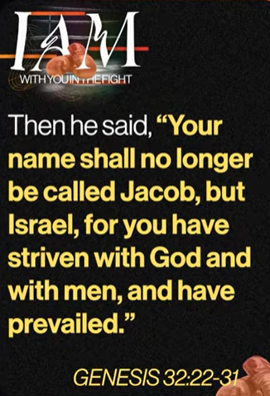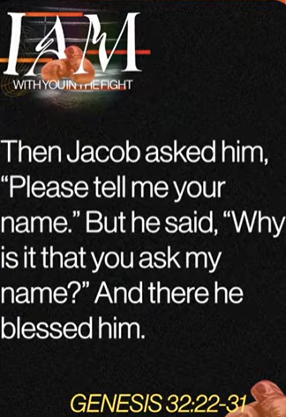

33:30/1:15:04
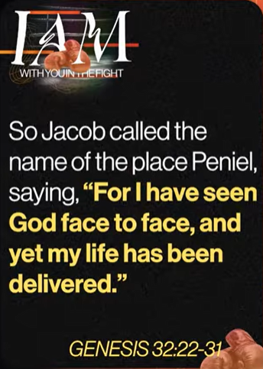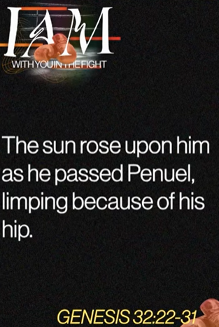
Genesis 32:22-31

Jacob sees the God. We look at this story in different angle. You can apply this in your life.

35:30/1:15:04

Jacob wrestling in the dark.

37:00/1:15:04
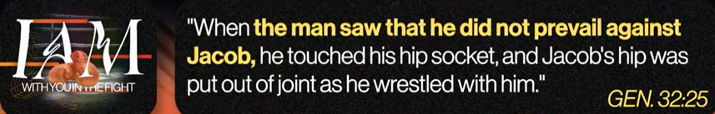
Gen 32:25
In this case, the father limits his strength and let children do their work.

39:00/1:15:04

God has his root plan. Jacob does his plan. Jacob is limp.

44:00/1:15:04

The limp dismantles Jacob in Isarael and changes the life of Jacob.

46:00/1:15:04
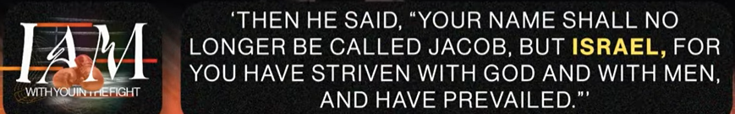
When you finally stop running, your RAM crashes. God does not remove his plan on you.
Jesus took our failure and give us the new identity and eternal life.

50:00/1:15:04
Forgive me to run mu life on my own. I will receive your forgiveness and a new identity.

03/07/2026, Menlo Church Worship, Legacy (last week)
https://www.youtube.com/live/7r7aPuwqkl0?si=4bKQfSfIdNLRgCnF
“I Am With You in the Fight | I Am: The God Who Gets Close,” Phil EuBank, Lead Pastor

Summary

