06/13/2026, Menlo Church Worship (Summary of last week, 05/31/2028)
https://www.youtube.com/watch?v=9aKCkFeMUmE
Hardware Failure | Glitch | Menlo Church Phil EuBank

5:23/1:16:06
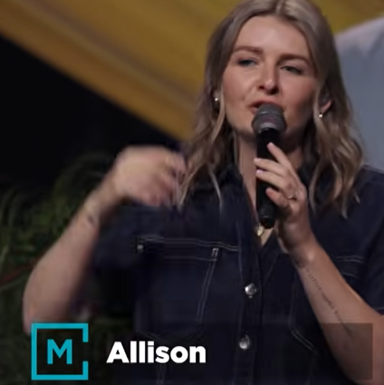
Allison Joy Li

Introduction:
10:00/1:16:06

Mark Swarner, Campus Pastor

24:05/1:16:06

25:00/1:16:06
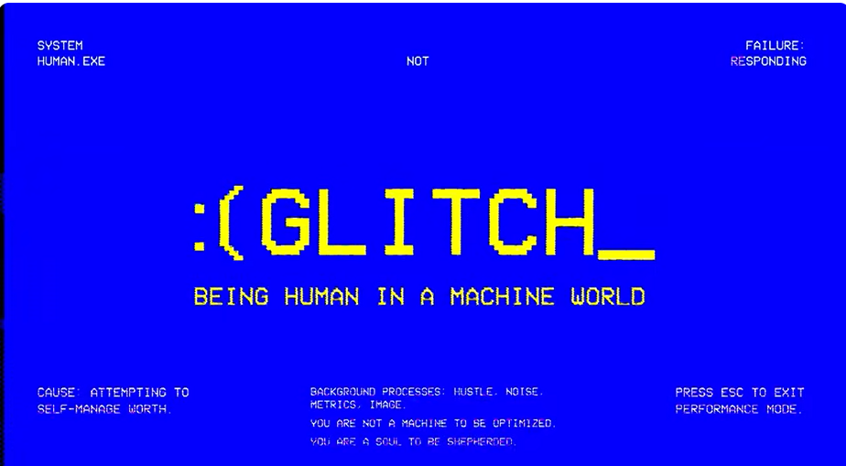

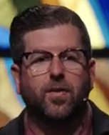
Phil EuBank, Lead Pastor

======
06/13/2026, Menlo Church Worship (Summary of last week, 05/31/2028)
https://www.youtube.com/watch?v=9aKCkFeMUmE
Hardware Failure | Glitch | Menlo Church Phil EuBank

