09/26/2026, Menlo Church Worship (Summary of last week, 09/20/2026)
https://youtu.be/y-_Oh53_pS4?si=NwTKPwdMUC6z5l35
https://github.com/peterhchen/1000_Family/tree/main/Church/2026
Kind of Kindness | Repentance For the Rest of Us | Menlo Church, Phil EuBank, Lead Pastor

0:00/37:36

Allison Joy Li

Introduction:
0:00/37:36

Mark Swarner, Campus Pastor

0:00/37:36


0:00/37:36
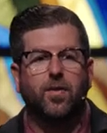
Phil EuBank, Lead Pastor

0:38/37:36
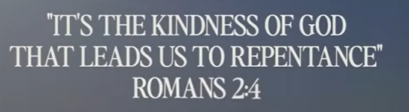
ROMANS 2:4
"IT'S THE KINDNESS OF GOD THAT LEADS US TO REPENTANCE"
0:46/37:36
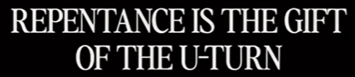

0:56/37:36
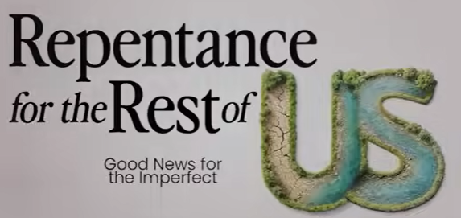
Repentance for the Rest of Us （適合我們所有普通人的悔改）

1:01/37:36
Phil EuBank, Lead Pastor

Last week, we talked Two-sided Coin (Repentance and Faith) of Repentance. This week, we will talk “Kind of Kindness (善事)” in the Repentance series.

4:18/37:36
Pray:
God, we repenting for our lives.

5:19/37:36
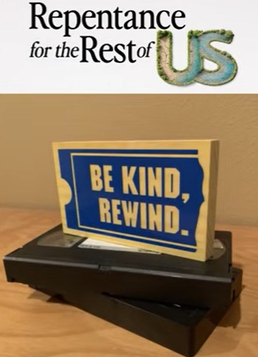
Be Kind to Rewind.
This is similar to the VHS tape rewind to watch the movie.

6:23/37:36

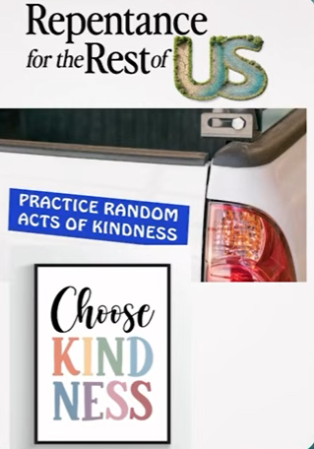
Repentance for the Rest of US
PRACTICE RANDOM ACTS OF KINDNESS
Choose KINDNES

Practice Random Acts of Kindness: Randomly do the kindness (kindness) to others.
Choose Kindness: No mater anywhere, any situation, always choose kindness to other people.

7:27/37:36
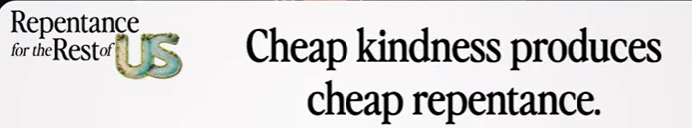
Cheap kindness produces cheap repentance (廉價的恩慈會帶來廉價的悔改。)

Deep kindness results great repentance.

7:50/37:36
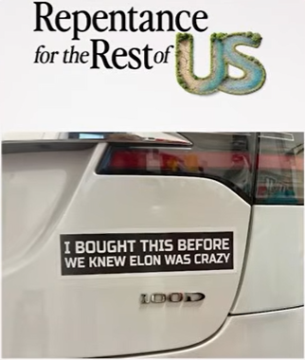
I bought this before we knew Elon was crazy.
We bought Tesla before Tesla gets popular. This sticker is at our parking lot.
You may not feel comfortable about this.

8:41/37:36
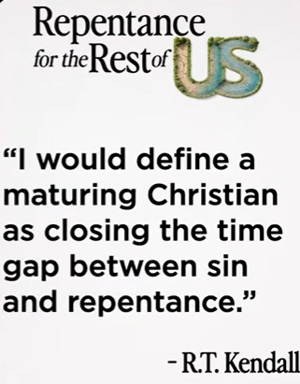
RT Kendal: I would define a maturing Christian as closing the time gap between sin and repentance.
我會將一個走向成熟的基督徒，定義為能夠縮短『犯罪』與『悔改』之間時間差距的人

There is a time gap between the sin and repentance.
Mature Christian will shrink the gap between sin and repentance.

9:48/37:36
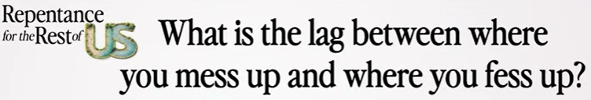
What is the time gap between sin (mess up) and repentance (confess up)?
在你犯错（mess up）与承认错误（fess up）之间，有多少时间延迟？

We are not 100% responsible but we never 0% responsible for the sin.

11:24/37:36

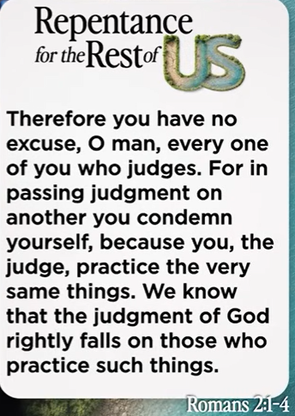

Romans 2:1-4.
Therefore, you have no excuse, O man, every one of you who judges. For in passing judgment on another you condemn yourself, because you, the judge, practice the very same things. We know that the judgment of God rightly falls on those who practice such things.

Core Message:
The text warns against judging other people. It explains that when you judge someone else, you condemn yourself because you are doing the exact same wrong things. It reminds us that God's judgment is fair and right.

Only God can judge people. Every one of us has sin. We cannot judge other people.

15:54/37:36
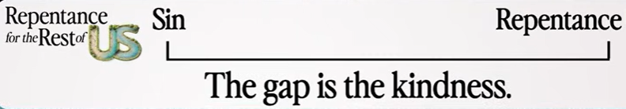
Roman 2:4
"Or do you presume on the riches of his kindness and forbearance and patience, not knowing that God's kindness is meant to lead you to repentance?"

Core Meaning:
This diagram shows that God's kindness fills the space between human wrongdoings (Sin) and turning back to God (Repentance). It means God uses His patience and love to help people change their hearts.

In everyday life, this gap means:
- No Immediate Punishment: When a person makes a mistake or does something wrong, God does not punish them instantly.
- A Space for Safety: Instead of anger, God offers a safe period of time filled with grace, patience, and love.
- An Invitation to Change: God uses this calm space to gently show the person a better way, helping them recognize their mistake and willingly turn their life around (repentance).

Between the Sin and Repentance, there is a gap called kindness. God is unhurried friends. God loves us. We have relationship with God, in time or all time.

16:51/37:36
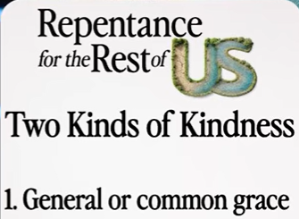
First kind of kindness: General or common grace.

- General or common grace: This is God's goodness given to everyone on Earth, whether they believe in Him or not. Examples include the sun rising, rain watering the crops, food to eat, and the beauty of nature.

We are swimming in an ocean of kindness all the time in God’s kindness to everyone of us.

17:46/37:36
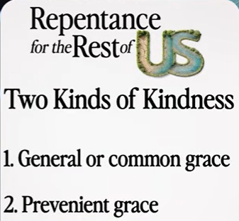
The second kind of kindness; Prevenient grace.

Simple Explanations of These Two Terms:
- General or common grace: This is God's goodness given to everyone on Earth, whether they believe in Him or not. Examples include the sun rising, rain watering the crops, food to eat, and the beauty of nature.
- Prevenient grace (先行恩典): This is a special kindness that comes before a person decides to follow God. "Prevenient" means "to come before." It is God working quietly in a person's heart, pulling them closer and helping them want to change (repent) before they even make a conscious choice to believe.
- Prevenient 這個英文單字源自拉丁文，意思是「先走一步」或「走在最前面」

20:29/37:36
Prevenient grace is a kind of kindness that goes ahead of us. God work ahead of us.
In our culture, fear is the only way to change people..
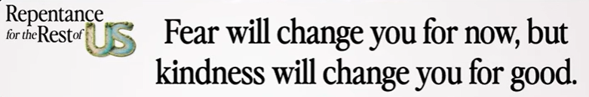Fear will change you for now, but kindness will change you for good.(恐懼能暫時改變你，但恩典（恩慈）能永遠改變你).

Political fear will change you now. Kindness will change you forever.

21:28/37:36

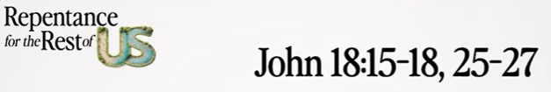

John 18:15-18
15 Simon Peter followed Jesus, and so did another disciple. Since that disciple was known to the high priest, he entered with Jesus into the courtyard of the high priest, 16 but Peter stood outside at the door. So the other disciple, who was known to the high priest, went out and spoke to the servant girl who kept watch at the door, and brought Peter in. 17 The servant girl at the door said to Peter, “You also are not one of this man's disciples, are you?” He said, “I am not.” 18 Now the servants and officers had made a charcoal fire, because it was cold, and they were standing and warming themselves. Peter also was with them, standing and warming himself.

John 18:25-27
25 Now Simon Peter was standing and warming himself. So they said to him, “You also are not one of his disciples, are you?” He denied it and said, “I am not.” 26 One of the servants of the high priest, a relative of the man whose ear Peter had cut off, asked, “Did I not see you in the garden with him?” 27 Peter again denied it, and at once a rooster crowed.

The main point of John 18:15-18 is to show how the pressure of fear quickly causes a person to compromise their loyalty.
- The Reality of Human Weakness: Peter had just proudly promised to die for Jesus. However, when a simple servant girl asked him a basic question in a cold, hostile courtyard, his immediate instinct was to protect himself.
- The Power of Fear: Under the weight of fear, Peter chose self-preservation over truth. His very first denial ("I am not") shows how quickly fear can make even the most passionate believer shrink back and break under pressure.

The main point of John 18:25-27 is that unaddressed fear leads to repeated failure and a complete collapse of loyalty.
- The Spiral of Fear: Peter did not just fail once; he denied Jesus a second and third time. When we let fear control our first choice, it becomes much easier to keep making the wrong choice to cover it up.
- The Certainty of Failure: The rooster crowing at the very end marks the exact moment Peter's self-confidence shattered. It proved that human willpower alone is not strong enough to stand firm against fear and danger.

Peter is fear and three times of lies.

21:55/37:36

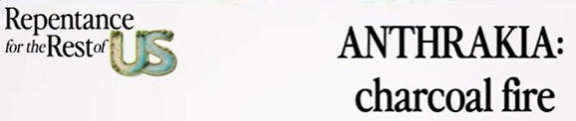
Greek word ANTHRAKIA, which translates directly to charcoal fire.

Core Meaning:
The sermon uses the word anthrakia to show that God does not ignore our darkest failures. Instead, Jesus brings us right back to the place of our mistakes—not to punish us with fear, but to completely heal and change us with His patient kindness.

charcoal fire means that Jesus does not avoid the messy, painful memories of our past; He steps directly into them to replace our shame with His grace.

************
************
09/26/2026, Menlo Church Worship (Summary of last week, 09/20/2026)
https://youtu.be/y-_Oh53_pS4?si=NwTKPwdMUC6z5l35
https://github.com/peterhchen/1000_Family/tree/main/Church/2026
Kind of Kindness | Repentance For the Rest of Us | Menlo Church, Phil EuBank, Lead Pastor

