11/08/2026, Menlo Church Worship (Summary of last week, 11/14/2026)
https://www.youtube.com/watch?v=mlQotBQ7E_0
https://github.com/peterhchen/1000_Family/tree/main/Church/2026
Identity in Christ, Identity in Crisis | Beyond the Ballot | Menlo Church, Phil EuBank, Lead Pastor

0:00/36:46
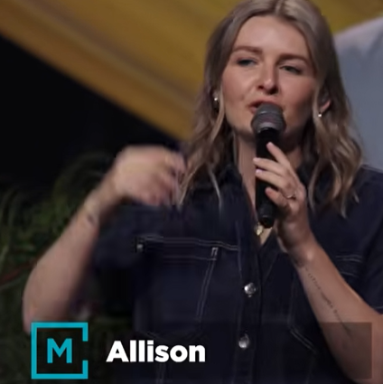
Allison Joy Li

Introduction:
0:00/36:46
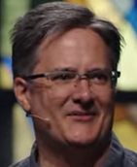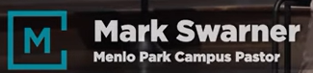
Mark Swarner, Campus Pastor

0:00/36:46
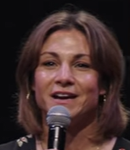

1:05/36:46

Matt Summers, Pastor of Spiritual Formation

1:08/36:46
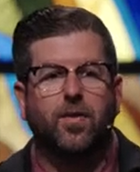
Phil EuBank, Lead Pastor

We are in the final message of the series, Beyond the ballot. We are survived with some injuries but we made it through. Some people feel lost, and some feel won.
The greatest win and the deepest losses are both temporary. There is a forever kingdom that we are way wiser to invest in.

3:32/36:46
Pray:
There is a greater kingdom and have a king for us. There is a love in the kingdom and wait for us.
Now th election is over. Everybody has to answer some version of question. How much of my life do I want politics to get from here.

4:36/36:46
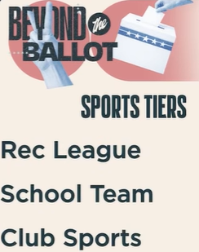
Student sports tiers: Rec (Recreation) League, School Team, Club Sports.

4:56/36:46

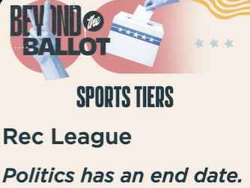
The first one is Rec (Recreation) League. It comes from a League Politics. It has an end date.

************
************
11/08/2026, Menlo Church Worship (Summary of last week, 11/14/2026)
https://www.youtube.com/watch?v=mlQotBQ7E_0
https://github.com/peterhchen/1000_Family/tree/main/Church/2026
Identity in Christ, Identity in Crisis | Beyond the Ballot | Menlo Church, Phil EuBank, Lead Pastor

