06/06/2026, Menlo Church Worship (Summary of last week, 05/31/2028)
https://www.youtube.com/watch?v=Vnm08C3ohyU
Infinite Loop | Glitch | Menlo Church Phil EuBank

5:23/1:16:07

5:30/1:16:07
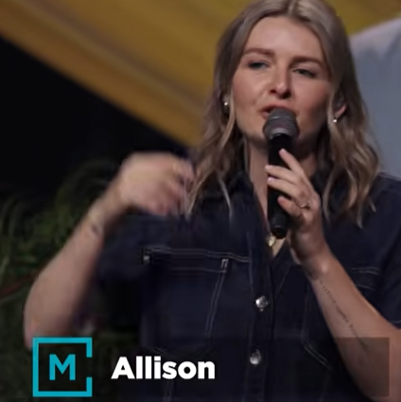
Allison Joy Li

Introduction:
10:00/1:16:07
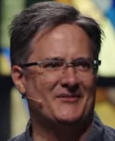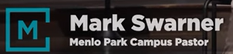
Mark Swarner, Campus Pastor

24:05/1:16:07
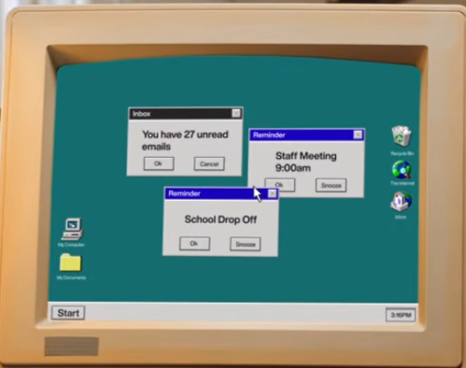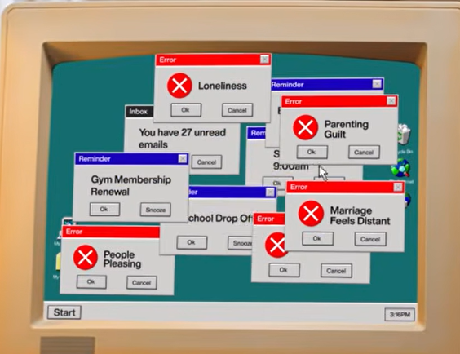

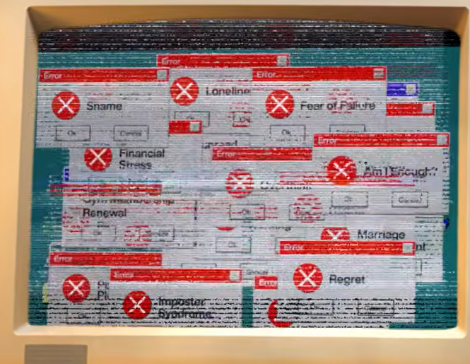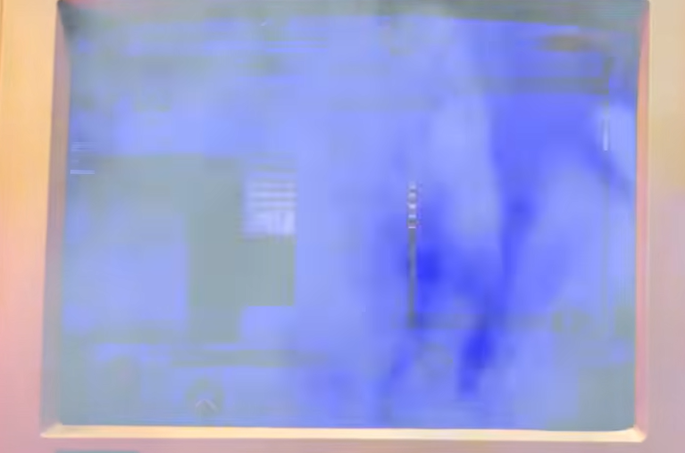

25:00/1:16:07
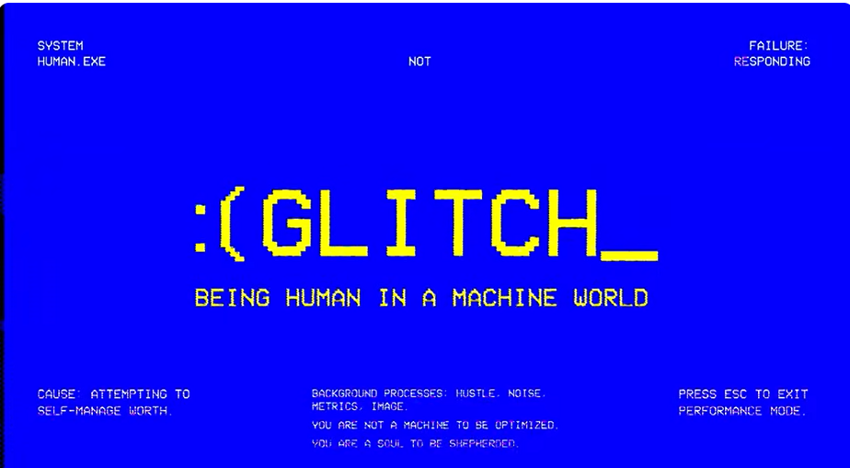

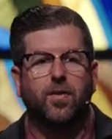
Phil EuBank, Lead Pastor
We are at the second series of Glitch. Last time we talk about what is the meaning of human in an age of AI. We talk about AI on Sunday. The Pope release hundreds of pages of AI on Monday. He is not copy from us but we did it first.

25:28/1:16:07
What if our Glitches are Beacons (Signals), and not just bugs.
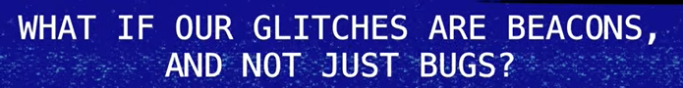

======
06/06/2026, Menlo Church Worship (Summary of last week, 05/31/2028)
https://www.youtube.com/watch?v=Vnm08C3ohyU
Infinite Loop | Glitch | Menlo Church Phil EuBank

