11/08/2025, Legacy (last week)
https://www.youtube.com/live/YduIauvn4vI?si=3FHsByi3VAHWeFXD
“From Running to Returning | Numb and Number,” Phil EuBank, Lead Pastor



"From Running to Returning | Numb and Number" describes the experience of being lost, the journey back to connection of faith, and a call for re-engagement with community/beliefs.

Introduction:
10:00/1:15:02



Phil EuBank, Lead Pastor


Are showing up to God’s Mission but missing his mercy?

"Are showing up to God's Mission but missing his mercy?": church focusses on mission activities but forgot the core concept of Christian of God's mercy.


God doesn’t mind repeating himself.

God repeatedly emphasizes or iterates key truths and messages, often for human understanding, similar to how authors might revise their work for clarity or how Jesus, Peter, and Paul repeated core teachings. This repetition is not a flaw but a deliberate method to ensure important messages are received and understood by people.

- Ensuring human understanding: God repeats Himself to make sure his message is heard, especially when people are not paying attention, as seen when God called to Samuel three times.
- Emphasizing core truths: Repeating key ideas helps to reinforce them, which is why writers of the New Testament often iterated the same truths from different angles to highlight their importance.
- Demonstrating divine decree: Repeating a message can signify that it is not just an idea, but a decree from God that will soon come to pass, as in Joseph's interpretation of Pharaoh's dream.
- Familiarity and depth: Repetition can be a way to help the message become deeply rooted in a person's heart, as seen in the practice of repeating prayers to develop a deeper sense of God's presence.

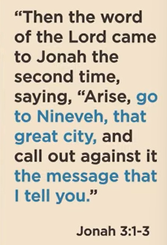
Jonah 3:1-3
Jonah Goes to Nineveh
3 Then the word of the Lord came to Jonah a second time: ² “Go to the great city of Nineveh and proclaim to it the message I give you.”
³ Jonah obeyed the word of the Lord and went to Nineveh. Now Nineveh was a very large city; it took three days to go through it.

Jonah 3:1-3 is that God gives Jonah a second chance to obey and go to the great city of Nineveh to preach God's message of impending destruction. In this passage, Jonah finally obeys God's command by traveling to Nineveh and announcing that it will be overthrown in 40 days, setting the stage for the city's subsequent repentance.
- Jonah's renewed obedience: After initially fleeing, Jonah follows God's direct command to go to Nineveh.
- God's powerful message: Jonah delivers God's warning that the city will be destroyed in 40 days unless its people repent.
- A call to repentance: The message is the catalyst for Nineveh's eventual repentance, which is foreshadowed in these verses as Jonah begins to preach.


Are you showing up to God’s mission but missing his mercy?

Actions are easier to move than attitudes.

“Actions are easier to move than attitudes" is that it is often more effective and practical to change a person's behavior first, in the hope that their underlying beliefs and feelings (attitudes) will follow, rather than trying to change their deeply held attitudes directly.
Key implications include:
- Behavior as a Catalyst: People may be more willing to change what they do (their actions) in response to new information, incentives, or requirements, even if their internal mindset (attitude) is initially resistant.
- Attitude Change Follows Action: Once a person has performed a new action for a period, their brain may work to reduce cognitive dissonance (the mental discomfort of having a new action that contradicts an old attitude) by aligning their attitude with their new behavior.
- Focus on the Tangible: Actions are observable and can be prompted or guided more easily than internal attitudes, which are deeply personal and often ingrained.
In essence, this perspective suggests that "doing" can lead to "believing."

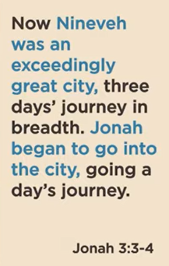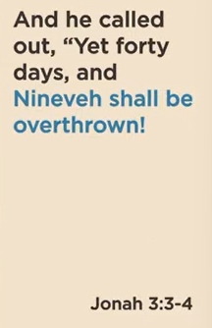
Jonah 3:3-4
New International Version
Jonah obeyed the word of the Lord and went to Nineveh. Now Nineveh was a very large city; it took three days to go through it. Jonah began by going a day’s journey into the city, proclaiming, “Forty more days and Nineveh will be overthrown

Jonah actions obey but attitudes still resist,

The main point of Jonah 3:3-4 is that Jonah, after his second chance from God, finally obeys by going to Nineveh and delivering a short, urgent warning: "Forty more days and Nineveh will be overthrown". This means that the people of Nineveh had a 40-day window to repent before their city would be destroyed by God. Jonah actions obey but attitudes still resist.

Jonah's obedience: In contrast to the first time God called him, Jonah this time immediately sets out for Nineveh, a difficult and long journey.
- The message: Jonah walks a day into the massive city and proclaims that it will be destroyed in 40 days if the people do not change their ways.
- The purpose: The message is a clear warning of impending judgment, intended to shock the people of Nineveh into taking God's message seriously, even though it's a summary of God's full command.
- The outcome: The people's response to this message is critical to the rest of the chapter; they repent, and God spares the city, which ultimately frustrates Jonah.

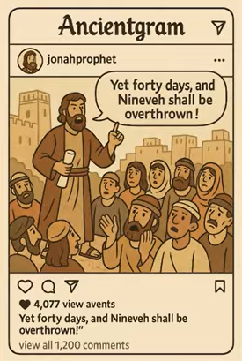
In 4o days, the Nineveh city will be destroyed by God,

God’s Mercy moves even when ours doesn’t.


Jonah 3:5-9
New International Version
⁵ The Ninevites believed God. A fast was proclaimed, and all of them, from the greatest to the least, put on sackcloth.
⁶ When Jonah’s warning reached the king of Nineveh, he rose from his throne, took off his royal robes, covered himself with sackcloth and sat down in the dust. ⁷ This is the proclamation he issued in Nineveh:
“By the decree of the king and his nobles:
Do not let people or animals, herds or flocks, taste anything; do not let them eat or drink. ⁸ But let people and animals be covered with sackcloth. Let everyone call urgently on God. Let them give up their evil ways and their violence. ⁹ Who knows? God may yet relent and with compassion turn from his fierce anger so that we will not perish.”

The main point of Jonah 3:5-9 is the powerful and widespread repentance of the people of Nineveh in response to Jonah's message. This passage highlights how they believed God's warning, showed it through actions like fasting and wearing sackcloth, and turned from their wicked ways, demonstrating that genuine faith leads to visible change across all social levels.
- Belief in God's word: The Ninevites believed the message Jonah delivered, taking his warning of destruction seriously as a message from God.
- Demonstration of repentance: Their belief was shown through actions: they proclaimed a fast, put on sackcloth (a sign of mourning and humility), and even covered their animals in sackcloth.
- Unity in repentance: This repentance was universal, with everyone from the greatest to the least participating, showing that their collective response was sincere.
- Hope for mercy: The people's reasoning for their actions was their hope that God might "yet relent and with compassion turn from his fierce anger".


God’s mission starts with mercy.
The main point is that God's mission, centered on salvation and reconciliation, begins with His mercy rather than human merit or actions. This mercy is demonstrated through acts like sending Jesus to forgive sins and offer new life, and as recipients of this grace, believers are then called to share this same mercy with others.
- God's mercy is the foundation: God's mission starts with His compassionate action and love, not with human righteousness. It's a gift offered to those who are undeserving, as seen in the biblical narratives of people who are flawed but are still shown mercy and given a path to redemption.
- Salvation through mercy: The core of God's mission is to rescue and restore creation, which includes saving people from sin through Jesus Christ. This rescue is an act of mercy, forgiving, justifying, and making people heirs of His kingdom because of His goodness, not because of their own achievements.
- Sharing the mission of mercy: As those who have received God's mercy, believers are called to extend that same mercy to the world. This means extending grace and compassion to others, especially those who are different or considered enemies, and living out God's mission in a way that reflects His heart for all humanity

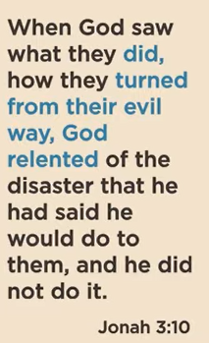
Jonah 3:10
New International Version
¹⁰ When God saw what they did and how they turned from their evil ways, he relented and did not bring on them the destruction he had threatened.

The main point of Jonah 3:10 is that God shows mercy and relents from his planned judgment when people genuinely repent of their evil ways. After the people of Nineveh turned from their wickedness, God changed his course of action and spared the city, demonstrating his compassionate nature and the conditional nature of his prophetic warnings of judgment.
- Repentance is conditional: The prophecy of destruction against Nineveh was conditional on their response. The people's repentance changed the outcome, showing that God's judgment can be averted through a change of heart and actions.
- God is merciful: The verse highlights God's compassion and willingness to forgive, showing he is not solely a God of judgment but also one of mercy.
- God "relents": While the word "repent" is used for God, it's important to understand that it's often used anthropomorphically. God doesn't change his mind in the human sense, but rather, his actions are a response to the actions of those he has judged.
- The power of repentance: The story shows the effectiveness of genuine repentance, not just in changing God's plan for a city, but also in demonstrating the broader principle of how God responds to a people who turn from sin.


If God answered your prayers for your enemies, would it look like redemption or revenge?


1 Corinthians 13:1-4
New International Version
13 If I speak in the tongues^{[a]} of men or of angels, but do not have love, I am only a resounding gong or a clanging cymbal. ² If I have the gift of prophecy and can fathom all mysteries and all knowledge, and if I have a faith that can move mountains, but do not have love, I am nothing. ³ If I give all I possess to the poor and give over my body to hardship that I may boast,^{[b]} but do not have love, I gain nothing.
⁴ Love is patient, love is kind. It does not envy, it does not boast, it is not proud.

The main point of 1 Corinthians 13:1-4 is that love is the most important and essential quality, without which all other spiritual gifts and good deeds are meaningless. The passage argues that spiritual gifts like speaking in tongues, prophecy, and great faith, as well as acts of sacrifice like martyrdom, are worthless if not performed with love. Love is presented as the fundamental "greatest way" that gives purpose to everything else.
- Spiritual gifts are useless without love: Even the most impressive spiritual abilities, such as speaking in different languages or having prophetic knowledge, amount to nothing if love is absent.
- Good deeds are pointless without love: Sacrificing possessions or even one's life for a cause is meaningless if done without love.
- Love is a prerequisite for all else: The passage establishes love as the supreme virtue that gives value to all other actions, gifts, and sacrifices.

11/08/2025, Legacy (last week)
https://www.youtube.com/live/YduIauvn4vI?si=3FHsByi3VAHWeFXD
“From Running to Returning | Numb and Number,” Phil EuBank, Lead Pastor

Summary:
"From Running to Returning": Jonah has been lost, re-connect faith, and re-engage beliefs.

1. “Are showing up to God's Mission but missing his mercy?”: Jonah externally follows God but internally missing the God's mercy.
2. “God doesn’t mind repeating himself.”: God repeat the truths/messages to human through Jesus, Peter, and Paul teachings.
3. Jonah 3:1-3: God gives Jonah a second chance to go to city Nineveh to preach God message.
4. “Actions are easier to move than attitudes": It is easier to change a person’s external behavior than person’s internal beliefs (attitudes).
5. Jonah 3:3-4: Jonah actions obey but attitudes still resist. God gives Jonah second chance to obey. Jonah obeys to Nineveh but delivers a message: "Nineveh people has 40-day to repent and the city would be destroyed by God.”
6. God’s Mercy moves even when ours doesn’t.
7. Jonah 3:5-9: Nineveh people change genuine faith to God.
8. “God’s mission starts with mercy.”: God's mission is mercy. Send Jesus to forgive human sins and give human new life.
9. Jonah 3:10: When Nineveh people genuinely repent of evil ways, God shows his mercy and stop his plan to destroy Nineveh city.
Conclusion:
1. If God answered your prayers for your enemies, God will forgive your enemies, not revenge.
2. 1 Corinthians 13:1-4: God love human.

