04/25/2026, Menlo Church Worship (Summary of last week, 04/19/2028)
https://www.youtube.com/watch?v=eifPHqAvMVE
“If You’re Real, Help Me |God, If You’re Real,” Phil EuBank, Lead Pastor

9:50/1:16:02
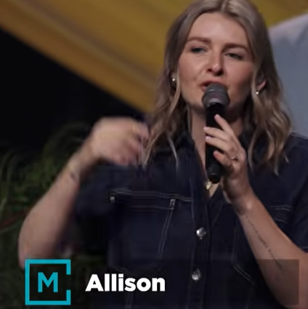
Allison Li

10:10/1:15:00
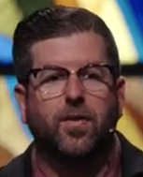
Phil EuBank, Lead Pastor

Introduction:
17:00/1:15:00

Mark Swarner, Campus Pastor

======
04/25/2026, Menlo Church Worship (Summary of last week, 04/19/2028)
https://www.youtube.com/watch?v=eifPHqAvMVE
“If You’re Real, Help Me |God, If You’re Real,” Phil EuBank, Lead Pastor

