12/24/2025, Legacy (last week)
https://www.youtube.com/live/5J1-5WD0mm8?si=lH8hqU5QRhMbxKJ5
“Christmas at Menlo | Christmas Eve Service,” Phil EuBank, Lead Pastor



Introduction:
22:00/1:15:08
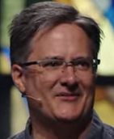

25:00/1:15:08
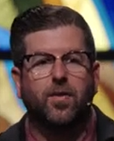
Phil EuBank, Lead Pastor

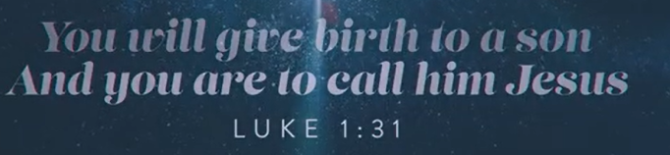



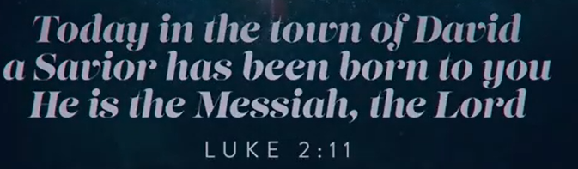
Luke 2:11


We are going to walk several weeks.
We have week between Christmas and New Year is historically one of the busiest ways of the year for movie theaters.
It is one of the highest earning box office revenue weeks of the year. Because when the family leaves and the house get quiet, we do not really want to sit. We don’t always get comfortable with that.


We want to sit in the dark and eat popcorn. We want to transport to different reality for three hours. We pay $20 for popcorn to escape the silence of our own living rooms.



Or look at our phone, dating apps, like hinge, tinder report of this week between Christmas and New Year. This is the peace week of the entire year.

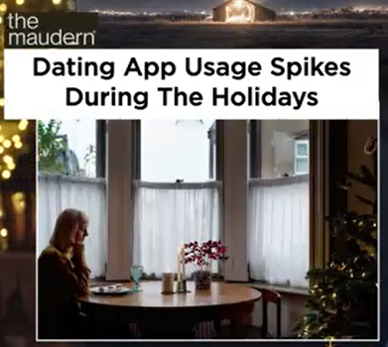

Sometimes around Christmas, people are not around the table. It is silence of the dead week and can amplify the loneness. We start to swiping and scroll ourselves desperate to fill the quiet with some type of noise.

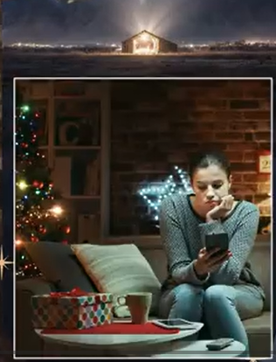

There is a National return week. We get billions of dollars in return merchandise over the next seven days.



On the surface, we have reasons to pick up the right color, right choice, etc. to satisfy our disappointed hope in January. We have culture of terrify the silence. The party is over, we go back to normal life.

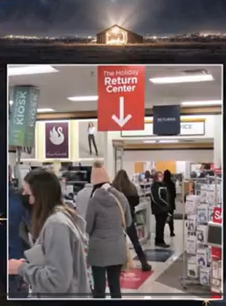

This dead week is silence. We feel like our soul is looking for something that Amazon cannot deliver for Christmas. This is a good description of human without God. This is the reason that Christmas actually come in in the first place throughout the human history. Humanity has largely lived in that Gap, feeling that kind of dead week feeling.



This is why human looking for star and Jesus was born in the Christmas.

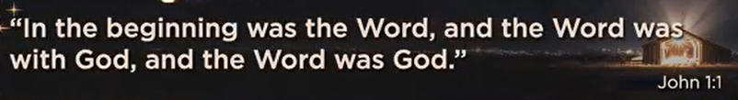

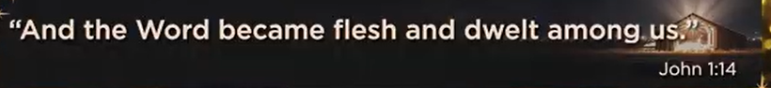

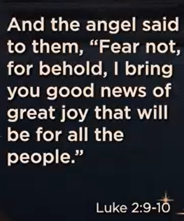



12/24/2025, Legacy (last week)
https://www.youtube.com/live/5J1-5WD0mm8?si=lH8hqU5QRhMbxKJ5
“Christmas at Menlo | Christmas Eve Service,” Phil EuBank, Lead Pastor

Summary:

