09/05/2026, Menlo Church Worship (Summary of last week, 08/30/2026)
https://youtu.be/d9_kJxWp-18?si=iPLy4AkzVvfvIqF5
https://github.com/peterhchen/1000_Family/tree/main/Church/2026
Small Fire, Big Forest (Thoughtful Witness) | What Is a Follower Of the Way? | Menlo Church
Matt Summers, Pastor of Spiritual Formation
Phil EuBank, Lead Pastor

0:00/35:07
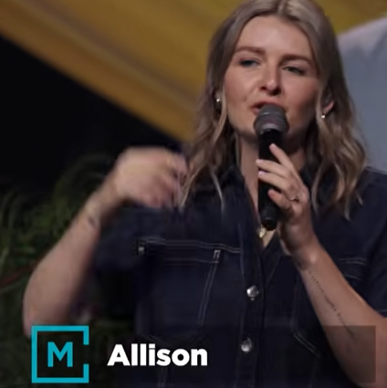
Allison Joy Li

Introduction:
0:00/35:07
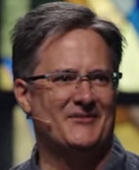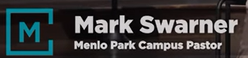
Mark Swarner, Campus Pastor

0:00/35:07
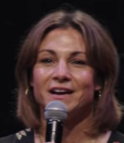

0:58/35:07
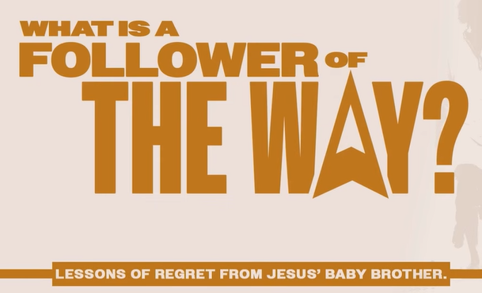

0:00/35:07
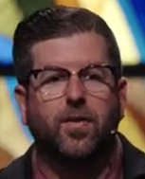
Phil EuBank, Lead Pastor

1:07/35:07
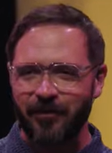
Matt Summers, Pastor of Spiritual Formation

Today, we talk about “Thoughtful Witness”

3:47/35:07
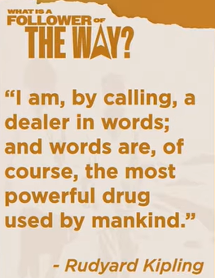
Rudyard Kipling: “I am, by calling,, a dealer in words; and words are of course, the most power drug used by mankind.”

Rudyard Kipling means that as a writer, he works with words, which possess an immense, drug-like power to influence, heal, or alter human thoughts and actions.

The quote in the image is by Rudyard Kipling from a speech he delivered to the Royal College of Surgeons in London on February 14, 1923.
- "A dealer in words": Kipling refers to his profession as a writer, storyteller, and poet. He views words as commercial or tangible goods that he crafts, trades, and shares with the world.
- "The most powerful drug used by mankind": He compares words to medicine or narcotics. Just like drugs, words have the power to alter human consciousness, soothe pain, incite passion, heal minds, or completely paralyze action. They can be used constructively to heal or destructively like a toxic substance.

************
************
09/05/2026, Menlo Church Worship (Summary of last week, 08/30/2026)
https://youtu.be/d9_kJxWp-18?si=iPLy4AkzVvfvIqF5
https://github.com/peterhchen/1000_Family/tree/main/Church/2026
Small Fire, Big Forest (Thoughtful Witness) | What Is a Follower Of the Way? | Menlo Church
Matt Summers, Pastor of Spiritual Formation

