06/27/2026, Menlo Church Worship (Summary of last week, 06/21/2026)
https://www.youtube.com/live/AWzCPG5F_mw?si=8zp05XDDl6LNy4sm
Father’s Day | Strength Doesn’t Have to Be Loud | Menlo Church Phil EuBank

7:089/1:16:25
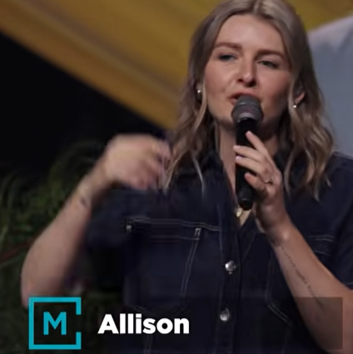
Allison Joy Li

Introduction:
6:49/1:16:25
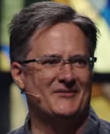
Mark Swarner, Campus Pastor

21:30/1:16:25
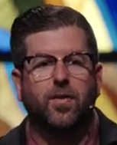
Phil EuBank, Lead Pastor

28:08/1:16:25

************
======
06/27/2026, Menlo Church Worship (Summary of last week, 06/21/2026)
https://www.youtube.com/live/AWzCPG5F_mw?si=8zp05XDDl6LNy4sm
Father’s Day | Strength Doesn’t Have to Be Loud | Menlo Church Phil EuBank

