10/10/2026, Menlo Church Worship (Summary of last week, 10/04/2026)
https://www.youtube.com/watch?v=dbF4VQL6Xdc&t=78s
https://github.com/peterhchen/1000_Family/tree/main/Church/2026
Still | Hope for Everyone | Menlo Church, Phil EuBank, Lead Pastor, Phil EuBank, Lead Pastor

0:00/36:58
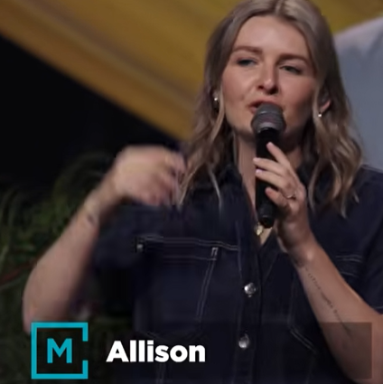
Allison Joy Li

Introduction:
0:00/36:58
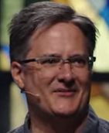
Mark Swarner, Campus Pastor

0:00/36:58


3:09/36:58
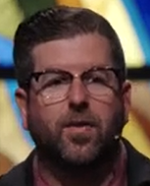
Phil EuBank, Lead Pastor

4:43/36:58
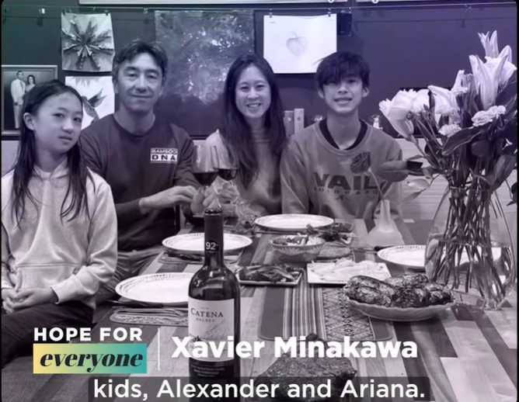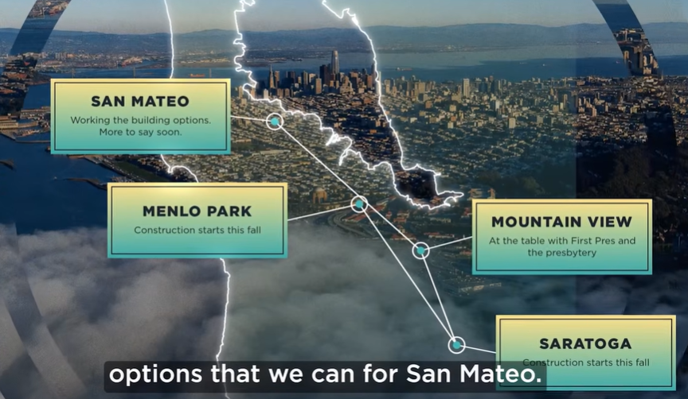

7:20/36:58
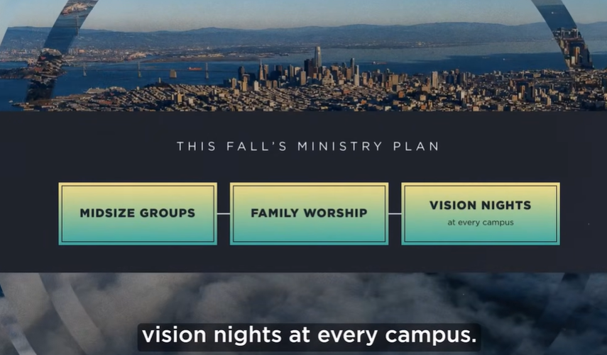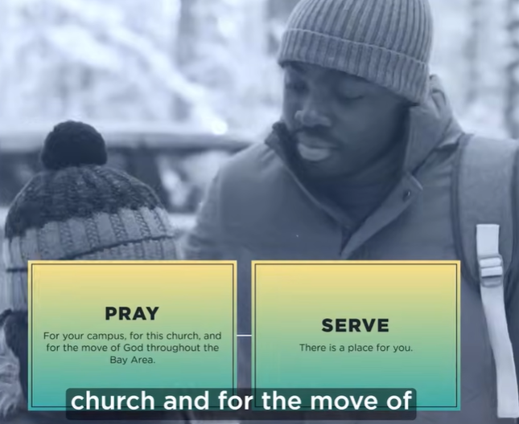

7:53/36:58
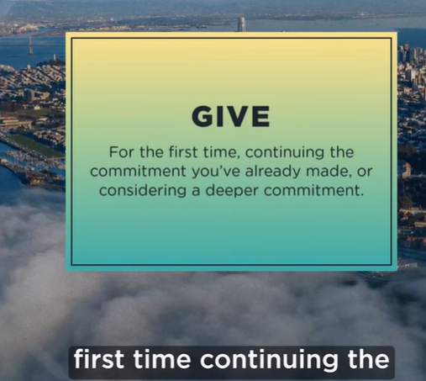

8:23/36:58
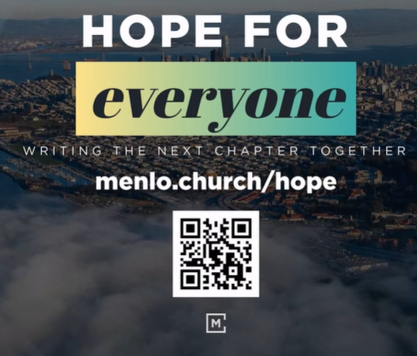

8:51/36:58
Phil EuBank, Lead Pastor
Pray: Thanks God show the truth for people around the world

Everybody in our life forecast the future.
The old Israelites did a lot of forecast a lot.

14:52/36:58
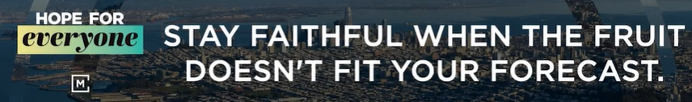
Stay faithful when the fruit doesn’t fit for your forecast.

15:04/36:58
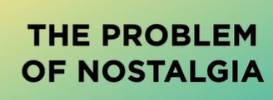
Nostalgia = 懷舊 (huái jiù) — 對過去美好時光的思念、眷戀。
和「鄉愁」不同：鄉愁是想念家鄉，懷舊是想念過去

15:24/36:58
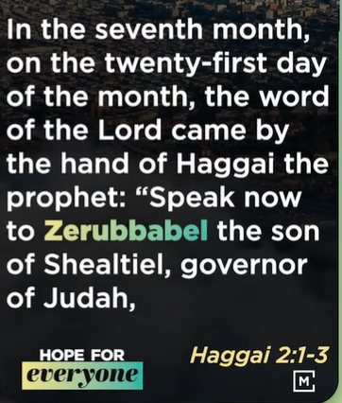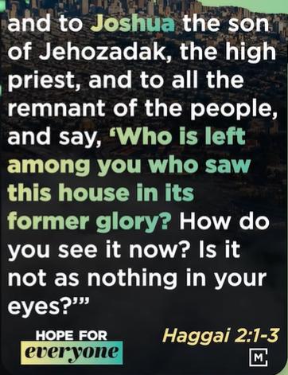
In the seventh month, on the twenty-first day of the month, the word of the Lord came by the hand of Haggai the prophet: "Speak now to Zerubbabel the son of Shealtiel, governor of Judah, and to Joshua the son of Jehozadak, the high priest, and to all the remnant of the people, and say, 'Who is left among you who saw this house in its former glory? How do you see it now? Is it not as nothing in your eyes?'
Haggai 2:1-3

The connection is this:
The people in Haggai had a forecast — the temple should look glorious like Solomon's. The fruit didn't fit: it looked like nothing. Nostalgia made them want to quit.
The sermon takes that moment and applies it to us: when your life doesn't match your forecast, nostalgia says "give up, the best days are gone." God says "stay faithful — I'm writing the next chapter."
Haggai 2:1-3 is the example. "Stay faithful when the fruit doesn't fit your forecast" is the lesson.

18:33/36:58
Don't let the memory of past glory kill your hope for the future. The rebuilt temple looked like nothing compared to Solomon's — but God said He is with them, and the glory to come will be greater than before.
Nostalgia says "it will never be as good as it was." God says "watch what I will do next."

Main Idea
The people were discouraged because the new temple looked like nothing next to the old one. God's answer: don't measure today by yesterday — be strong, keep building, for I am with you, and the future glory will surpass the past.

In one sentence:
When today looks small compared to the past, God says: be strong and keep building, for I am with you.

19:25/36:58
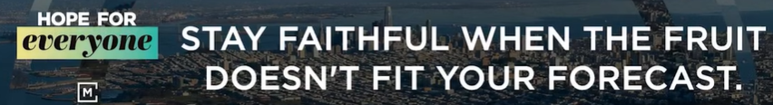
You stay in faith. God gives you fruit.

19:45/36:58
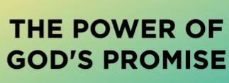
The second point in Haggai’s message for God’s people is the power of God’s promise.
God is still reminding us today. God calls us in life. God’s kingdom will come without timeline.

20:19/36:58
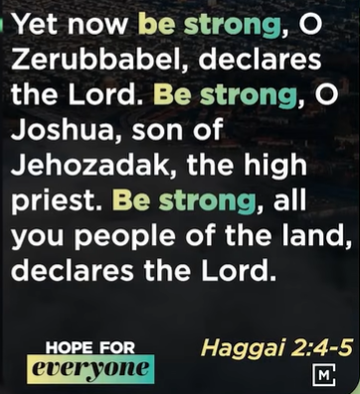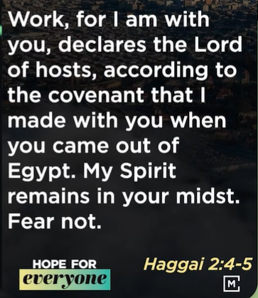
Haggai 2:4-5
Yet now be strong, O Zerubbabel, declares the Lord. Be strong, O Joshua, son of Jehozadak, the high priest. Be strong, all you people of the land, declares the Lord.
Work, for I am with you, declares the Lord of hosts, according to the covenant that I made with you when you came out of Egypt. My Spirit remains in your midst. Fear not.

Main idea:
Be strong and work, for I am with you, declares the Lord — fear not.

21:45/36:58
Be strong, no matter what you see in front.
Jesus gives us the new covenant.

24:39/36:58


25:04/36:58
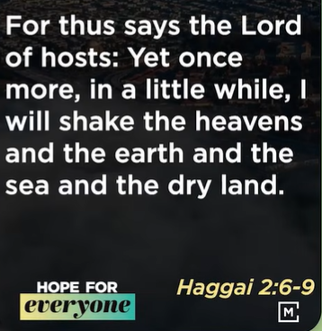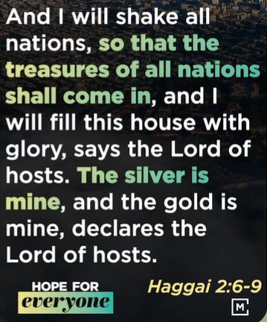
Haggai 2:6-9
For thus says the Lord of hosts: Yet once more, in a little while, I will shake the heavens and the earth and the sea and the dry land.
And I will shake all nations, so that the treasures of all nations shall come in, and I will fill this house with glory, says the Lord of hosts. The silver is mine, and the gold is mine, declares the Lord of hosts.

Main idea:
God will shake the heavens, the earth, and all nations, and fill this house with glory — for the silver and the gold are His.

Shirt meaning:
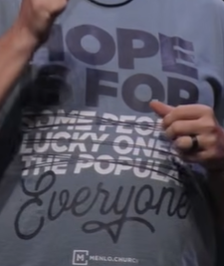
Hope is for. Everyone (not some people, lucky ones, the popular ones)
The shirt's point in one sentence: Hope is not just for some people, the lucky ones, or the popular — it is for everyone.
中文：盼望不是只給某些人、幸運的人或受歡迎的人，而是給每一個人。

The temple was the place God used to live.

30:23/36:58
God plan is unshakable. Whatever AI becomes, AI never shakes God.
The kingdom of God brings the hope to everyone.

34:22/36:58
Keep on doing: Pray, serve, give

36:30/36:58
Pray: We have faith to God. We keep on pray, serve, and give.

************
************
10/04/2026, Menlo Church Worship
"Still | Hope for Everyone" — Phil EuBank, Lead Pastor
https://www.youtube.com/watch?v=dbF4VQL6Xdc&t=78s
Q. What is "Still"?
A. Still: even now, despite everything. "Still | Hope for Everyone" means even after going through so much, hope is for everyone — not some people, the lucky ones, or the popular ones.
1. Haggai 2:1-9 — Stay faithful when the fruit doesn't fit your forecast.
2. The problem of nostalgia: Nostalgia looks backward. Hope looks forward. The people of Haggai's time looked back at the old temple period instead of hoping for the future.
3. Haggai 2:1-3: Don't look back at yesterday. Be strong, for the future glory.
4. Haggai 2:4-5: Fear not. The power of God's promise remains with us. Be strong, no matter what you see.
5. Haggai 2:6-9: God will shake the heavens, the earth, and all nations, and fill this house with glory — for the silver and the gold are His.（萬軍之耶和華必震動天地、滄海、旱地和萬國，使萬國的珍寶都帶來，充滿這殿的榮耀——因為金銀都是祂的。）
6. Haggai 2:1-9 says "be strong and work, for I am with you." We do the work of "pray, serve, give" with faith.

===
===

2026年10月4日，Menlo Church 主日崇拜
「Still | 人人有盼望」—— Phil EuBank 主任牧師
問：「Still」是什麼意思？
答：Still：即使如此、儘管經歷了一切。「Still | 人人有盼望」的意思是：即使經歷了這麼多，盼望仍然是給每一個人的——不是只給某些人、幸運的人或受歡迎的人。
1. 哈該書 2:1-9 —— 當果子不符合你的預期時，仍要持守忠心。
2. 懷舊的問題：懷舊向後看，盼望向前看。哈該時代的人回望過去聖殿的輝煌，卻對未來失去盼望。
3. 哈該書 2:1-3：不要回望昨日，要為將來的榮耀剛強。
4. 哈該書 2:4-5：不要懼怕。神應許的大能與我們同在。無論眼前看見什麼，都要剛強。
5. 哈該書 2:6-9：神必震動天地、滄海、旱地和萬國，使榮耀充滿這殿——因為金銀都是祂的。
6. 哈該書 2:1-9 說「要剛強做工，因為我與你們同在」。我們憑信心去做「禱告、服事、奉獻」的工作。

===
===
2026年10月4日、メンロー教会 主日礼拝
「Still | すべての人に希望を」—— フィル・ユーバンク 主任牧師
問：「Still」とはどういう意味ですか？
答：Still：それでもなお、すべてを経験したにもかかわらず。「Still | すべての人に希望を」とは、これほど多くのことを経験した後でも、希望はすべての人のためのものだという意味です——一部の人や幸運な人、人気のある人だけのものではありません。
1. ハガイ書 2:1-9 —— 実りがあなたの予測と合わなくても、忠実であり続けなさい。
2.ノスタルジアの問題：ノスタルジアは後ろを向く。希望は前を向く。ハガイの時代の人々は、かつての神殿の栄光を振り返り、未来への希望を失った。
3. ハガイ書 2:1-3：昨日を振り返るな。将来の栄光のために強くあれ。
4. ハガイ書 2:4-5：恐れるな。神の約束の力は私たちと共にある。目の前に何が見えても、強くあれ。
5. ハガイ書 2:6-9：神は天と地、海と乾いた地、すべての国々を揺り動かし、この宮を栄光で満たされる——銀も金も神のものだから。
5. ハガイ書 2:1-9 は「強くあれ、働け、わたしがあなたがたと共にいる」と言う。私たちは信仰をもって「祈り、奉仕、献金」の働きをする。

