05/07/2026, Menlo Church Worship (Summary of last week, 04/26/2028)
https://youtu.be/cCRBTjDan7g?si=0DjQAn4jVHLfV6Oy

“Digital Thorns,” Joey Odom, Guest Speaker, Menlo Church Sermon (Phil EuBank, Lead Pastor)

5:08/34:02
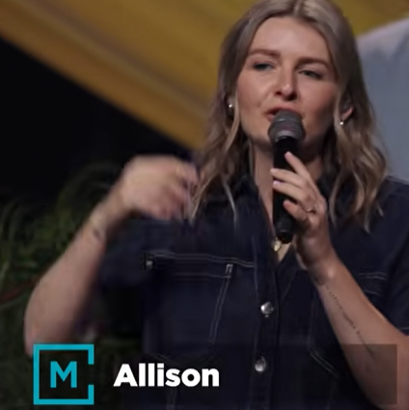
Allison Li

Introduction:
14:25/34:02
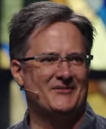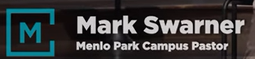
Mark Swarner, Campus Pastor

16:08/34:02
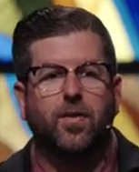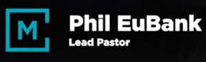
Phil EuBank, Lead Pastor

We are thrilled to have Joey Odom to be our guest speaker.
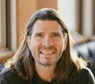
Joey Odom, Aro, Co-Founder

======
05/07/2026, Menlo Church Worship (Summary of last week, 04/26/2028)
https://youtu.be/cCRBTjDan7g?si=0DjQAn4jVHLfV6Oy

“Digital Thorns,” Joey Odom, Menlo Church Sermon, Phil EuBank, Lead Pastor

