07/11/2026, Menlo Church Worship (Summary of last week, 07/05/2026)
https://youtu.be/5x95NFgjozY?si=od5Abnw7g2GkCMba
https://github.com/peterhchen/1000_Family/tree/main/Church/2026
The Five Pillars of Effort (Islam) | Let's Be Honest| Menlo Church Phil EuBank, Lead Pastor

0:00/35:11

Allison Joy Li

Introduction:
0:00/35:11

Mark Swarner, Campus Pastor

0:19/35:11

Was Jesus a Prophet … or the son of God?

0:25/35:11

Was Jesus the promised messiah or are we still waiting?

0:30/35:11
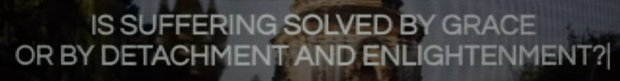
Is suffering solved by grace or by detachment and enlightenment?

0:34/35:11
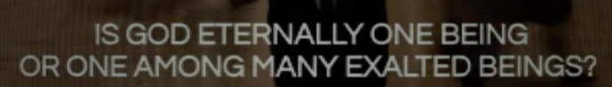
Is God eternally one being or one among many exalted beings?

0:42/35:11
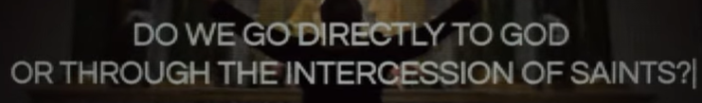
Do we go directly to God or through the intercession of Saint?

0:47/35:11

Is Jesus the only way or one of many perspectives?

0:51/35:11
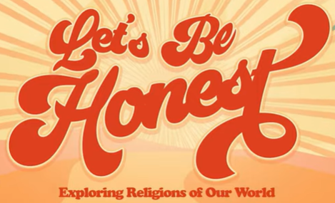

0:55/35:11

Phil EuBank, Lead Pastor

1:02/35:11
We are at the second part of series of “Let’s Be Honest”.

1:53/35:11
1) June 28: Judaism, 2) July 5: Islam, 3) July 12: Buddhism, 4) July 19: Mormonism, 5) July 26: Catholicism, 6) August 2: The Nones/Agnostic, 7) August 9: The Gospel

Today, we discuss 2) The Five Pillars of Effort (Islam)

5:00/35:11
There is a big difference of report card and birth certificate.
Report card tells us the performance of your work in life. Birth certificate tells us how you who are born.
Islam has their way of faith and life. The knee and follow to God.
Christian system is structure and path of peace and clear. It tells what God wants from us. There is no guessing at all.

6:00/35:11
Report Card vs Birth Certificate
Most Muslims (The followers of Islam) follows the five pillars of Islam.

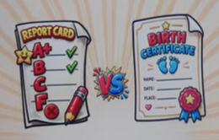

7:00/35:11
If you are a Muslims, there are five very specific things that you have to follows.
The first one is Shahada which is the testimony of Faith). We have heard “Allah is the only God and Muhammad is his prophet”.

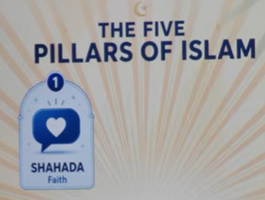

7:32/35:11
The second pillar is Salah. The prayers have to pray five times a day. Each time, you have to stop your work and submit your will to pray.
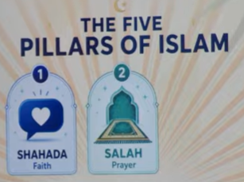

7:51/35:11
The third pillar of Islam is Zakat. You have to give up money in a mandatory way to support the needs of the poor around you. It built into Muslims. There is no optional.
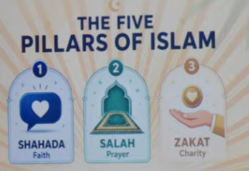

8:11/35:11
The fourth pillar is Sawn which is fasting. During the month of Ramadan. That month, during the day. They don’t eat, they don’t drink. They don’t enjoy other comforts until after the sun goes down.

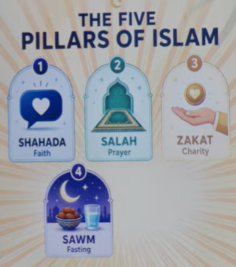

8:43/35:11

The fifth pillar of Islam is Hajj, which is the Pilgrimage to Mecca in your lifetime if you are able.
You join with millions of people who are doing the same thing.

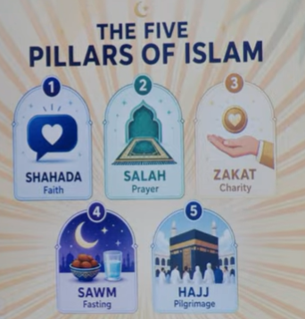

9:00/35:11
These five pillars are not suggestions for Muslims. They are obligations. They are the way that you show God that you are serious to follow God. These five pillars are your report card. The score is kept in your account for eternity.

************
************

07/11/2026, Menlo Church Worship (Summary of last week, 07/05/2026)
https://youtu.be/5x95NFgjozY?si=od5Abnw7g2GkCMba
https://github.com/peterhchen/1000_Family/tree/main/Church/2026
The Five Pillars of Effort (Islam) | Let's Be Honest| Menlo Church Phil EuBank, Lead Pastor

We have several questions:
Was Jesus a Prophet … or the son of God?
Was Jesus the promised messiah or are we still waiting?
Is suffering solved by grace or by detachment and enlightenment?
Is God eternally one being or one among many exalted (崇高的) beings ?
Do we go directly to God or through the intercession of Saint?
Is Jesus the only way or one of many perspectives?

We are at the second part of series of “Let’s Be Honest”.
1:53/35:11
1) June 28: Judaism, 2) July 5: Islam, 3) July 12: Buddhism, 4) July 19: Mormonism, 5) July 26: Catholicism, 6) August 2: The Nones/Agnostic, 7) August 9: The Gospel

