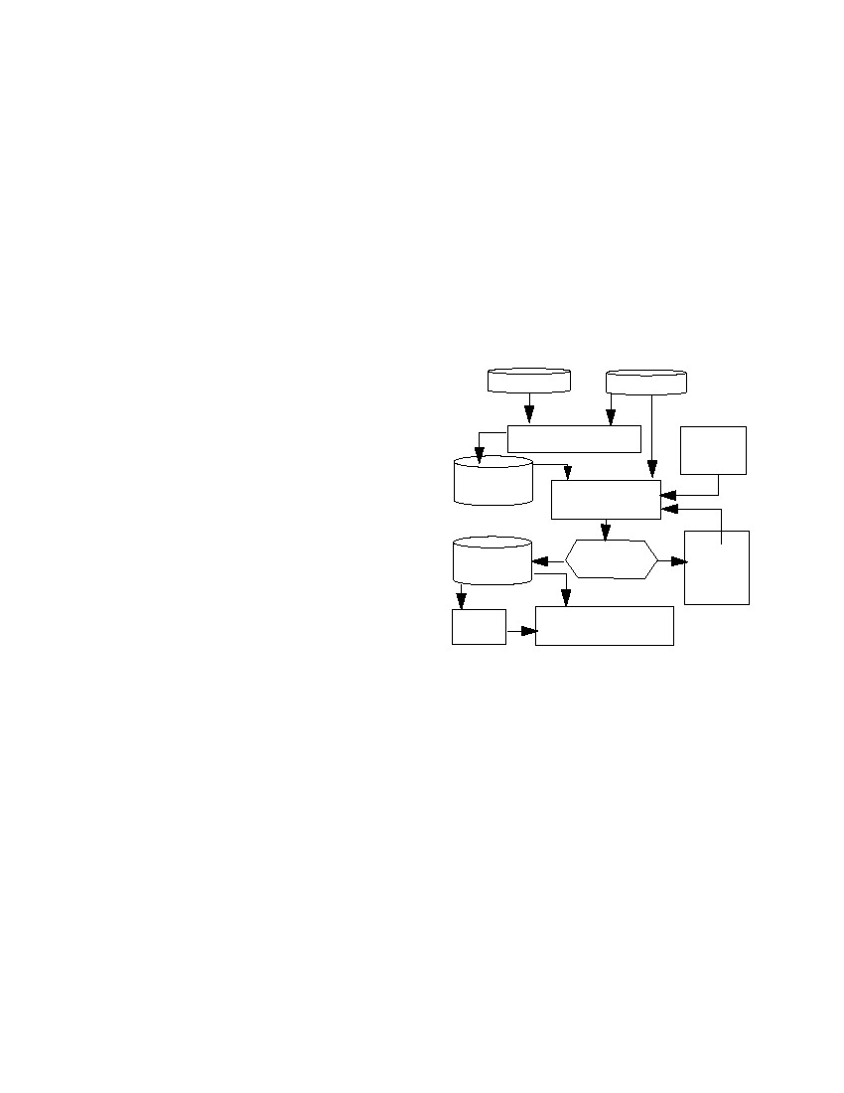
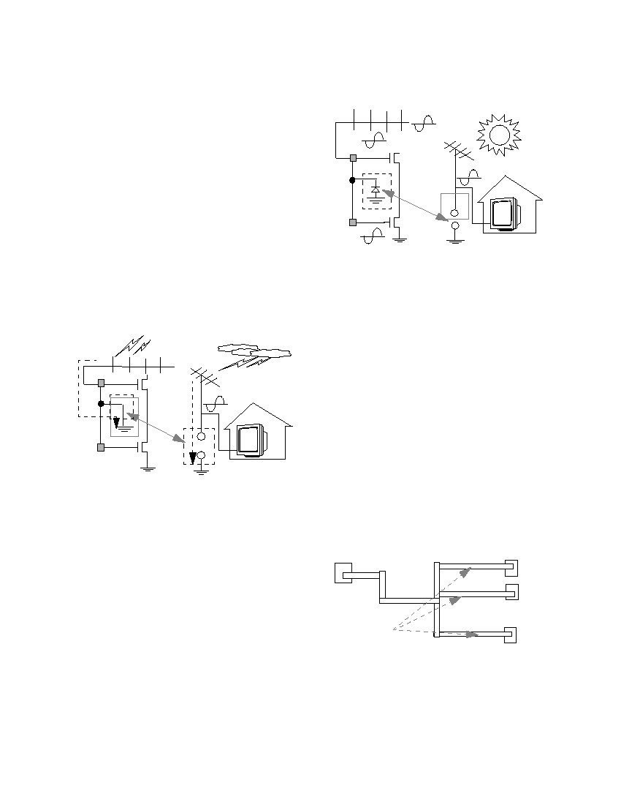
Fixing Antenna Problem by Dynamic Diode
Dropping and Jumper Insertion
Peter H. Chen and Sunil Malkani
TeraLogic, Inc.
1240 Villa Street
Mountain View, CA 94041
pchen@teralogic-inc.com
Abstract
This paper describes three ways to ﬁx antenna prob-
lems: (1) diode dropping, (2) jumper insertion, and (3)
diode dropping with extension wires. Basic principles of
these methods are compared and results are presented.
Diode structures, SPIC simulation, and diode slicing are
also discussed in this paper.
Chun-Mou Peng
International Tech. Univ.
1650 Warburton Avenue
Santa Clara, CA 95050
chunmou@itu.edu
James Lin
National Semi. Corp.
2900 Semiconductor Drive
Santa Clara, CA 95051
James.Lin@nsc.com
2.
Runset
3.
GDSII File
5.
4.
Antenna Violation
Verification
6.
Add Diode and
Add Jumper
Summary
Error
9.
1. Diode
Design /
Simulation
1. Introduction
Antenna problems have existed in the chip manufac-
turing industry for more than one decade. In this paper,
we present a systematic way to ﬁx these problems. This
paper includes the following:
• Antenna explanations
• Antenna ratio deﬁnitions
• Antenna check out violation by veriﬁcation
tools
• Comparison of diode dropping and jumper
insertion methods
• Diode characterizations and structures
• Diode dropping, jumper insertion, and diode
dropping with extension wires
• Design Rule Checking (DRC) and Logic Versus
Schematics (LVS) checking
• Chip-level protection diode dropping for blocks
• Diode timing delay checking
• An image of a diode cross-section (by slicing)
8.
7.
Yes All Antennae No Increase
TapeoutExtension
Fixed?
GDSII FileWire
Length
11.10.
TimingReticle Generation /
Analysis
Wafer Manufacturing
Figure 1.
Overall ﬂow for ﬁxing antenna problems
2. Flow Chart for Antenna Problem Fixing
The overall ﬂow for ﬁxing antenna problems by
dynamic diode dropping and jumper insertion is shown
in Figure 1.
The major steps depicted in Figure 1 are explained as
follows:
1. Diode size and structure is determined through
SPICE simulation.
2. The file runset specifies the maximum antenna ratio.
3. GDSII files contain the chip’s layout with clean
DRC and LVS.
4. The antenna verification tool is used to check the
antenna violation location. A violation or a non-vio-
lation is based on the specified antenna ratio.
5. The results of antenna violations are stored in the
error and summary files.
6. The antenna fixing tool is used to add diodes and
jumpers.
7. If all the antenna violations are fixed in Step 6, then
the verification tool is used to verify DRC and LVS.
8. If the violation are not fixed, then use jumper or
Authorized licensed use limited to: Mentor Graphics. Downloaded on October 7, 2009 at 18:53 from IEEE Xplore. Restrictions apply.
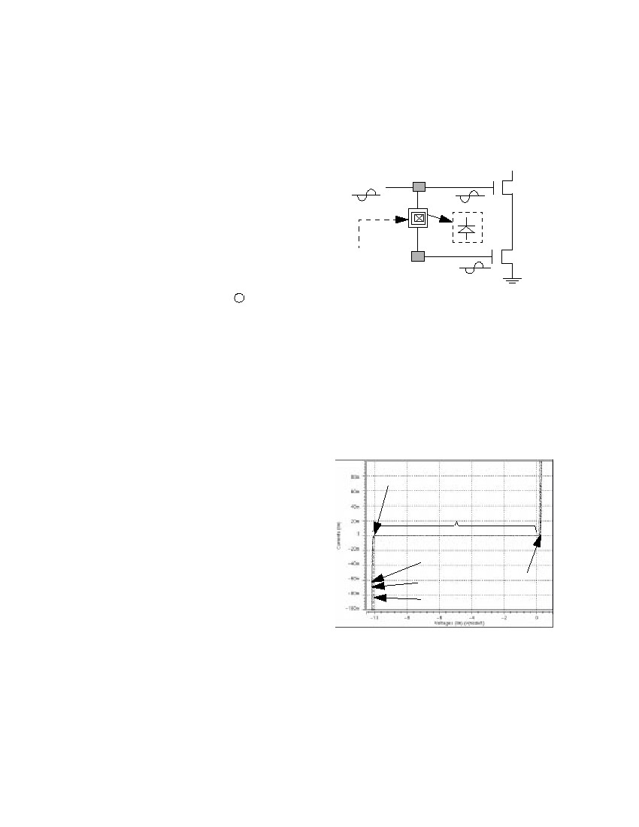
dropping diode with extension wires approaches.
9. If all the antenna violations are fixed and DRC/LVS
are clean, then tapeout the chip.
10. Timing analysis can be checked by Standard Delay
Format (SDF).
11. This step is used to manufacture the wafer.
M2
Total Wire Area
Antenna Ratio = ---------------------------------------------------------
Total Input Port Area
M1
3. Antenna Explanation
During wafer manufacturing, if the wire connected to
the input port is too long, the accumulated charges
(caused by UV light, etc.) on the long wires that are near
the input port damage the device. This reduces the wafer
manufacturing yield. Analogies for antenna problems
during wafer manufacturing and normal operation are
shown as Figures 2 and 3. During manufacturing, diodes
which do not connect to any power source are ﬂoating
devices. These ﬂoating devices can be used to discharge
accumulated charges on the long wires during wafer man-
ufacturing.
UV light
+
++
+
Antenna
Problem
⇔
M1
Diode
-
-
Figure 3.
Analogy of antenna problem during cir-
cuit normal operation
+
M1
M2
Charge
flow
into
ground
Figure 2.
+
+
Antenna
Problem
⇔
M1
Diode
+++
+
- ---
Analogy of antenna problem during man-
ufacturing
When wafers are manufactured, these diodes are no
longer used as discharging devices. They become reverse
bias diodes and act like an open circuit. With very little
parallel capacitance to input ports during normal opera-
tion, the transmitted signals can maintain their integrity.
In Figures 2 and 3: M1 denotes Metal 1s, which are
always small pieces of metal. M2 denote Metal 2s, which
may be small or big pieces of metal. Diode locations
should be as close to input ports as possible. Diodes are
dropped on Metal 2.
Where:
Total Wire Area : The total area of a wire starts
from the input port before reaching the topmost routing
layer. (For example, for a ﬁve metals process, a wire is
started from Metal 1 to Metal 2, and then to Metal 3. For
this wire, Metal 3 is the topmost layer. The total wire area
is counted from Metal 1 to Metal 2. This is the area that
accumulates charges and damages the input port. The area
after the topmost layer to the output port is irrelevant to
the antenna ratio, since the charges in this area are dis-
charged to the output gate once the connection is estab-
lished during wafer manufacturing.) The area of Metal 3
is not counted, since once Metal 3 is ﬁnished during man-
ufacturing, the whole wire is connected. The charge ﬂows
into the output port due to the output port’s low imped-
ance.
Total Input Port Area : The total input port area is
the total area of the input ports that are connected with
this selected net. Figure 4 shows the antenna ratio for
Metal 3. The total area of the metal is the summation. The
total input port area is the summation of ports 1, 2, and 3.
Metal 1
Metal 2
Output Metal 2
port
Metal 3
Total
wire area
Figure 4.
Metal 1
Metal 1
Metal 1
Port 3
Port 1
Port 2
Antenna ratio for metal 3
4. Antenna Ratio Deﬁnition
5. Antenna Rule Checking
The antenna ratio of a particular net is deﬁned as:
Authorized licensed use limited to: Mentor Graphics. Downloaded on October 7, 2009 at 18:53 from IEEE Xplore. Restrictions apply.
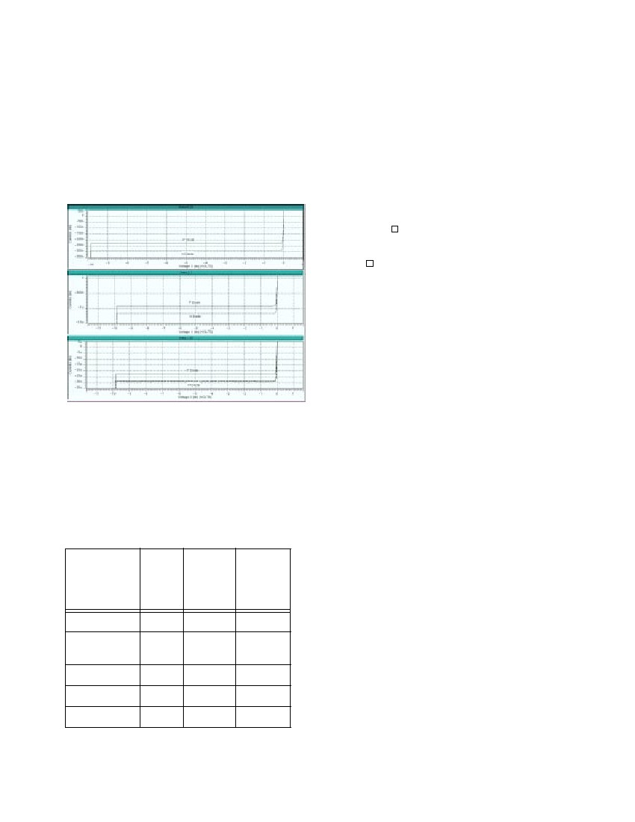
Use layout veriﬁcation tools to check antenna errors.
The error reports should contain the following informa-
tion:[4]
1. The violated position of the wire: The ( x, y ) posi-
tion of which the antenna ratio of the wire exceeds
the specified antenna ratio, e.g, 400.
2. Error flattened: Since the wire is connected to every
module, it should not be hierarchical. Therefore, the
errors should be flattened. Set the error flattened
option if the tool is a hierarchical verification tool. If
the verification tool is not hierarchical, you do not
need to set this option.
3. Chip level: At the chip level, since each block’s
antenna problem is fixed, we only need to consider
the interconnection among the blocks. Since the
whole chip may be very large (e.g., 1 million gates),
to check the whole chip antenna violation might take
R
a long time (several days on a SUN Ultra-SPARC
workstation). If the chip is too big, chip-level
antenna violations can be avoided by putting a pro-
tection diode on every input pin. This can be done
very quickly, in general within few seconds to one
minute. If the chip is not too big and run time is
acceptable, then antenna violation checking and
dynamic diode dropping and jumper insertion
approaches can still be used.
ports. If the chip is too dense and the tool cannot find
the space to drop the diode, jumpers can also be
inserted or extension wires near the input ports can
be added for diode insertion. In the operation mode,
these diodes act like reverse diodes. Within the
clamp voltage range, the signals are preserved with
very small leakage currents as shown in the Figure 7.
.
M1
M2
Drop diode
(to form a
reverse bias diode)
Figure 5.
M1
Examples of tool dropping a diode
7. Diode Characterization
Figure 6 presents the P-diode’s characterization. Three
diode sizes (0.25, 1.0, and 25.0 ∝μ ) are compared. They
all have the same clamped voltages (e.g., -10 V). We
determined the appropriate diode based on the DRC rule
for each process. In this paper, we use the
1.1µm ⋅ 1.1 ∝μ for 0.35µm process.
2
6. Three Solutions for Antenna Problem
The three solutions proposed to solve the antenna
problem are described as follows:[2, 3]
1. Router options: Break signal wires and routes to
upper levels. This reduces the charge amount for
each net during manufacturing. This is called the
“jumper approach.”
2. Embedded protection diode: Add protection diodes
on every input port for every standard cell. However,
these protection diodes consume the cell area
resources and increase manufacturing costs. Even
though the diodes are not necessary, these diodes are
always embedded.
3. Dynamic dropping diode after placement and route:
Fixing only the wire with the antenna violation
which will not waste routing resources. During wafer
manufacturing, all the inserted diodes are floating (or
ground). Since the input ports are high impedance,
the charge on the wire flows through the insert float-
ing/ground diode (composite) instead of flowing into
the input port. One diode can be used to protect all
input ports that are connected to the same output
-10 V
Operation Range
Reverse Bias of n-Diode
0.5µm ⋅ 0.5µm
1µm ⋅ 1µm
5µm ⋅ 5µm
0.7 V
Figure 6.
Reverse bias of N-Diode operation dia-
gram
The SPICE simulation results show that the P-Diode
has the same clamped voltage (e.g., -10 V) as the N-
Diode shown in Figure 6; except the leakage currents are
different. The leakage currents, shown in Figure 7 for the
0.35µm process, are as follows:
Authorized licensed use limited to: Mentor Graphics. Downloaded on October 7, 2009 at 18:53 from IEEE Xplore. Restrictions apply.
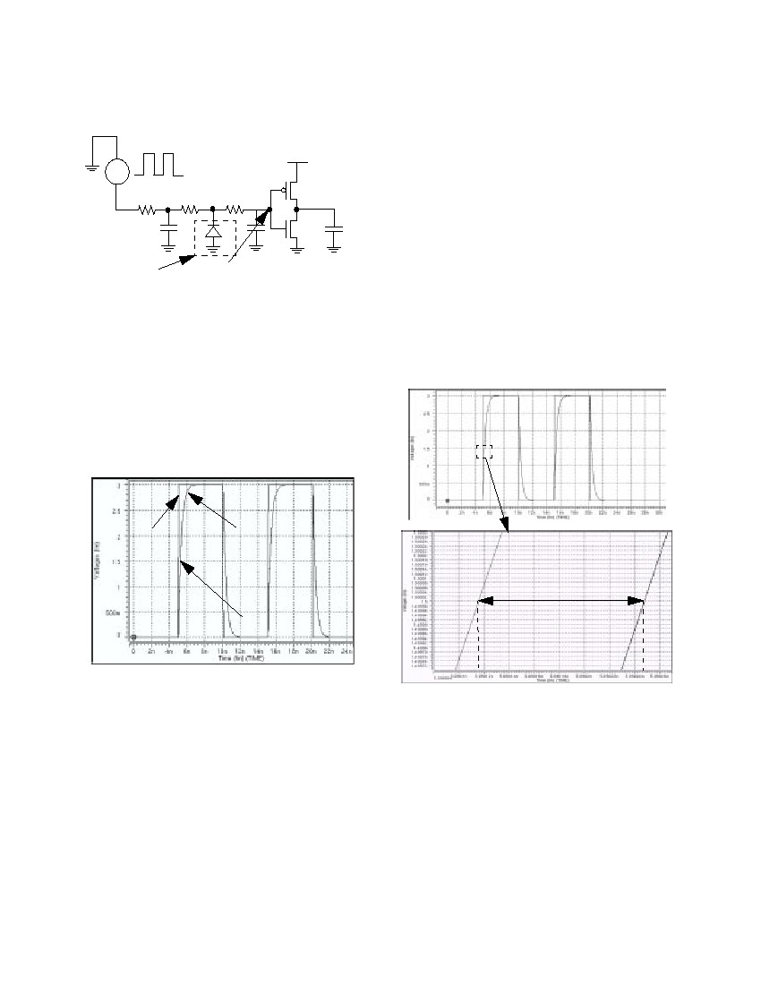
1.
2.
P-Diode 225 nA and 290 nA for diode area
0.5µm ⋅ 0.5 ∝μ
P-Diode 900 nA and 1.2 ∝Α for diode area
1µm ⋅ 1 ∝μ
3. P-Diode 22.5 ∝Α and 29 ∝Α for diode area
5µm ⋅ 5 ∝μ .
From Figure 6 and 7, we observe that the signal trans-
missions will not be destroyed or degraded during normal
operations.
9. Timing Impact
The following calculation shows the timing compari-
son between jumper and diode insertion approaches.[1]
1. Jumper Insertion: Each jumper needs at least two
vias. In the 0.35 ∝μ technology, via resistance is
around 10 Ω . In 0.25 ∝μ technology or above, via
resistance is around 100 Ω or more.
R' = R
Where:
R
2.
LL
--⋅ ---- ≅ 60mΩ ⋅ ---- ≅ 3 – 10Ω
WW
: The sheet resistance of metal.
R' : The resistance of metal with length L .
Diode Insertion:
Diode Capacitance
ε ox34.5µF ⁄ cm
C' ≅ C ox = -------- = ---------------------------------
--
t ox–5
0.4 ⋅ 10 cm
2
= 0.86f F ⁄ ∝μ
Where:
C' and C ox : Capacitance of the diode
Figure 7.
P-Diode and N-Diode leakage currents
with diode size 0.25, 1.0, and 25.0 ∝μ
2
ε ox : Permittivity of diode
t ox : Thickness of the diode
Time Constant
τ = ( R + R' ) ⋅ ( C + C' )
R'C'
--= R ⋅ C ⋅  1 + ---- ⋅  1 + ----
R C
Where:
τ : Time delay of metal with diode/via.
For 0.35 ∝μ design with 350 ∝μ wire, the formula
is as follows:
R'5 C'1fF
---- = ----- » ---- = ----------------
R60 C10pF
In Figure 8, set the following parameters for very long
wire:
VIN: 200 MHz input signal from output port
R1: 120 Ω for long wire resistance
C1: 2.4 pF for long wire capacitance
R2: 10 Ω for short wire resistance
D1: N-Diode with area 1.1µm ⋅ 1.1µ m
C2: 0.2 pF for short wire capacitance
R3: 5 Ω for short wire resistance
8. Comparison
Table 1 shows the comparison of the three approaches
used to solve antenna problems.
Table 1: Comparison of three approaches
Embed-
ded
Diode
Yes
Yes
No
More
Yes
Dynamic
Drop-
ping
Diode
No
No
Yes
Least
No
Impact
Jumper
Cell Area
Routability/
Chip Size
Completeness
Timing
Integration
No
Yes
No
Most
Yes
Authorized licensed use limited to: Mentor Graphics. Downloaded on October 7, 2009 at 18:53 from IEEE Xplore. Restrictions apply.
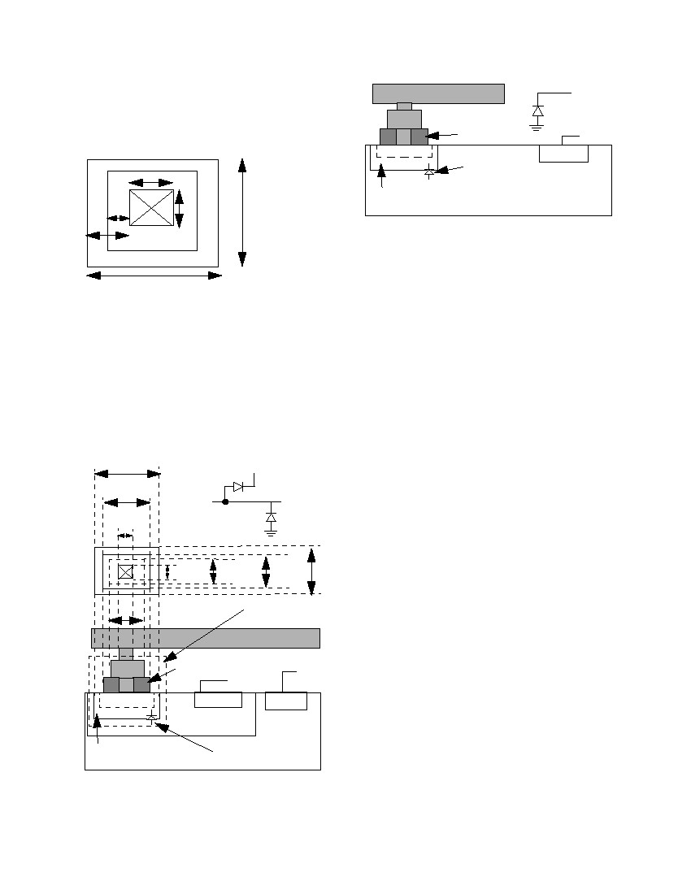
VDD: 3.0 V
C3: 1.0 fF for CMOS capacitance
Input Signal from
Output Port (200 MHz)
VIN
R1
R2
R3
1.8/0.4
VDD: 3.0 V
C3: 1.0 fF for CMOS capacitance
The total wire’s timing delay is 0.1ns . The timing
VDD
delay caused by this N-Diode is 0.0001ns , which is neg-
ligible. In the real design, the wire’s patterns are much
more complicated, but the inserted diode’s effect is simi-
lar.
C1
Dropping
Diode
D1
C2
0.9/0.4
C3
10. Advantages of The Dynamic Diode Drop-
ping Approach
Figures 8, 9, and 10 show the dynamic diode dropping
approach to have the following advantages:
1. Least timing degradation (better than embedded)
2. Least waste of chip area during manufacturing
3. Least impact on routability. The jumper only
approach is unusable on very dense chips.
Delay Signal at
Input Port
Figure 8.
Timing simulation of diode insertion
Figure 9 shows the simulation circuits of timing delay
of a very long wire with a 200 MHz input signal (from the
output port). This very long wire with an N-Diode (P-
Diode) or without a diode has about 0.3 nsec timing
delay. The dropping diode’s timing effect is negligible.
The forward diode has the same time delay as the reverse
diode but it drops the maximum amplitude of the signals
at some voltage level. Therefore, the forward diode can-
not be used to solve the antenna problem.
Input
Signal
from
Output
Port
Delay
Signal
at
Input
Port
Time Delay
0.0001ns
Figure 9.
Timing delay simulation of a very long
wire with N-diode
Figure 10 shows the result of a medium long wire
with the following conﬁgurations:
VIN: 200 MHz input signal from output port
R1: 17 Ω for long wire resistance
C1: 5.3 pF for long wire capacitance
R2: 1.0 Ω for short wire resistance
D1: N-Diode with area 1.1µm ⋅ 1.1µ m
C2: 0.125 pF for short wire capacitance
R3: 0.5 Ω for short wire resistance
Figure 10. Timing delay simulation of a medium
long wire N-diode
11. Diode Structure
Figure 11 shows a top view of diode structure for the 0.35
∝μ process. A diode is composed by a via, Metal 1, and
+
Composite. Dropping an N-Diode on top of N – IMP
within P-Substrate forms a reversed bias diode during
normal operation, as shown in Figure 13. Forward diodes
Authorized licensed use limited to: Mentor Graphics. Downloaded on October 7, 2009 at 18:53 from IEEE Xplore. Restrictions apply.
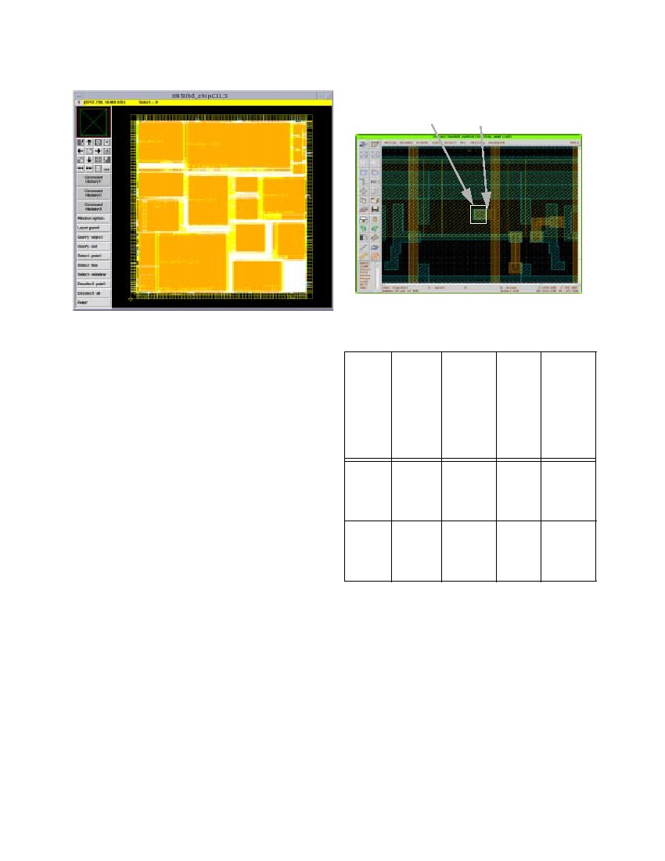
degraded the signals; whereas, reverse diodes can pre-
serve the signals during normal operation. Figures 12 and
13 show the reverse bias of a P-Diode and an N-Diode for
the P-MOS and N-MOS processes, respectively.
M2
M1
Oxide
N-COMP
M1
0 or 1
VSS
P+
VSS
P-Substrate
0.5µm
+
N – IMP
0.5µm
Via
0.3µm
Metal 1
Composite
1.1µm
Figure 11. Top view of diode structure
There are four kinds of dropping diodes, they are as
follows:
1. N-Diode with P-IMP
2. P-Diode with N-IMP
3. N-Diode with N-IMP
4. P-Diode with P-IMP
Figures 12 and 13 show dropping a P-Diode for the P-
MOS Process and an N-Diode for the N-MOS Process,
respectively.
VDD
Reverse
Bias
N+-Diode
0.1µm
1.1µm
Figure 13. N-Diode dropping for the N-MOS pro-
cess
12. Procedures for Fixing Antenna Violations
The procedure for ﬁxing antenna violations are illus-
trated below:[4]
1. Make sure the rule file specifications follow your
process design rules and DRC rules.
2. Bring up the tool for antenna fixing.
3. Create the new library or open the existing library.
4. Stream in GDSII file.
5. Import the P-Diode and the N-Diode from the GDSII
format or create them from scratch.
6. Open the top level cell.
7. Drop the diodes (P-Diode or N-Diode) without
extension wires according to the rule files specified
in Step 1.
8. Insert the jumper for the rest of the violation (if there
is no space to drop a diode).
9. Increase the extension wire to accommodate a bigger
area, e.g, 5 ∝μ .
10. (Repeat Step 9 until all the violations are cleaned.)
11. Save the design in a GDSII format.
12. Visually check the diode insertion one-by-one.
Search and trace all the diodes which are inserted.
Examine the diode structure, location of dropped
diodes, and make sure the diodes touch the right lay-
ers.
Figure 14 shows a Teralogic tl850 design which ﬁxes
antenna violations by dynamic diode dropping and
jumper insertion. For dense designs, it is hard for tools to
ﬁnd the space to drop the diodes. The extension wire
gives more space for diode dropping. The extension
wire’s width is very important for the design rule. If the
extension wire width is too small, it causes notch errors.
The right wire has a bigger width (the same as the diode
width) and will not cause any DRC error. Figure 15 shows
a diode connected to an extension wire.
1.5µm
M1
1.1µm
0.5µm
0.7µm
1.5µm
0.5µm
0.7µm
M2
M1
P-COMP
Oxide
+
N
VSS
P+
1.1µm
N-diode
VDD
+
P – IMP
VSS
VDD
Reverse P-Substrate
Bias
N+-Diode
Figure 12. P-Diode dropping for P-MOS process
Authorized licensed use limited to: Mentor Graphics. Downloaded on October 7, 2009 at 18:53 from IEEE Xplore. Restrictions apply.
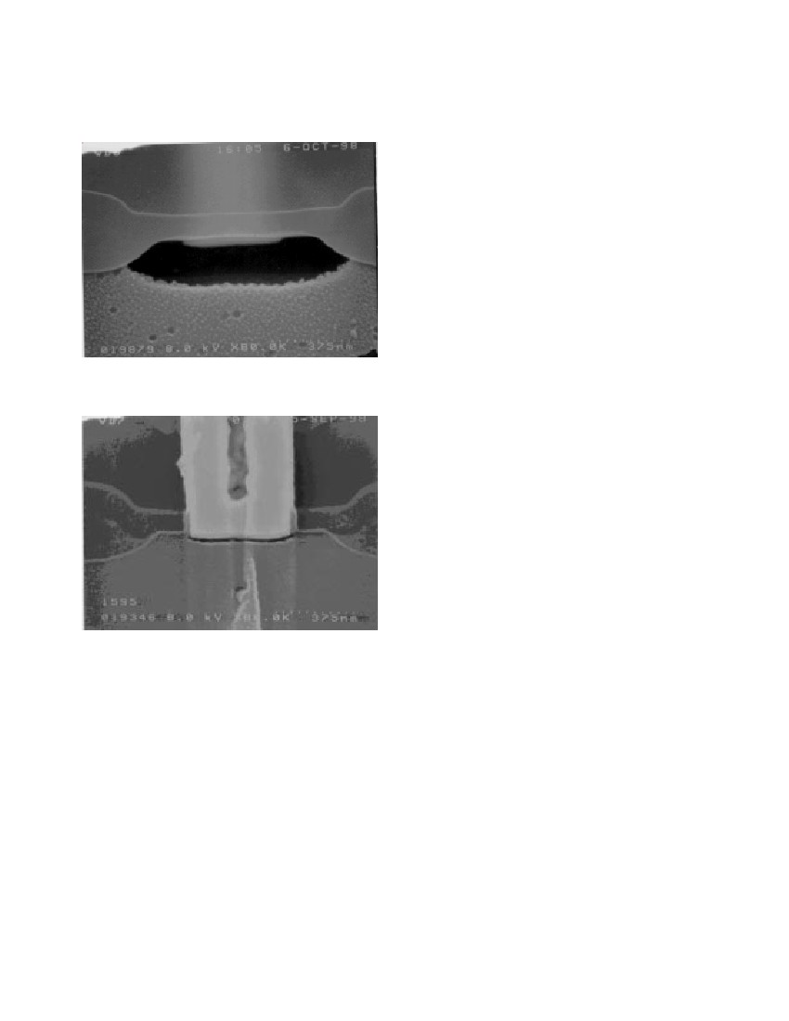
diodes, and most of the violations can be ﬁxed after the
ﬁrst run of diode dropping.
diode
extension wire
Figure 15. Diode insertion with wire extension
Figure 14. Antenna ﬁxed by diode dropping and
jumper insertion
Table 2: Dynamic diode and jumper insertion
Diode
insertion
without
exten-
sion
wires
M4: 0
M3: 21
M2: 0
M1: 0
M4: 0
M3: 1
M2: 0
M1: 0
Diode
insertion
with 20
∝μ
exten-
sion
wires
M4: 0
M3: 0
M2: 0
M1: 0
N/A
13. Dynamic Diode/Jumper Insertion Results
Table 2 shows some results of 0.35 ∝μ technology.
The speciﬁcation of a maximum antenna ratio is 400
without diode insertion, and the maximum ratio is 5000
with diode insertion. Both design examples in Table 2 are
approximately one-quarter of a million gates. Here, we
deﬁne the dense design as core utilization of more than
90% and the sparse design as core utilization of less than
50%.
For the dense design example, the original number of
antenna violations for Metal 3 is 154. After diode drop-
ping, the number of violations for Metal 3 is reduced to
21. After adding jumpers, the violations for Metal 3 are
reduced to 3. Finally, using 20 ∝μ extension wires to
drop the diode, the antenna violations are clean. Note that
in the topmost metal (e.g., Metal 4), there never are
antenna violations. Since after the wire is connected, the
charge discharges into the output port. Normally, Metal 1
also has no antenna violations. This is because Metal 1’s
resources are occupied by standard cells. Therefore, there
is very limited space for the router to generate the antenna
problem. Metal 2 violations are very easy to ﬁx, since the
tool can always ﬁnd the space to drop a diode. Metal 3
violations are difﬁcult to ﬁx due to the limited space
resources.
For some designs with limited routing resources (e.g.,
when only three metals are used), core utilization is low
(e.g., 49%). These designs have lots of space to insert
Design
no
Viola-
tion
Add
jumper
Design
1:
dense
design
Design
2:
sparse
design
M4: 0
M3: 154
M2: 23
M1: 0
M4: 0
M3: 788
M2: 521
M1: 0
M4: 0
M3: 3
M2: 0
M1:0
M4: 0
M3: 0
M2: 0
M1: 0
14. Diode Slicing
The purpose of the diode slicing is to make sure that
the diode that inserted do not cause any leakage current
and timing degradation. Figures 16 and 17 show the
cross-section of a diode. Figure 16 shows a cross-section
of an N-Diode just before entering into the tungsten plug
(contact). The diffusion stain (the dark black area on N-
COMP) shows that the diffused junction is big enough.
Figure 17 shows the same N-Diode on a different die
through the center of the tungsten plug. The N-COMP
Authorized licensed use limited to: Mentor Graphics. Downloaded on October 7, 2009 at 18:53 from IEEE Xplore. Restrictions apply.
area is not stained. Figures 16 and 17 show that the con-
tact is touching the N-COMP area correctly.
be used successfully to solve most antenna violation
problem.
This article do not consider the effect of diode inser-
tion for clock net and memory blocks. Since the clock net
is balanced tree structure, diode insertion will affect the
skew and timing degradation problem. Therefore, diode
insertion to clock net and memory block are not recom-
mended.
This paper’s approach can be applied to both block
level and top level’s antenna ﬁxing. Timing delay can be
veriﬁed from the RC extraction and SPICE tools. The
timing delay caused by diode insertion is within 0.02%
for critical net (the longest nets in design, such as clock
net). DRC and LVS are veriﬁed after ﬁxing antenna prob-
lems. If the tool does not generate the transistor level
netlist, diode insertion can not be checked. In LVS check-
ing, just check for short circuits only.[4]
Figure 16. Cross-section of contact before entering
into the tungsten plug
16. Acknowledgment
The following people have been help for this paper:
Kevin Weaver and James Lin performed the diode slicing,
Leonard Jen’s SPICE simulation; Shariar Motie, Tracey
Tu, and Jerry Noble performed placement and route; Tim
Tan prepared the layout library and technology ﬁle;
Elithebeth Taylor’s proof reading; Sunil Malkani, Eitan
Cadouri, and Alvin Ling’s support; Geoffrey Ying and
Chang-sheng Ying’s help about the development of Syn-
opsys SLE tool.
17. References
Figure 17. Same contact on a different die through
the center of the tungsten plug
[1] Paul Penfield, Jr. and Jorge Rubenstein, “Signal
Delay in RC Tree Networks,” 18th Design Automa-
tion Conference, IEEE, pp. 613-617,1981.
[2] Michael Santarini, “Tool Automatically Removes
Antenna Violations,” EE Times, Issue 1013, p. 88,
June 22, 1998.
[3] Changsheng Ying, “Techniques for Removing
Antenna Rule Violations,” Patent Pending, Stanza
System, Inc., Cupertino, California, 95014.
[4] Peter H. Chen et al, “VLSI Design Flow,” National
Semiconductor Corporation, Santa Clara, CA 95052,
May, 1997.
15. Conclusion
For dense designs (core utilization of more than 90%),
dynamic diode dropping, jumper insertion, and dropping
diodes with extension wires are three approaches which
can be used to solve antenna violations. For design engi-
neers, try to loosen up core utilization 5% to 7%, in order
to leave some margin for diode and jumper insertion
approaches.
For sparse designs (core utilization less than 50%),
diode dropping alone is ﬂexible enough to solve antenna
problem. The three approaches proposed in this paper can
Authorized licensed use limited to: Mentor Graphics. Downloaded on October 7, 2009 at 18:53 from IEEE Xplore. Restrictions apply.

