Fixing Antenna Problem by
Synopsys SLE
Peter H. Chen and
Sunil Malkani
Chun-Mou Peng
Geoffrey Ying
TeraLogic, Inc.
1240 Villa Street
pchen@teralogic-inc.com
suilm@teralogic-inc.com
International Tech. Univ.
1650 Warburton Avenue
chunmou@itu.edu
Synopsys Corp.
700 E. Middleﬁeld Rd.
gying@synopsys.com
ABSTRACT
Antenna problems have existed in the chip manufacturing industry for more than one decade. It
damages the devices and therefore reduces the yield during the wafer manufacturing. This paper
describes three ways to ﬁx antenna problems: (1) diode dropping, (2) jumper insertion, and (3)
diode dropping with extension wires by using the Synopsys’s SLE tool. Many tools try to solve
the antenna problem using the router approach by putting jumper in the block level. It might
causes extra delay by introducing the jumper. In the chip level, there jumper insertion approach is
not suitable due to the chip hierarchy. Synopsys SLE drops the diode dynamically and add jumper
insertion to solve the antenna problem successfully in both block level and chip level. The timing
degradation effect is a big concern for the diode dropping. We have experienced a number of
chips has the timing degradation after the diode insertion. Some investigation are presented in this
study including the SPICE simulation and diode slicing. Those SPICE simulation result and diode
slicing picture are provided to make sure it si working correctly. We ﬁnally ﬁnd out the diode
insertion should be avoided in the memory block or around the critical net, such as clock net.
Basic principles of these methods are compared and results are presented. Diode structures, SPIC
simulation, and diode slicing are also discussed in this paper.
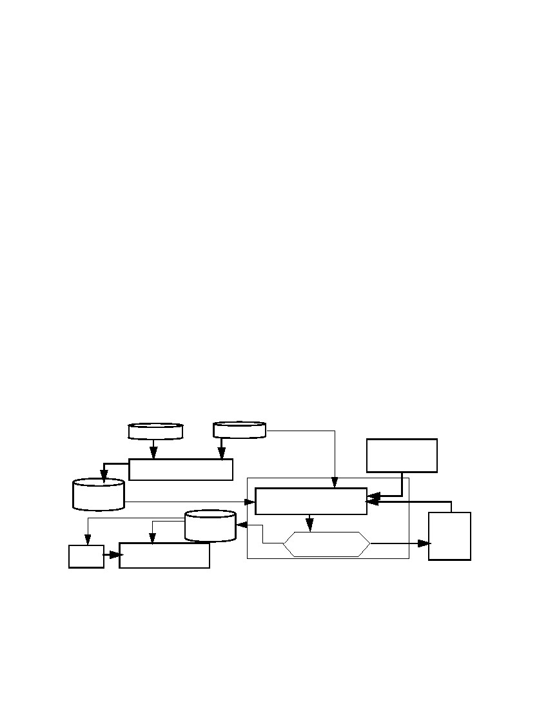
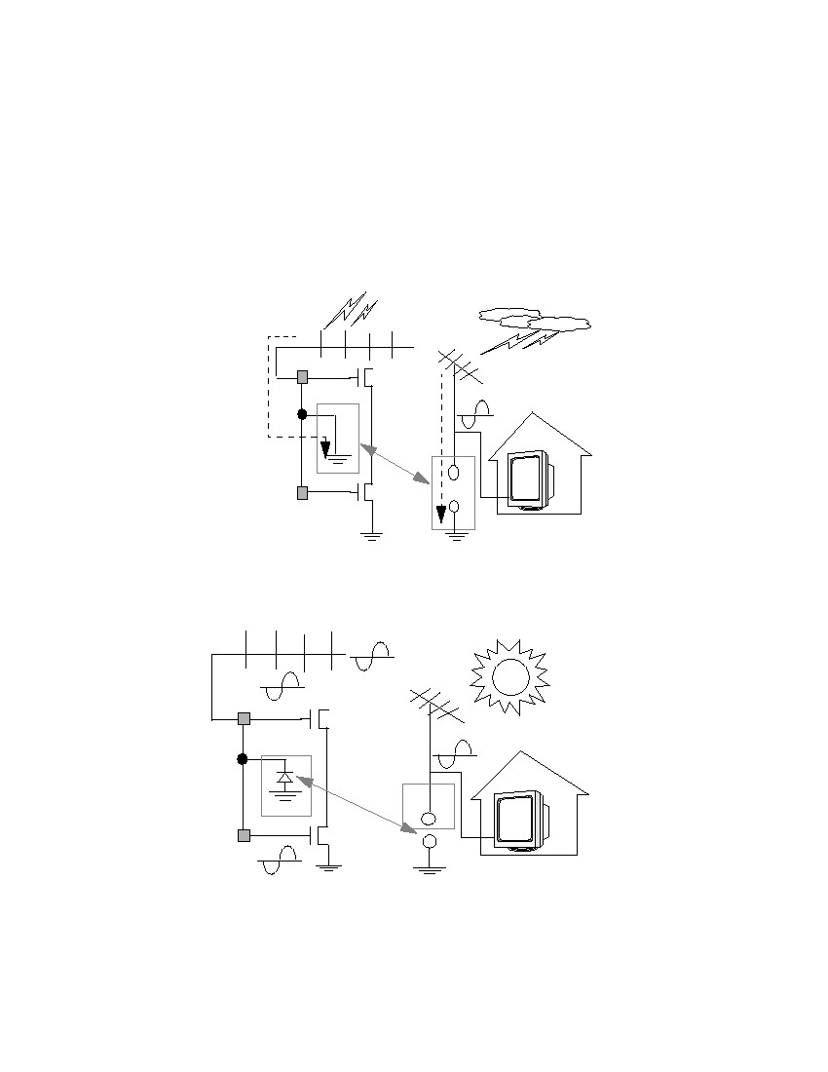
1.0 Introduction
Antenna problems have existed in the chip manufacturing industry for more than one decade. In
this paper, we present a systematic way to describe this problem by Teralogic tl850 chip and ﬁx
by using Synopsys SLE. tl850 is a High Deﬁnition TV (HDTV) chip designed by Teralogic, inc.
and manufactured by Taiwan Semiconductor Manufacturing Corporation (TSMC). This paper
includes the following topics:
• Antenna explanations
• Antenna ratio deﬁnitions
• Antenna check out violation by veriﬁcation tools
• Comparison of diode dropping and jumper insertion methods
• Diode characterizations and structures
• Diode dropping, jumper insertion, and diode dropping with extension wires
• Design Rule Checking (DRC) and Logic Versus Schematics (LVS) checking
• Chip-level protection diode dropping for blocks
• Diode timing delay checking by RC extraction and SPICE Simulation
• Diode structure veriﬁcation by slicing
2.0 Flow Chart for Fixing the Antenna Problem
The overall ﬂow for ﬁxing antenna problems by dynamic diode dropping and jumper insertion is
shown in Figure 1.
2.
Runset
4.
Antenna Violation
Verification
3.
GDSII File
1.
Diode Design /
Simulation /
Design Rule File
5.
Summary
Error
9.
11.
Reticle Generation /
Wafer Manufacturing
Tapeout
GDSII File
Yes
Synopsys SLE
6.
Add Diode and
Add Jumper
7.
All Antennae
Fixed?
10.
Timing
Analysis
8.
Increase
Extension
No
Wire
Length
Figure 1. Overall Flow for Fixing Antenna Problems
SNUG San Jose 2000
2
Fixing Antenna Problem by Synopsys SLE
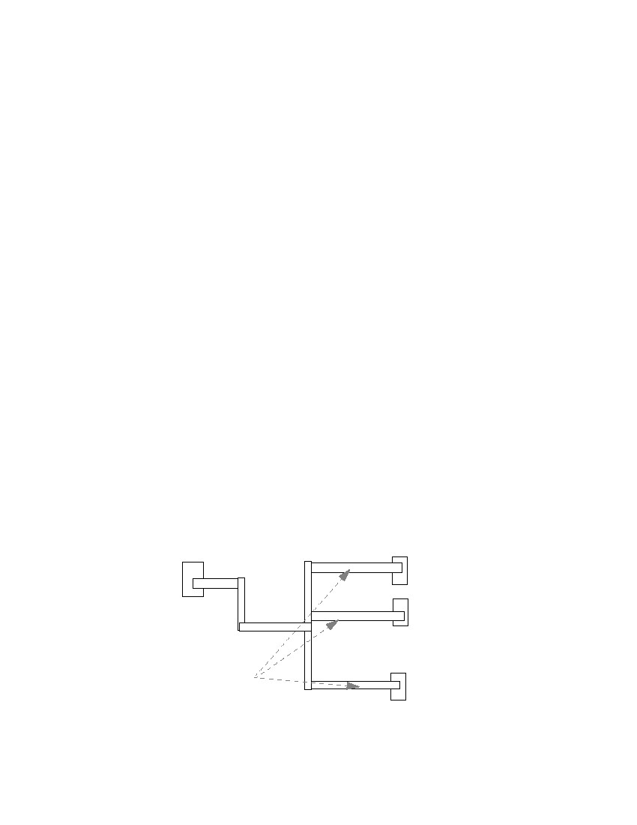
3.0 Antenna Explanation
During wafer manufacturing, if the wire connected to the input port is too long, the accumulated
charges (caused by UV light, etc.) on the long wires that are near the input port damage the
device. This reduces the wafer manufacturing yield. Analogies for antenna problems during wafer
manufacturing and normal operation are shown as Figures 2 and 3. During manufacturing, diodes
which do not connect to any power source are ﬂoating devices. These ﬂoating devices can be used
to discharge accumulated charges on the long wires during wafer manufacturing.
UV light
M1
M2
+++
+
+
+
+
Antenna
Problem
⇔
Charge
flow
into
ground
M1
Diode +++
+
- ---
Figure 2. Analogy of antenna problem during manufacturing
M1
M2
Antenna
Problem
⇔
M1
Diode
-
-
Figure 3. Analogy of antenna problem during circuit normal operation
SNUG San Jose 2000
3
Fixing Antenna Problem by Synopsys SLE

When wafers are manufactured, these diodes are no longer used as discharging devices. They
become reverse bias diodes and act like an open circuit. With very little parallel capacitance to
input ports during normal operation, the transmitted signals can maintain their integrity.
In Figures 2 and 3: M1 denotes Metal 1s, which are always small pieces of metal. M2 denote
Metal 2s, which may be small or big pieces of metal. Diode locations should be as close to input
ports as possible. Diodes are dropped on Metal 2.
4.0 Antenna Ratio Deﬁnition
The antenna ratio of a particular net is deﬁned as:
Total Wire Area
Antenna Ratio = ---------------------------------------------------------
Total Input Port Area
Note that the antenna rule violation deﬁnition is foundry and process speciﬁc. For example,
TSMC design rules (0.18 ∝μ ) uses total perimeter area of metal wire vs. gate area.
Where:
Total Wire Area : The total area of a wire starts from the input port before reaching the topmost
routing layer. (For example, for a ﬁve metals process, a wire is started from Metal 1 to Metal 2,
and then to Metal 3 (metal 4 and 5 is not used for this example). For this wire, Metal 3 is the top-
most layer for this wire. The total wire area is counted from Metal 1 to Metal 2. This is the area
that accumulates charges and damages the input port. The area after the topmost layer to the out-
put port is irrelevant to the antenna ratio, since the charges in this area are discharged to the output
gate once the connection is established during wafer manufacturing.) The area of Metal 3 is not
counted, since once Metal 3 is ﬁnished during manufacturing, the whole wire is connected. The
charge ﬂows into the output port due to the output port’s low impedance.
Total Input Port Area : The total input port area is the total area of the input ports that are con-
nected with this selected net. Figure 4 shows the antenna ratio for Metal 3. The total area of the
metal is the summation. The total input port area is the summation of ports 1, 2, and 3.
Metal 1
Metal 2 Metal 1
Metal 1
Metal 1
Port 1
Port 2
Output Metal 2
port
Metal 3
Total
wire area
Port 3
Figure 4. Antenna ratio for metal 3
SNUG San Jose 2000
4
Fixing Antenna Problem by Synopsys SLE
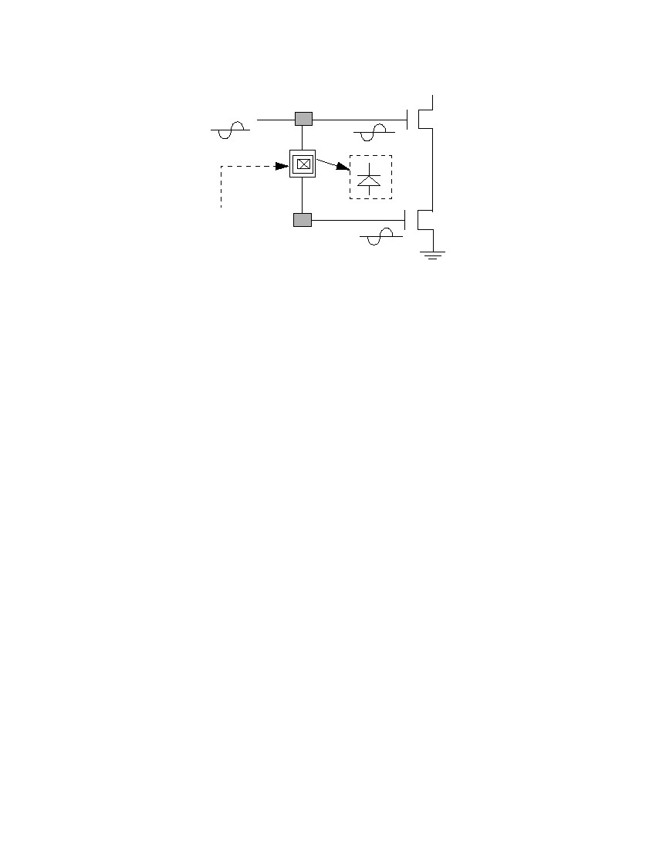
5.0 Antenna Rule Checking
Use layout veriﬁcation tools to check antenna errors. The error reports should contain the follow-
ing information:[4]
1. The violated position of the wire: The ( x, y ) position of which the antenna ratio of the wire
exceeds the speciﬁed antenna ratio, e.g, 400.
2. Error ﬂattened: Since the wire is connected to every module, it should not be hierarchical.
Therefore, the errors should be ﬂattened. Set the error ﬂattened option if the tool is a hierarchi-
cal veriﬁcation tool. If the veriﬁcation tool is not hierarchical, you do not need to set this
option.
3. Chip level: At the chip level, since each block’s antenna problem is ﬁxed, we only need to
consider the interconnection among the blocks. Since the whole chip may be very large (e.g.,
1 million gates), to check the whole chip antenna violation might take a long time (several
days on a SUN Ultra-SPARC workstation). If the chip is too big, chip-level antenna viola-
tions can be avoided by putting a protection diode on every input pin. This can be done very
quickly, in general within few seconds to one minute. If the chip is not too big and run time is
acceptable, then antenna violation checking and dynamic diode dropping and jumper insertion
approaches can still be used.
R
6.0 Three Solutions for Antenna Problem
The three solutions proposed to solve the antenna problem are described as follows:[2, 3]
1. Router options: Break signal wires and routes to upper levels. This reduces the charge amount
for each net during manufacturing. This is called the “jumper approach.”
2. Embedded protection diode: Add protection diodes on every input port for every standard cell.
However, these protection diodes consume the cell area resources and increase manufacturing
costs. Even though the diodes are not necessary, these diodes are always embedded.
3. Dynamic dropping diode after placement and route: Fixing only the wire with the antenna vio-
lation which will not waste routing resources. During wafer manufacturing, all the inserted
diodes are ﬂoating (or ground). Since the input ports are high impedance, the charge on the
wire ﬂows through the insert ﬂoating/ground diode (composite) instead of ﬂowing into the
input port. One diode can be used to protect all input ports that are connected to the same out-
put ports. If the chip is too dense and the tool cannot ﬁnd the space to drop the diode, jumpers
can also be inserted or extension wires near the input ports can be added for diode insertion. In
the operation mode, these diodes act like reverse diodes. Within the clamp voltage range, the
signals are preserved with very small leakage currents as shown in the Figure 7.
SNUG San Jose 2000
5
Fixing Antenna Problem by Synopsys SLE
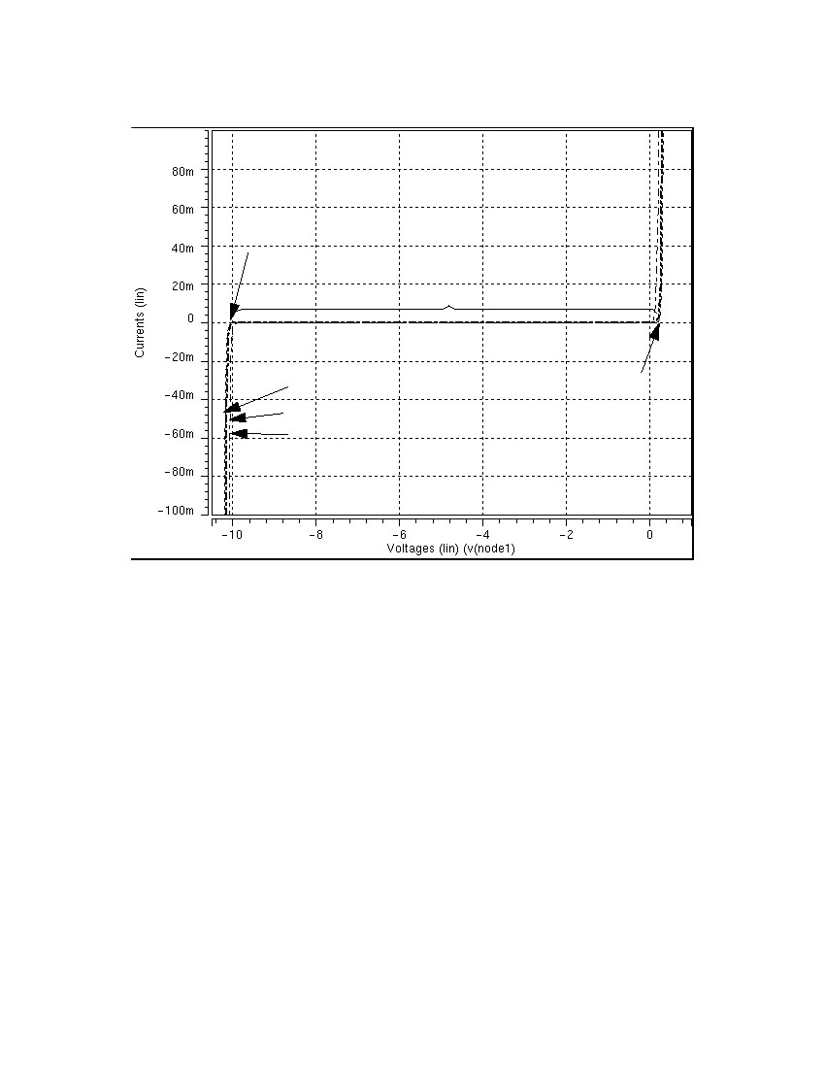
.
M2
M1
M1
Drop diode
(to form a
reverse bias diode)
Figure 5. Examples of tool dropping a diode
7.0 Diode Characterization
Figure 6 presents the P-diode’s characterization. Three diode sizes (0.25, 1.0, and 25.0 ∝μ ) are
compared. They all have the same clamped voltages (e.g., -10 V). We determined the appropriate
diode based on the DRC rule for each process. In this paper, we use the 1.1µm ⋅ 1.1 ∝μ for
0.35µm process.
2
SNUG San Jose 2000
6
Fixing Antenna Problem by Synopsys SLE
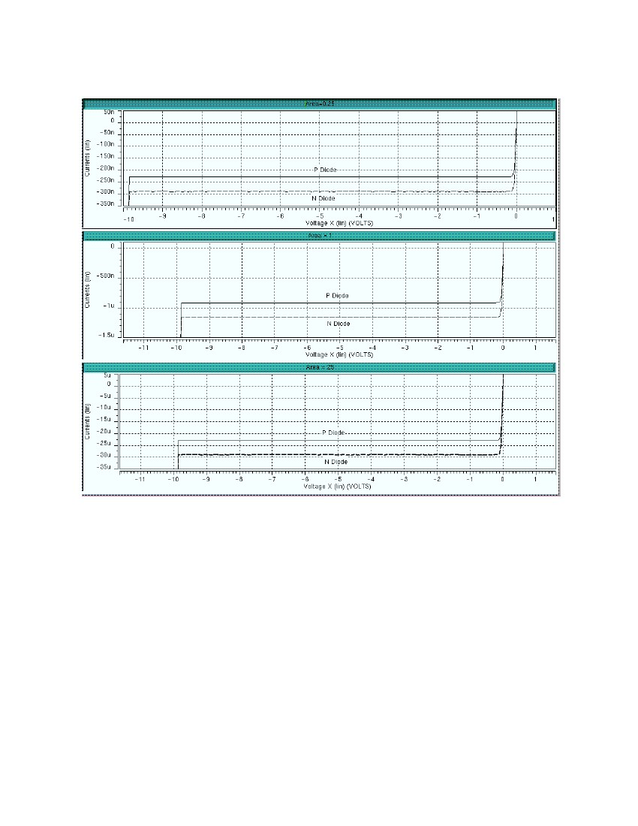
-10 V
Operation Range
Reverse Bias of n-Diode
0.5µm ⋅ 0.5µm
1µm ⋅ 1µm
5µm ⋅ 5µm
0.7 V
Figure 6. Reverse bias of N-Diode operation diagram
The SPICE simulation results show that the P-Diode has the same clamped voltage (e.g., -10 V)
as the N-Diode shown in Figure 6; except the leakage currents are different. The leakage currents,
shown in Figure 7 for the 0.35µm process, are as follows:
1. P-Diode 225 nA and 290 nA for diode area 0.5µm ⋅ 0.5 ∝μ
2. P-Diode 900 nA and 1.2 ∝Α for diode area 1µm ⋅ 1 ∝μ
3. P-Diode 22.5 ∝Α and 29 ∝Α for diode area 5µm ⋅ 5 ∝μ .
From Figure 6 and 7, we observe that the signal transmissions will not be destroyed or degraded
during normal operations.
SNUG San Jose 2000
7
Fixing Antenna Problem by Synopsys SLE
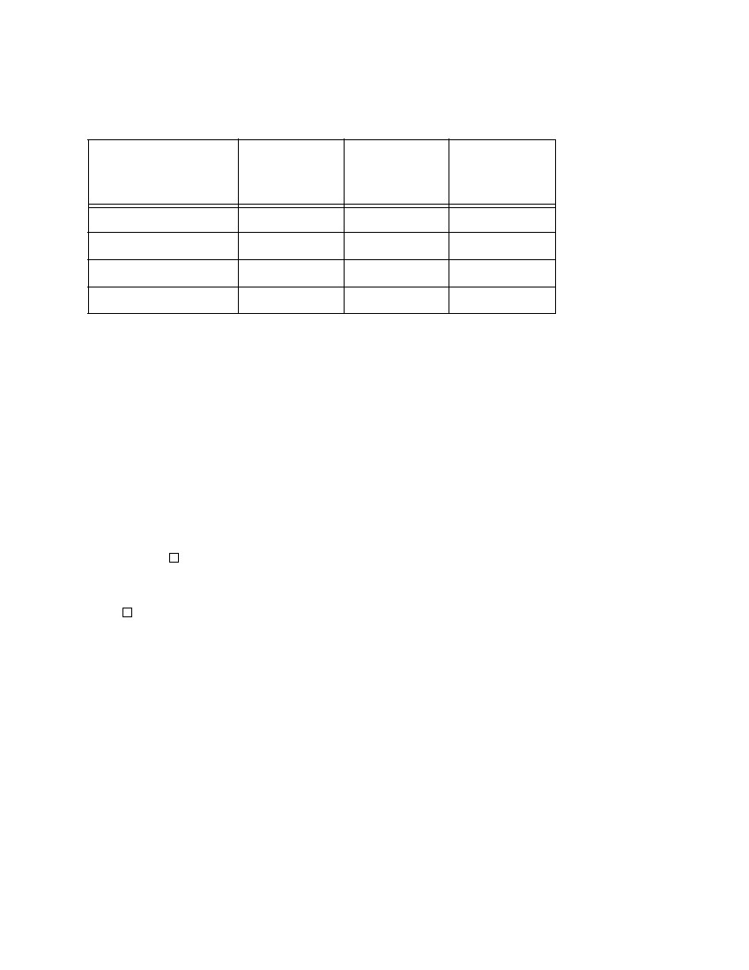
Figure 7. P-Diode and N-Diode leakage currents with diode size 0.25, 1.0, and 25.0 ∝μ
2
8.0 Comparison
Table 1 shows the comparison of the three approaches used to solve antenna problems.
SNUG San Jose 2000
8
Fixing Antenna Problem by Synopsys SLE
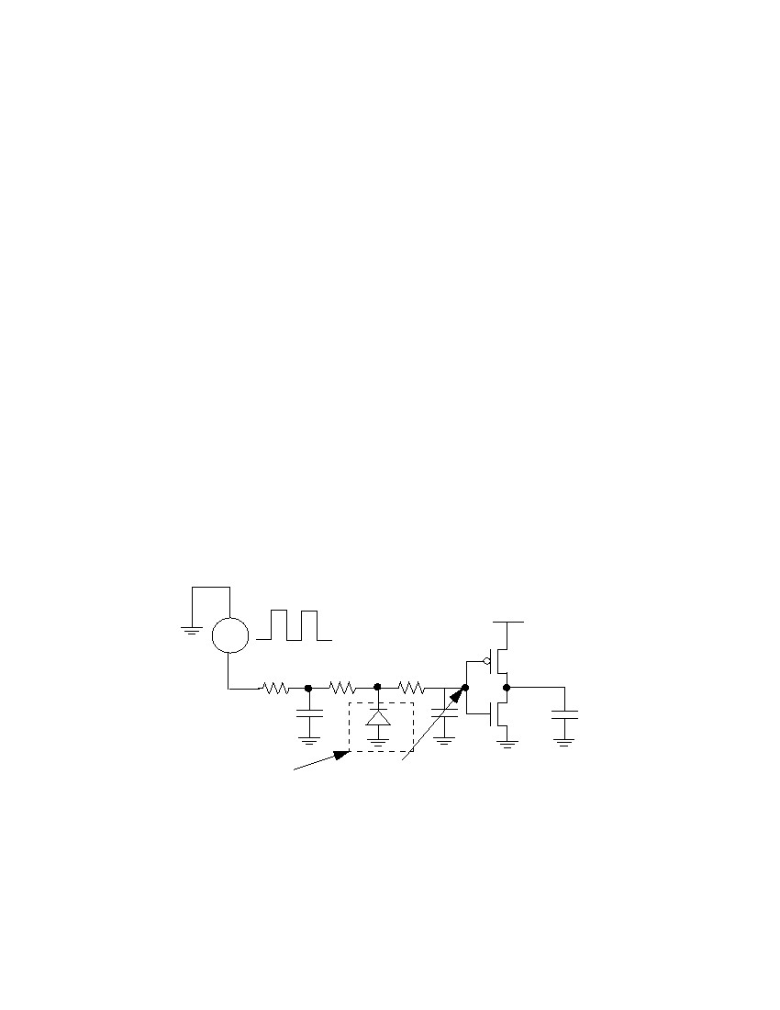
Table 1: Comparison of three approaches
Impact
Cell Area
Routability/Chip Size
Completeness
Timing
Jumper
No
Yes
No
Most
Embedded
Diode
Yes
Yes
No
More
Dynamic
Dropping
Diode
No
No
Yes
Least
9.0 Timing Impact
The following calculation shows the timing comparison between jumper and diode insertion
approaches.[1]
1. Jumper Insertion: Each jumper needs at least two vias. In the 0.35 ∝μ technology, via resis-
tance is around 10 Ω . In 0.25 ∝μ technology or above, via resistance is around 100 Ω or
more.
LL
--R' = R ⋅ ---- ≅ 60mΩ ⋅ ---- ≅ 3 – 10Ω
WW
Where:
R
: The sheet resistance of metal.
R' : The resistance of metal with length L .
2. Diode Insertion:
Diode Capacitance
ε ox34.5µF ⁄ cm
C' ≅ C ox = -------- = ---------------------------------
--
t ox–5
0.4 ⋅ 10 cm
2
= 0.86f F ⁄ ∝μ
Where:
C : Capacitance of the original wire
C' and C ox : Capacitance of the inserted diode
ε ox : Permittivity of diode
SNUG San Jose 2000
9
Fixing Antenna Problem by Synopsys SLE
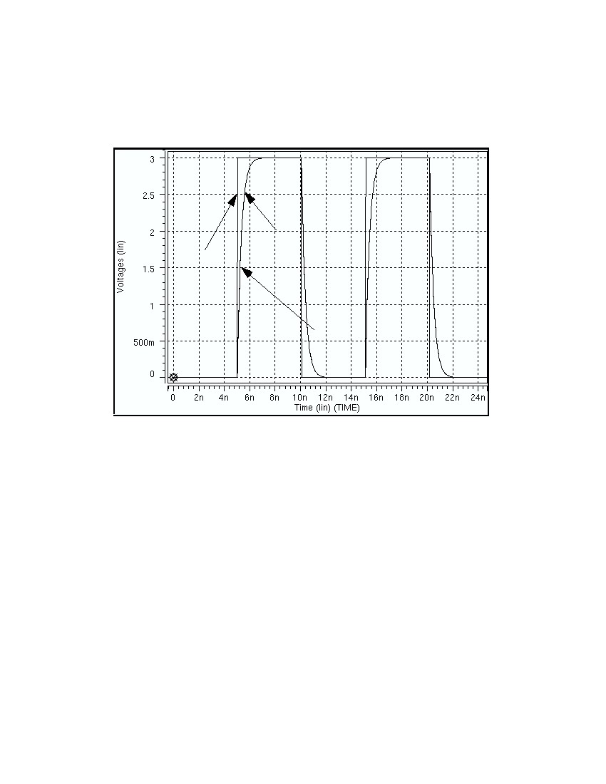
t ox : Thickness of the diode
Time Constant Formula:
τ = ( R + R' ) ⋅ ( C + C' )
C'R'= R ⋅ C ⋅  1 + ---- ⋅  1 + ------CR 
Where:
τ : Time delay of metal with diode/via.
For 0.35 ∝μ design with 350 ∝μ wire, the formula is as follows:
R'5 C'1fF
---- = ----- » ---- = ----------------
R60 C10pF
From the Time Constant formula, we know the timing delay is negligible.
In Figure 8, set the following parameters for very long wire:
VIN: 200 MHz input signal from output port
R1: 120 Ω for long wire resistance
C1: 2.4 pF for long wire capacitance
R2: 10 Ω for short wire resistance
D1: N-Diode with area 1.1µm ⋅ 1.1µ m
C2: 0.2 pF for short wire capacitance
R3: 5 Ω for short wire resistance
VDD: 3.0 V
C3: 1.0 fF for CMOS capacitance
Input signal from
output port (200 MHz)
VIN
VDD
1.8/0.4
C2
0.9/0.4
R1
C1
R2
R3
D1
C3
Dropping
diode
Delay signal at
input port
Figure 8. Timing simulation of diode insertion
Figure 9 shows the simulation circuits of timing delay of a very long wire with a 200 MHz input
signal (from the output port). This very long wire with an N-Diode (P-Diode) or without a diode
SNUG San Jose 2000
10
Fixing Antenna Problem by Synopsys SLE
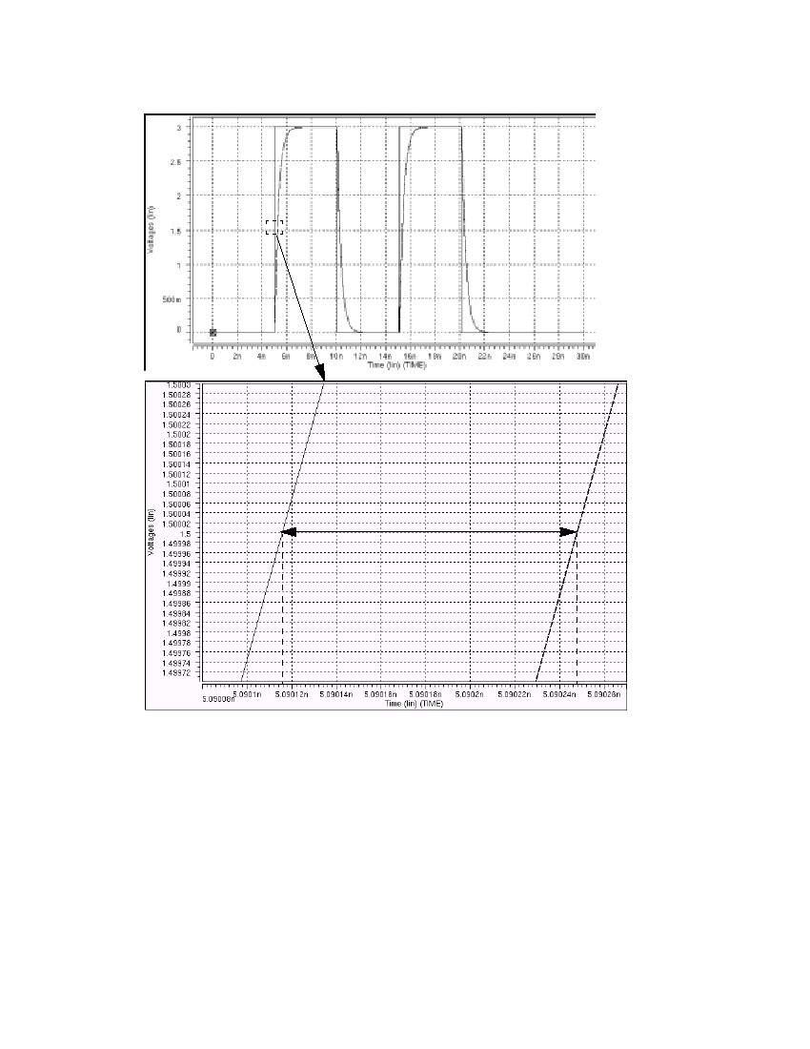
has about 0.3 nsec timing delay. The dropping diode’s timing effect is negligible. The forward
diode has the same time delay as the reverse diode but it drops the maximum amplitude of the sig-
nals at some voltage level. Therefore, the forward diode cannot be used to solve the antenna prob-
lem.
Input
signal
from
output
port
Delay
signal
at
input
port
Time delay caused by long wire
Figure 9. Timing delay simulation of a very long wire with N-diode
Figure 10 shows the result of a medium long wire with the following conﬁgurations:
VIN: 200 MHz input signal from output port
R1: 17 Ω for long wire resistance
C1: 5.3 pF for long wire capacitance
R2: 1.0 Ω for short wire resistance
D1: N-Diode with area 1.1µm ⋅ 1.1µ m
C2: 0.125 pF for short wire capacitance
R3: 0.5 Ω for short wire resistance
VDD: 3.0 V
C3: 1.0 fF for CMOS capacitance
The total wire’s timing delay is 0.1ns . The timing delay caused by this N-Diode is 0.0001ns ,
which is negligible. In the real design, the wire’s patterns are much more complicated, but the
inserted diode’s effect is similar.
SNUG San Jose 2000
11
Fixing Antenna Problem by Synopsys SLE
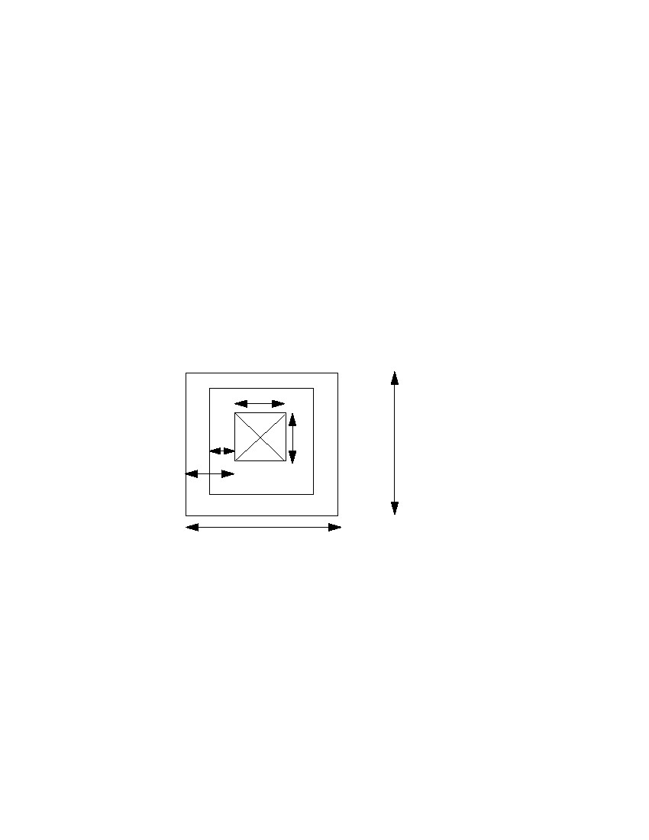
0.0001ns
Figure 10. Timing delay simulation of a medium long wire N-diode
10.0Advantages of The Dynamic Diode Dropping Approach
The designers may insert diodes within a given physical design tool ﬂow. SLE's approach is post
P&R. Its main advantage, ﬂow-wise, are:
1. works with users' existing physical design ﬂow
2. the only way to solve antenna violations for mixed-signal / analog designs. Since analog cir-
cuit design can not routed with P&R tool.
SNUG San Jose 2000
12
Fixing Antenna Problem by Synopsys SLE
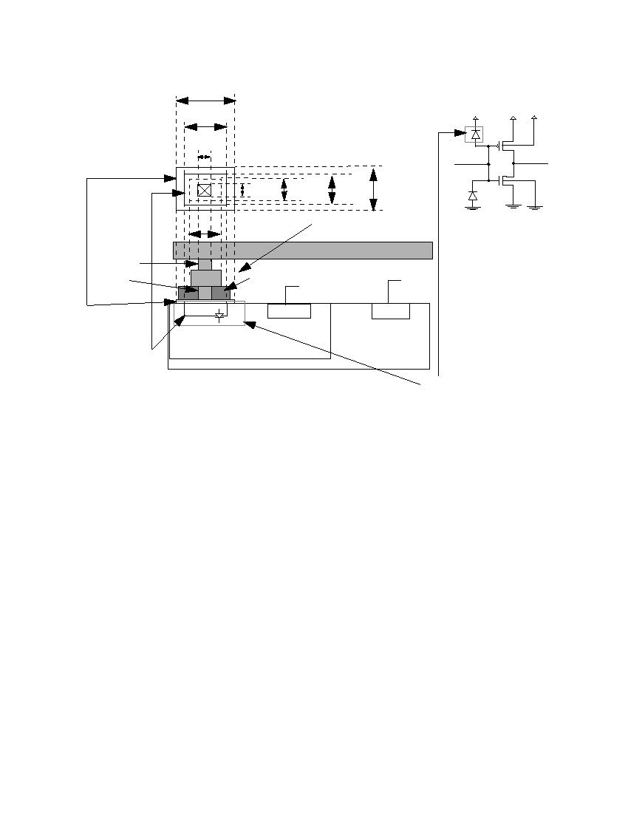
Figures 8, 9, and 10 show the dynamic diode dropping approach to have the following advantages:
1. Least timing degradation (better than embedded)
2. Least waste of chip area during manufacturing
3. Least impact on routability. The jumper only approach is unusable on very dense chips.
11.0Diode Structure
Figure 11 shows a top view of diode structure for the 0.35 ∝μ process. A diode is composed by a
+
via, Metal 1, and Composite. Dropping an N-Diode on top of N – IMP within P-Substrate
forms a reversed bias diode during normal operation, as shown in Figure 13. Forward diodes
degraded the signals; whereas, reverse diodes can preserve the signals during normal operation.
Figures 12 and 13 show the reverse bias of a P-Diode and an N-Diode for the P-MOS and N-MOS
processes, respectively.
0.5µm
0.1µm
0.5µm
Via
0.3µm
1.1µm
Metal 1
Composite/Diffusion
1.1µm
Figure 11. Top view of diode structure
Two kinds of dropping diodes are described as follows:
1. N-Diode with N-IMP ( N implant )
2. P-Diode with P-IMP ( P implant )
Figures 12 and 13 show dropping a P-Diode for the P-MOS Process and an N-Diode for the N-
MOS Process, respectively. Note that transistor part are not shown in both diagrams. NIMP
( N implant ) , PIMP ( P implant ) , and DIFF are the fundamental mask layers. PDIFF and
NDIFF are derived from these fundamental mask layers.
+
+
+
+
SNUG San Jose 2000
13
Fixing Antenna Problem by Synopsys SLE
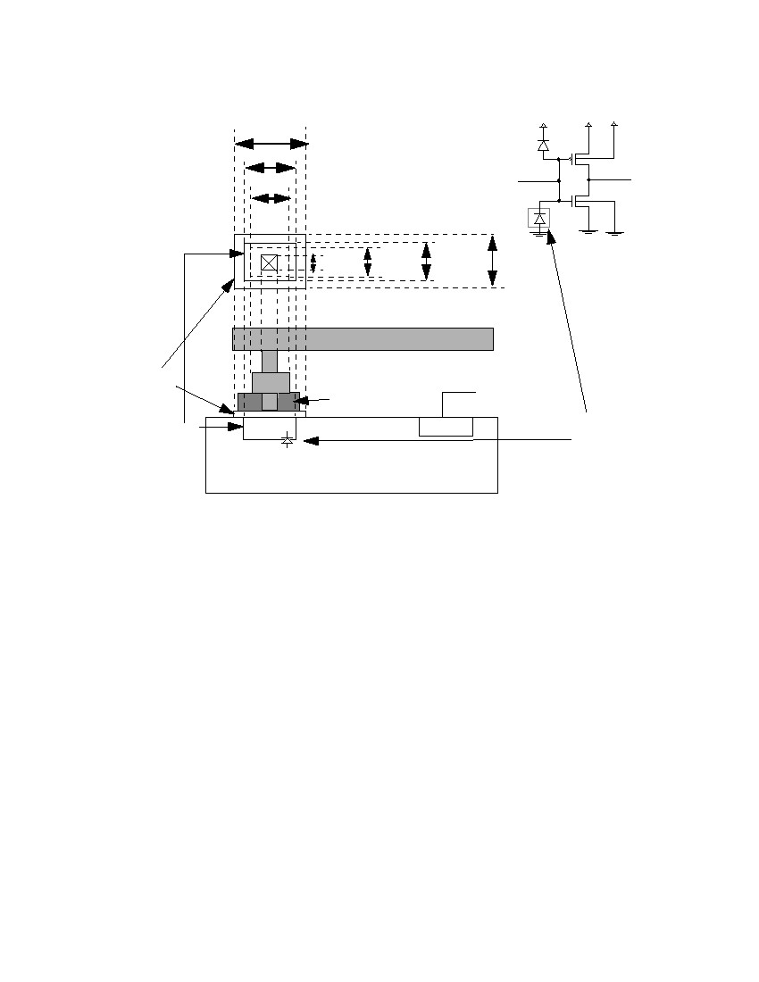
1.5µm
1.1µm
0.5µm
0.5µm 0.7µm
0.7µm
M2
Via
Contact
P implant
PDIFF
NWELL
+
VDD
VDD VDD
1.5µm
1.1µm
M1
bulk
bulk
N-diode
M1
Oxide
N
+
VDD
+
VSS
P
VSS
P-Substrate
Reverse
Bias P-Diode
VDD
Figure 12. Dynamic dropping P-Diode (PN protection diode) structure for P-MOS Process
SNUG San Jose 2000
14
Fixing Antenna Problem by Synopsys SLE
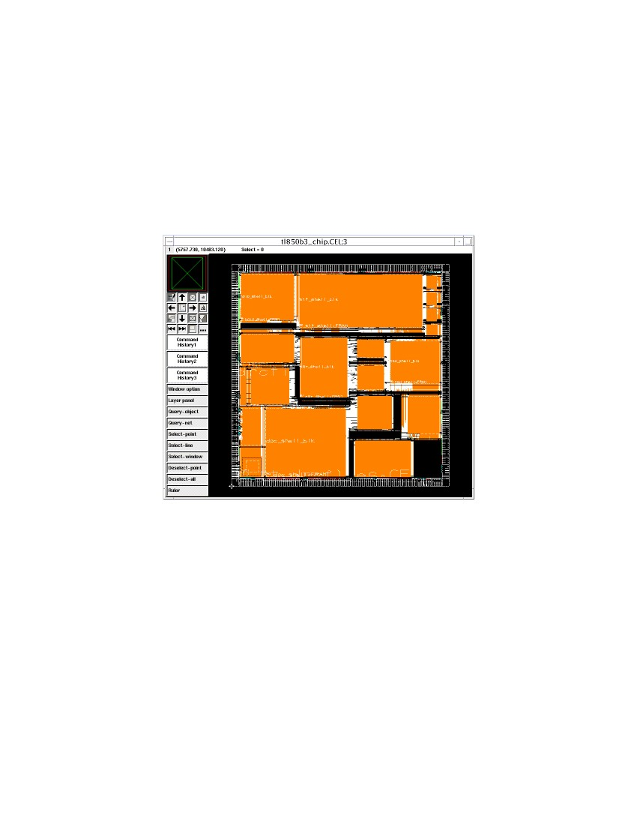
VDD
VDD VDD
1.5µm
1.1µm
0.7µm
1.5µm
0.5µm 0.7µm
1.1µm
M1
bulk
bulk
M2
+
N – IMP
NDIFF
P-Substrate
M1
Oxide
P
VSS
+
VSS
Reverse
Bias
N-Diode
Figure 13. Dynamic dropping N-Diode (NP protection diode) structure for N-MOS Process
12.0Procedures for Fixing Antenna Violations
The procedure for ﬁxing antenna violations are illustrated below:[4]
1. Make sure the rule ﬁle speciﬁcations follow your process design rules and DRC rules.
2. Bring up the tool for antenna ﬁxing.
3. Create the new library or open the existing library.
4. Stream in GDSII ﬁle.
5. Import the P-Diode and the N-Diode from the GDSII format or create them from scratch.
6. Open the top level cell.
7. Drop the diodes (P-Diode or N-Diode) without extension wires according to the rule ﬁles
speciﬁed in Step 1.
8. Insert the jumper for the rest of the violation (if there is no space to drop a diode).
9. Increase the extension wire to accommodate a bigger area, e.g, 5 ∝μ .
10. (Repeat Step 9 until all the violations are cleaned.)
11. Save the design in a GDSII format.
SNUG San Jose 2000
15
Fixing Antenna Problem by Synopsys SLE
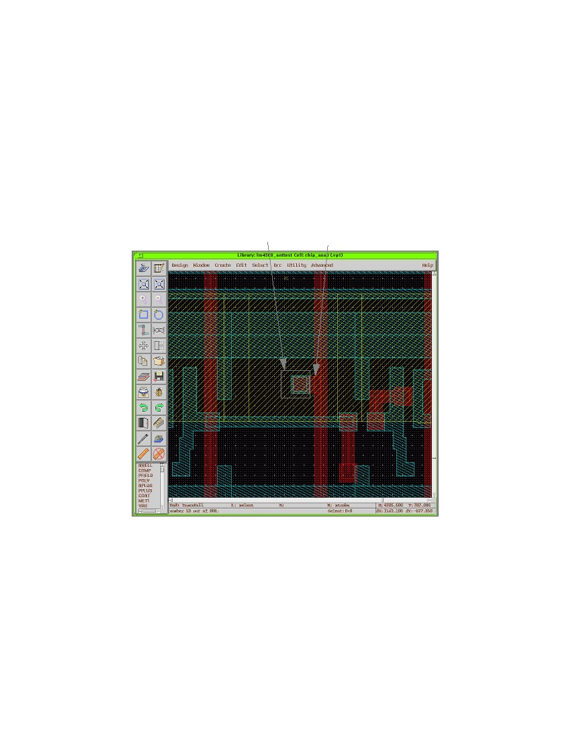
12. Visually check the diode insertion one-by-one. Search and trace all the diodes which are
inserted. Examine the diode structure, location of dropped diodes, and make sure the diodes
touch the right layers.
Figure 14 shows a Teralogic tl850 design which ﬁxes antenna violations by dynamic diode drop-
ping and jumper insertion. For dense designs, it is hard for tools to ﬁnd the space to drop the
diodes. The extension wire gives more space for diode dropping. The extension wire’s width is
very important for the design rule. If the extension wire width is too small, it causes notch errors.
The right wire has a bigger width (the same as the diode width) and will not cause any DRC error.
Figure 15 shows a diode connected to an extension wire.
Figure 14. Antenna ﬁxed by diode dropping and jumper insertion
13.0Dynamic Diode/Jumper Insertion Results
Table 2 shows some results of 0.35 ∝μ technology. The speciﬁcation of a maximum antenna ratio
is 400 without diode insertion, and the maximum ratio is 5000 with diode insertion. Both design
examples in Table 2 are approximately one-quarter of a million gates. Here, we deﬁne the dense
design as core utilization of more than 90% and the sparse design as core utilization of less than
50%.
For the dense design example, the original number of antenna violations for Metal 3 is 154. After
diode dropping, the number of violations for Metal 3 is reduced to 21. After adding jumpers, the
SNUG San Jose 2000
16
Fixing Antenna Problem by Synopsys SLE

violations for Metal 3 are reduced to 3. Finally, using 20 ∝μ extension wires to drop the diode,
the antenna violations are clean. Note that in the topmost metal (e.g., Metal 4), there never are
antenna violations. Since after the wire is connected, the charge discharges into the output port.
Normally, Metal 1 also has no antenna violations. This is because Metal 1’s resources are occu-
pied by standard cells. Therefore, there is very limited space for the router to generate the antenna
problem. Metal 2 violations are very easy to ﬁx, since the tool can always ﬁnd the space to drop a
diode. Metal 3 violations are difﬁcult to ﬁx due to the limited space resources.
For some designs with limited routing resources (e.g., when only three metals are used), core uti-
lization is low (e.g., 49%). These designs have lots of space to insert diodes, and most of the vio-
lations can be ﬁxed after the ﬁrst run of diode dropping.
diode
extension wire
Figure 15. Diode insertion with wire extension
SNUG San Jose 2000
17
Fixing Antenna Problem by Synopsys SLE
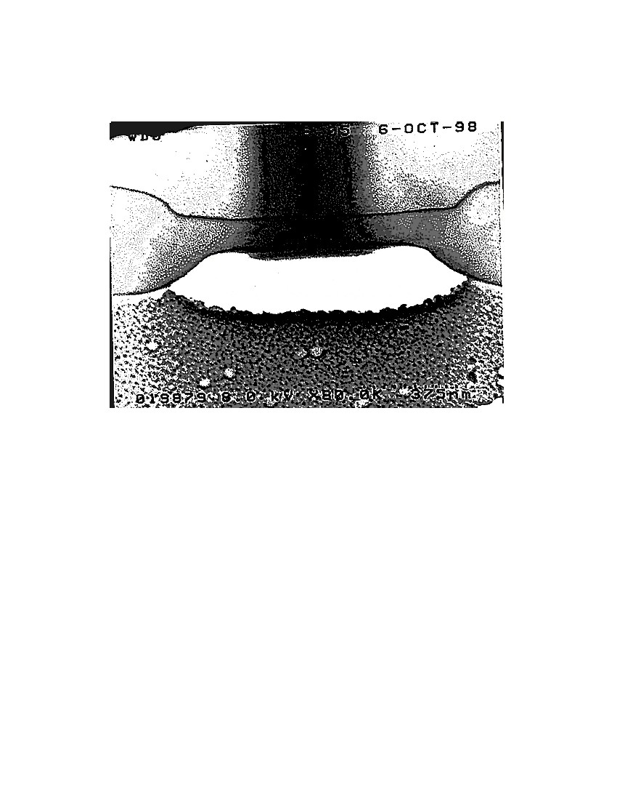
Table 2: Dynamic diode and jumper insertion
Diode insertion
without exten-
sion wires
M4: 0
M3: 21
M2: 0
M1: 0
M4: 0
M3: 1
M2: 0
M1: 0
Diode insertion
with 20 ∝μ
extension wires
M4: 0
M3: 0
M2: 0
M1: 0
N/A
Design names
Design 1:
dense design
Violation
M4: 0
M3: 154
M2: 23
M1: 0
M4: 0
M3: 788
M2: 521
M1: 0
Add jumper
M4: 0
M3: 3
M2: 0
M1:0
M4: 0
M3: 0
M2: 0
M1: 0
Design 2:
sparse design
14.0RC Extraction and SPICE Timing Simulation (Optional)
We need to perform the SPICE analysis to understand the timing impact after the diode insertion.
The following steps are used to get the delay information from SPICE.
1. Perform the critical path and longest path from Synopsys Prime Time.
2. Select a path, for example, longest path, starting from one ﬂip-ﬂop (register) and terminated at
the other ﬂop-ﬂop (register).
3. Get the RC extraction information, i.e., Standard Delay Format (SDF) information by per-
forming the RC analysis.
4. Extract the selected path RC information including sun-node.
5. Insert the diode into the closest node by examining the layout’s diode inserted position by
Synopsys SLE.
6. Set the data input and clock waveforms for the triggering the starting register in the selected
path.
7. Perform the SPICE analysis by comparing the timing delay before diode insertion and after
diode insertion.
The timing impact is negligible.
15.0Diode Slicing
The purpose of the diode slicing is to make sure that the diode that inserted do not cause any leak-
age current and timing degradation. Figures 16 and 17 show the cross-section of a diode. Figure
16 shows a cross-section of an N-Diode just before entering into the tungsten plug (contact). The
diffusion stain (the dark black area on N-COMP) shows that the diffused junction is big enough.
Figure 17 shows the same N-Diode on a different die through the center of the tungsten plug. The
SNUG San Jose 2000
18
Fixing Antenna Problem by Synopsys SLE
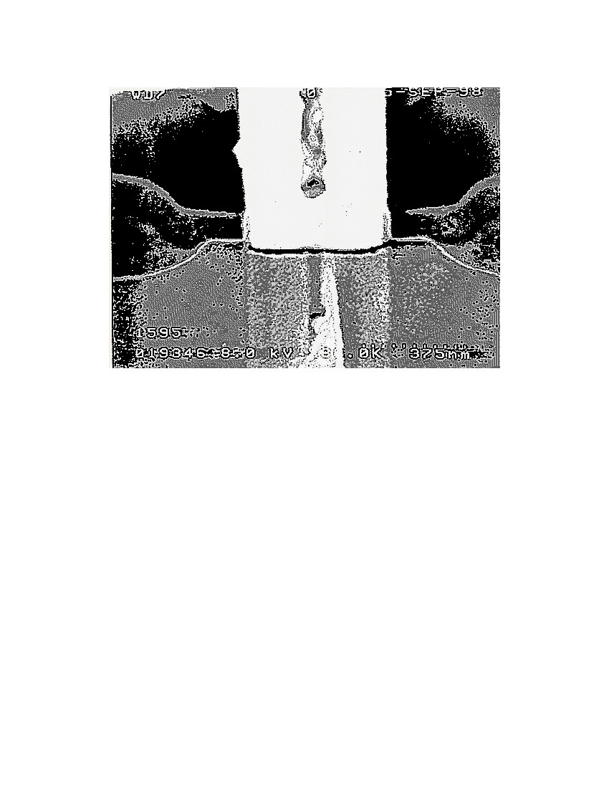
N-COMP area is not stained. Figures 16 and 17 show that the contact is touching the N-COMP
area correctly.
Figure 16. Cross-section of contact before entering into the tungsten plug
SNUG San Jose 2000
19
Fixing Antenna Problem by Synopsys SLE
Figure 17. Same contact on a different die through the center of the tungsten plug
16.0Conclusions and Recommendations
For dense designs (core utilization of more than 90%), dynamic diode dropping, jumper insertion,
and dropping diodes with extension wires are three approaches which can be used to solve
antenna violations. For design engineers, try to loosen up core utilization 5% to 7%, in order to
leave some margin for diode and jumper insertion approaches.
For sparse designs (core utilization less than 50%), diode dropping alone is ﬂexible enough to
solve antenna problem. The three approaches proposed in this paper can be used successfully to
solve most antenna violation problem.
This article do not consider the effect of diode insertion for clock net and memory blocks. Since
the clock net is balanced tree structure, diode insertion will affect the skew and timing degradation
problem. Therefore, diode insertion to clock net and memory block are not recommended. The
SLE can be improved to avoid the diode insertion for memory block and clock net.
This paper’s approach can be applied to both block level and top level’s antenna ﬁxing. Timing
delay can be veriﬁed from the RC extraction and SPICE tools. The timing delay caused by diode
insertion is within 0.02% for critical net (the longest nets in design, such as clock net). DRC and
SNUG San Jose 2000
20
Fixing Antenna Problem by Synopsys SLE
LVS are veriﬁed after ﬁxing antenna problems. If the tool does not generate the transistor level
netlist, diode insertion can not be checked. In LVS checking, just check for short circuits only.[4]
17.0Acknowledgments
The following people have been help for this paper: Kevin Weaver and James Lin performed the
diode slicing, Leonard Jen’s SPICE simulation; Shariar Motie, Tracey Tu, and Jerry Noble per-
formed placement and route; Tim Tan prepared the layout library and technology ﬁle and Eddie
Tan for the runset and layout veriﬁcation; Elizabeth Taylor’s proof reading; Sunil Malkani, Eitan
Cadouri, and Alvin Ling’s support; Geoffrey Ying and Chang-sheng Ying’s help about the devel-
opment of Synopsys SLE tool.
18.0References
1. Paul Penﬁeld, Jr. and Jorge Rubenstein, “Signal Delay in RC Tree Networks,” 18th Design
Automation Conference, IEEE, pp. 613-617,1981.
2. Michael Santarini, “Tool Automatically Removes Antenna Violations,” EE Times, Issue 1013,
p. 88, June 22, 1998.
3. Chang-sheng Ying, “Techniques for Removing Antenna Rule Violations,” Patent Pending,
Stanza System, Inc., Cupertino, California, 95014.
4. Peter H. Chen et al, “VLSI Design Flow,” National Semiconductor Corporation, Santa Clara,
CA 95052, May, 1997.
SNUG San Jose 2000
21
Fixing Antenna Problem by Synopsys SLE

