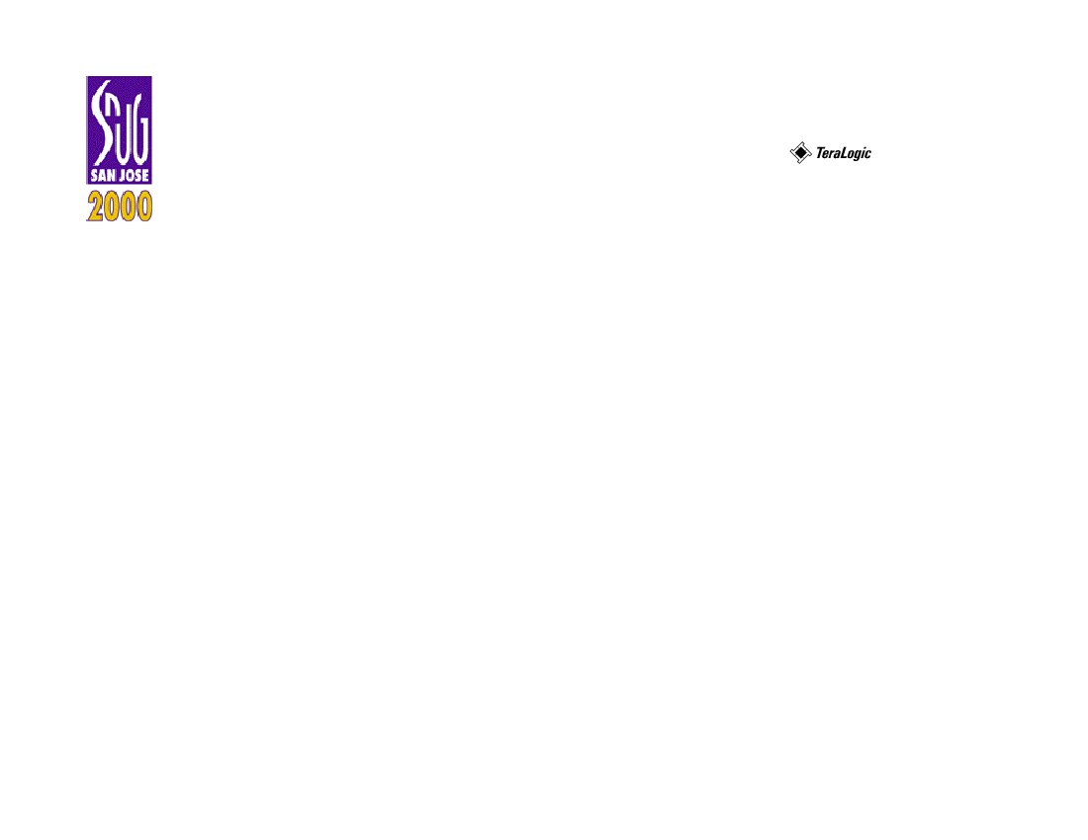
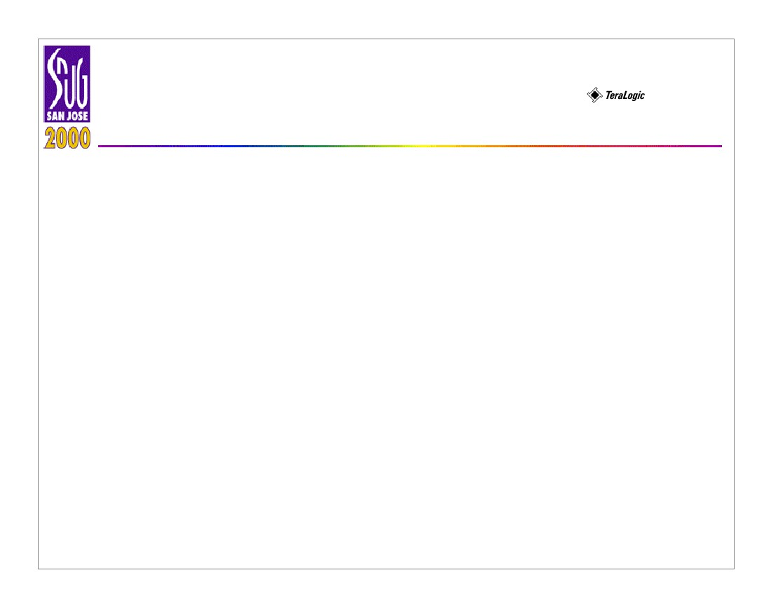
Peter H. Chen
1
Fixing Antenna Problem by
Synopsys SLE
Peter H. Chen, Sunil Malkani, Chun-Mou Peng, and
Geoffrey Ying
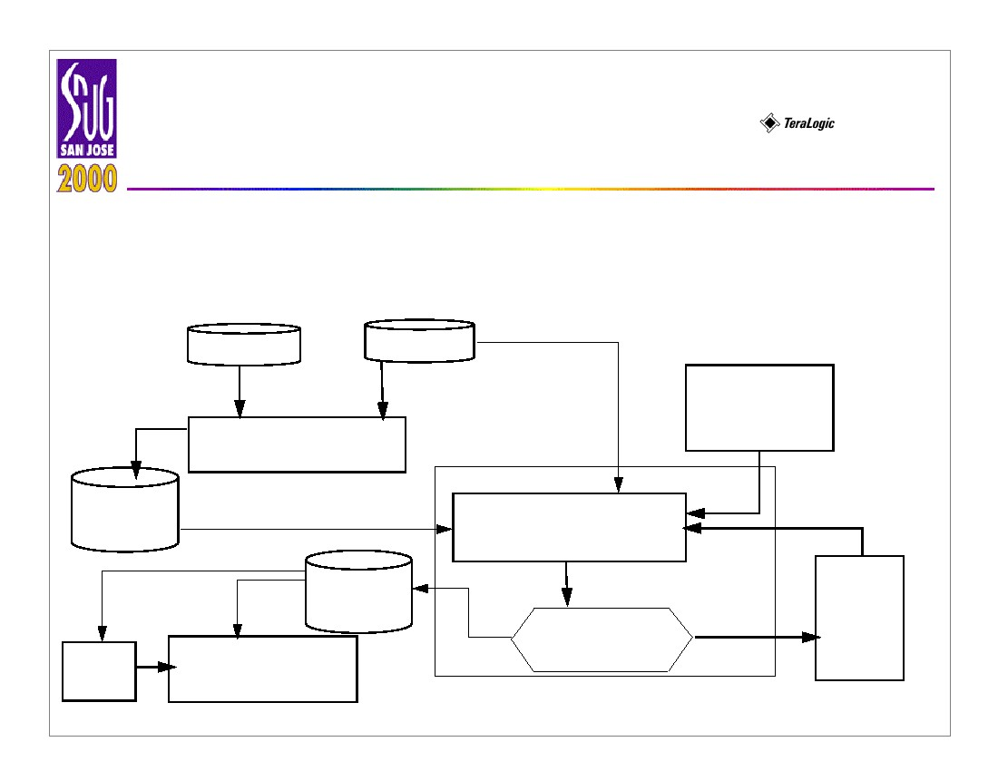
Fixing Antenna Problem by
Synopsys SLE
Peter H Chen
2
• Introduction
- Antenna explanations
- Antenna ratio deﬁnitions
- Antenna check out violation by veriﬁcation tools
- Comparison of diode dropping and jumper insertion methods
- Diode characterizations and structures
- Diode dropping, jumper insertion, and diode dropping with extension wire
- Chip-level protection diode dropping for blocks
- Diode timing delay checking by RC extraction and SPICE Simulation
- Diode structure veriﬁcation by slicing
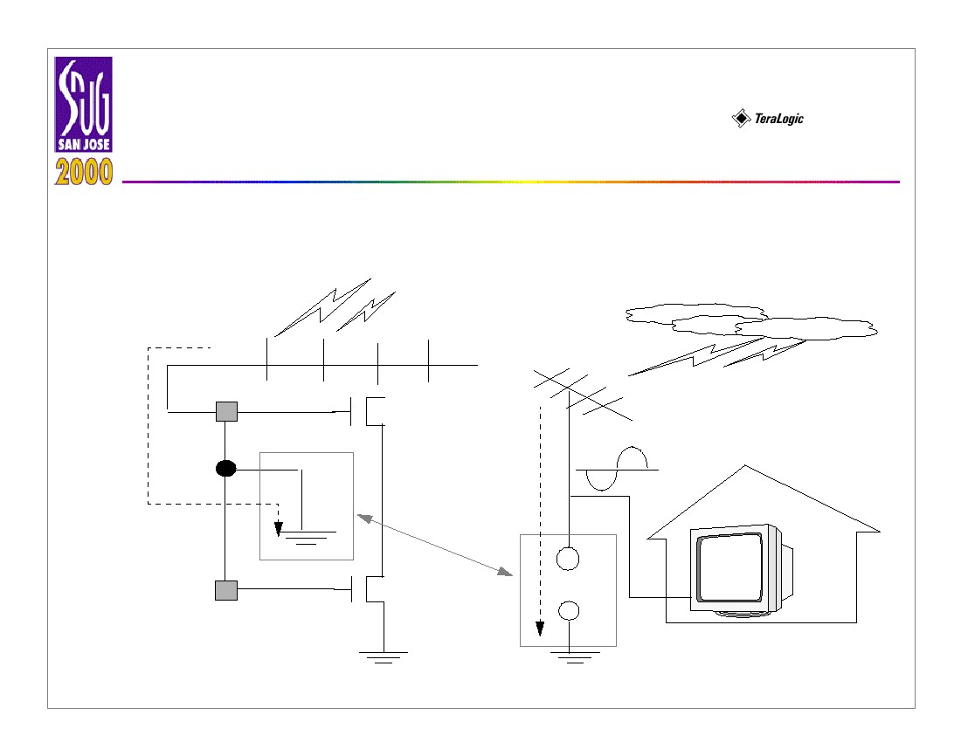
Fixing Antenna Problem by
Synopsys SLE
• Flow Chart for Fixing the Antenna Problem
2.
Runset
4.
Antenna Violation
Verification
3.
GDSII File
1.
Peter H Chen
3
5.
Summary
Error
9.
11.
Reticle Generation /
Wafer Manufacturing
Tapeout
GDSII File
Yes
Synopsys SLE
6.
Add Diode and
Add Jumper
7.
All Antennae
Fixed?
Diode Design /
Simulation /
Design Rule File
10.
Timing
Analysis
8.
Increase
Extension
No
Wire
Length
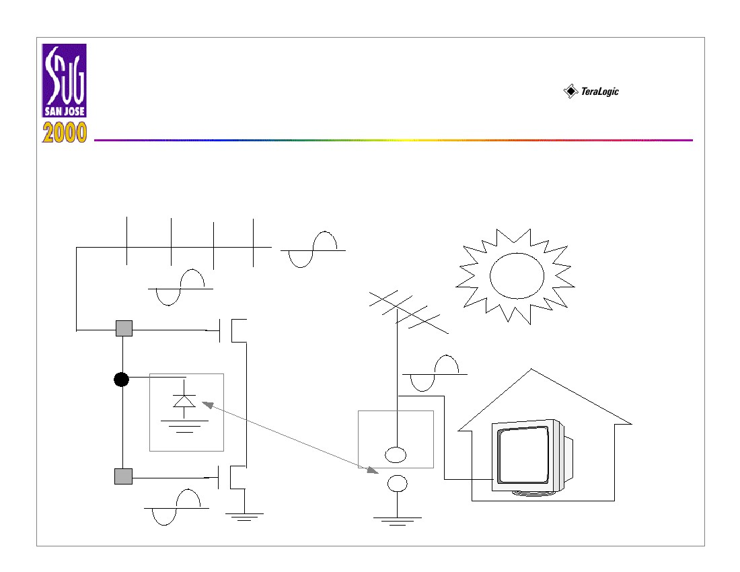
Fixing Antenna Problem by
Synopsys SLE
• Antenna During Manufacturing
Peter H Chen
4
UV light
+
+
M1
M2
+
+
+
+
+
Antenna
Problem
⇔
Charge
flow
into
ground
M1
Diode
+++
+
- ---
Fixing Antenna Problem by
Synopsys SLE
• Antenna During Normal Operation
Peter H Chen
5
M1
M2
Antenna
Problem
⇔
M1
Diode
-
-
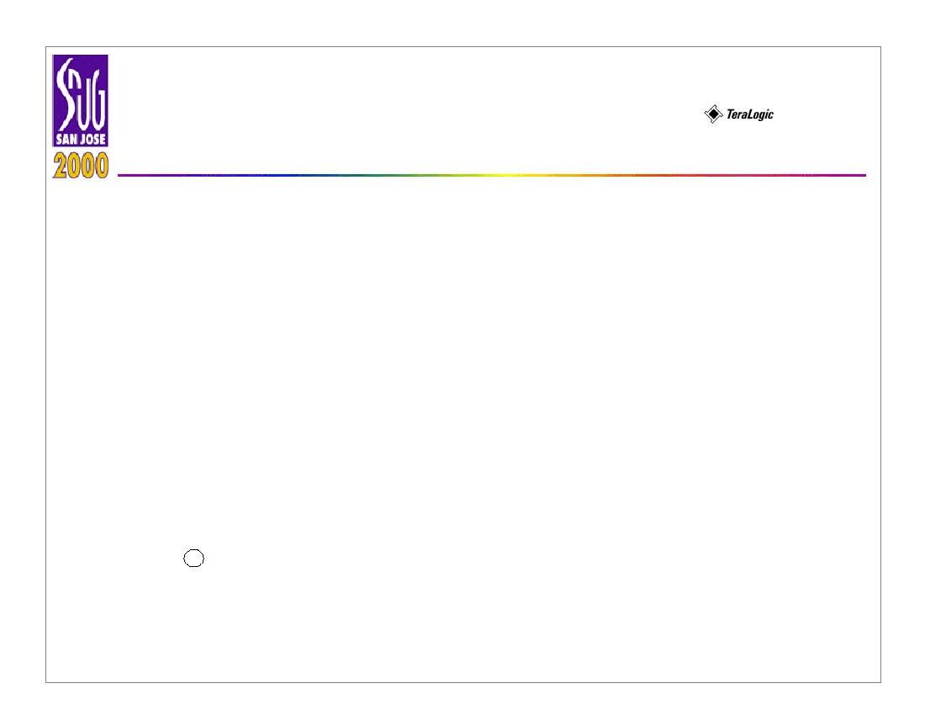
Fixing Antenna Problem by
Synopsys SLE
• Antenna Ratio Deﬁnition
The antenna ratio of a particular net is deﬁned as:
Total Wire Area
Antenna Ratio = ---------------------------------------------------------
Total Input Port Area
Peter H Chen
6
Note that the antenna rule violation deﬁnition is foundry and process
speciﬁc. For example, TSMC design rules (0.18 ∝μ ) uses total perimeter area
of metal wire vs. gate area.
Fixing Antenna Problem by
Synopsys SLE
Peter H Chen
7
• Antenna Rule Checking
- The violated position of the wire: The ( x, y ) position of which the antenna
ratio of the wire exceeds the speciﬁed antenna ratio, e.g, 400.
- Error ﬂattened: Since the wire is connected to every module, it should not
be hierarchical. Therefore, the errors should be ﬂattened. Set the error
ﬂattened option if the tool is a hierarchical veriﬁcation tool. If the
veriﬁcation tool is not hierarchical, you do not need to set this option.
- Chip level: At the chip level, since each block’s antenna problem is ﬁxed,
we only need to consider the interconnection among the blocks. Since
the whole chip may be very large (e.g., 1 million gates), to check the
whole chip antenna violation might take a long time (several days on a
R
SUN Ultra-SPARC workstation). If the chip is too big, chip-level
antenna violations can be avoided by putting a protection diode on
every input pin.
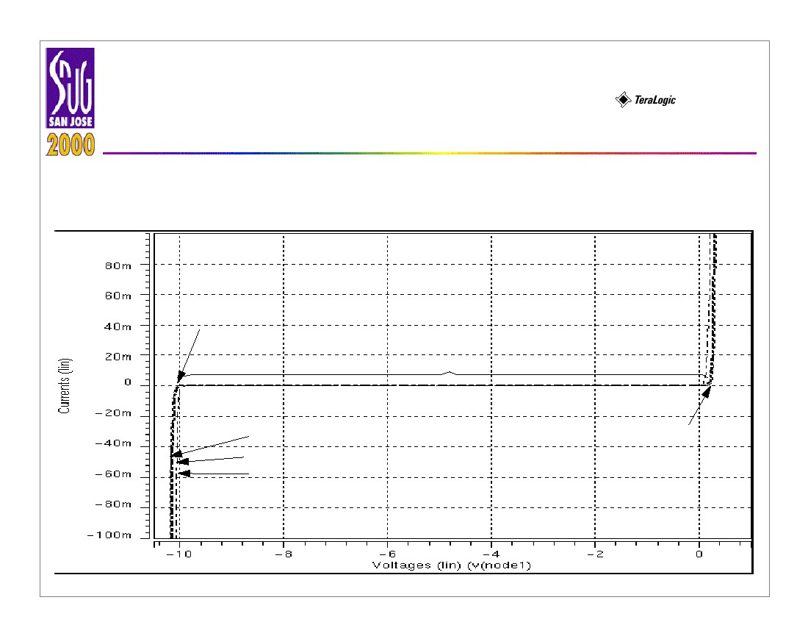
Fixing Antenna Problem by
Synopsys SLE
Peter H Chen
8
• Three Solutions for Antenna Problem
- Router options: Break signal wires and routes to upper levels.
- Embedded protection diode: Add protection diodes on every input port
for every standard cell.
- Dynamic dropping diode after placement and route: Fixing only the wire
with the antenna violation which will not waste routing resources.
reverse diodes.
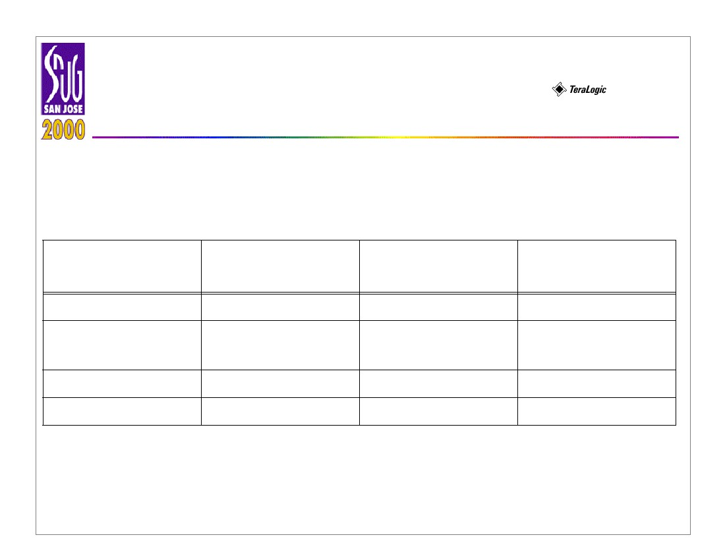
Fixing Antenna Problem by
Synopsys SLE
• The Leakage Current vs. Different Diode Area
Peter H Chen
9
-10 V
Operation Range
Reverse Bias of n-Diode
0.5µm ⋅ 0.5µm
1µm ⋅ 1µm
5µm ⋅ 5µm
0.7 V
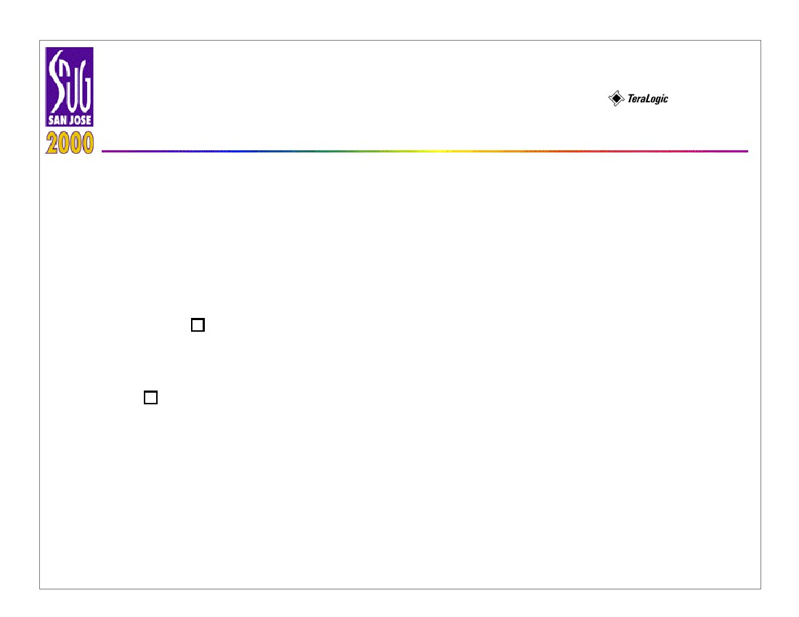
Fixing Antenna Problem by
Synopsys SLE
• Different Approaches Comparison
Table 1: Comparison of three approaches
Impact
Cell Area
Routability/Chip
Size
Completeness
Timing
Jumper
No
Yes
No
Most
Embedded Diode
Yes
Yes
No
More
Peter H Chen
10
Dynamic Dropping
Diode
No
No
Yes
Least
Fixing Antenna Problem by
Synopsys SLE
Peter H Chen
11
• Jumper Insertion Timing Impact: Each jumper needs at least
two vias. In the 0.35 ∝μ technology, via resistance is around 10
Ω . In 0.25 ∝μ technology or above, via resistance is around 100
Ω or more.
'=R
Where:
R
: The sheet resistance of metal.
LL
--⋅ ---- ≅ 60mΩ ⋅ ---- ≅ 3 – 10Ω
WW
R' : The resistance of metal with length L .
Fixing Antenna Problem by
Synopsys SLE
• Diode Insertion Timing Impact:
Diode Capacitance
ε ox2
34.5µF ⁄ cm
C' ≅ C ox = -------- = --------------------------------- = 0.86f F ⁄ ∝μ
--
t ox–5
0.4 ⋅ 10 cm
Where:
C' and C ox : Capacitance of the diode
Peter H Chen
12
ε ox : Permittivity of diode and t ox : Thickness of the diode
Time Constant:
 1 + R' ⋅  1 + C'τ = ( R + R' ) ⋅ ( C + C' ) = R ⋅ C ⋅----------
R C
Where:
τ:
Time delay of metal with diode/via.
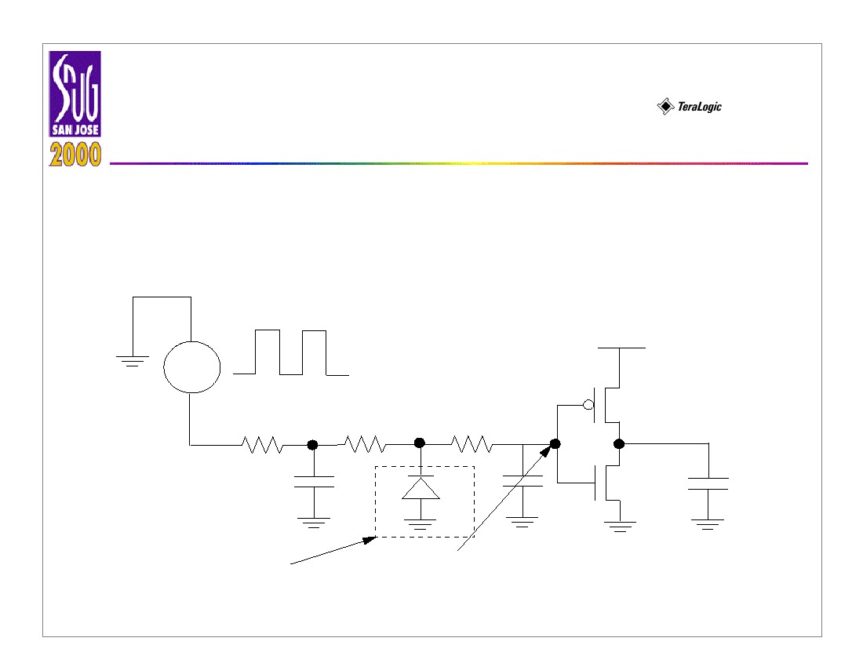
Fixing Antenna Problem by
Synopsys SLE
• Timing Impact
Peter H Chen
13
For 0.35 ∝μ design with 350 ∝μ wire, the formula is as follows:
R'5 C'1fF
---- = ----- » ---- = ----------------
R60 C10pF
Where:
τ : Time delay of metal with diode/via.
For 0.35 ∝μ design with 350 ∝μ wire, the formula is as follows:
R'5 C'1fF
---- = ----- » ---- = ----------------
R60 C10pF
From the Time Constant formula, we know the timing delay is negligible.
Fixing Antenna Problem by
Synopsys SLE
• SPICE Simulation for Diode Insertion
Peter H Chen
14
Input signal from
output port (200 MHz)
VIN
VDD
1.8/0.4
0.9/0.4
R1
C1
R2
R3
D1
C2
C3
Dropping
diode
Delay signal at
input port
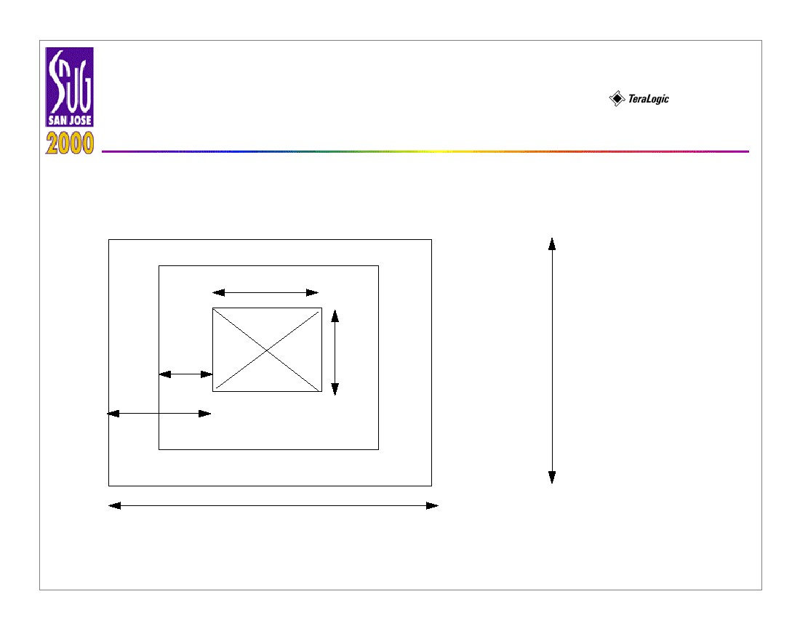
Fixing Antenna Problem by
Synopsys SLE
Peter H Chen
15
• Advantages of The Dynamic Diode Dropping Approach
- The designers may insert diodes within a given physical design tool ﬂow.
SLE's approach is post P&R. Its main advantage, ﬂow-wise, are:
- works with users' existing physical design ﬂow
- the only way to solve antenna violations for mixed-signal / analog
designs. Since analog circuit design can not routed with P&R tool.
- Least timing degradation (better than embedded)
- Least waste of chip area during manufacturing
- Least impact on routability. The jumper only approach is unusable on
very dense chips.
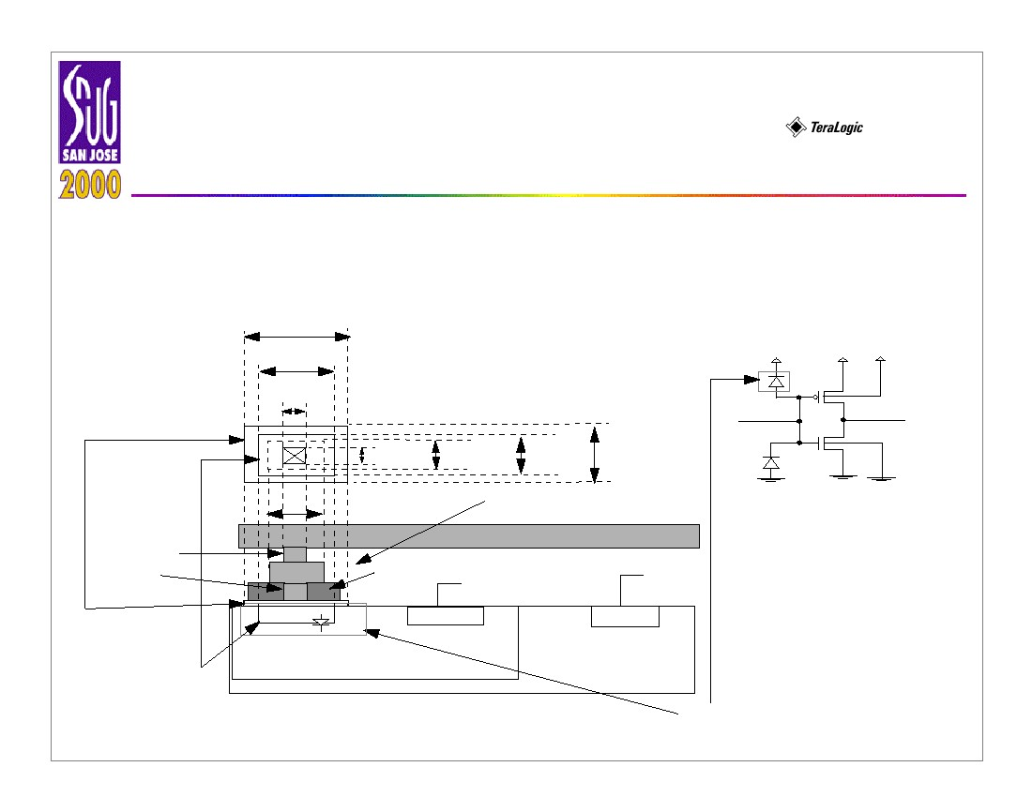
Fixing Antenna Problem by
Synopsys SLE
• Diode Structure
0.5µm
Peter H Chen
16
0.1µm
0.5µm
Via
0.3µm
1.1µm
Metal 1
Composite/Diffusion
1.1µm
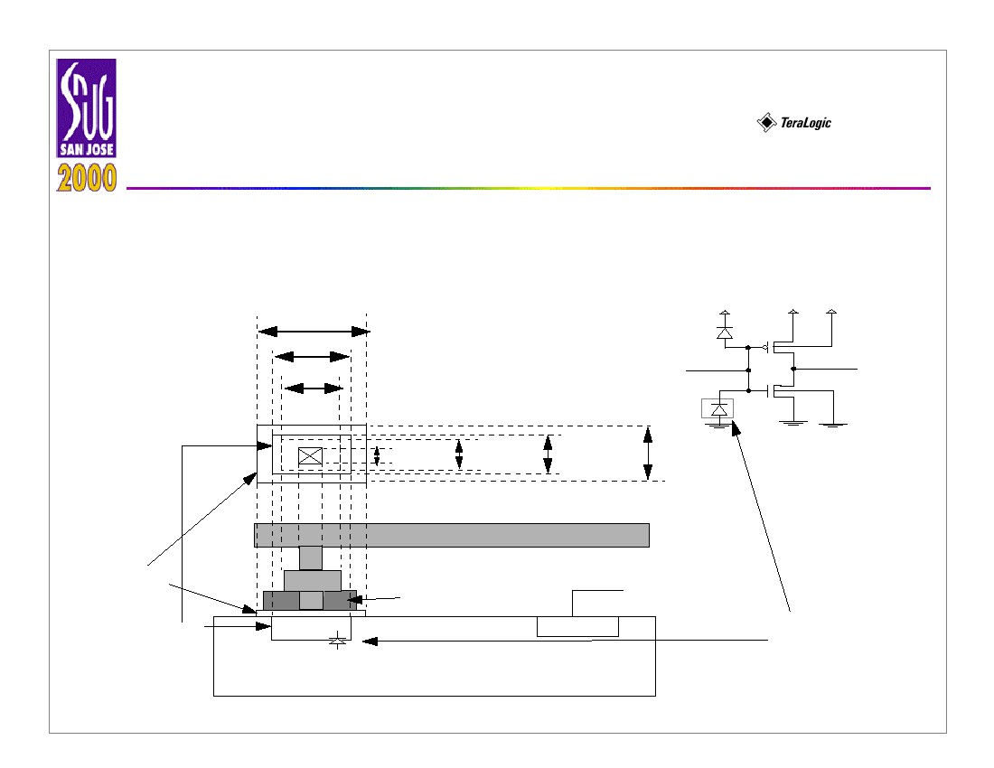
Fixing Antenna Problem by
Synopsys SLE
• P-Diode with P-IMP ( P implant )
+
Peter H Chen
17
1.5µm
1.1µm
0.5µm
0.5µm
0.7µm
0.7µm
1.5µm
1.1µm
VDD
VDD
VDD
M1
bulk
bulk
N-diode
M2
Via
Contact
P implant
+
M1
Oxide
N
+
VDD
+
VSS
P
VSS
VDD
PDIFF
NWELL
P-Substrate
Reverse
Bias P-Diode
Fixing Antenna Problem by
Synopsys SLE
• N-Diode with N-IMP ( N implant )
VDD
Peter H Chen
18
+
VDD
VDD
1.5µm
1.1µm
0.7µm
1.5µm
0.5µm
0.7µm
1.1µm
M1
bulk
bulk
M2
+
N – IMP
M1
Oxide
NDIFF
P-Substrate
P
+
VSS
Reverse
Bias
N-Diode
VSS
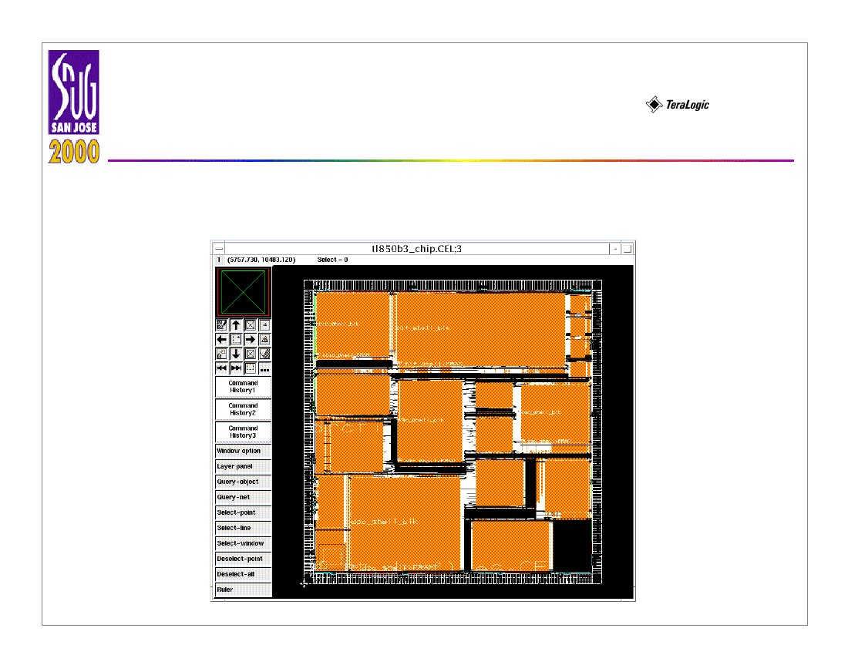
Fixing Antenna Problem by
Synopsys SLE
• Procedures for Fixing Antenna Violations
Peter H Chen
19
1. Make the rule ﬁle speciﬁcations.
2. Bring up the tool for antenna ﬁxing.
3. Create the new library and stream in GDSII ﬁle.
4. Import the P-Diode and the N-Diode and open the top level cell.
5. Drop diodes w/o extension wires per Step 1.
6. Insert the jumper for the rest of the violation
7. Increase the extension wire to accommodate a bigger area.
8. (Repeat previous step until all the violations are cleaned.)
9. Save the design in a GDSII format.
10.Visually check the diode insertion.
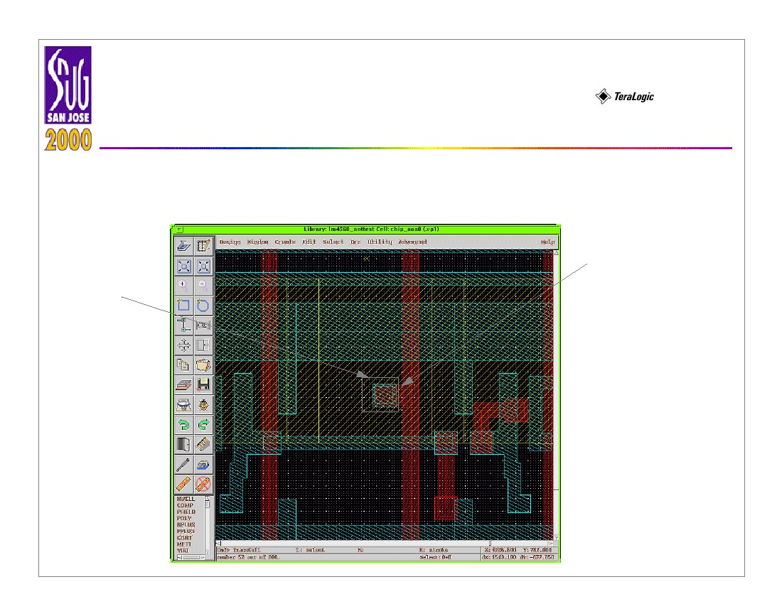
Fixing Antenna Problem by
Synopsys SLE
• Tapeout Chip Example
Peter H Chen
20
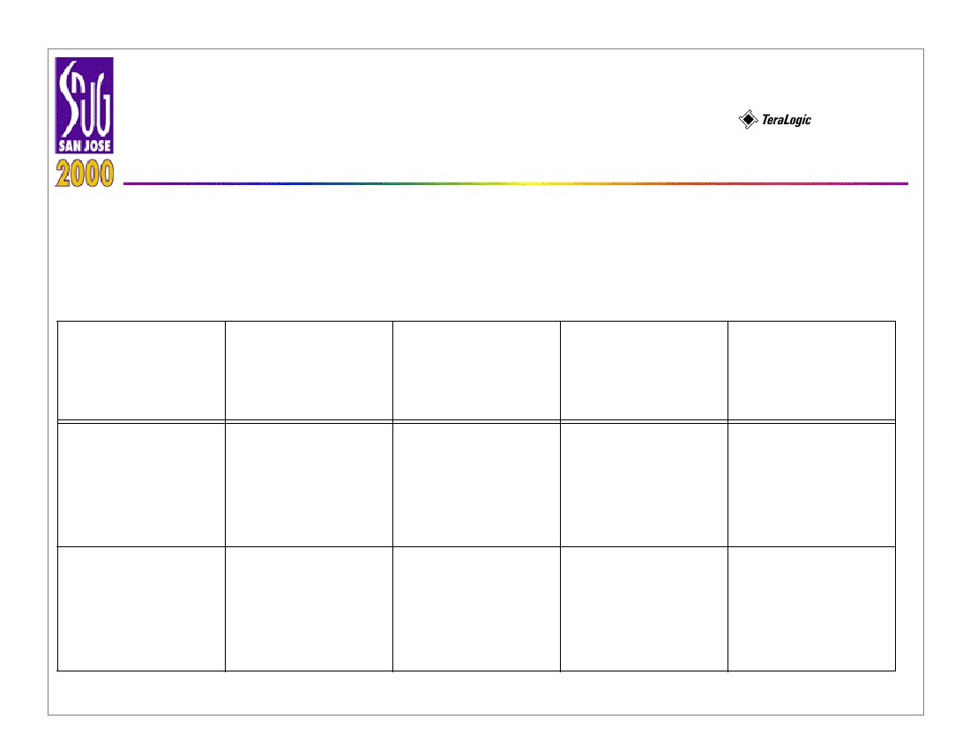
Fixing Antenna Problem by
Synopsys SLE
• Extension Wire Example
Peter H Chen
21
extension wire
diode
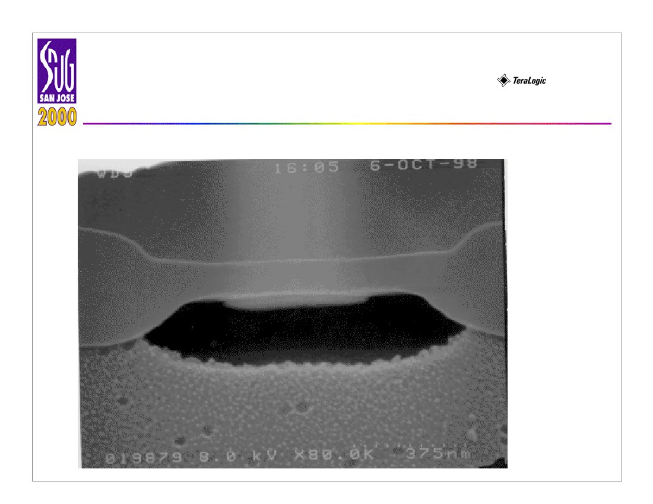
Fixing Antenna Problem by
Synopsys SLE
• Antenna Fixing Results
Table 2: Dynamic diode and jumper insertion
Design names
Design 1:
dense design
Violation
M4: 0
M3: 154
M2: 23
M1: 0
M4: 0
M3: 788
M2: 521
M1: 0
Diode inser-
Add jumpertion without
extension wires
M4: 0
M3: 21
M2: 0
M1: 0
M4: 0
M3: 1
M2: 0
M1: 0
M4: 0
M3: 3
M2: 0
M1:0
M4: 0
M3: 0
M2: 0
M1: 0
Peter H Chen
22
Diode inser-
tion with 20 ∝μ
extension wires
M4: 0
M3: 0
M2: 0
M1: 0
N/A
Design 2:
sparse design
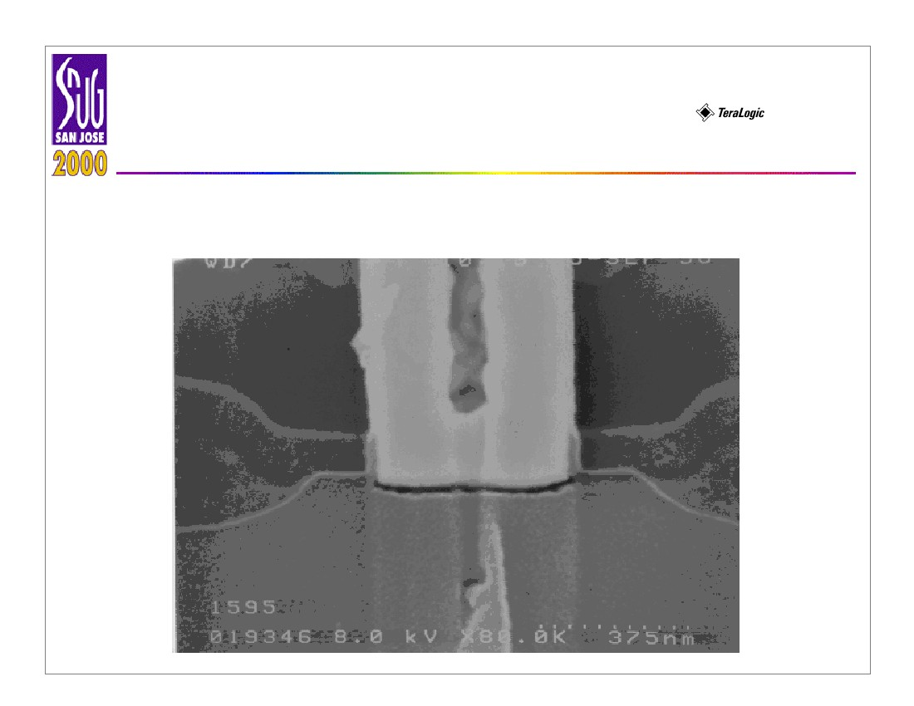
Fixing Antenna Problem by
Synopsys SLE
Peter H Chen
23
• Diode Veriﬁcation: Before Tungsten Plug insertion
Fixing Antenna Problem by
Synopsys SLE
• Diode Veriﬁcation: After Tungsten Plug
Peter H Chen
24
Fixing Antenna Problem by
Synopsys SLE
• Conclusions
Peter H Chen
25
For dense designs (core utilization of more than 90%), dynamic diode
dropping, jumper insertion, and dropping diodes with extension wires are three
approaches which can be used to solve antenna violations. For design
engineers, try to loosen up core utilization 5% to 7%, in order to leave some
margin for diode and jumper insertion approaches.
For sparse designs (core utilization less than 50%), diode dropping
alone is ﬂexible enough to solve antenna problem. The three approaches
proposed in this paper can be used successfully to solve most antenna
violation problem.
Fixing Antenna Problem by
Synopsys SLE
• Recommendations
Peter H Chen
26
This article do not consider the effect of diode insertion for clock net and
memory blocks. Since the clock net is balanced tree structure, diode insertion
will affect the skew and timing degradation problem. Therefore, diode insertion
to clock net and memory block are not recommended. SLE can be improved to
avoid the clock and critical net diode insertion.
This paper’s approach can be applied to both block level and top level’s
antenna ﬁxing. Timing delay can be veriﬁed from the RC extraction and SPICE
tools. The timing delay caused by diode insertion is within 0.02% for critical net
(the longest nets in design, such as clock net). DRC and LVS are veriﬁed after
ﬁxing antenna problems. If the tool does not generate the transistor level netlist,
diode insertion can not be checked. In LVS checking, just check for short
circuits only.

