Why Characterization?
Characterization provides the size, height, width, function, delay, timing constraint, and power information for PVT corner. This information provides by the real-SPICE (Eldo) or near-SPICE (ADiT/Turbo) tools.

The analog block/macro can be translated into digital block to speed up the simulation time. The characterization of the analog block/macro is the step to transform the analog block into digital block.

Due to floating point nature of amplitude, waveform shape, and strength, the analog signal cannot be (or meaningless) digitally characterized. Only the digital signals in the analog block, i.e, such as, data line and clock line can be characterized.

What to characterize?
1. Input Capacitance: Average of input capacitance characterization of all data waveform, i.e., waveform shape HL-HL/LH-LH/HL-LH/LH-HL.
2. Max Output Capacitance: Minimum of all the driving strengths of max output capacitance characterization of all data waveform
3. Synchronized Setup/Hold time: The Setup/Hold Time of all data waveform from the input pin to the first DFFs. Input pin to DFFs path are required to search.
4. Synchronous Delay Time: The Time Delay from the last DFF to the output pin for a related input pin. The input pin to the last DFF path and DFF to the output pin path are required to search.
5. Static Power Model: Cell Leakage Power (average of all the states at power down mode) and Static Power (power of each state). The paths are required to search for fixed, duplicated test, bias structure are required to identify in order to reduce the number of tests.
6. Dynamic Power: Slew dependent of witching Power from each input to each out power pin.

Characterization Flow
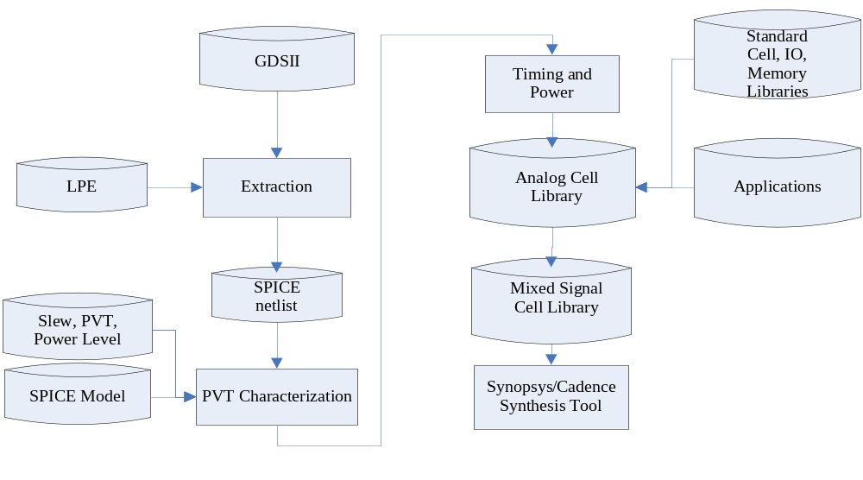

Figure 1. Characterization Flow

Library Format
Synopsys Liberty Format (Lib): Can be compiled into Binary DB format.
Cadence Timing Library Format (TLF).

NP Problems in Analog IPs Characterization
For an analog block, or an IP block, the basic IP contains the input cap, output cap, and static power (or power down mode) analysis. For advanced characterization, the synchronous setup/hold time, synchronous delay time, and dynamic power analysis.
Since IP is getting very big (several million transistors), the simulation time lasts several weeks to several month due to the NP-effect. Traditional SPICE and Turbo SPICE will not help too much about this problem. It is impractical to characterize the IP by using the traditional way for NP-problem. There is no solution for NP-problem mathematically, for NP-problem, the easiest way is to find the short cut via the knowledge-based.

Do not try to resolve the problem directly since NP-problems are one of the three most difficult problems in the mathematical world. For NP-Thinking, we need to think hierarchically, methodologically, and Partial Set.

Hierarchically
For the same IP, a hierarchical SPICE netlist (e.g., 5 Meg) is much smaller than flatten (e.g., 5K) netlist for the same IPs. It has the 1000 time differences in size and simulation and process time to grow NP-fashion. To do this way, the layout engineer should keep the cell hierarchy. The Mentor’s X-Calibre always keeps the cell hierarchy. If the layout engineer flattens the cell, that particular cell needs extra care. Otherwise, the duplicated hierarchy should be simulated only once.

Methodologically
The analog cell library is shared by all Analog design departments (such as, ADC, DAC, PLL, REG, PWM, Ethernet, USB, DSP, DBU, CBU, MBU, etc.) for several thousand of IPs. All the Analog IP, the Analog IP information processing time should not be duplicated in every analog department and each IPs. If the same NAND gates uses 10 times in and there are 2000 IPs, then 1/10x2000 (or 1/20,000) time are saved.

Partial Set
If the information can be obtained from the partial circuit, just use the partial circuit to do the simulation instead of entire chip. The partial circuit cut the month of run time into several seconds.

Characterization

Parameter
PVT parameters (Process, Voltage, Temperature)
Unit definition: nsec, pf, volt, amp, Ohm,
Default definition: Default definition for threshold, etc.
Threshold Definition: Transition threshold (90%, 10%)
Limits: max. output load and max transition time (or Slew Rate)
Wireload model: default 10 100K, etc. Estimate the wire characteristics in the absence of physical data. Wire load model from different vendor and distribution histogram on the chip.

Functionality
Functionality simulation: Combination of logic input and output.

Optimization, Delay Simulation
Area, Power, Timing Constraint (Synchronous Setup/Hold Time), Synchronous Propagation Delay Time
Requires: Input Capacitance, Transition Time (Output Slew Rate).

Measurement and Verification
Check if capacitance value is in expected range.
Checks if model behave like expected:
- Bigger Load -> Bigger Delay.
- Bigger input slew -> Bigger Transition Time.
- Bigger driving strength -> Smaller Delay.
- Higher Temperature -> Bigger Time Delay
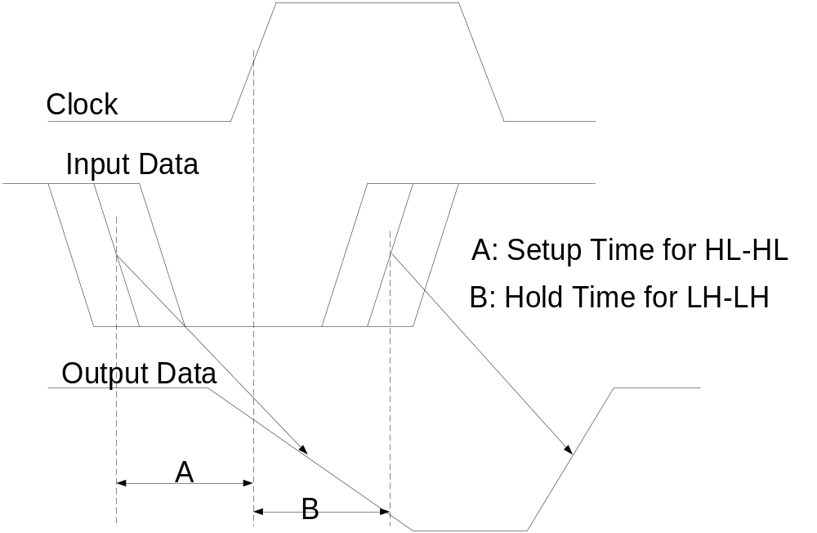

Figure 2. Setup Time for waveform HL-HL and Hold Time for LH-LH

Slew Rate Definition
The slew rate definition is used to describe the output waveform for max capacitance calculation.

The following diagram shows an equation for determining IC slew rate.

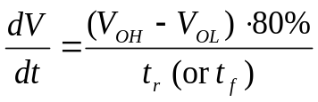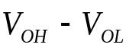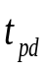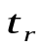
90%
10%
Input
Output
Figure 3. Slew Rate Definition
The formula requires the signal rise time (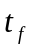) or fall time (), and the Output Low Voltage (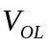) and Output High Voltage (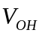). The pick of 90%-10% margin is used to avoid the noise margin.

Digital Slew Rate
In digital world, the slew rate of a device refers the amount of time [ or ] that takes an IC to switch from 10% to 90% of its final value.

The output slew rate is fixed for ASIC for each technology.

For the lower frequency (e.g., 100 MHz or period = 10nsec), it normally fix at 2nsec. However, for higher frequency design (e.g., 10 GHz or period = 0.1nsec), 2nsec slew rate does not enough to describe a waveform. The slew rate should be at least 10% of the period (e.g., slew rate = 0.01nsec for 10 GHz or period = 0.1nsec).

For analog IP designer, the slew rate should be specified by analog designer, by each analog IP. For example, a 1GHz speed USB and 50GHz should have different waveform period and therefore the slew rate should be different for max capacitance measurement.

For FPGA design, the slew rate is selectable according to FPGA’s configuration. For example, the Xilinx 20KE FPGA may be configured for a Fast slew rate of 0.4nsec rise and fall time, or slow slew rate of 1.1nS rise time and 2.04nsec fall time. In addition, GTL / GTLP devices also offer an adjustable slew rate for their GTL interfaces.

Schematic Design Tool
Schematic Designer tools (by Mentor/Cadence/Synopsis) generate the Analog Cell Library and SPICE netlist for Analog IP Design. Since the analog cells are reuse by all the analog IP designs, they only need to be characterized once. Therefore, some gate level model for SPICE simulation should be established in order to convert the MOS (device) level into gate level simulation.

IPs examples:
ADC, DAC, PLL, REG, LVTS, HSIO, USB, Storage (SATA, Series Link), DSP, Ethernet, DBU (Display), MBU (Media), CBU (Communication).

Delay Model

