Input Capacitance Characterization

Capacitance Characterization includes Intrinsic Capacitance and Input Capacitance Characterization.
Intrinsic Capacitance is used in fast dynamic power calculation for full chip, i.e., 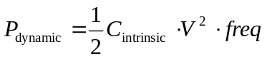. This power calculation is an informal way of power estimation. Therefore, Intrinsic Capacitance is not in the liberty attribute, i.e., there is no way to put the characterized Intrinsic capacitance in the Synopsys Library. Note that Dynamic Power is calculated by summing all the input pin state toggling.

Input Capacitance can be roughly estimate by Mentor Graphics/XCalibre or Synopsys/StarRC using the 3-D field solver. Why we still need to characterize the input capacitance instead of using XCalibre.

There are at least four reasons that 3-D field solver cannot do. First, 3-D field solver estimate the input capacitance based on dimension, it is not a real electrical characteristic. Second, 3-D field solver can only estimate the typical corner of input capacitance, i.e., Best Corner, Worst Corner, and any other conditions (10% below and etc.) are missing. SPICE characterization for input capacitance is needed in formal release. The 3-D field solve data can only used for QA or for to prevent the characterization mistake in SPICE testbench. Third, so far, the 3-D field solver can only see the capacitance which is connected to the input pin. If the input pin is connected to a resistor, the 3-D field solver estimates input capacitance for resistor is 0 which is definitely wrong. Fourth, 3-D field solver can only lump the capacitances connected to input pin, i.e., the other layers or isolated by the resistors can not be lumped together.
For the above reasons, the SPICE is mandatory to characterize all corners/conditions of input capacitance.

Formula to calculate the input capacitance:
Charge Formula: 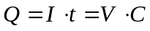 (1)
From the switch side: 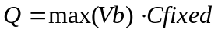 (2)
From the DUT side: 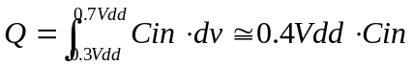 (3)
Where 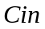 is the downstream capacitance of DUT.
From (1), (2), and (3), we have: (4)
Therefore, we have: 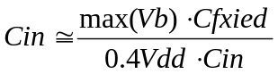 (5)
Note: The 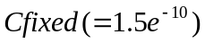 is any capacitor that is big enough to hold the DUT charge and discharge.

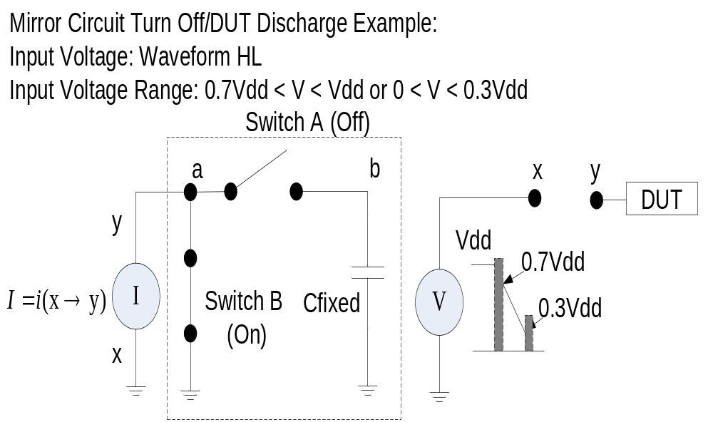

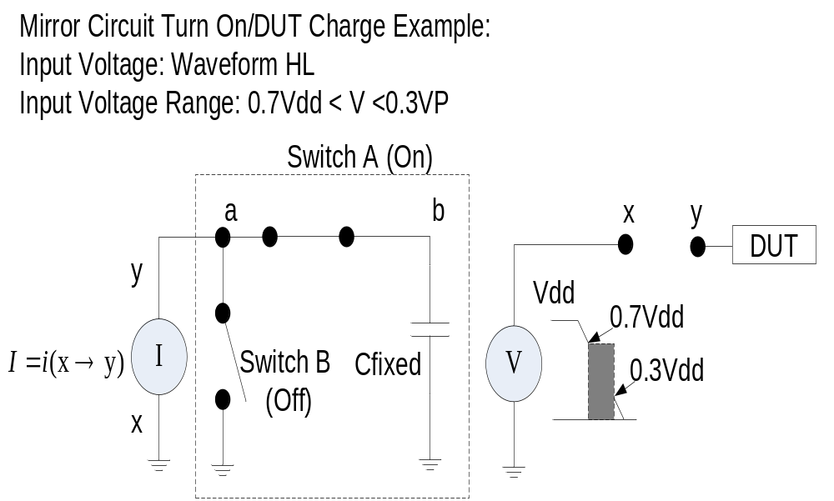

Switch:
Max Resistance: 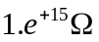
Min Resistance: 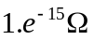
0.3VP
0.7VP
VP
V
R
Switch B
GRB a_a_a b_b_b VCR PWL (1) CLK GND
+ 0.0, 1.e-15 ‘VP*0.3-0.001’, 1.0e-15
+ ‘0.3*VP’, 1.e+15 ‘0.7*VP’, 1.0e+15
+ ‘0.7*VP+0.001’, 1.e-15 VP, 1.0e-15
0.3VP
0.7VP
VP
V
R
Switch A
GRB a_a_a b_b_b VCR PWL (1) CLK GND
+ 0.0, 1.e+15 ‘VP*0.3-0.001’, 1.0+15
+ ‘0.3*VP’, 1.e-15 ‘0.7*VP’, 1.0e-15
+ ‘0.7*VP+0.001’, 1.e+15 VP, 1.0e+15

