Modeling Antenna Effect of Area, Operating Voltage, and at Varied Temperature

Abstract:

This work shows the operating conditions of area, voltage, and temperature for the solution of antenna effect:
1) DC sweep from-10V to 10V (area factor from 0.0001 to 1).
2) Area effect of antenna drain current
3) Voltage effect of antenna drain current
4) Temperature effect of antenna drain current
a) Voltage = -6v, temp = -25, 0, 500 degree C
b) Voltage = 0v, temp = -25, 0, 500 degree C
c) Voltage = 6v, temp = -25, 0, 500 degree C
In order to drain the unwanted current from the plasma during the fab, the drain current should be as high as possible to.

What is the best drain current?
From the diagram, we can tell: Voltage +6v is required. Voltage -6V and 0V are not the good choice. Area has effect on drain current.
Note:
1. MOS is another good choice instead of Diode to keep the layout structure consistent, evenly distributed and power consumption and engineering re-ordering (spared MOS for backup and ion-implant for Silicon debugging).
2. Some SPICE can only area effect and some can model temperature effect. The results are based on Level = 3 (Fowler-Nordheim Model) for area effect and Voltage effect and Level =1 (Berkeley Level =1 Model) for temperature effect.

- DC sweep from-10V to 10V (area factor from 0.0001 to 1).
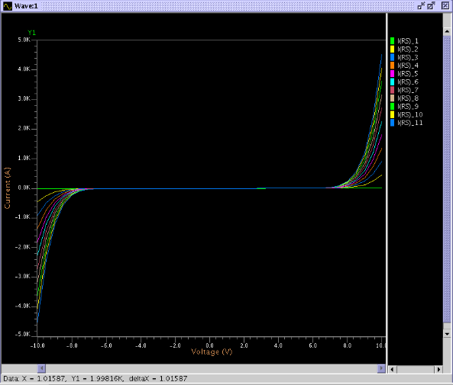

2) Diode SPICE Model Level =3 (Fowler-Nordheim Model).
Note: Berkeley Level =1 cannot model the area effect.
Leakage Current from Area Effect of a Diode:
Area Factor = 0.0001, 0.005, 0.01 of a typical 0.25u diode.
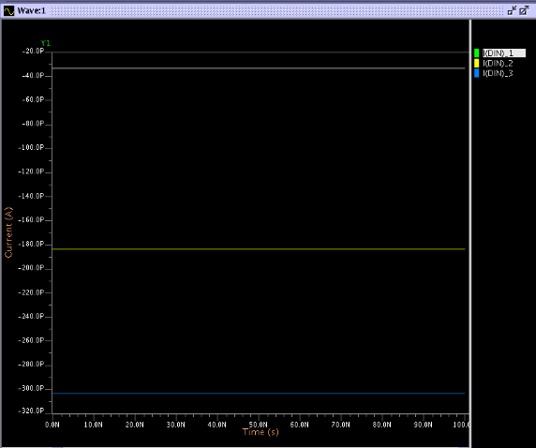

3) Leakage Current of Voltage Effect across the diode:
Voltage = -10V, -5V, 0V, 5V, 10V
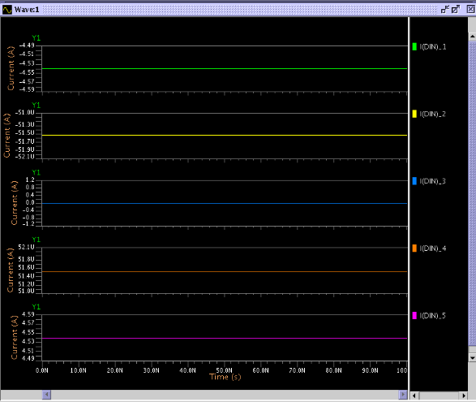

4) Temperature effect for diode’s leakage Current of diode. Due to Level =3 (Fowler-Nordheim model cannot modeling the temperature effect). Use Berkeley Level=1 instead.
a) Voltage cross the diode = -6v (reverse bias), temperatures = -25, 0, 500 degree C
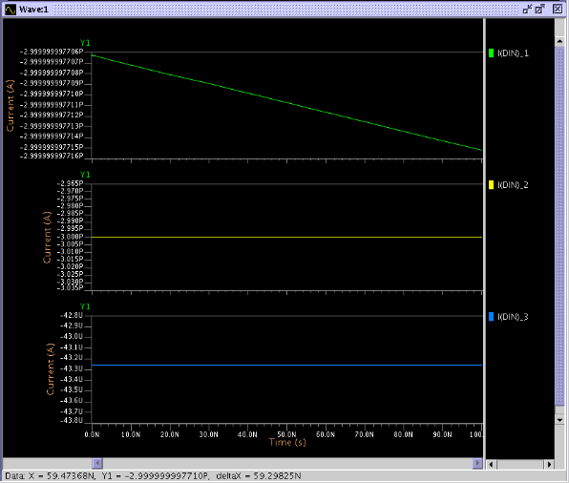

b) Voltage cross the diode = 0v (no bias), temperatures = -25, 0, 500 degree C
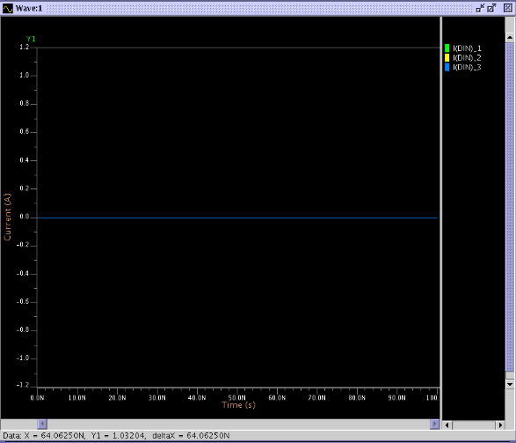

c) Voltage cross the diode = +6v (forward bias), temperatures = -25, 0, 500 degree C
