An Automatic way of Antenna Solution

Peter H. Chen
Peter.hp.chen@gmail.com

October, 2009

Analog Mixed Signal Division
Mentor Graphics, Inc.
Hsinchu, Taiwan
Table of Content
1. Abstract: 3
2. Introduction 3
3. Antenna Fundamental 3
4. Post-Layout Antenna Fixing 3
4.1 Algorithm 3
4.1.1 Explanation 3
4.2 Procedure 3
5. Cell Placement Antenna Fixing 3
6. Hybridization Antenna Fixing 3
7. Conclusion 3

1. Abstract:
This paper proposes a simplified design process containing solutions to both the antenna effect problem and increasing the efficiency of cell placement for million-gates chip layout.

2. Introduction
Working within the ASIC industry, time to market is very important. With Very Deep Sub-Micron (VDSM) processes, issues with timing enclosure, cell placement efficiency, the antenna effect, signal integrity, etc. have impacted our ability to meet market requirements in a timely manner. By focusing on the design process, two of the major issues, the antenna problem and cell placement efficiency, can be addressed. I propose using Knowledge Based Priority Placement (KBPP), which utilizes design knowledge to simplify those two issues.

3. Antenna Effect
The antenna problem has existed in the semiconductor industry for more than a decade. In the production of the modern VLSI semiconductor, etching plasma is used to deposit or remove material on wafers. The etching plasma causes destructive charges to be built up on the wafer. This problem is more critical in VDSM VLSI design since thinner oxides are even more susceptible to damage. During wafer manufacturing, aluminum or polysilicon wires in the plasma ambient that are not covered with dielectric collect charges and serve as “antenna.” When the potential becomes high enough, it will discharge through the gate dioxide and cause cell damage. Damage can include electrical stress that decreases the breakdown voltage of the gate oxide, resulting in a decreased yield rate during wafer manufacturing. It has been hypothesized that UV light bombardment on the etching plasma during the manufacturing process increases the antenna effect; however, I have found that it increases the effectiveness of protection diodes since they are the miniature solar cells and they conduct the charge instead of the gate dioxide. []
3.1 Possible Solutions
To prevent this, we can dig a drainage trench, reduce the antenna lengths, insert jumpers in the post-layout phase, or connect protection diodes as close to the input ports as possible. The first two options are not feasible as they necessitate changing the design of a completed chip during the manufacturing process. Among these solutions, only post-layout jumper insertion and protection diodes can be used in the physical design period. However, even smart routers are not able to insert jumpers because chips are so dense. Jumpers also cause more time delay than diodes and cause timing enclosure problems. The following calculation shows the timing comparison between jumper and diode insertion approaches. In jumper insertion, each jumper needs at least two vias. In 0.35m technology, via resistance is around 10. In 0.25 m technology or below (such as 0.18m), via resistance is around 100 or more. The bigger the resistance, the worse the timing delay is. This phenomenon is more severe in deeper sub-micron technology.
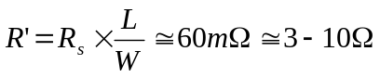, (1)
Where:
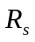 is the sheet resistance of metal
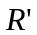 is the resistance of metal with length L.
If we use diode insertion, the diode capacitance is the factor that affects the timing delay. The following equation estimates typical diode capacitance.
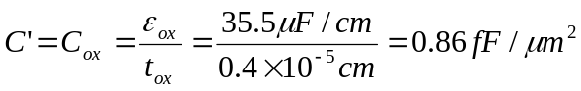, (2)
Where
C is the capacitance of the original wire
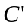 and 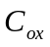are capacitance of metal with length L
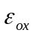 is the permittivity of diode
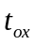 is the thickness of the diode.
If we add one jumper (with two vias) and one protection diode for a wire 350 ⎧m long, we have the following estimate timed delay.
= (R + R’) ⋅ (C + C’)
= R⋅C ⋅ (1+ R’ / R)⋅ (1+ C’ /C) (3)
Assume a wire with 60 and 1-pF capacitance. If we compare dropping two vias at 3 (total 6) versus dropping a protection diode at 0.86 fF from equation (3), we can see that the delay caused by the protection diode (C’ /C 0.86 fF /1pF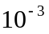) is much less than that caused by the jumper insertion [or router option] (R’ / R 6 / 60 0.1). Therefore, the timing delay caused by dropping the diode is negligible.

Simulation Results
Figures 1 and 2 simulate the inverter with a protection diode during the manufacturing process. The protection diode size also affects the cumulative current. Assume a current pulse is generated from the etching plasma into the input gate. The input gate is protected by a protection diode with area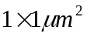. The plasma current source (Is) is set to the following conditions:
- current amplitude = 10 mA
- period = 20 ns
- pulse width = 5 ns
- 1 ns in both the rising and falling edge
- initial delay 2 ns.
Resistors R1, R2, and R3, are set to 5. Capacitances C1, C2, and C3 are set to 0.75pF. Both N-MOS and P-MOS are tied to ground. Voltages are measured and displayed at node NI and the input port (node N3). Since the protection diode provides drainage, the plasma current at the input gate is kept to zero (Figure 2).

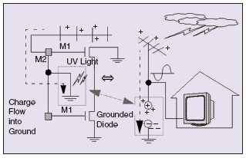
Fig. 1. Analogy of protection diode fixing antenna problem during manufacturing.

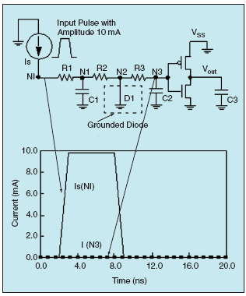
Fig. 2. SPICE simulation: input port is grounded by the protection diode.

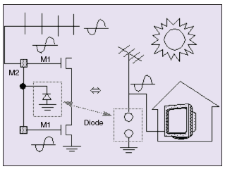
Figure 3 Analog of normal circuit operation

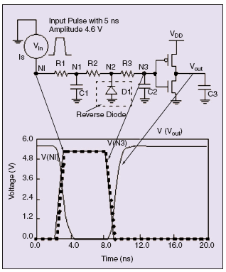
Fig. 4. SPICE simulation: Input port is protected by diode during the normal operation.

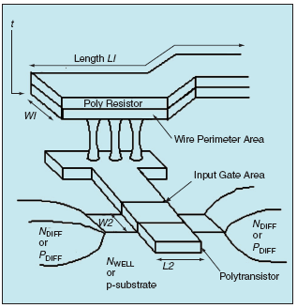
Fig. 5. Dimension definition of a typical 0.25m process.

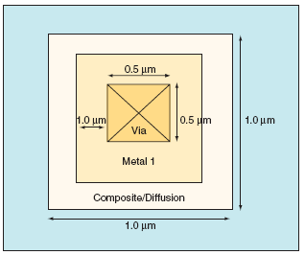
Fig. 6. Protection diode top view

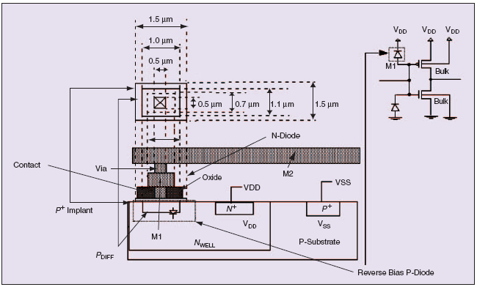
Fig. 7. P-Diode structure for P-MOS process

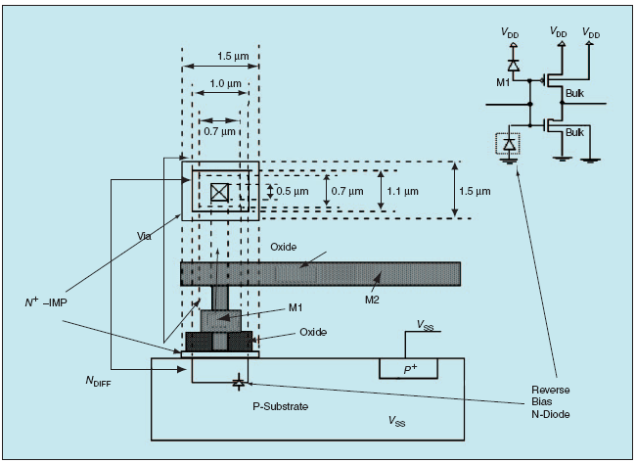
Fig. 8. N-Diode structure for N-MOS process

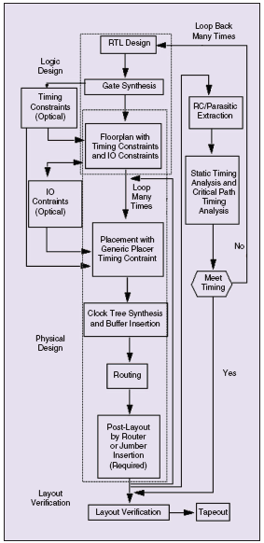
Fig. 9. Traditional flow.

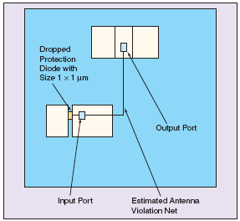
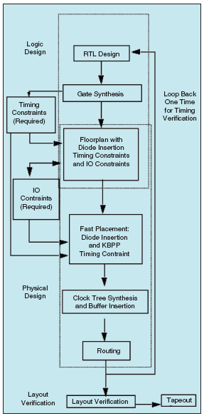

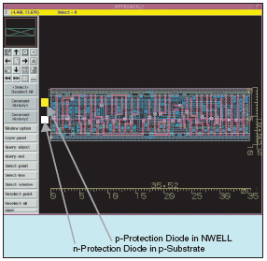
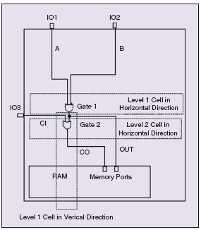

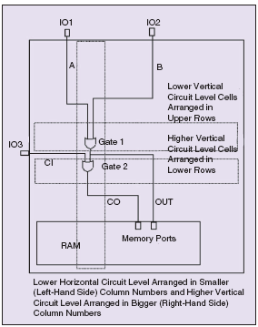

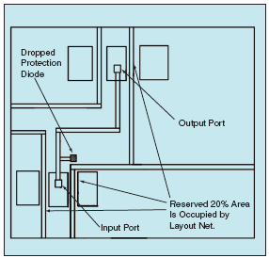

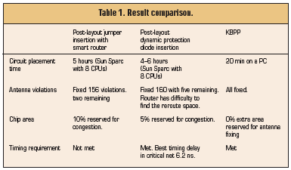

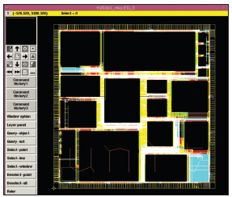

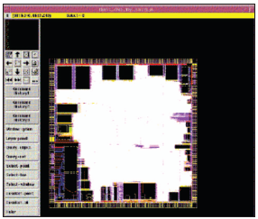

4. Post-Layout Antenna Fixing
4.1 Algorithm
4.1.1 Explanation

4.2 Procedure
5. Cell Placement Antenna Fixing
6. Hybridization Antenna Fixing
7. Conclusion

8. Acknowledgement
Thanks great supports from my family, LSI Logic, National Semiconductor, Teralogic, Mentor Graphics, US/Taiwan patent office, IEEE/ISQED, IEEE/Devices and Circuits Magazine, and ITU Faculty.

9. References
- Paul Penfield, Jr. and Jorge Rubenstein, “Signal Delay in RC Tree Networks,” 18th Design Automation Conference, IEEE, pp. 613-617, 1981.
- Michael Santarini, “Tool Automatically Removes Antenna Violations,” EE Times, Issue 1013, p. 88, June 22, 1998.
- D. Beasley, D. R. Bull, and R. R. Martin, “An Overview of Genetic Algorithms: Part 1, Fundamentals,” University Computing, Vol. 15, pp. 58-69 and pp. 170-181, 1993.
- D. Beasley, D. R. Bull, and R. R. Martin, “An Overview of Genetic Algorithms: Part 2, Research Topics,” ibid., Vol. 15, pp. 170-181, 1993.
- Peter H. Chen, “Beat the Competition: A knowledge-Based Design Process Addressing the Antenna Effect and Cell Placement,” IEEE Circuits and Devices, pp. 18-27, May/June 2004.
- Peter H. Chen, S. Malkani, C. M. Peng, and J. Lin, “Fixing Antenna Problem by Dynamic Diode Dropping and Jumper Insertion,” IEEE/ISQED, pp. 275-282, San Jose, California, 2000.
- Peter H. Chen, S. Malkani, C. M. Peng, and G. Ying, “Fixing Antenna by Synopsys SLE,” SNUG, TA4, pp. 1-21, San Jose, California, 2000.
- Peter H. Chen and et al, “Chapter 8: Physical Design Exchange Format,” IEEE Standards-P1481 for Integrated Circuit Delay and Power Calculation System, pp. 265-299, http://www/vhdl.org/vi/dpc, 1997.
- Peter H. Chen and et al, “LSI datapath placer implementation specification,” LSI Logic Corp, Milpitas, California, 1995.
- C. K. Cheng and E. S. Kuh, “Module Placement Based on Resistive Network Optimization,” IEEE Trans. on Computer-Aided Design of Integrated Circuits and Systems, Vol. CAD-3, No. 3, pp. 218-225, July, 1984.
- W. E. Donath, “Placement and Average Interconnection Lengths of Computer Logic,” IEEE Transactions on Circuits and Systems, Vol. CAS-26, No. 4, pp. 272-277 (April 1979).
- K. M. Hall, “An r-Dimensional Quadratic Placement Algorithm,” Management Science, Vol. 17, No. 3, pp. 219-229, November, 1970.
- J. M. Kleinhans and et al, “GORDIAN: VLSI Placement by Quadratic Programming and Slicing Optimization,” IEEE Transaction on Computer-Aided Design, Vol. 10, No. 3, pp. 256-365, March 1991.
- J-M. Luchies, P. Simon, F. Kuper, and W. Maly, “Relation between Product Yield and Plasma Process Induced Damage,” Proceedings of the P2ID Conference, pp. 7-10, June, 1998.
- R. A. Rutenbar, “Simulated Annealing Algorithms: An Overview.” IEEE Circuits and Devices, pp. 19-26 (Jan. 1989)
- H. C. Shin and C. Hu, “Plasma Etching Antenna Effect on Oxide-Silicon Interface Reliability,” Solid-State Electronics, Vol. 36, No. 9, pp. 1356-1358 (1993).
- H. C. Shin and C. Hu, “Thin Gate Oxide Damage Due to Plasma Processing,” Sci. Technol., 11, pp. 463-373, 1994.
- K. Shahookar and P. Mazumder, “A Genetic Approach to Standard Cell Placement using Meta-Genetic Parameter Optimization,” IEEE Transaction on Computer-Aided Design, Vol. 9, No. 5 (May, 1990)
- R-S. Tsay, E. S. Kuh, and C-P. Hsu, “PROUD: A Fast Sea-Of-Gates Placement Algorithm,” 25th ACM/IEEE Design Automation Conference, pp. 318-426 (1988).

