12/27/2025, Legacy (last week)
https://www.youtube.com/live/9fu_vdVRpMM?si=U8usNoNdp-G7olN9
“Come All Ye Lonely | Come All Ye Faithless,” Phil EuBank, Lead Pastor



“Ye” = “y’all.” The phrase
1. " Come All Ye Lonely" means “Come here. All of you who are Lonely".
2. "Come All Ye Faithless" means “Come here. All of you who are without faith".




Phil EuBank, Lead Pastor

Introduction:
18:00/1:14:58


Speech:
22:00/1:14:58


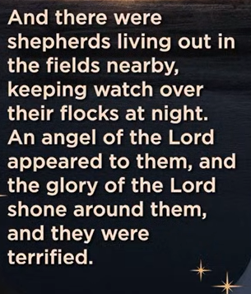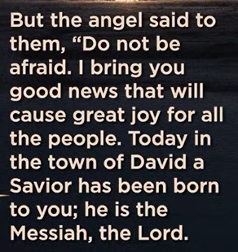

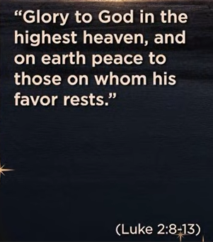
Luke 2:8-13
English Standard Version
The Shepherds and the Angels
⁸ And in the same region there were shepherds out in the field, keeping watch over their flock by night. ⁹ And an angel of the Lord appeared to them, and the glory of the Lord shone around them, and they were filled with great fear. ¹⁰ And the angel said to them, “Fear not, for behold, I bring you good news of great joy that will be for all the people. ¹¹ For unto you is born this day in the city of David a Savior, who is Christ the Lord. ¹² And this will be a sign for you: you will find a baby wrapped in swaddling cloths and lying in a manger.” ¹³ And suddenly there was with the angel a multitude of the heavenly host praising God and saying,

The main point of Luke 2:8-13 (and extending to 2:14) is the divine announcement of Jesus's birth as the long-awaited Savior (Messiah, Lord) to humble shepherds, bringing "good news of great joy for all people," confirmed by a simple sign (baby in a manger) and celestial praise ("Glory to God in the highest, peace on earth"), revealing God's love and salvation reaching the lowly, not just the powerful.
Key Elements & Meanings:
- "Shepherds": Humble, marginalized people, showing God's grace reaches the poor and overlooked.
- "Angel of the Lord & Glory of the Lord": God's powerful presence, initially terrifying but followed by reassurance.
- "Do not be afraid": A common divine greeting, signaling good news, not judgment.
- "Good News of Great Joy for All People": The core message; salvation is here, available universally.
- "Savior, Christ the Lord": Jesus is identified with divine titles (Messiah, Master, Son of David).
- "Today in the town of David": Emphasizes the immediate, real fulfillment of prophecy in Bethlehem.
- "Sign: a baby wrapped in cloths, lying in a manger": A humble, contrasting sign of the mighty Lord's arrival, showing God's humble entrance.
- "Host of Heavenly Angels": A celestial choir praising God and announcing peace for people of good will.
In essence, it's the unveiling of God's plan to bring salvation and peace through the humble birth of His Son, Jesus, to the most unexpected recipients, demonstrating His love for all.

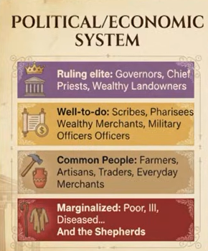
Political/Economic System
a. Ruling Elite: Governors, Chief Priests, Wealthy Landowner
b. Well-to-do: Scribes, Pharisees, Wealthy Merchants, Military officers
c. Common People: Farmers, Artisans, Traders, everyday Merchants
d. Marginalized: Poor, Ill, Diseased, Shepherds, etc.

The social/economic structure described (Governors, Priests, Scribes, Merchants, Farmers, Poor) perfectly depicts the stratified Roman Province of Judea/Galilee around the turn of the 1st Century CE (Year 0), a hierarchical society where Roman rule, Jewish religious authority (Temple/Synagogue), and local economic power (landowners, merchants) created distinct classes from the ruling elite (Procurator/King, High Priests) down to the impoverished marginalized, a system seen in biblical narratives. [1, 2]

Here's a breakdown of that system:
- Ruling Elite (a): The Roman Governor (like Pontius Pilate) held ultimate political power, supported by local figures like the Chief Priests (Sadducees) controlling the Temple, alongside powerful Jewish landowners (Herodians) benefiting from Roman patronage.
- Well-to-do/Middle Class (b): Scribes (legal experts), Pharisees (religious leaders/teachers), wealthy merchants, and military officers formed this influential group, often bridging Roman and Jewish worlds but distinct from the very top.
- Common People (c): The vast majority—farmers (peasants), artisans, small traders, and everyday merchants—were the backbone, subject to heavy taxes and Roman rule.
- Marginalized (d): The poorest, sick (lepers), disabled, shepherds (often seen as outside settled society), and others lived on the fringes, dependent on charity or precarious labor. [1, 2]
This rigid system was characterized by heavy taxation (Roman & Temple), limited social mobility, and significant tension between the powerful and the oppressed, setting the stage for events described in the New Testament. [1, 2]

AI responses may include mistakes.
[1] https://theses.gla.ac.uk/2397/1/1990leephd.pdf
[2] http://files.eshkolot.ru/tuval1.pdf


a. God shows up in the ordinary.
b. God inveites the uninvited.
c. God makes news with peace.

The main point across the three statements is that God's presence and actions are not limited to the extraordinary or expected; rather, God demonstrates a universal and inclusive concern for all people, often appearing in everyday situations, extending grace to those who are typically marginalized, and prioritizing peace as a central message.
Specifically:
- "God shows up in the ordinary" emphasizes that the divine can be found in everyday life and common circumstances, not just in spectacular or sacred settings.
- "God invites the uninvited" highlights God's radical inclusivity and mercy, reaching out to those who are typically excluded or overlooked by society.
- "God makes news with peace" underscores that God's message and impact often center on the establishment of harmony and reconciliation, which is presented as a transformative, newsworthy event.

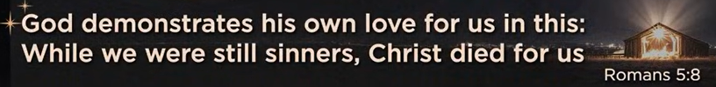
Romans 5:8
English Standard Version
⁸ but God shows his love for us in that while we were still sinners, Christ died for us.

The main point of Romans 5:8 is that God demonstrated His deep, unconditional love (agape) by sending Jesus to die for humanity while we were still sinners, ungodly, and undeserving, proving His love isn't based on our merit but on His character, offering reconciliation and eternal life to those who believe. It's a pivotal verse showing that Christ's sacrifice wasn't for the good, but for the wicked, making His grace and the hope of salvation truly powerful and accessible.
Key aspects of Romans 5:8
- "But God demonstrates His own love for us...": God actively proved His love, rather than just stating it.
- "...while we were still sinners...": This highlights that God's love came before we were righteous; we were His enemies, not His friends, when He acted.
- "...Christ died for us.": Jesus' death on the cross was the ultimate act of this love, taking the penalty for our sins and making reconciliation with God possible.
The significance for believers
- Unconditional Love: God's love is not earned; it's freely given.
- Hope in Sin: Even in our darkest moments, God's love remains, offering forgiveness and a path to a full life.
- Motivation for Faith: This demonstration of love encourages believers to trust in Christ, live for Him, and have hope in His promises.

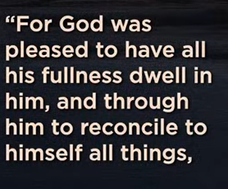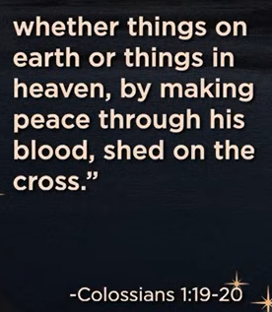
Colossians 1:19-20
English Standard Version
¹⁹ For in him all the fullness of God was pleased to dwell, ²⁰ and through him to reconcile to himself all things, whether on earth or in heaven, making peace by the blood of his cross.

The main point of Colossians 1:19-20 is that God's fullness dwells in Jesus Christ, and through His death on the cross, Christ achieves cosmic reconciliation, making peace between heaven and earth by redeeming all things to Himself, bridging the gap caused by sin and offering restoration to humanity. Jesus, as the God-man, fulfills His divine mission to bring harmony and is the exclusive source of peace, uniting believers to God.
Key Aspects:
- Fullness in Christ: God's complete divine nature (fullness) chose to reside permanently in Jesus.
- Reconciliation: Jesus's mission was to restore broken relationships, especially between God and humanity, which was fractured by sin.
- Peace-Making: Peace isn't automatic; it's actively made through the "blood of His cross," signifying Christ's sacrificial death.
- Cosmic Scope: This reconciliation extends to "all things, whether on earth or in heaven," restoring God's rule over creation.
In essence, these verses highlight Jesus's supreme deity and His redemptive work to bring everything back into right relationship with God.

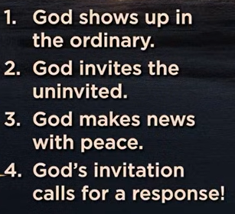
1. God shows up in the ordinary.
2. God inveites the uninvited.
3. God makes news with peace.
4. God’s invitation calls for a response!

The provided points outline a theological message focused on the nature of God's interaction with the world and humanity, suggesting several main ideas:
- Divine presence is universal: God's presence and action are not limited to sacred spaces or extraordinary events; they can be found within the everyday experiences of life.
- Grace is inclusive: God's invitation to relationship or salvation is extended widely, specifically to those who might be considered outsiders, marginalized, or overlooked by society.
- Peace is paramount: A central message of God's presence or action in the world is the establishment of peace (shalom), and this is a significant and newsworthy event.
- Faith requires action: Recognizing and accepting God's invitation necessitates a personal decision or response, implying a call to commitment or a change in lifestyle.
In essence, the overarching theme is that God is actively and inclusively engaged with all aspects of the world, making the universal offer of peace that demands a personal response

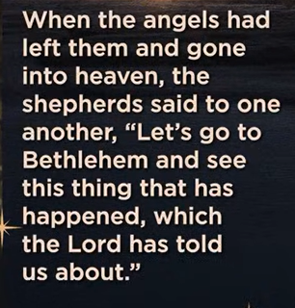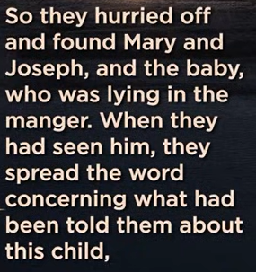

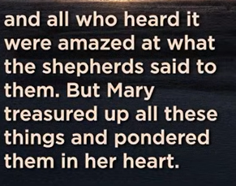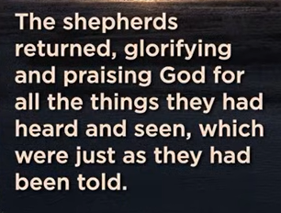
Luke 2:15-20
English Standard Version
¹⁵ When the angels went away from them into heaven, the shepherds said to one another, “Let us go over to Bethlehem and see this thing that has happened, which the Lord has made known to us.” ¹⁶ And they went with haste and found Mary and Joseph, and the baby lying in a manger. ¹⁷ And when they saw it, they made known the saying that had been told them concerning this child. ¹⁸ And all who heard it wondered at what the shepherds told them. ¹⁹ But Mary treasured up all these things, pondering them in her heart. ²⁰ And the shepherds returned, glorifying and praising God for all they had heard and seen, as it had been told them.

The main point of Luke 2:15-20 is the shepherds' immediate, joyful response to the news of Jesus' birth: they hurried to see Him, confirmed the angelic message, became the first evangelists by spreading the "good news," and returned praising God for the Savior, demonstrating faith, action, and worship. It highlights God's message of salvation reaching the humble and marginalized first, inspiring a ripple effect of sharing and glorifying God.
Here's a breakdown of the key actions and themes:
- Urgency & Obedience: The shepherds "went with haste," showing immediate trust and obedience to the angelic message.
- Confirmation: They found Mary, Joseph, and the baby Jesus exactly as described, verifying the divine announcement.
- Evangelism: They couldn't keep the good news to themselves, becoming the first to "make known the saying" about the Christ child, acting as "Christmas evangelists".
- Amazement & Reflection: Those who heard the shepherds "wondered at what they were told," and the shepherds themselves "returned, glorifying and praising God" for all they had seen and heard.
- God's Glory: The passage emphasizes God's glory and the humble, yet profound, way He brought salvation to the world, starting with the least likely recipients.

12/27/2025, Legacy (last week)
https://www.youtube.com/live/9fu_vdVRpMM?si=U8usNoNdp-G7olN9
“Come All Ye Lonely | Come All Ye Faithless,” Phil EuBank, Lead Pastor

“Ye” = “y’all.” The phrase
1. " Come All Ye Lonely " means “Come here. All of you who are Lonely".
2. "Come All Ye Faithless" means “Come here. All of you who are without faith".

Summary:
1. Luke 2:8-13: Luke 2:8-13 announces of Jesus's birth as the long-awaited Savior (Messiah, Lord) to humble shepherds, bringing "good news of great joy for all people."
2. Roman Province in the 1st Century CE (Year 0), Political/Economic System:
a. Ruling Elite: Governors, Chief Priests, Wealthy Landowner
b. Well-to-do: Scribes, Pharisees, Wealthy Merchants, Military officers
c. Common People: Farmers, Artisans, Traders, everyday Merchants
d. Marginalized: Poor, Ill, Diseased, Shepherds, etc.
3. Romans 5:8: God demonstrated His deep, unconditional love (agape) by sending Jesus to die for humanity while we were still sinners, ungodly, and undeserving, proving His love isn't based on our merit but on His character, offering reconciliation and eternal life to those who believe. It's a pivotal verse showing that Christ's sacrifice wasn't for the good, but for the wicked, making His grace and the hope of salvation truly powerful and accessible.

4. Colossians 1:19-20: God's fullness dwells in Jesus Christ, and through His death on the cross, Christ achieves cosmic reconciliation, making peace between heaven and earth by redeeming all things to Himself, bridging the gap caused by sin and offering restoration to humanity. Jesus, as the God-man, fulfills His divine mission to bring harmony and is the exclusive source of peace, uniting believers to God.
Key Aspects:
- Fullness in Christ: God's complete divine nature (fullness) chose to reside permanently in Jesus.
- Reconciliation: Jesus's mission was to restore broken relationships, especially between God and humanity, which was fractured by sin.
- Peace-Making: Peace isn't automatic; it's actively made through the "blood of His cross," signifying Christ's sacrificial death.
- Cosmic Scope: This reconciliation extends to "all things, whether on earth or in heaven," restoring God's rule over creation.
In essence, these verses highlight Jesus's supreme deity and His redemptive work to bring everything back into right relationship with God.

6. The provided points outline a theological message focused on the nature of God's interaction with the world and humanity, suggesting several main ideas:
- Divine presence is universal: God's presence and action are not limited to sacred spaces or extraordinary events; they can be found within the everyday experiences of life.
- Grace is inclusive: God's invitation to relationship or salvation is extended widely, specifically to those who might be considered outsiders, marginalized, or overlooked by society.
- Peace is paramount: A central message of God's presence or action in the world is the establishment of peace (shalom), and this is a significant and newsworthy event.
- Faith requires action: Recognizing and accepting God's invitation necessitates a personal decision or response, implying a call to commitment or a change in lifestyle.
In essence, the overarching theme is that God is actively and inclusively engaged with all aspects of the world, making the universal offer of peace that demands a personal response

7. Luke 2:15-20: Shepherds hurried to see Him, confirmed the angelic message, became the first evangelists by spreading the "good news," and returned praising God for the Savior, demonstrating faith, action, and worship. It highlights God's message of salvation reaching the humble and marginalized first, inspiring a ripple effect of sharing and glorifying God.
Here's a breakdown of the key actions and themes:
- Urgency & Obedience: The shepherds "went with haste," showing immediate trust and obedience to the angelic message.
- Confirmation: They found Mary, Joseph, and the baby Jesus exactly as described, verifying the divine announcement.
- Evangelism: They couldn't keep the good news to themselves, becoming the first to "make known the saying" about the Christ child, acting as "Christmas evangelists".
- Amazement & Reflection: Those who heard the shepherds "wondered at what they were told," and the shepherds themselves "returned, glorifying and praising God" for all they had seen and heard.
- God's Glory: The passage emphasizes God's glory and the humble, yet profound, way He brought salvation to the world, starting with the least likely recipients.

