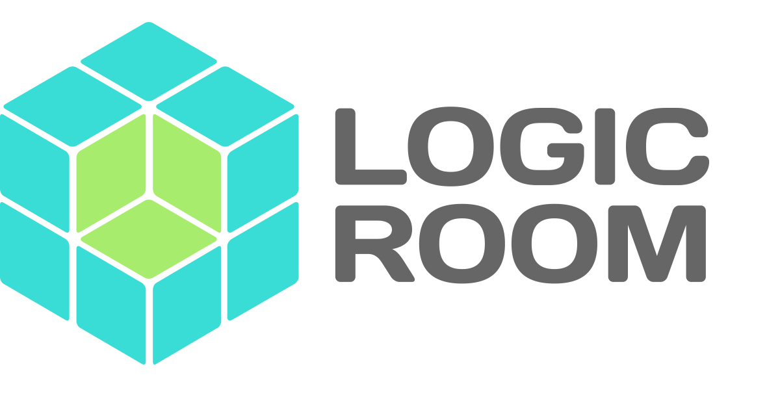

Report for Recruitment Comparison Platform

Compiled by Pete Heard­

# Introduction

This application is intended to provide a way to connect architectural firms with candidates. The key selling points of this application are

1. It’s industry specific search capability with advanced matching for job opening and candidates
2. It’s ability to create a graphical visualization of how appropriate a candidate is for a role based on a number of (weighted) variables.

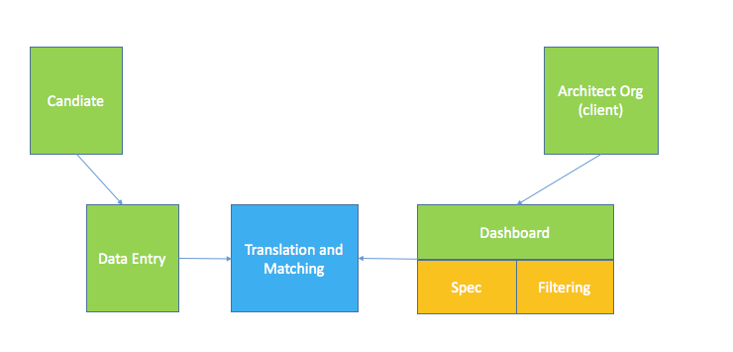

# Recommendations

After our 45-minute discussion we discussed 2 possible approaches you can take to developing this application.

## Approach 1: Partnership

We discussed partnering with a recruitment agency and offering them the opportunity to take part in an initial trail run of the application. This would involve initially meeting with them and showing them some designs and looking for some input from them.

Then developing a basic prototype of the application and working with them during the candidate selection. It would be best to only develop the critical component (the visualization tool) and leave the delay development of other parts until you know what works.

## Approach 2: Landing Page

The other alternative we discussed was to use a landing page with some targeted adverts on a relevant social network (such as linked in). The basic idea is that you create an online sales copy with a clear call to action as to why someone would use this application. Then you send traffic to it using paid ads. You provide a way for the potential user to enter their details in order to get more information. At this stage you either have a very basic prototype working or you simply use it as a way to measure effectiveness and inform them you will be in touch as soon as you launch.

We discussed using an offshore agency for the more basic landing page but a UK designer to help with your User Experience (UX). UX is a highly communicative affair and as such offshoring this will always be difficult because of the language barriers.

# Costs

For `Approach 2` I recommend the following:

Logo Design (offshore: circa £30)

Wordpress Website and Landing Page Design and Development (offshore: circa £200 - $500)

UX Design: (UK Based : circa £500 per day)

Advertising: (£200 - £500)

# Links

**Logo Design** : <https://www.peopleperhour.com/hourlie/bespoke-logo-design-unlimited-concepts-revisions-source-files-favicon/270156?ref=listings>

**Wordpress Landing Page** : <https://www.peopleperhour.com/hourlie/premium-custom-one-page-psd-design-home-page-landing-papge-web-app-design-only/276210?ref=listings>

**UX Design** : if you drop [john@innovatecreative.co.uk](mailto:john@innovatecreative.co.uk) a line with your requirement for the UK UX work they have a good designer who works there, they can also build your entire site for you and give you more help but this will be a lot more expensive than offshoring parts of it and organizing it yourself

**Development:** If you want some help with the Web/Mobile development I can offer to help to find someone for you from my network when you are further along.